There are 5 projects in this solution:

1. Console app HelloWorld
2. DllTest
3. RESTFulDemo
4. WcfService1
5. UnitTestHelloWorld

I added 3 different APIs for this console app to use. There are options to select which API (REST, SOAP, DLL) to use, in app.config of HelloWorld project.

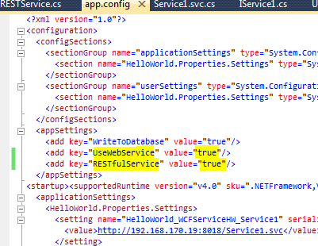

Flowchart below shows how to set the key values in app.config to call different APIs
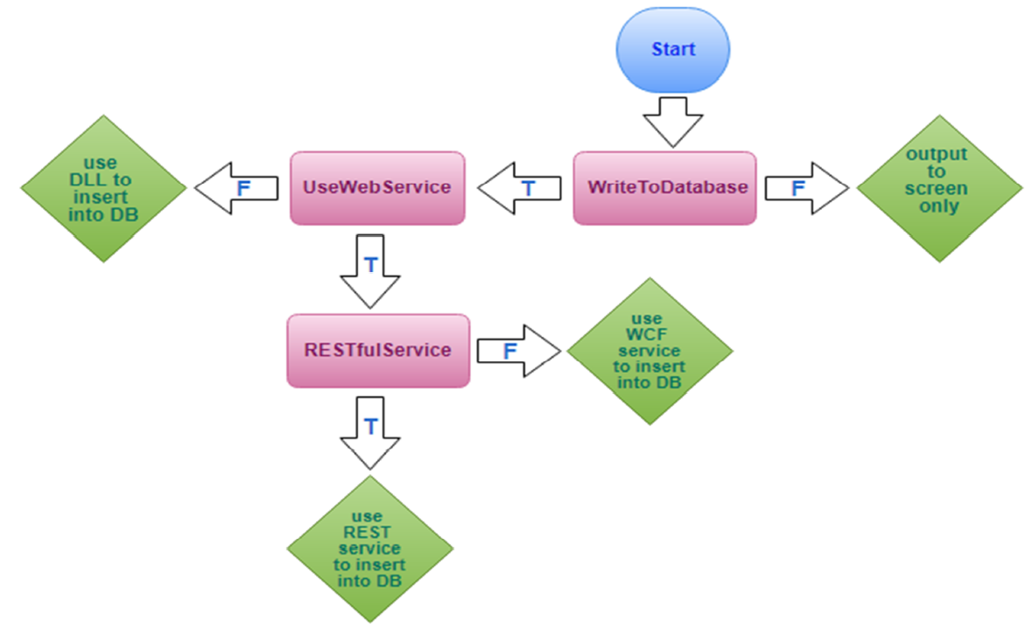

Some notes here:

1. In HelloWorldUseAPIs.cs, when the code calls REST service:
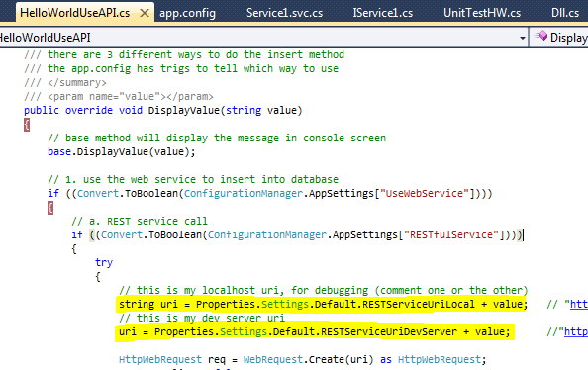

The uri values for localhost and dev server are set in:
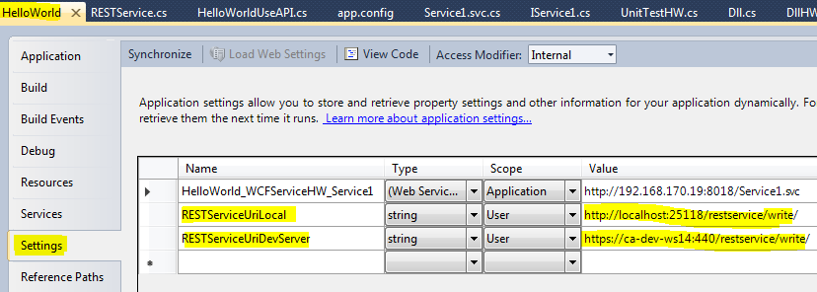

These uri’s are for my localhost and my dev server, please change to your uri values, and then comment one or the other to test it either on localhost or on server. My dev server is internal, so you will not be able to access it from internet.

We can also do a browser test for the REST service, and the result looks like this:
https://ca-dev-ws14:440/restservice/write/LilyTest has inserted the value into database table
and returned “true” in the browser.
“Not secure” warning is because I made a self-signed certificate on my dev server which is not
trusted by SSL.
This service works for HelloWorld console app too.

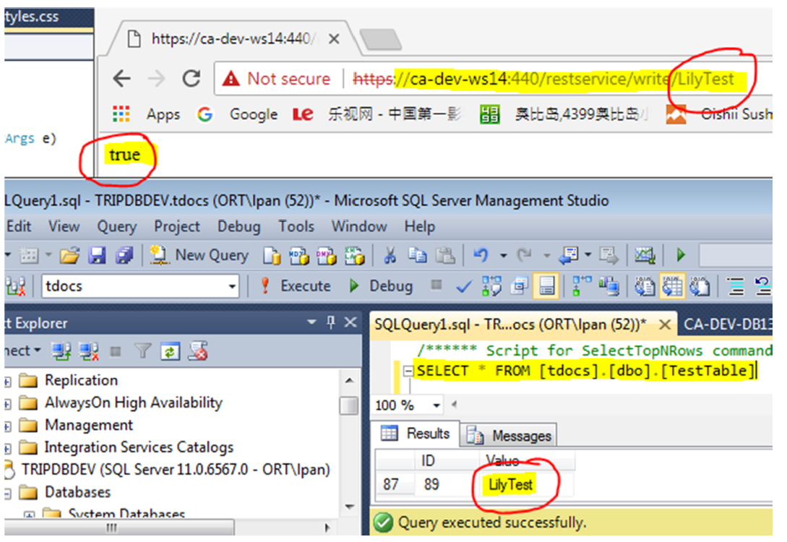

2. In HelloWorldUseAPI.cs, when the code calls WCF SAOP service, please comment one or the
other, to try either the local reference (debug purpose) or the web reference (when service published on server).

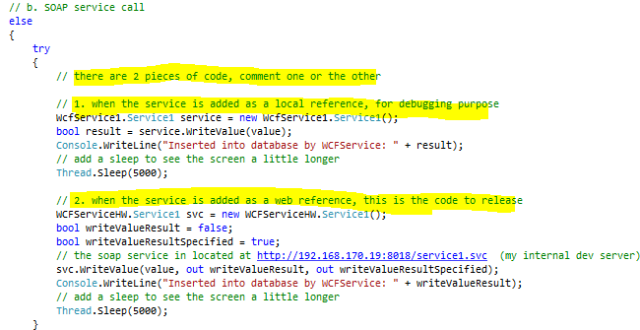

When you try the web reference, please not to use my web reference. Because I published it on my internal dev server which will not be connected from outside.

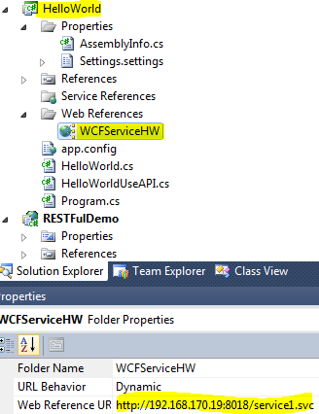

Please publish the WCF SOAP service on your server, and then go to “Add Web Reference” with your own service link.

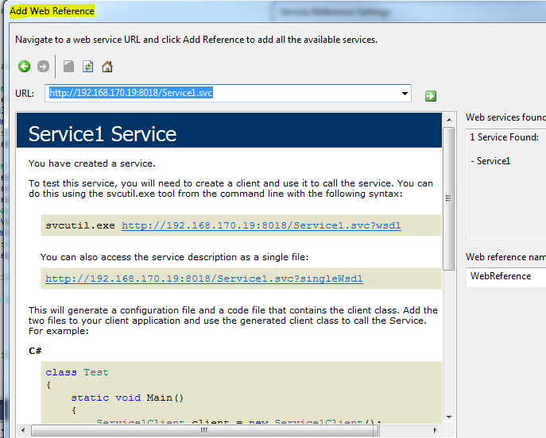

3. The connection string for the DLL is set in here:
I will delete my connection string value, so you will put your own value in there.

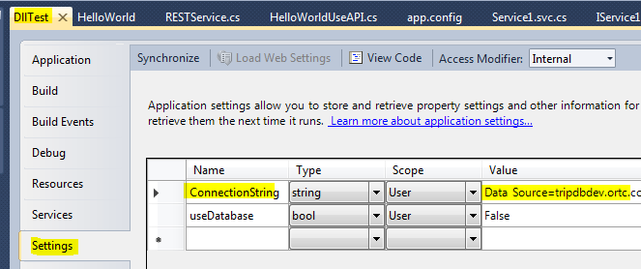

In DllHW.cs, if you would like to test the database insert method, this is where you put your own query.
I have created a TestTable in my dev database and it works with my code.
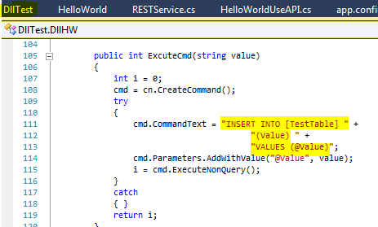

In the DLL I also added GetValue( ) method so we have options of either getting
value from the database or just hard coding “Hello World” for now. GetValue( ) is turned off now and it could be turned on in the config file: useDatabase.
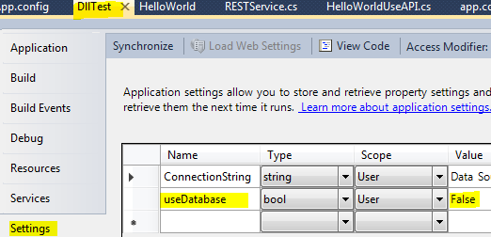

4. I will also delete all connection strings in RESTFulDemo and in WcfService1. Please add your
own connection strings in there if you will test the code.

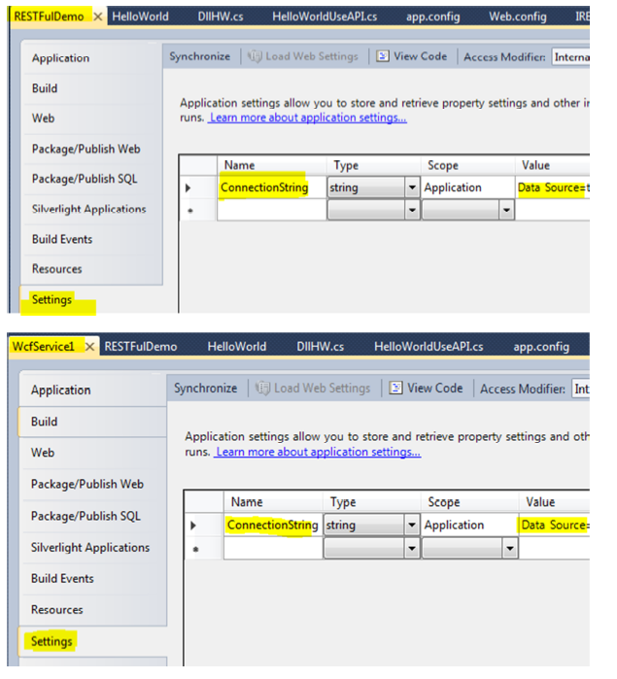

5. I did unit test for the DLL, to check if the return value is “Hello World”, and the database
insert method.

6. Interface, abstract class are used in the code.
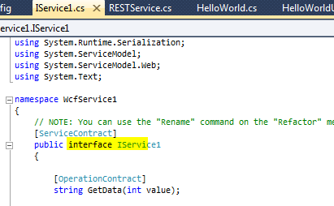
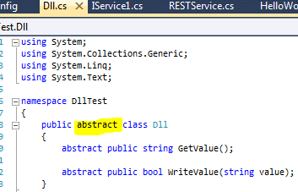

Conclusion:

The DLL is easy to use, but it has to be added locally in each application, and if there are changes in the DLL then we will have to rebuild the DLL, also all applications that use the DLL will have to re-reference the DLL and rebuild too. The SOAP service can be consumed from the server on internet, and it’s stable, but if there are changes in the Service Contract of the service, the client app will also have to re-reference the service and rebuild the code. Also we have to make sure all the configurations match on the server side and on client side, such as endpoints, binding etc., otherwise it will not work. Especially when SSL is enabled on the server, the configurations could be a little complicated for the client side. The REST service is easier for client apps to use especially easy for mobil apps, because there is no reference required, if there are changes in the service, as long as the uri is not changed, the client side doesn’t have to do make any changes.

