High Veryhigh Low Verylow

雷速表頭的四種顏色 似乎標示比賽關注度高低?? 不是聯盟顏色@@ 以下是CSS參考

|  |  |  |
| --- | --- | --- |
| 紅色 | .main-content .very-high | #df202f |
| 橘色 | .main-content .high | #fe9101 |
| 淺灰 | .main-content .low | #fed244 |
| 深灰 | .main-content .very-low | #999 |

天氣  .icon-icon_clock_01, ~ .icon-icon_clock_09

正在比賽的時間 .icon-icon_weather_1 ~  .icon-icon_weather_11

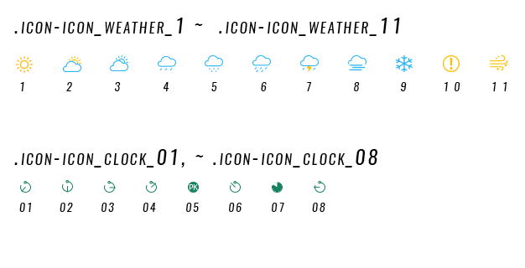

隱藏彈框

即時進球通知 雷速是用JS去調資料的 <http://static.leisu.com/js/bifen-js.js?v=20160716>

    showScoreBox = function (t, s, e, i, a, o, n) {

var d = $.cookie("score_box");

 d = d ? d.split(";") : [];

for (var c = t + a + o, r = 0; r < d.length; r++)

            if (c == d[r]) return;

        d.push(c);

        var l = d.length;

        l > 20 && (d = d.slice(15)), $.cookie("score_box", d.join(";"), {

            expires: 1

 }), playSound();

 var p = "";

p += "  <li>", p += '    <i class="close icon-btn_goalclose_n"></i>', p += '    <div class="vs-name">', p += o ? '      <span class="vsl win"><i class="left-win icon-icon_goal"></i>' + e + '</span><b class="score">' + a + '</b><span class="vsr">' + i + "</span>" : '      <span class="vsl">' + e + '</span><b class="score">' + a + '</b><span class="vsr win">' + i + ' <i class="right-win icon-icon_goal"></i></span>', p += "    </div>", p += '    <div class="vs-title">', p += '      <span class="match-name">' + s + '</span><span class="time">' + n + "'</span>", p += "    </div>", p += "  </li>";

var h = $(p); h.find(".close").click(function () {$(".bf-nav-info .score-box li.hide").length + 1 == $(".bf-nav-info .score-box li").length && $(".bf-nav-info .score-box").hide(), $(this).parent().addClass("hide") }), $(".bf-nav-info .score-box .score-box-ul").append(h), $(".bf-nav-info .score-box").show(),

function (t) {

                setTimeout(function () {

                    1 == $(".bf-nav-info .score-box .score-box-ul > li").length ? ($(".bf-nav-info .score-box").fadeOut(), t.remove()) : (t.fadeOut(), t.remove())

                }, 1e4)

            }(h)

    },

<div class="bf-nav-info lighton hidden-xs" id="bf-nav-info">

  <div class="wrap">

    ....

  </div>

  <!--wrap-->

  <!--即时进球通知-->

  <div class="score-box">

    <div class="score-box-wrap"> <a href="javascript:;" class="fold-btn"><i class="icon-arrow_r_up"></i></a>

      <ul class="score-box-ul">

        <li> <i class="close icon-btn_goalclose_n"></i>

          <div class="vs-name"> <span class="vsl win"><i class="left-win icon-icon_goal"></i>西非足球学院</span><b class="score">3-0</b><span class="vsr">阿善提黄金</span> </div>

          <div class="vs-title"> <span class="match-name">加纳超</span><span class="time">76'</span> </div>

        </li>

        <li> <i class="close icon-btn_goalclose_n"></i>

          <div class="vs-name"> <span class="vsl">西非足球学院</span><b class="score">3-0</b><span class="vsr win">阿善提黄金<i class="right-win icon-icon_goal"></i></span></div>

          <div class="vs-title"> <span class="match-name">加纳超</span><span class="time">76'</span> </div>

        </li>

      </ul>

      <i class="icon-icon_goal_line"></i> </div>

    <!--score-box-wrap-->

  </div>

  <!--score-box-->

</div> <!--bf-nav-info-->

比分 bifen-tooltip

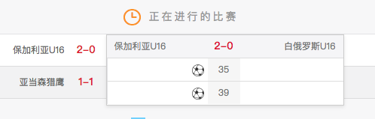

<td class="tr-vs-score”>

...

               <!--比分弹框-->

               <div class="bifen-tooltip hide" style="top: 0px; left: 54px;">

                <div class="table-wrap">

                  <table>

                    <thead>

                      <tr>

                        <td class="left-icon">保加利亚U16</td>

                        <td class="score">2-0</td>

                        <td class="right-icon">白俄罗斯U16</td>

                      </tr>

                    </thead>

                    <tbody>

                      <tr>

                        <td class="left-icon"><i class="icon-icon_goal"></i></td>

                        <td class="time">35</td>

                        <td class="right-icon"></td>

                      </tr>

                      <tr>

                        <td class="left-icon"><i class="icon-icon_goal"></i></td>

                        <td class="time">39</td>

                        <td class="right-icon"></td>

                      </tr>

                    </tbody>

                  </table>

                </div>

              </div>

</td>

三大指數 sbTooltip

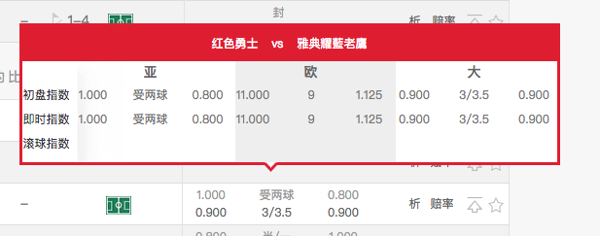

<td class="tr-sb”>

...

              <!--三大指数弹框 START-->

              <div class="sbTooltip hide" style="top:-165px;left:-224px;"> <i class="icon-arrow_subform"></i>

                <div class="tooltipHead"> <span>科林蒂安</span> <span>vs</span> <span>智利大学</span> </div>

                <div class="tooltipContent">

                  <div class="bg1"></div>

                  <div class="bg2"><i class="icon-shadow_03"></i></div>

                  <div class="bg3"></div>

                  <table class="table-sb-tool">

                    <thead>

                      <tr>

                        <th>&nbsp;</th>

                        <th colspan="3"><span class="bold">亚</span></th>

                        <th colspan="3"><span class="bold">欧</span></th>

                        <th colspan="3"><span class="bold">大</span></th>

                      </tr>

                    </thead>

                    <tbody>

                      <tr class="first">

                        <td class="title-color">初盘指数</td>

                        <td class="oddsasia"><span>0.825<i></i></span></td>

                        <td class="wide-panlu oddsasia">半/一</td>

                        <td class="oddsasia"><span>1.025<i></i></span></td>

                        <td class="oddseurope"><span>1.615<i></i></span></td>

                        <td sd="" class="euro-panlu oddseurope">3.5</td>

                        <td class="oddseurope"><span>6.500<i></i></span></td>

                        <td class="oddsbigsmall"><span>1.025<i></i></span></td>

                        <td class="wide-panlu oddsbigsmall">2/2.5</td>

                        <td class="oddsbigsmall"><span>0.825<i></i></span></td>

                      </tr>

                      <tr class="realtime">

                        <td class="title-color">即时指数</td>

                        <td class="oddsasia"><span class="data-up">0.900<i class="icon-arrow_index_up_gif"></i></span></td>

                        <td class="wide-panlu oddsasia">半/一</td>

                        <td class="oddsasia"><span class="data-down">0.950<i class="icon-arrow_index_down_gif"></i></span></td>

                        <td class="oddseurope"><span class="data-up">1.666<i class="icon-arrow_index_up_gif"></i></span></td>

                        <td sd="" class="euro-panlu oddseurope">3.5</td>

                        <td class="oddseurope"><span class="data-down">5.500<i class="icon-arrow_index_down_gif"></i></span></td>

                        <td class="oddsbigsmall"><span class="data-down">0.800<i class="icon-arrow_index_down_gif"></i></span></td>

                        <td class="wide-panlu oddsbigsmall">2</td>

                        <td class="oddsbigsmall"><span class="data-up">1.050<i class="icon-arrow_index_up_gif"></i></span></td>

                      </tr>

                      <tr class="ball">

                        <td class="title-color">滚球指数</td>

                        <td class="oddsasia"><span>0.900<i></i></span></td>

                        <td class="wide-panlu oddsasia">平手</td>

                        <td class="oddsasia"><span>0.950<i></i></span></td>

                        <td class="oddseurope"><span class="data-down">1.002<i class="icon-arrow_index_down_gif"></i></span></td>

                        <td sd="" class="euro-panlu oddseurope">51</td>

                        <td class="oddseurope"><span class="data-up">401.000<i class="icon-arrow_index_up_gif"></i></span></td>

                        <td class="oddsbigsmall"><span class="data-up">3.650<i class="icon-arrow_index_up_gif"></i></span></td>

                        <td class="wide-panlu oddsbigsmall">2.5</td>

                        <td class="oddsbigsmall"><span class="data-down">0.190<i class="icon-arrow_index_down_gif"></i></span></td>

                      </tr>

                    </tbody>

                  </table>

                </div>

              </div>

<!--三大指数弹框 END--></td>

我的收藏彈框

<!-- 我的收藏弹框 -->

    <div class="my-collection"> <i class="icon-btn_close close-col"></i>

      <div class="col-head"> <span class="col-title">我的收藏</span> <span>热刺</span> <span>vs</span> <span>曼联</span> </div>

      <div class="col-content">

        <div class="bg1"></div>

        <div class="bg2"></div>

        <div class="bg3"></div>

        <table class="table-sb-tool">

          <thead>

            <tr>

              <th>&nbsp;</th>

              <th colspan="3">即时指数</th>

              <th colspan="3">初盘指数</th>

            </tr>

          </thead>

          <tbody>

            <tr>

              <td>亚</td>

              <td><span class="data-up">0.75<i class="icon-arrow_index_up"></i></span></td>

              <td>受两球半</td>

              <td><span>1.03<i></i></span></td>

              <td><span class="data-down">1.03<i class="icon-arrow_index_down"></i></span></td>

              <td>受两球半</td>

              <td><span>1.03<i></i></span></td>

            </tr>

            <tr>

              <td>欧</td>

              <td><span class="data-up">0.75<i class="icon-arrow_index_up"></i></span></td>

              <td>受两球半</td>

              <td><span>1.03<i></i></span></td>

              <td><span class="data-down">1.03<i class="icon-arrow_index_down"></i></span></td>

              <td>受两球半</td>

              <td><span>1.03<i></i></span></td>

            </tr>

            <tr>

              <td>大</td>

              <td><span class="data-up">0.75<i class="icon-arrow_index_up"></i></span></td>

              <td>受两球半</td>

              <td><span>1.03<i></i></span></td>

              <td><span class="data-down">1.03<i class="icon-arrow_index_down"></i></span></td>

              <td>受两球半</td>

              <td><span>1.03<i></i></span></td>

            </tr>

          </tbody>

        </table>

      </div>

    </div>