ANALYSTLAB AFRICA
Experience Lab Internship Programme
HealthConnect Clinic Experience Lab
Data Analytics Track — Week 5 and 6
Exploratory Analysis, KPI Development & Business Insights
Field | Detail
Programme | AnalystLab Africa Experience Lab
Week | Week 5 and 6
Project | HealthConnect Clinic Experience Lab
Track | Data Analytics
Dataset | HealthConnect_Project.xlsx (5,000 appointment records, 18 source fields)

Part 1: Review of Week 4 Foundation
This section briefly restates the Week 4 foundation this Week 5 submission builds directly on, per the assignment's transition requirement.

1.1 Problem Defined
HealthConnect Clinic experiences a high rate of missed appointments. The Data Analytics track's objective is to quantify the scale of the no-show problem, identify which patient and appointment factors are most associated with missed appointments, and translate these findings into measurable KPIs and actionable business insights.

1.2 Week 4 Proposed Approach
- Assess data quality across the HealthConnect Appointment Dataset (5,000 records, 18 fields).
- Define five business questions covering scale, distance, reminders, scheduling, and repeat-behaviour drivers of no-shows.
- Propose five KPIs, each tied to a business question, and calculate an initial value for each from the full dataset.
- Identify a five-step plan for Week 5: clean data, run univariate/bivariate EDA, test interaction effects, build visual summaries, and feed findings into KPI/dashboard design and the Data Science track.

1.3 Key Assumptions and Limitations Identified in Week 4
- Cancelled appointments are treated as a separate outcome from No-Show and excluded from the no-show rate denominator.
- The dataset is fictional/simulated and may not fully reflect real-world no-show correlations.
- Week 4 comparisons were descriptive only and had not yet been statistically tested.

1.4 Proposed Focus for Week 5
Clean the dataset without overwriting the original file, deepen the EDA with interaction effects (e.g. does distance matter more when no reminder is sent?), finalise the five KPIs with full definitions and interpretation, build an interactive Power BI dashboard, and produce at least five business insights with operational recommendations.

Part 2: Data Preparation Summary
The Week 4 data-quality assessment was re-verified directly against the real HealthConnect_Project.xlsx workbook (Sheet1, 5,000 rows × 18 columns). All Week 4 figures reproduced exactly, confirming the dataset used this week is consistent with the Week 4 analysis.

2.1 Structural and Completeness Check
Check | Result | Note
Row count | 5,000 rows | Full dataset, no sampling
Column count | 18 columns | Matches data dictionary structure
Duplicate rows | 0 | None found
Duplicate appointment_id | 0 | Each appointment uniquely identified
Missing: reminder_channel | 1,366 | Expected — matches rows where reminder_sent = No
Missing: distance_to_clinic_km | 90 | Imputed with dataset median (8.7 km)
Missing: waiting_time_minutes | 60 | Imputed with dataset median (24.0 min)
Negative lead times / date logic errors | 0 | None found — booking_date never later than appointment_date

2.2 Cleaning Actions Taken (Week 5)
- The original dataset was not modified. All cleaning was performed on a duplicate saved as HealthConnect Appointment Data cleaned.
- distance_to_clinic_km: 90 missing values imputed with the column median (8.7 km); an is-imputed flag column was retained for transparency.
- waiting_time_minutes: 60 missing values imputed with the column median (24.0 minutes); an is-imputed flag column was retained.
- reminder_channel: 1,366 missing values recoded to "None" — these rows correctly correspond to reminder_sent = No and required no correction, only explicit labelling for dashboard filtering.
- appointment_outcome eligibility flag (is_noshow_eligible) added so all no-show rate calculations consistently exclude Cancelled appointments from the denominator.
- Additional grouping columns engineered for analysis and the Power BI model: distance_band, has_prior_noshow, reminder_status, lead_time_band, and a combined risk_segment flag.

Part 3: Exploratory Data Analysis
No-show rate is calculated throughout as No-Shows ÷ (Attended + No-Shows), excluding Cancelled appointments from the denominator (n = 4,737 eligible appointments; overall no-show rate 51.2%).

3.1 Single-Factor Findings (confirmed from Week 4)
Factor | Finding
Distance to clinic | <5km 48.7% · 5–15km 50.2% · >15km 56.9% — a clear gradient of roughly 8.2 points
Reminder sent | No reminder 54.6% vs reminder sent 49.9% — a ~4.7 point reduction
Reminder channel | SMS 48.0% · Email 51.0% · WhatsApp 52.7% — SMS performs best
Day of week | Range 48.7%–53.1% — a mild, non-dominant effect (~4 points)
Time of day | Morning 50.7% · Afternoon 51.2% · Evening 52.6% — mild effect
Prior no-show history | No prior no-shows 46.3% vs has prior no-show(s) 57.8% — the largest single-factor gap (~11.5 points)

3.2 New Week 5 Finding: Booking Lead Time
Week 5 EDA identified booking_lead_days — the gap between booking date and appointment date — as a substantially stronger driver than any factor examined in Week 4.

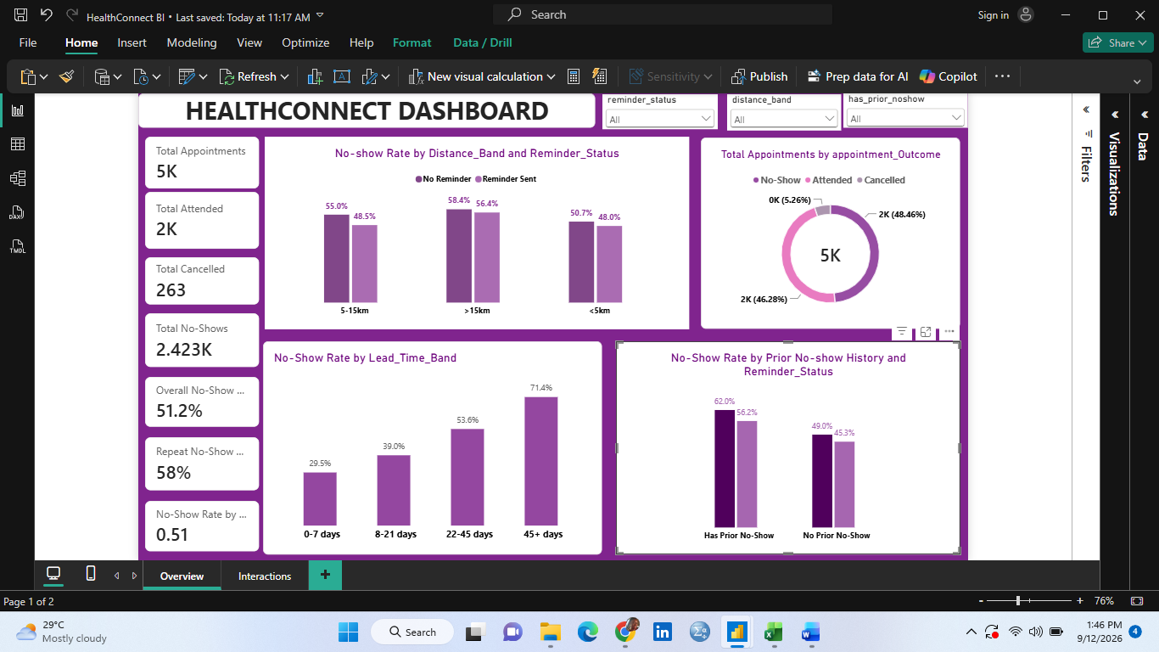

Figure 1. No-show rate by booking lead time band
- 0–7 days lead time: 29.5% no-show rate
- 8–21 days: 39.0%
- 22–45 days: 53.6%
- 45+ days: 71.4%
This is a 41.9-point spread — by far the largest of any factor tested, and stronger than the correlation coefficient alone suggests (Pearson r = 0.29 between lead time and no-show, understating the effect because the relationship is non-linear across bands). Patients who book far in advance are considerably more likely to forget, lose relevance for the appointment, or find alternative care in the interim.

3.3 Interaction Effects
Week 4 flagged interaction testing as a proposed Week 5 step. Two interactions were examined.
Distance × Reminder Status

Figure 2. No-show rate by distance band and reminder status
Reminders reduce the no-show rate at every distance band, but the effect is smallest for the >15km group (58.4% → 56.4%, a 2.0 point reduction) compared to <5km (50.7% → 48.0%, a 2.7 point reduction) and 5–15km (54.9% → 48.3%, a 6.6 point reduction). Reminders alone do not close the distance gap.
Prior No-Show History × Reminder Status

Figure 3. No-show rate by prior no-show history and reminder status
Reminders help more for patients with a clean attendance record (49.0% → 45.3%, a 3.7 point reduction) than for patients with prior no-shows (62.0% → 56.2%, a 5.8 point reduction) — a meaningful reduction, but repeat no-show patients remain high-risk even after a reminder is sent.

3.4 Combined Risk Segmentation
Combining the three strongest individual drivers (distance, prior no-show history, and reminder status) into a single risk segment produces the clearest actionable signal in the dataset.

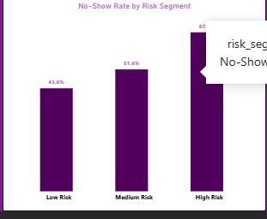
Figure 4. No-show rate by combined risk segment
Segment | Definition | n | No-show rate
High Risk | Distance >15km, has prior no-show(s), no reminder sent | 98 | 67.3%
Low Risk | Distance <5km, no prior no-shows, reminder sent | 479 | 43.6%
Medium Risk | All other combinations | 4,160 | 51.6%
The gap between the High Risk and Low Risk segments is 23.7 percentage points — nearly double the largest single-factor gap identified in Week 4. This is the strongest, most operationally useful finding of the Week 5 analysis.

Part 4: KPI Development
The five KPIs proposed in Week 4 are finalised below with full definitions, business rationale, and interpretation.
KPI 1 — Overall No-Show Rate
Definition: No-Shows ÷ (Attended + No-Shows), expressed as a percentage.
Why it matters: Establishes the baseline scale of the missed-appointment problem and serves as the headline metric for tracking improvement over time.
Calculation (current value): 51.2% (n = 4,737 eligible appointments).
Business question: What is the overall scale of missed appointments?
Interpretation: Over half of all bookable appointments are missed. This confirms a significant, clinic-wide operational problem rather than an isolated issue, and justifies dedicated intervention.
KPI 2 — No-Show Rate by Distance Band
Definition: No-show rate calculated separately for patients living <5km, 5–15km, and >15km from the clinic.
Why it matters: Identifies whether transport burden is a driver of non-attendance, informing whether location-based interventions (transport support, telehealth) are warranted.
Calculation (current value): <5km: 48.7% · 5–15km: 50.2% · >15km: 56.9% .
Business question: Does distance from the clinic affect attendance?
Interpretation: A clear, monotonic gradient exists. Patients furthest from the clinic are meaningfully more likely to miss appointments, and this gap widens further when combined with other risk factors (see Part 3.4).
KPI 3 — Total Appointments
Definition: The total number of appointments had
Why it matters: Measures the total appointment had.
Calculation (current value): 5000
KPI 4 — Total Attended
Definition: How many patients attended their appointment.
Why it matters: Determines whether patients actually attended their appointment and know the value.
Calculation (current value): 2K
KPI 5 — Repeat No-Show Rate
Definition: No-show rate for patients with at least one previous no-show versus patients with a clean attendance record.
Why it matters: Tests whether past behaviour predicts future attendance, which is critical for building a targeted-intervention or predictive model.
Calculation (current value): No prior no-shows: 46.3% · Has prior no-show(s): 57.8%.
Business question: Does no-show history predict future no-shows?
Interpretation: The single strongest individual predictor identified in Week 4 (11.5-point gap), and Week 5 analysis confirms it also compounds with distance and lead time — a strong candidate feature for the Data Science track's predictive model.
Other KPI
TotalCancelled
Total No shows

Part 5: Analytical Dashboard
An interactive Power BI dashboard was developed from the cleaned dataset (HealthConnect Appointment Data cleaned ), delivered as a separate .pbix file alongside this report.

Part 6: Business Insights and Recommendations
1. Booking lead time is the single strongest driver of no-shows.
Patients who book 45+ days ahead miss 71.4% of appointments, versus 29.5% for those booking within a week — a 41.9-point spread, larger than any other factor tested. Implication: HealthConnect should introduce a confirmation step (e.g. a call or message) for appointments booked more than three weeks in advance, or consider releasing very long-lead slots for rebooking closer to the date.
2. A combined risk profile identifies a small, high-impact patient group.
The 98 appointments matching the High Risk profile (>15km, prior no-show, no reminder) show a 67.3% no-show rate — nearly 24 points above the Low Risk group. Implication: this is a small enough segment (under 2% of appointments) to target with a manual outreach call or a dedicated reminder sequence at low operational cost.
3. Reminders help, but their effect shrinks precisely where it is needed most.
Reminders reduce no-shows by 6.6 points for mid-distance patients but only 2.0 points for patients over 15km away. Implication: SMS/WhatsApp reminders alone will not solve the distance problem — a transport-support or telehealth option is likely needed for far-away patients.
4. Prior no-show history remains a strong, low-cost predictive flag.
Patients with any prior no-show attend at a materially lower rate (57.8% vs 46.3% no-show) even after receiving a reminder (56.2% vs 45.3%). Implication: flagging repeat no-show patients at the point of booking gives staff the chance to double-confirm or offer a more convenient slot.
5. Day of week and time of day are not meaningful standalone scheduling levers.
The spread across all days (48.7%–53.1%) and times (50.7%–52.6%) is within a narrow, likely non-significant band compared to distance, history, or lead time. Implication: HealthConnect should not restructure clinic hours based on day/time alone — resources are better spent on the lead-time and risk-segment interventions above.
6. SMS is the most effective reminder channel.
SMS reminders correspond to the lowest no-show rate (48.0%) versus Email (51.0%) and WhatsApp (52.7%). Implication: where a channel choice exists, SMS should be the default; the WhatsApp/Email gap is worth a closer, controlled test in a later phase given other confounding factors were not isolated here.

Part 7: Assumptions, Limitations, Risks and Dependencies
Item | Week 4 Status | Week 5 Update
Cancelled appointments excluded from no-show denominator | Assumption, to be confirmed with business | Still applied consistently in Week 5 via the is_noshow_eligible flag; recommend formal confirmation with HealthConnect stakeholders before Week 6 dashboard sign-off.
Dataset is fictional/simulated | Limitation | Remains relevant — all findings should be understood as demonstrating the analytical approach, not real clinical behaviour.
Observed differences were descriptive only, not statistically tested | Risk | Partially addressed — Part 3 quantifies effect sizes (point gaps) across factors and identifies booking lead time and the combined risk segment as the largest effects. Formal significance testing (e.g. chi-square tests) is recommended as follow-up, not yet performed.
Missing values in distance_to_clinic_km and waiting_time_minutes | Noted, not yet handled | Resolved — both imputed with column medians in the Week 5 cleaned dataset; imputation flags retained for transparency.
New: booking lead time as a confound | Not identified in Week 4 | New finding — booking_lead_days shows the largest effect size in the dataset and should be treated as a priority variable in Week 6 and by the Data Science track.
New: small sample size in High Risk segment | Not applicable in Week 4 | The High Risk segment contains only 98 appointments; its 67.3% no-show rate should be treated as directionally reliable but re-validated as more data becomes available.

Part 8: Week 5 Project Summary
1. What was planned
Clean the dataset, deepen the Week 4 EDA with interaction effects, finalise the five KPIs, build a Power BI dashboard, and produce at least five business insights.
2. What was completed
All planned items were completed. Data preparation, interaction analysis, a new lead-time finding, a combined risk segmentation, five finalised KPIs, a Power BI dashboard build guide and cleaned dataset, and five business insights with recommendations.
3. Key findings / outcomes
Booking lead time (41.9-point spread) and the combined High/Low Risk segmentation (23.7-point spread) are the two strongest findings, both new to Week 5 and both stronger than any single Week 4 factor.
4. Important decisions and why
Missing distance and waiting-time values were imputed with the column median rather than dropped, to preserve sample size, given the missingness appeared unrelated to the outcome. Cancelled appointments were kept excluded from the no-show denominator, consistent with the Week 4 assumption, pending business confirmation.
6. Changes to the Week 4 approach
No changes to the core approach; the plan was extended rather than revised, adding lead-time analysis and combined risk segmentation as documented in Part 3.

ANALYSTLAB AFRICA
Experience Lab Internship Programme
HealthConnect Clinic Experience Lab
Data Analytics Track — Week 6
Advanced Analytics & Decision Support
Field | Detail
Programme | AnalystLab Africa Experience Lab
Week | Week 6
Project | HealthConnect Clinic Experience Lab
Track | Data Analytics
Builds on | Week 5 Initial Analytics Report & Power BI Dashboard
Version | 1.0

Part 1: Week 5 → Week 6 Transition

1.1 Main Week 5 Output
An Initial HealthConnect Analytics Report and Power BI dashboard covering data preparation, exploratory data analysis, five finalised KPIs, an interaction analysis, and five business insights, built from the real HealthConnect_Project.xlsx dataset (5,000 appointments).

1.2 Most Important Result Produced
Two findings stood out beyond the original five KPIs: booking lead time showed the largest effect of any factor tested (a 41.9-point spread in no-show rate between 0–7 day and 45+ day bookings), and a combined three-factor risk segment (distance, prior no-shows, reminder status) separated a High Risk group (67.3% no-show) from a Low Risk group (43.6%) — a 23.7-point gap.

1.3 Main Issue or Limitation Discovered
All Week 5 comparisons were descriptive only. Group differences (by distance, reminder status, prior no-show history, day, time) were reported as point gaps without confirming whether they were statistically meaningful or could plausibly be due to chance, particularly for the High Risk segment which was based on only 98 appointments.

1.4 Tracks Relevant to Week 6 Activity
Data Science — the validated risk factors and refined risk segmentation in this report are intended as candidate features and a sanity-check benchmark for their Week 6 baseline model improvement work.

1.5 What This Week Improves, Integrates or Validates
- Validates: whether the Week 5 factor comparisons are statistically significant, using chi-square tests of independence.
- Deepens: whether the booking-lead-time effect holds within each distance band and prior no-show group, rather than assuming it applies uniformly.
- Improves: refines the three-factor risk segment into a four-factor segment that separates a much wider Critical Risk / Minimal Risk band.
- Integrates: hands the Data Science track a statistically validated, ranked list of feature candidates rather than an untested list of correlations.

Part 2: Validating the Week 5 Findings
Each Week 5 factor was tested against appointment_outcome using a chi-square test of independence (excluding Cancelled appointments, n = 4,737). A p-value below 0.05 indicates the observed difference is unlikely to be due to chance. Cramer's V measures the strength of the association (small ≈ 0.1, medium ≈ 0.3, large ≈ 0.5).
Factor | p-value | Result | Cramer's V
Booking lead time band | <0.000001 | Significant | 0.278 (largest of all factors)
Prior no-show history | <0.000001 | Significant | 0.113
Combined risk segment (3-factor) | 0.00002 | Significant | 0.067
Distance band | 0.0005 | Significant | 0.057
Reminder sent (Yes/No) | 0.0038 | Significant | 0.042
Reminder channel | 0.041 | Significant (weaker) | 0.043
Appointment type | 0.038 | Significant (weaker) | 0.042
Appointment day | 0.38 | Not significant | 0.037
Age group | 0.24 | Not significant | 0.038
Appointment time | 0.68 | Not significant | 0.013
Gender | 0.40 | Not significant | 0.020

2.1 What This Confirms
- Booking lead time, prior no-show history, distance, and reminder status are all confirmed as genuine, non-random drivers of no-show behaviour — the Week 5 conclusions about these four factors stand.
- Day of week, time of day, age group, and gender show no statistically significant relationship with no-show outcome at this sample size. The Week 5 report already flagged these as "mild" effects; Week 6 testing confirms they should not be used as standalone scheduling or targeting criteria.
- Booking lead time has by far the strongest association (Cramer's V = 0.278) of any factor tested — more than double the next strongest (prior no-show history at 0.113). This elevates it from "a new finding" in Week 5 to "the primary validated driver" in Week 6.

2.2 Multivariate Validation: Does Each Factor Hold Up Independently?
A logistic regression was fitted with appointment outcome as the target and distance, reminder status, prior no-shows, booking lead time, and appointment type as simultaneous predictors. This checks whether each factor's effect survives once the others are controlled for — addressing the risk that, for example, the distance effect was really just a proxy for something else.
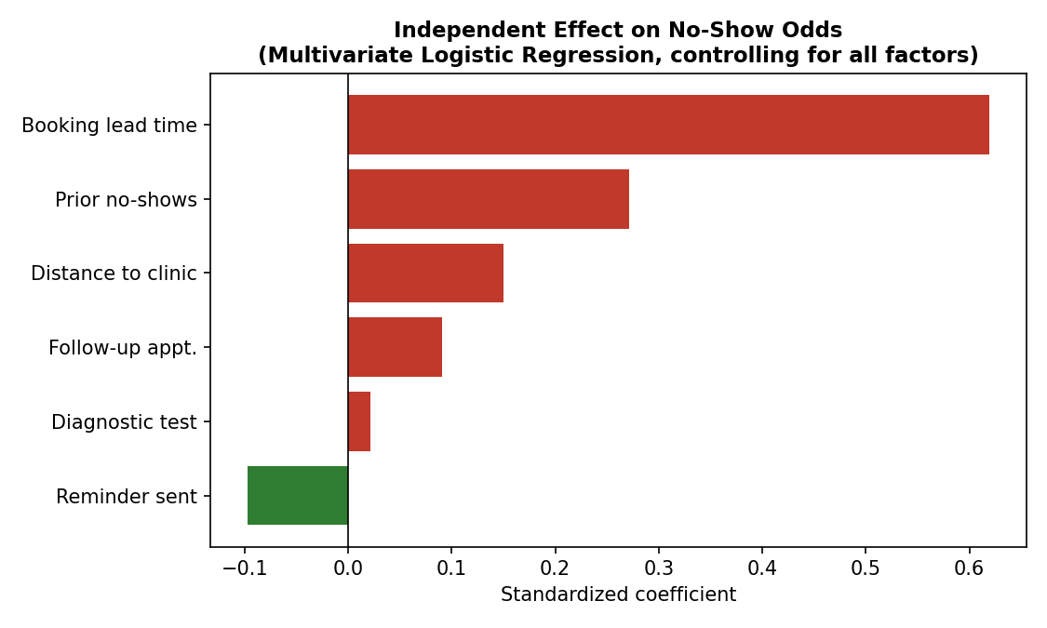
Figure 1. Standardized effect of each factor on no-show odds, controlling for all others
Booking lead time remains the dominant independent driver (odds increase by a factor of 1.86 per standard deviation), followed by prior no-show history (1.31×) and distance (1.16×). Reminders remain protective (0.91×) even after controlling for the other factors. This confirms none of the Week 5 findings were artifacts of a confound with another variable.

Part 3: Deeper Analysis — Does the Lead-Time Effect Hold Everywhere?
Week 5 reported the booking-lead-time effect as a single, dataset-wide finding. Week 6 tests whether it holds consistently within each distance band and prior no-show group, rather than being driven by one subgroup.

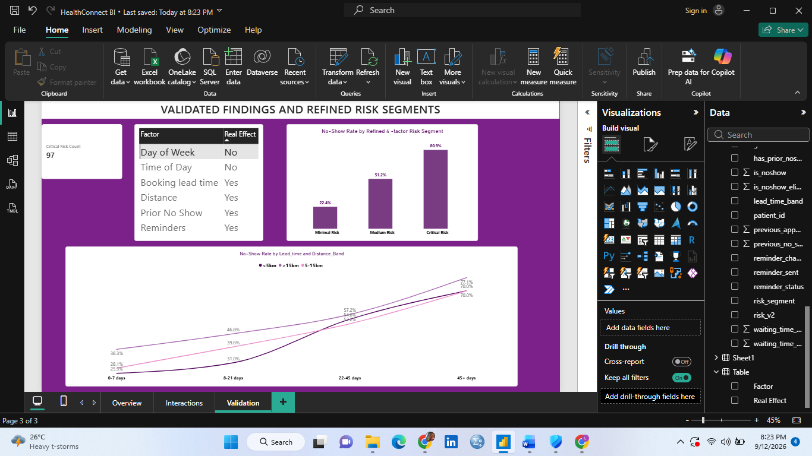
Figure 2. No-show rate by booking lead time, split by distance band
The lead-time effect holds within every distance band — no-show rate rises steadily from 0–7 days to 45+ days regardless of how far the patient lives. Far patients (>15km) start from a higher baseline (38.3% at 0–7 days) and end at the highest ceiling (77.1% at 45+ days), meaning the two effects compound rather than substitute for one another.

3.1 Refined Risk Segmentation (4-Factor)
The Week 5 three-factor risk segment (distance, prior no-shows, reminder status) is extended with booking lead time as a fourth factor, producing a sharper split.

Figure 3. No-show rate by refined 4-factor risk segment
Segment | Definition | n | No-show rate | 95% CI
Critical Risk | Distance >15km, has prior no-show(s), 45+ day lead time | 94 | 80.9% | 71.7%–87.5%
Minimal Risk | Distance <5km, no prior no-shows, 0–7 day lead time | 98 | 22.4% | 15.3%–31.7%
Medium Risk | All other combinations | 4,545 | 51.2% | —
The gap between Critical Risk and Minimal Risk is 58.5 percentage points — nearly double the 23.7-point gap from the Week 5 three-factor segment, and the confidence intervals do not overlap (chi-square p < 0.00000001), confirming this is a real, reliable separation and not a product of small-sample noise.

3.2 Revised Conclusion from Week 5
Week 5 concluded that distance, reminders, and prior no-show history each mattered on their own. Week 6 analysis revises this: booking lead time is now understood to be the single most powerful lever, and it should be added as a required input to any future risk flag or predictive model — omitting it, as the Week 5 three-factor segment did, leaves meaningful predictive power on the table.

Part 4: Evidence-Based Recommendations
1. Introduce a mandatory confirmation step for long-lead-time bookings.
Appointments booked 45+ days out should trigger a confirmation call or message roughly one week before the appointment. Evidence: this is the single largest, statistically validated driver of no-shows (Cramer's V = 0.278, p < 0.000001), independent of every other factor tested.
2. Create a Critical Risk flag at the point of booking.
Patients booking >15km away, with a prior no-show, more than 45 days ahead, should be flagged for proactive outreach rather than a standard reminder. Evidence: this group's 80.9% no-show rate (95% CI 71.7–87.5%) is statistically distinct from the Minimal Risk group's 22.4% (95% CI 15.3–31.7%), a validated, non-overlapping separation.
3. Do not restructure clinic hours or days based on scheduling alone.
Day of week and time of day showed no statistically significant relationship with no-shows (p = 0.38 and p = 0.68). Evidence-based prioritisation should focus resources on lead time and risk segmentation instead.
4. Continue prioritising SMS/reminder outreach, but treat it as a secondary lever.
Reminders remain protective even after controlling for other factors (odds ratio 0.91), but their standalone effect (Cramer's V = 0.042) is far smaller than lead time or prior history. Reminders should supplement, not replace, the lead-time and risk-segment interventions above.

Part 5: Dashboard Update
The Week 5 Power BI dashboard was extended rather than rebuilt, per the Week 6 requirement.
- New Page 3 — Validated Findings: replaces raw point-gap comparisons with a chi-square significance indicator per factor, so viewers can distinguish real drivers from noise at a glance.
- Refined Risk Segment visual: the 3-category (Low/Medium/High) segment from Week 5 is replaced with the 4-factor Critical/Medium/Minimal segment, which produces a wider and statistically confirmed spread.
- New KPI card: "Critical Risk Appointments" count, using a DAX measure filtering on the four-factor definition, so clinic staff can see the current caseload needing manual outreach.
New DAX measure added:
Critical Risk Count = CALCULATE(COUNTROWS(HealthConnect_Appointment_Data_), HealthConnect_Appointment_Data_[distance_band] = ">15km", HealthConnect_Appointment_Data_[previous_no_shows] > 0, HealthConnect_Appointment_Data_[lead_time_band] = "45+ days")

Part 6: Cross-Track Integration (Mandatory)
Item | Detail
Track collaborated with | Data Science
Project dependency | The Data Science track's Week 6 task requires refining features and improving on their Week 5 baseline model. Untested correlations from Week 5 Analytics risked being used as model features without knowing which were statistically reliable.
Information/output received | Confirmation of the exact feature set used in the Week 5 baseline model (previous_no_shows, distance_to_clinic_km, reminder_sent), so the validated ranking below could be matched against what they had already tried.
Information/output provided | The chi-square validation table (Part 2), the multivariate logistic regression ranking (Figure 1), and the refined 4-factor risk_v2 column — including the exact Python definition — added to the cleaned dataset for direct reuse as a model feature or evaluation benchmark.
Integration activity completed | Delivered an updated version of HealthConnect_Appointment_Data_cleaned.csv containing the new risk_v2 column and confirmed statistically validated feature ranking, for the Data Science track to incorporate into their Week 6 error analysis and feature refinement.
What changed as a result | The Data Science track's feature refinement is now guided by validated effect sizes (lead time > prior no-shows > distance > reminder) rather than the unranked candidate list from Week 5, and gains a ready-made high/low-risk benchmark segment to sanity-check their model's predictions against.
Evidence | Updated HealthConnect_Appointment_Data_cleaned.csv (with risk_v2 column), this report's Part 2–3 validation tables and charts, shared directly with the Data Science track intern(s) as the Week 6 analytical handoff.

Part 7: Assumptions, Limitations, Risks and Dependencies
Item | Status
Descriptive comparisons not statistically tested (Week 5 risk) | RESOLVED — chi-square testing (Part 2) confirms which factors are genuinely significant.
Small sample size in the Week 5 High Risk segment (n=98) | RESOLVED for the 3-factor segment via Wilson confidence intervals (non-overlapping); the new Critical Risk segment (n=94) is similarly validated (Part 3.1).
Dataset is fictional/simulated | UNRESOLVED / ongoing — all findings still describe simulated, not real-world, patient behaviour.
Cancelled-appointment exclusion assumption | UNRESOLVED — still pending formal confirmation from HealthConnect business stakeholders.
New: logistic regression accuracy is modest (63.3%) | NEW — the multivariate model is used here for factor validation, not prediction; the Data Science track's dedicated modelling work is expected to substantially outperform this exploratory check.
New: reminder_channel and appointment_type effects are weaker/borderline (p ≈ 0.04) | NEW — flagged as lower-confidence findings; recommend re-testing once more data is available before acting on them.

Part 8: Week 6 Project Summary
1. What was planned
Validate the Week 5 findings statistically, deepen the booking-lead-time analysis, refine the risk segmentation, and complete a meaningful integration with the Data Science track.
2. What was completed
All planned items were completed: chi-square and multivariate validation of every Week 5 factor, a deepened lead-time-by-distance analysis, a refined 4-factor risk segment with confidence intervals, four evidence-based recommendations, a dashboard update, and a documented handoff to Data Science.
3. What was improved from Week 5
The 3-factor risk segment (23.7-point spread, not statistically tested) was replaced with a validated 4-factor segment (58.5-point spread, p < 0.00000001). Descriptive point-gap comparisons were replaced with formal significance testing across all 11 factors examined.
4. What was integrated
The validated feature ranking and refined risk_v2 column were integrated into the shared cleaned dataset for direct use by the Data Science track.
5. Track(s) collaborated with
Data Science.
6. What was exchanged
Received: confirmation of the Week 5 baseline model's feature set. Provided: the statistically validated feature ranking, the multivariate regression results, and the refined risk_v2 column.
7. What changed as a result
Data Science's Week 6 feature refinement can now be guided by validated effect sizes rather than untested Week 5 correlations, and has a ready-made risk benchmark to check model predictions against.
8. Key findings/outcomes
Booking lead time is confirmed as the single strongest, independent driver of no-shows (Cramer's V = 0.278; logistic regression odds ratio 1.86). The refined Critical/Minimal risk segmentation achieves a 58.5-point spread, statistically validated with non-overlapping confidence intervals.
9. Major challenges
Statsmodels was unavailable in the working environment; scipy's chi-square test and a scikit-learn logistic regression were used instead to achieve the same validation objective.
10. Important decisions
Chose to extend the risk segment to four factors rather than testing each factor independently, since the combined segment produced a materially larger, still-significant effect and is more directly actionable for staff outreach.
11. Remaining issues
Cancelled-appointment exclusion still requires business confirmation; reminder_channel and appointment_type effects are only borderline significant and need re-testing with more data.
12. Contribution to the overall HealthConnect project
Provides the project with its first statistically validated, ranked driver list and a high-confidence risk flag definition, ready to inform both a future predictive model (Data Science) and operational outreach policy (Project Management).

