  - Clustering
  - Lecture 6, 25 – 9 - 2026
Last Lecture recap:
Mapping:
Given a genome and some mapping code, find out the number of gene expression that matches the genome in different positions.
Example: Given genome: TAATGCCATGGATG and gene expression sequence: TAA, CCA, GCC, GAT, ATG, CCA
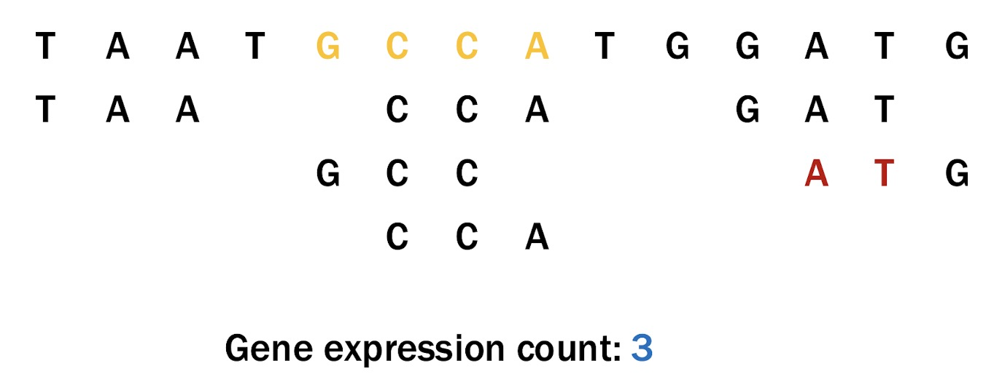
Prepare the data set before sampling:
Data Cleansing:
Denoise data (if applicable), Remove outliers, Handling missing data, Remove duplicates, Categorical data encoding, Data normalization
Data Exploration:
Mean and median: location; range, variance
Percentiles: spread (50% percentiles indicates the median of the data set)
Mode: gives the most frequent value.
Visualize distributions:
Histogram: The height of each bar indicates the number of objects
﻿﻿Shape of histogram depends on the number of bins
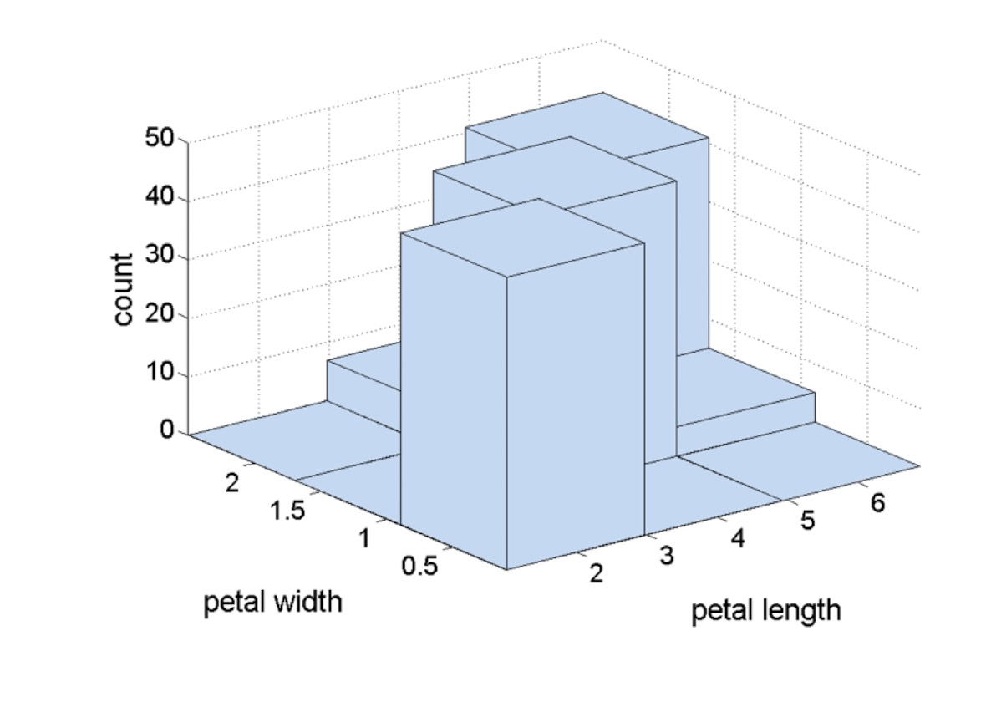
Box plots:
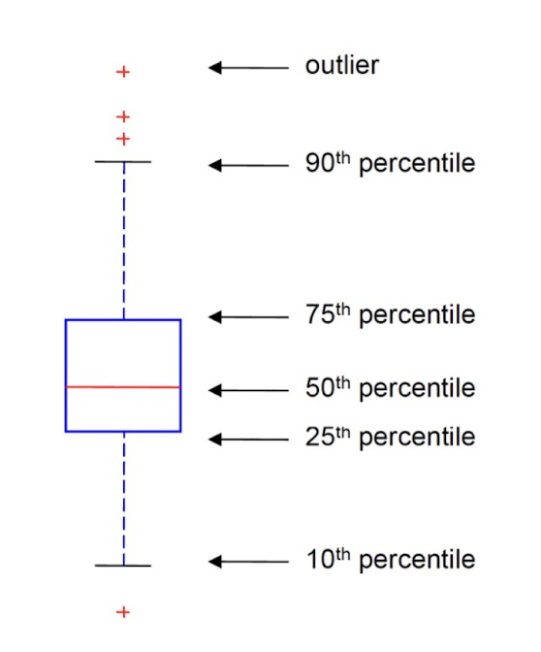

Clustering
Importance of Clustering:
Better organization and searching: Group similar items to browse or retrieve them efficiently and summarize large collections.
Medically: Allow us to identify co-express / differentially expressed genes

Process of Clustering:
- Represent items to be clustered numerically (e.g. F1, F2, F3…)
- Input a clustering method and assigns each items into separate groups (e.g. F1, F3 and F8 are bananas in group 1, F2, F4 and F6 are apples in group 2, F5, F7 and F9 are oranges in group 3)
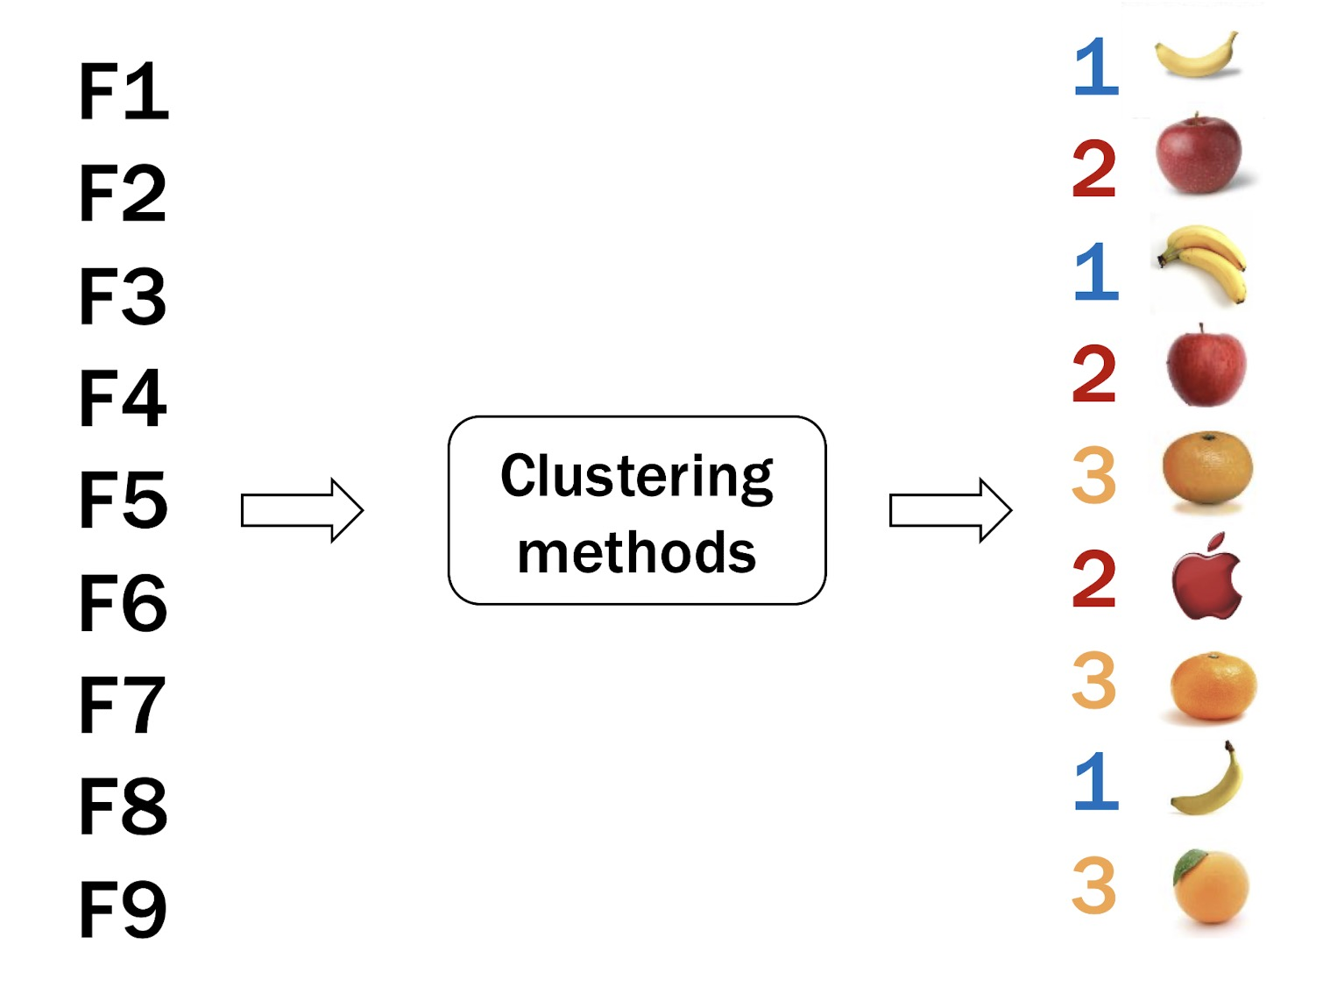

Similarity
Value of similarity increase as objects become more alike
Its value always between 0 and 1
Dissimilarity or distance
Value of Dissimilarity decrease as objects become more alike
Its value also always between 0 and 1 with 0 means no difference under the measure.

Cosine Similarity
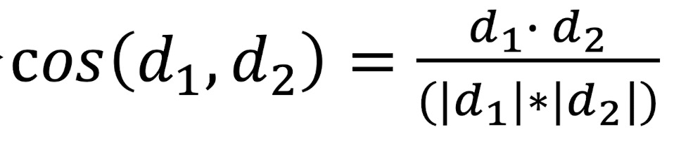
Cosine similarity measures the angle between two vectors.
Pearson Correlation
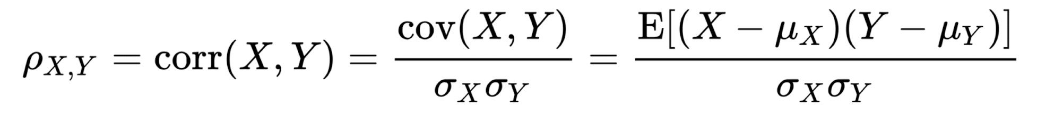
−1: for negative linear correlation (i.e. opposite slope)
+1: for positive linear correlation (i.e. same slope)
0: unregular shape

Distance:
Euclidean distance
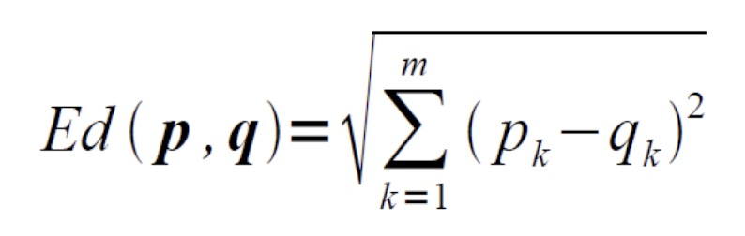
0: identical coordinates between two points, increase in value indicates larger geometrical distance between two points
Minkowski distance
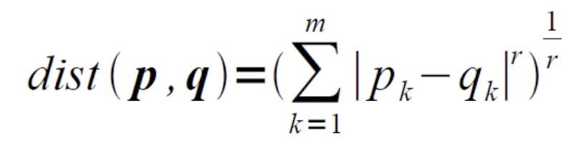
r = 1 | Hamming distance
r = 2 | Euclidean distance
r = ∞ | Maximum coordinate difference

