Sequence Alignment and Gene Expression Matrix
- Why sequencing matter
In Prof. Lo (CUHK President) research, gene sequencing has been proven to be able to diagnose certain genetic disease, e.g. Down Syndrome even before infant is born.
Gene sequencing allows us to notice any mutation or unexpected gene modification as early as possible and treat it immediately.

- Recap on Data Processing
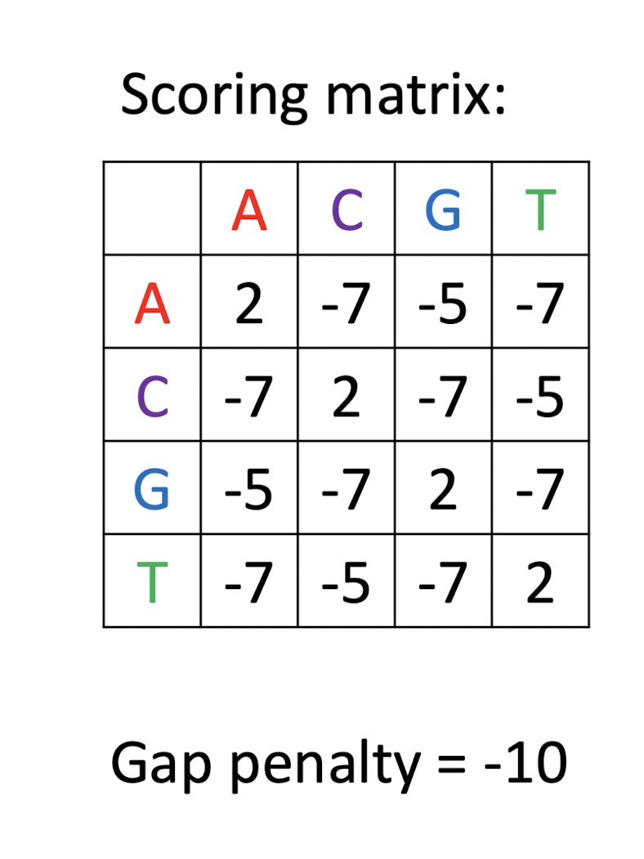

From this example, we can find out the following rules regarding data matrix;
- Identical bases receive +2
- Mismatches have different deduction, i.e. A–G and C–T receive −5, other mismatched pairs receive −7.
- Every gap receives −10.

The table below summarize the counting methods:
Pair | A–A, C–C, G–G, T–T | A–G or C– | Other mismatch | Gap
Score | +2 | −5 | −7 | −10

We want to find the route that has the lowest score (in terms of value)

- Creating a DP table
We now have two different gene sequence:
ACCG and ACG, creating the filled table below:
 |  | A | C | C | G
 | 0 | −10 | −20 | −30 | −40
A | −10 | 2 | −8 | −18 | −28
C | −20 | −8 | 4 | −6 | −16
G | −30 | −18 | −6 | −3 | −4

To create this table, we need to check which one route contain the lowest value
For example, for F(4, 2) , if move from F(3,2) to F(4,2), the value would be 2+ (-10) = -8. But if move from F(4,1) to F(4,2), the value would be -30 which is much larger than -8. So we choose -8 in this case.

4. Traceback the optimal alignment
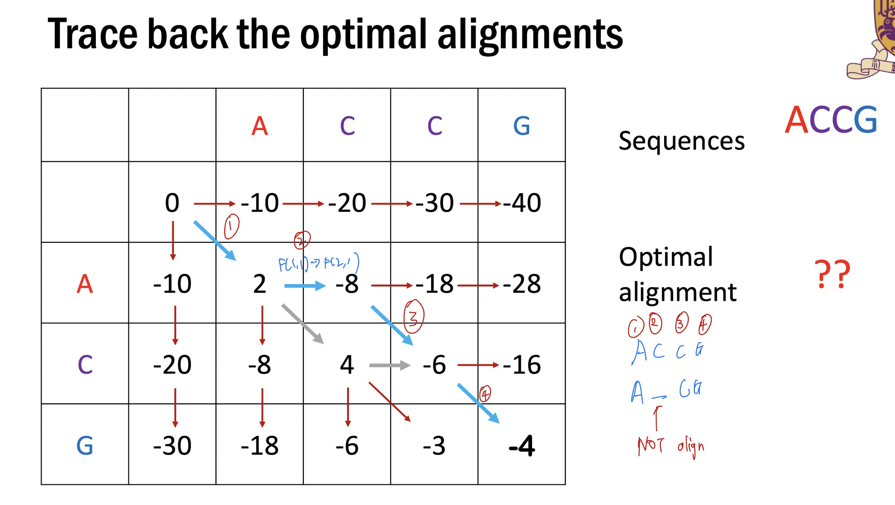
5. Importance of DP table
- Sequence alignment can be used to identify sequence similarity.
- Given an alignment and the scoring matrix, we can easily calculate the alignment score.
- To efficiently find the optimal alignment, we need to use dynamic programming, which divides the original problem into smaller problems and solves the original problem recursively.
- ﻿﻿DP table stores answer of sub-problems and the construction path11 Why measure expression as well as DNA sequence

6. Why need to sequence gene
From the lecture, we have learnt that phenotype = genotype + environment.

Although one can hardly control the environmental factor, it is possible to understand and modify genotype, making gene sequencing an important topic to be studied.
By understanding the genotype of human, many disease including cancer, Down Syndrome or some inherited disease can be cured.

However, since each human only have around 0.001% difference in their genome and among the whole genome, only around 1% is responsible for protein synthesis, gene sequencing needs to be extremely sensitive and accurate, otherwise may miss the genes we are looking for.

7. RNA sequencing to a matrix
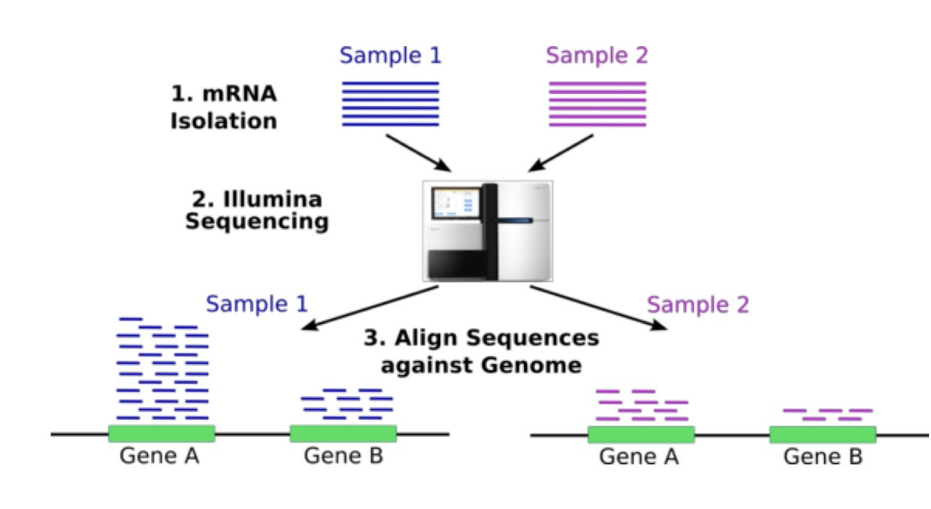
- Collect samples and isolate their mRNA
- Sequence the isolated mRNA to obtain many short genes.
- Map the genes according to a reference genome so each read can be associated with a genomic region
- Count reads assigned to each gene in each sample and arrange the counts into a matrix like the one below
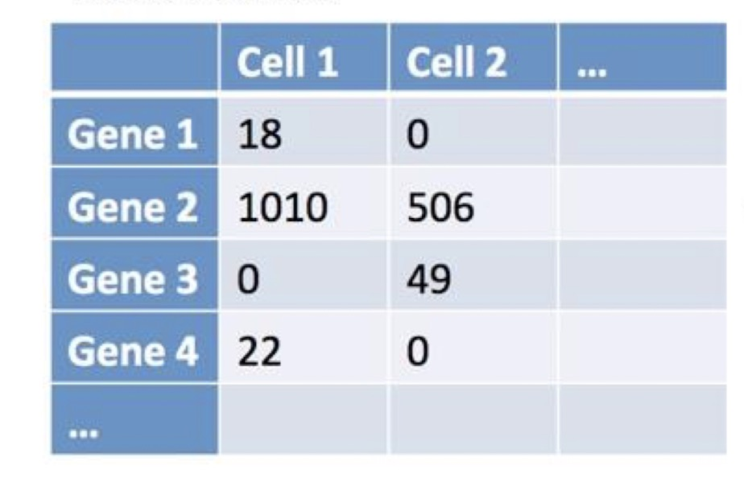
- Compares the difference in their gene’s components

