NAME  Lim, Charlemagne |  | DATE  02/04/2017 | SCORE
SCHEDULE  S/10:00 – 1:00 | SCORE |  | SCORE

LABORATORY EXERCISES
RECURSION

OBJECTIVES:
- Understand recursion and its parts
- Use recursion to solve programming problems

PROCEDURE:
- Encode the C++ program below.
- Save as rec1.cpp , and rec2.cpp, respectively.
- Compile and run the program by pressing Ctrl + F9.
- For each syntax or logical error encountered in the given program, do the following:
- Correct the error
- Recompile the program
- Repeat step 4 until no errors are encountered in the program.
- Illustrate the output of the modified program.

Program No. 1

#include <iostream>
using namespace std;

void numberFunction(int i) {
cout << "The number is: " << i << endl;
i++;
if(i<10) {
numberFunction(i);
Output:

}
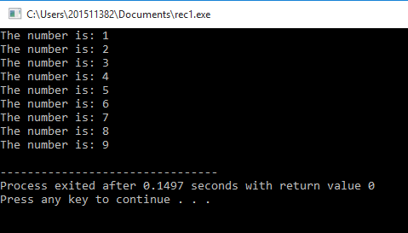
}

int main() {

int i = 1;
numberFunction(i);

return 0;
}

Program No. 2

#include <iostream>
using namespace std;

int factorial(int);

int main() {
int n;
cout<<"Enter a number to find factorial: ";
cin>>n;
cout<<"Factorial of "<<n<<" = "<<factorial(n);
return 0;
}
Output:

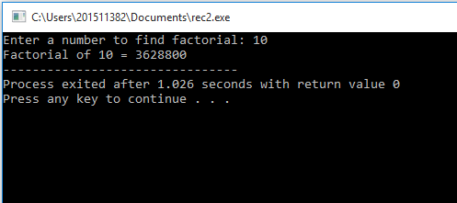
int factorial(int n) {
if (n>1) {
return n*factorial(n-1);
}
else {
return 1;
}
}

Supplementary Problem

- A recursive function that sums up the 10 integers in an array.
Program:
Program:

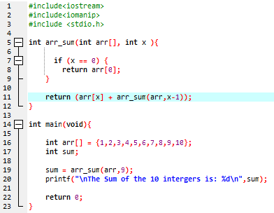
#include<iostream>
#include<iomanip>

int arr_sum(int arr[], int x ){
if (x == 0) {
return arr[0];
}
return (arr[x] + arr_sum(arr,x-1));
}
int main(void){

int arr[] = {1,2,3,4,5,6,7,8,9,10};
int sum;
sum = arr_sum(arr,9);
printf("\nThe Sum of the 10 integers is: %d\n",sum);

return 0;
}
Output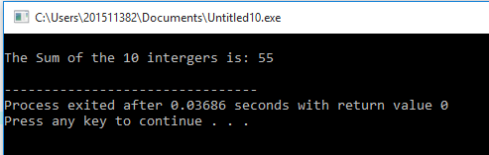:

Output:

The Sum of the 10 integers is 55

- A recursive function to produce the Fibonacci number for a given index in the series.
Use the function int Fibonacci (int n)

Program:
Program:
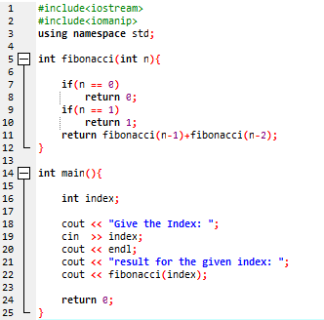

#include<iostream>
#include<iomanip>
using namespace std;

int fibonacci(int n){
if(n == 0)
return 0;
if(n == 1)
return 1;
return fibonacci(n-1)+fibonacci(n-2);
}

int main(){

int index;
cout << "Give the Index: ";
cin >> index;
cout << endl;
cout << "result for the given index: ";
cout << fibonacci(index);

return 0;
}

Output:
Output: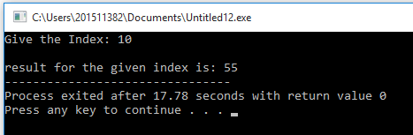

Give Index: 10

The result of the given Index is: 55

- A recursive function which raises its first parameter to the power of its second parameter.
Use the function int power (int number, int power)

Program:
Program:
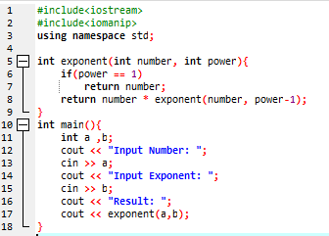

#include<iostream>
#include<iomanip>
using namespace std;

int exponent(int number, int power){
if(power == 1)
return number;
return number * exponent(number, power-1);
}
int main(){
int a ,b;
cout << "Input Number: ";
cin >> a;
cout << "Input Exponent: ";
cin >> b;
cout << "Result: ";
cout << exponent(a,b);
}

Output:
Output:
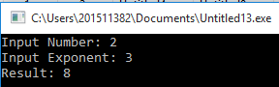

Input Number: 2
Input Exponent: 3
Result: 8

