School of Engineering
Diploma in AI & Data Engineering

EGT204
Data Preparation Project
JIE Sustainability
Final Report
12 August 2024

Project Team Members
S/N | Group | Name | Admin Number
1 | 4 | Lim Jin Bin | 221128Z
2 | 4 | Issac Lim | 230744Q
3 | 4 | Edric | 234554Z

Table of Contents
Business Understanding 3
Problem: 3
Business Objectives: 4
Data mining goals: 4
Data Understanding 5
Constraints: 5
Assumptions: 5
Data dictionary: 5
Data Preparation 6
Platform and tools: 6
Data Cleaning and Aggregations: 6
Visualisation 9
Dashboard 1 (Edric): 9
Dashboard 2 (Jin Bin): 12
Dashboard 3 (Issac Lim): 15
Dashboard 4 (Issac Lim): 16
Discussion 17
Conclusion 17
References 18
Appendix: 19

Business Understanding

Problem:
According to the International Energy Agency, global energy demand and consumption have nearly tripled since 1970. This has led to a significant Increase in CO2 emission. Thanks to this, global average temperatures have risen by about 1.2 degrees Celsius over the last 50 years. This has led to an increase in extreme weather events e.g more frequent and severe heat waves. In fact, the Minister for Sustainability and the Environment of Singapore has said that if this trend were to continue, Singapore would face potential 40-degree Celsius days by 2045.

Additionally, the Climate Action Tracker (CAT) rated Singapore's emission reduction path as the lowest among five levels, labelling it a "seriously deficient country" in 2022. Therefore, addressing these challenges is crucial for Singapore's sustainability and future climate resilience

Business Objectives:
- Analyse the current state and trends of carbon emissions in Singapore to track our progress towards Net Zero Emission by 2050
- Analyse the conditions and trends in sectors with high carbon emissions in Singapore and provide recommendations for emission reduction.

Data mining goals:
- What is the relationship between annual carbon emissions and GDP over the past few years?
- Compare the per capita carbon emissions of Singapore with those of other developed countries in Asia and the global average to understand Singapore’s standings against them
- Analyse the carbon emissions of various sectors in Singapore in 2022 and identify the 3 main contributing sectors.
- Based on the carbon emissions of these three main sectors in the past 10 years, find out what is their relative contribution towards Singapore’s yearly carbon emission and use the data obtained to make suggestions to reduce the carbon emissions.
No. | Tasks | Estimated hours
1 | Business Understanding | 7 hours
2 | Data Understanding | 11 hours
3 | Data Preparation | 24 hours
4 | Modelling (dashboards) | 10 hours
5 | Evaluation | 4 hours
6 | Deployment (Report & presentation slides) | 9 hours

Data Understanding

Constraints:
- Limited data: It was hard to find some of the datasets we needed.
- Data accurate as of until 2022: Some countries do not have carbon emissions for certain years as they are non-existent during that time.
- Inconsistency: some datasets were in different formats which made it hard to merge our datasets.

Assumptions:
- Assumed that emission changes are due to the policies and strategies put in place by the government.
- CO2 emissions are completely split among the different sectors every year.

Data dictionary:
Co2_countries_cleaned,co2_per_capita_countries_cleaned,co2_per_gdp_cleaned, co2_sector_cleaned
Data field | Description | Data type
Country | Name of country | object
Year (1970 - 2022) | Per capita emissions of the year | float64
population_cleaned
Data field | Description | Data type
Country | Country name | object
Year | The year | int64
Population | Number of people in the country | int64
Continent | Continent where the country is located | object

Data Preparation

Platform and tools:
- Google Colab/python
- Data cleaning
- Data aggregation
- Grouping the required data into datasets
- Merge datasets
- PowerBI/Power query editor
- Transform the data into the format we want
- Visualise our data in charts

Data Cleaning and Aggregations:
From (Figure 1) the code prints out all the null values and duplicated values for every dataset.
Here are the insights for each dataset regarding missing values and duplicates
Dataset | duplicate | Null
co2_countries | 1 | 112
co2_per_capita | 1 | 112
co2_per_gdp | 1 | 402
co2_sector | 1 | 2532
gdp | 1 | 3246
Population | 0 | 1332

From (Figure 2) we drop all the duplicated and null values for the datasets.

Data mining goal 1 (Edric): What is the relationship between annual carbon emissions and GDP over the past few years?
Initially, the data was difficult to understand and interpret due to unnamed columns. After removing the first row and shifting the second row to serve as column headers, the data became more legible. We then saved the file as a new CSV for further exploration and preparation in Power BI (see code in the appendix).

From (Figure 3), I set the first row of the data as the column names

From (Figure 4), I took only the row where the country is Singapore

Data mining goal 2 (Jin Bin): Compare the per capita carbon emissions of Singapore with those of other developed countries in Asia and the global average to understand Singapore’s standings against them

From (Figure 5), I created a new dataframe from co2_per_capita where country = Singapore and GLOBAL TOTAL showing their per capita emission from 1970 to 2022. This range of years was chosen because it is when all our datasets overlap so we standardised on it for easier comparison.

From (Figure 6), I then added a new column ‘continent’ by using their country name. There were some countries that were not classified properly to their respective continents and were left as unknown, so since it was only a small portion of the countries, I individually searched for the countries' continents and manually classified them.

From (Figure 7), I Grouped the dataframe by continent, focusing on Asia, and ranked countries by their emissions each year. The ranking (1 = Highest emissions, 50 = lowest emissions) provides a clear visual of emission trends and Singapore’s relative position.

From (Figure 8), I reshaped the per capita emissions dataframe and merged it together with the population dataset so that I can format the data appropriately for chart creation on the dashboard.

Data mining goal 3 (Issac): Analyse the carbon emissions of various sectors in Singapore in 2022, and identify the 3 main contributing sectors.

From (Figure 9), This creates a new dataframe called sg_sectors from co2_sector_cleaned where the country column name is equal to Singapore, showing all the sectors contributing to CO2 emissions in Singapore.

From (Figure 10), This creates a new dataframe that filters to the year of 2022 for all the sectors.

From (Figure 11), Transforming the data for easier PowerBI visualisation where the sectors become individual columns.

From (Figure 12), This creates a column called ‘total’ which is the sum of all the sectors added up together .

From (Figure 13), This converts all the individual sector values into a percentage of a main sector to prepare for data visualisation.

From (Figure 15), Downloading the files that I need for data visualisation

Data mining goal 4 (Issac): Based on the carbon emissions of these three main sectors in the past 10 years, find out what is their relative contribution towards Singapore’s yearly carbon emission and use the data obtained to make suggestions to reduce the carbon emissions.

From (Figure 14), This creates a new dataframe showing the CO2 contributions of the different sectors in the most recent 10 years (2013 to 2022).

From (Figure 16), Downloading the files that I need for data visualisation

Visualisation

Dashboard 1 (Edric):
What is the relationship between annual carbon emissions and GDP over the past few years?
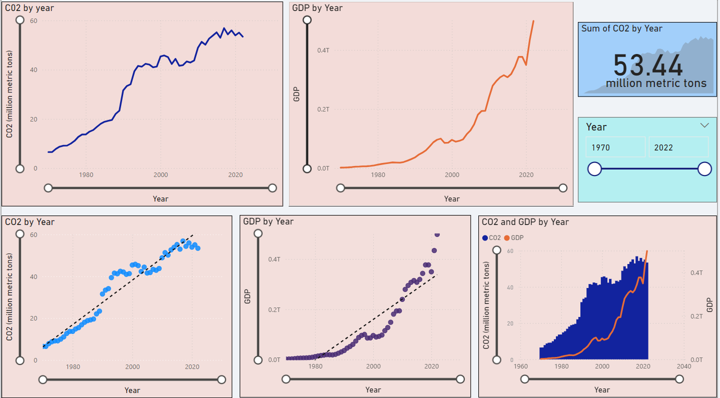
The hypothesis is that as a country’s GDP increases, CO2 emissions also rise due to higher energy consumption and industrial activities associated with economic growth. However, the reverse is not necessarily true—an increase in CO2 emissions does not always lead to GDP growth.

Top left (annual amount of CO2): This line chart shows the trend of CO2 emissions over the years. A steady rise in CO2 means an increase in emissions.
Top right (combined GDP by year): This graph shows the trend of GDP over the years. Significant increases indicate economic growth.

The main objective of these graphs were to examine the relationship between CO2 emissions and GDP separately, looking at their individual trends over time. Using line graphs, we can visualise continuous data and easily see both trends and changes in each variable.

Bottom left (scatter plot of sum of CO2 by year): scatter plot with best-fit line shows a strong correlation between year and CO2 emissions

Bottom center (scatterplot of sum of GDP by year): Similarly, this scatterplot shows a strong relationship between year and GDP growth.

Together with the best-fitting lines, the scatter plots show how CO2 emissions and GDP are strongly correlated with time. A high level of goodness of fit of the points indicates a strong correlation. This visualisation facilitates measurement of the relationship between variables and time, allowing for a detailed understanding of their behaviour and patterns over time
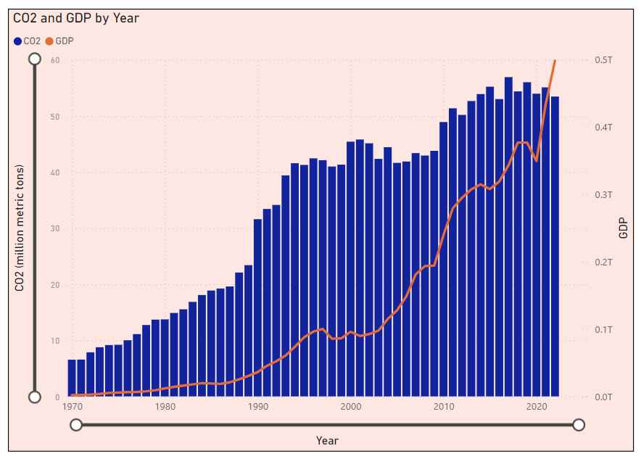
This graph overlays CO2 and GDP data for direct comparison with trends.
Blue bars (CO2 levels): The blue bars represent the total annual CO2 emissions. This shows the amount of CO2 released annually over the period.

Orange line (total GDP): The orange line represents the aggregate GDP for each year. This line shows the trend of economic growth

Each graph on the dashboard helps to better capture the relationship between CO2 emissions and GDP over the past five decades, enabling analysis of trends, correlations and potential causes.

Many global situations took place in 1997 to around 2009 one of which is the asian financial crisis. The loss of confidence in the economy leads to high employment rate and a decline in the standard of living. Following the crisis, many affected economies implemented reforms and began to recover, leading to a resumption of GDP growth by the early 2000s. This recovery is visible as the GDP line resumes its upward trajectory after the dip. During the crisis, industrial activity slowed down, reducing energy consumption and a corresponding decrease in CO2 emissions.

Another significant event to look at would be the dotcom crisis occurring around 2000 to 2001. Although it primarily affected the American technology bubble, there was still a ripple effect affecting the global economy. The dotcom crisis led to a steep slowdown in stock market and economic growth, especially in the technology and telecommunications sectors as shown by Singapore's GDP drop in 2001.

Although the dotcom crisis affected the GDP, the co2 on the other hand was not affected mainly because the crisis itself was not industrial or energy related. This would explain the lack of correlation at that point in the graph.

Dashboard 2 (Jin Bin):
Compare the per capita carbon emissions of Singapore with those of other developed countries in Asia and the global average.
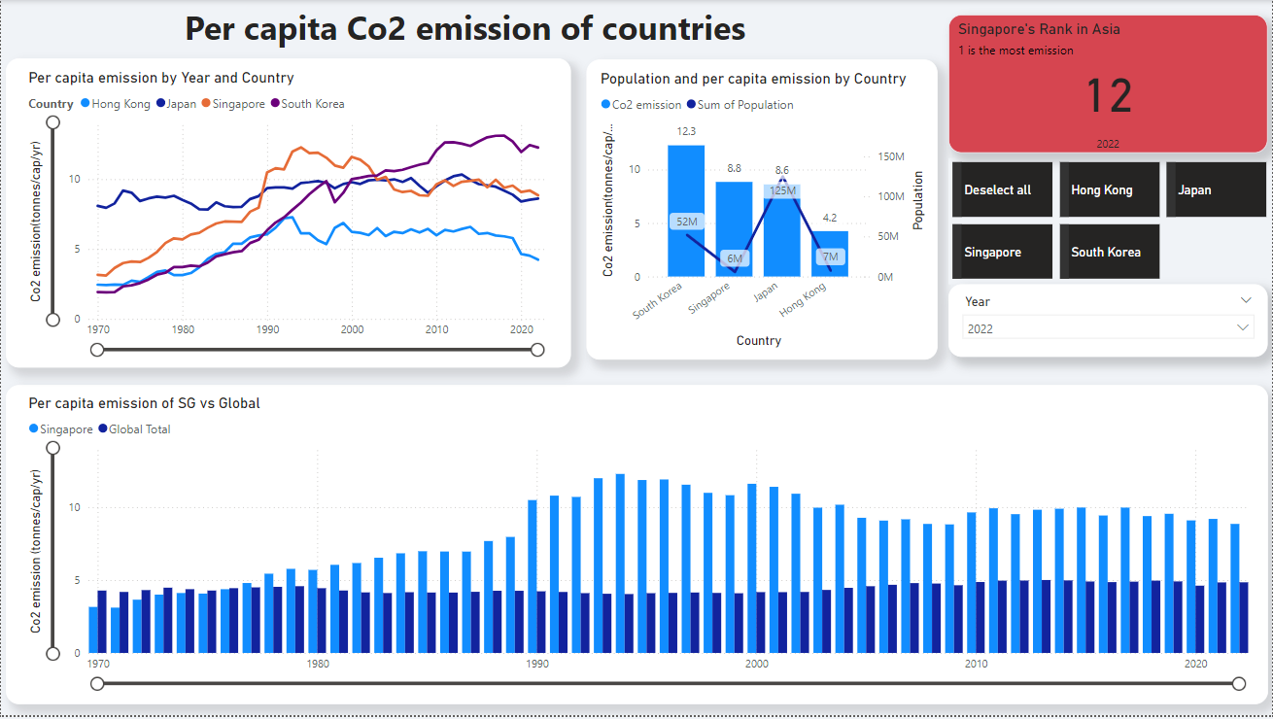
For this dashboard, I only included Singapore, Japan, South Korea, and Hong Kong as all 4 are highly developed economies in Asia.

Starting with the line graph on the top left, it shows the per capita CO2 emissions for the selected countries over time, from 1970 to 2022. This allows us to see trends and changes in emissions over the decades.

The bar graph on the right displays CO2 emissions and population of the countries for the selected year, which can be adjusted using the country and year slicer. This provides a quick comparison for any year of interest

The red box on the right indicates Singapore's rank in terms of per capita emissions, with 1 being the rank with the highest emissions and 48 being the lowest.

The graph at the bottom compares the emissions of SG against the global average to see how Singapore fares on a global scale.
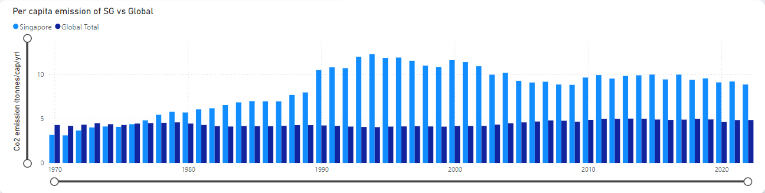

This chart shows that Singapore consistently has higher per capita CO2 emissions compared to the global average over the past few decades. Despite some improvements in recent years, the data shows that Singapore is still a long way from meeting the global average. Therefore, this highlights the need for more aggressive policies and technological innovations to reduce per capita emissions.
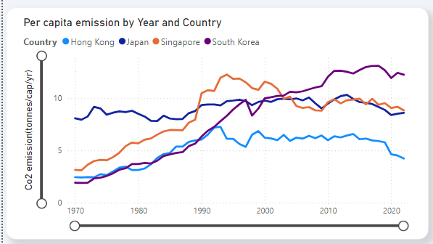
We can see that Singapore’s emission had increased significantly from the 1970s to 1994, aligning with its rapid industrialization. In contrast to this, it is encouraging to see that emissions have consistently decreased afterwards. Next, we can see that Japan and Hong Kong’s emissions have been relatively stable since 1970, suggesting that the policies they have in place are effective in managing their per capita emissions. In contrast, South Korea’s emission has shown a consistent increase in emissions with no signs of significant decrease. It will not be included in the comparison.
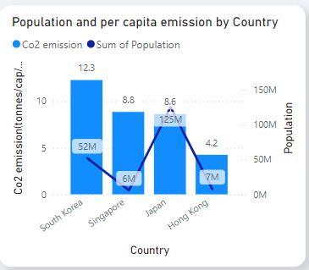

While Japan may have maintained their emission level, they are only 0.2tons/per capita behind Singapore. Therefore, I decided to compare only Singapore and Hong Kong as they both have similar population levels but Hong Kong’s per capita emission is almost ½ of Singapore's.

Recommendations (from Hong Kong):
- The first idea is the enhancement of electric vehicle (EV) incentives.
- Currently Singapore offers a tax rebate of up to $15,000 off the Additional Registration Fee if you buy an electric vehicle.
- Singapore can adopt Hong Kong’s "One-for-One Replacement" scheme, which offers significant tax rebates of almost up to about $30,000 for replacing old vehicles with EVs which is almost double that of our current one. This way, people who are thinking of buying new cars will also be attracted towards getting EVs

- Another area of improvement is enhancing Singapore's Green Mark Certification.
- Currently, this certification is mandatory only when the building is first constructed and voluntary thereafter.
- Singapore can adopt Hong Kong’s approach which is to make regular energy audits mandatory every 5 years for all industrial and residential buildings. By doing so, it promotes more consistent

Dashboard 3 (Issac Lim):
Analyse the carbon emissions of various sectors in Singapore in 2022, and identify the 3 main contributing sectors.

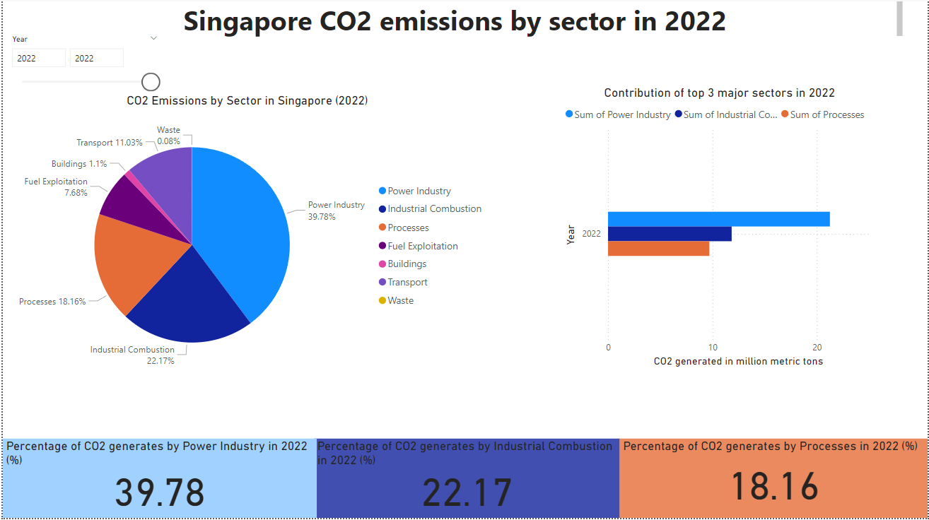

Here are concise insights based from graph showing:

Singapore's carbon emissions are contributed from 7 sectors : Power industry, Industrial combustion, Processes，Fuel exploitation, Buildings,Transport, and Waste.
The 3 main sectors identified are Power Industry (39.8%),Industrial combustion (22.17%), Processes (18.16%).they accounted for 80.2% of the total emissions.This is mainly due to Singapore being an international oil storage and refining center,it also reminds us that the focus of future carbon emission reduction should be on these sectors.

Dashboard 4 (Issac Lim):
Analyse the conditions and trends in sectors with high carbon emissions in Singapore and provide recommendations for emission reduction.
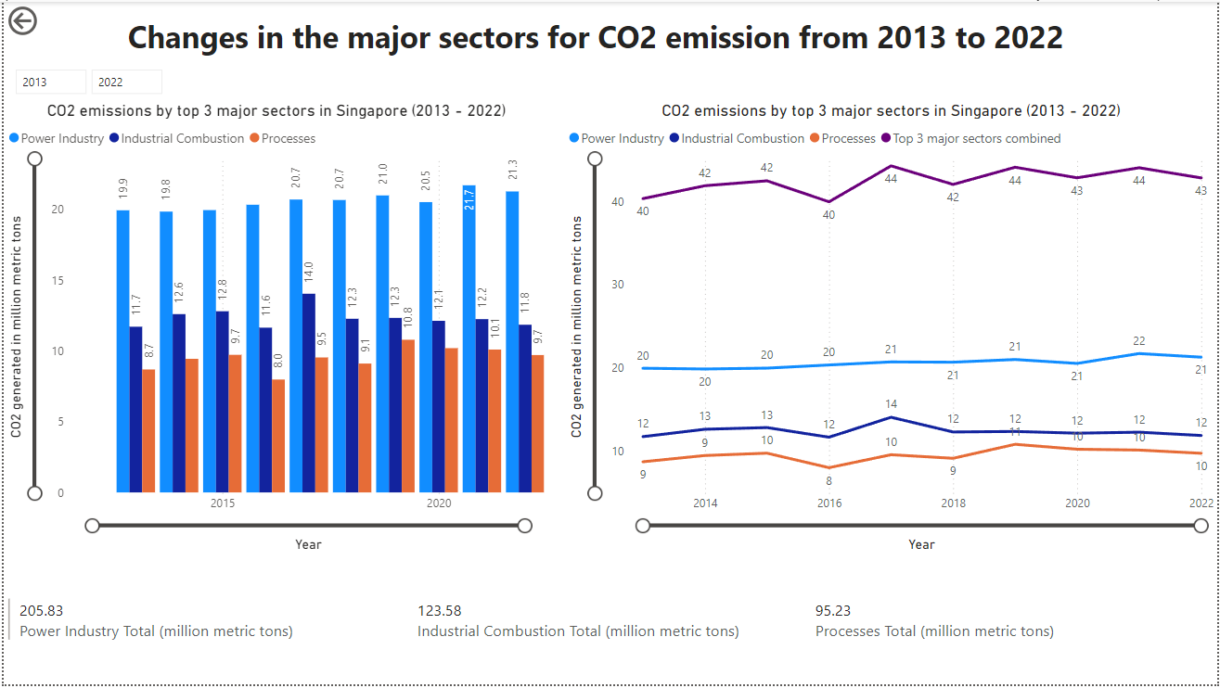
Here are concise insights based from graph showing:

All three sectors and total amount of emissions have shown to be stable and have been at a high level. This shows that although Singapore has been working hard to reduce carbon dioxide emissions in the past 10 years, the results are not ideal. It also shows that our country's industrial structure has not made any adjustments over the past years. These three areas have always been the main pillars of Singapore's economic development.

Recommendations

How to minimise emissions from the major sectors is the key to quickly moving toward a low-carbon future as such here are my suggestions.

1. Impose strict restrictions on the development of enterprises with large emissions.
While these industries serve as crucial pillars for a country's economic development, the prioritisation of human life and health over economic growth holds greater significance. Although such a choice may have short-term implications for the country's economy, it ultimately brings long-term benefits to both current and future generations.
2. Regulate organisational electricity consumption.
Currently, many government departments, schools, public places, and companies maintain an air conditioning temperature of below 20 degree celsius. This practice leads to excessive power consumption. The government should establish guidelines specifying the acceptable air conditioning settings for these organisations. We can refer to the Italian government's 2022 regulations. The indoor air conditioning temperature in public buildings cannot be lower than 25 degrees in Summer. Individuals or organisations that do not comply with this regulation will be prosecuted.

3. Accelerate the use of solar energy as our main renewable energy source.
Our country is located near the equator and there is inexhaustible solar energy. The government should pass legislation as soon as possible such as implementing policies like the "Rooftop Solar Initiative". In addition to ensuring that all new buildings and renovated buildings must install solar cells In addition to the panels, older buildings and residences are also required to install solar panels in phases over five years.

Discussion
We started by identifying the business problem from areas of interest and familiarity, and then identified the required data sources. We then sourced datasets together, which we spent a lot of time on without any results.

We later changed our approach, searched separately, then first judged whether there was sufficient data, cleaned, prepared and explored the data, then created meaningful visualisations of the data and created our business objective from there.

Conclusion
The insights derived from the above analysis provides people with a clearer understanding of the country’s carbon emissions and provides actionable emission reduction strategies thereby fostering our progress towards net zero emissions in 2050.

References
- https://climateactiontracker.org/countries/singapore/
- https://www.nccs.gov.sg/
- https://interactive.zaobao.com/singapore-carbon-emissions/
- https://www.edpr.com/apac/en/where-do-singaporeans-stand-terms-carbon-dioxide-emissions-capita-compared-rest-world
- https://ourworldindata.org/co2/country/singapore
- https://www.lta.gov.sg/content/ltagov/en/industry_innovations/technologies/electric_vehicles/transitioning_to_evs.html
- https://www.thestandard.com.hk/section-news/section/11/260790/Tax-breaks-slashed-for-electric-vehicles
- https://edgar.jrc.ec.europa.eu/report_2023#emissions_table
- https://www.channelnewsasia.com/commentary/singapore-heat-hot-weather-aircon-home-office-consumption-4242321
- https://www.sg101.gov.sg/economy/growing-our-economy/1997/
- https://www.youtube.com/watch?v=bXyQZ_SPS5U

Appendix:

Initial Data Preparation

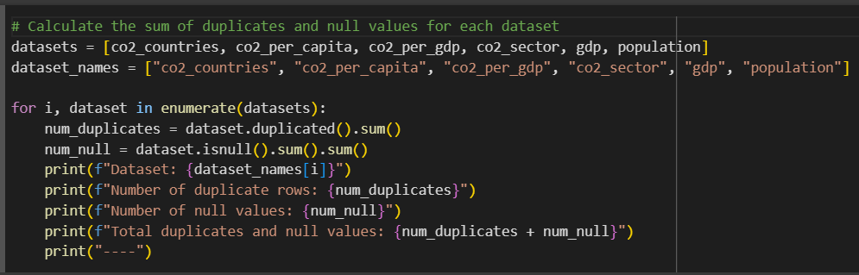
Figure 1- Snippet of removing (Null/Duplicate) values

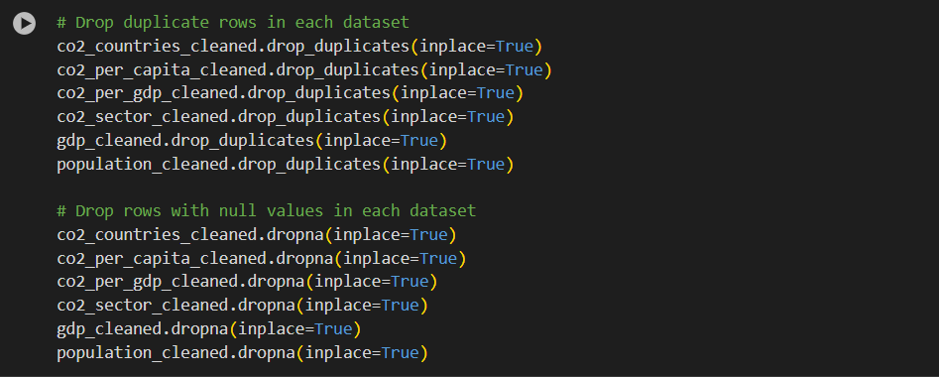
Figure 2 - Snippet of Dropping (Null/Duplicate) values

Further Data Preparation
Q1: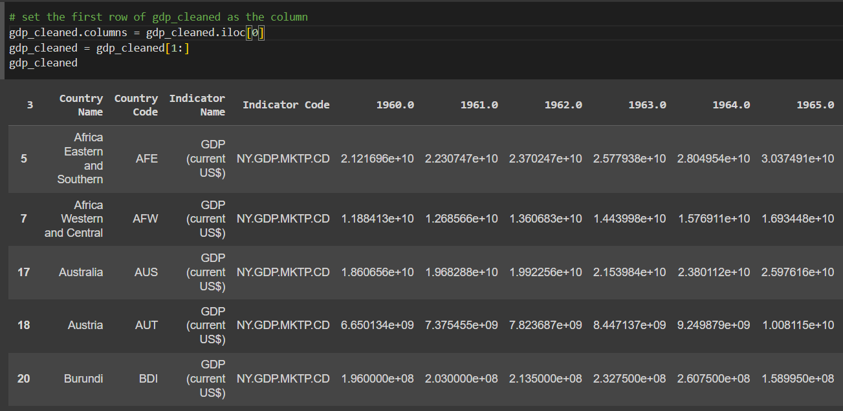
Figure 3 - snippet of setting the column name
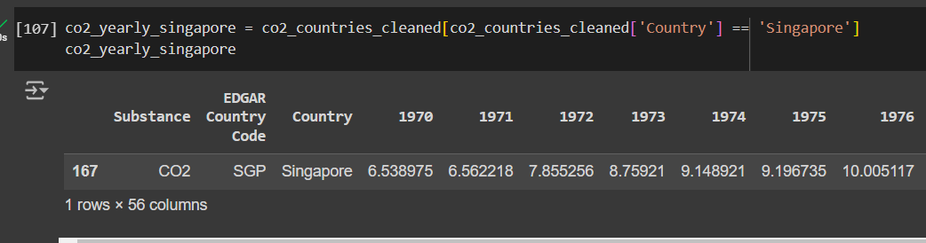
Figure 4 -snippet of filtering Singapore
Q2:
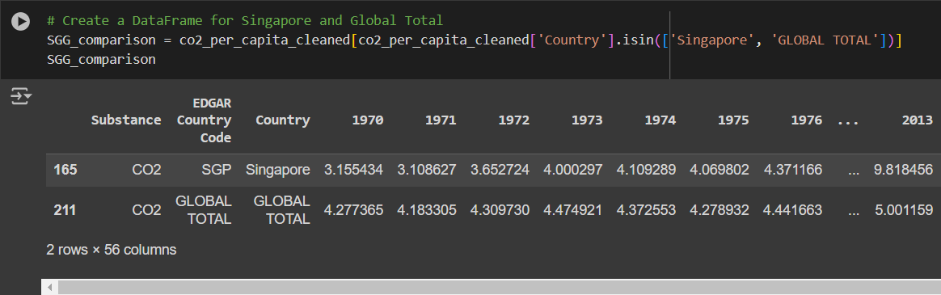
Figure 5 - snippet of filtering Singapore and Global Total
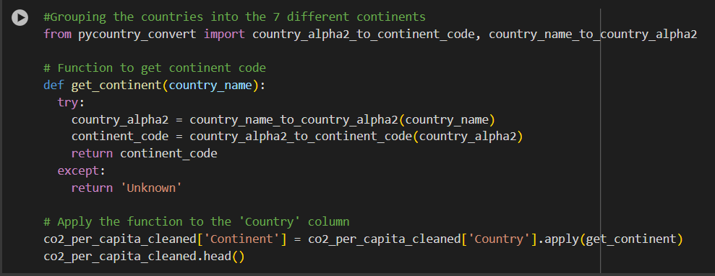
Figure 6 - snippet of creating continent column
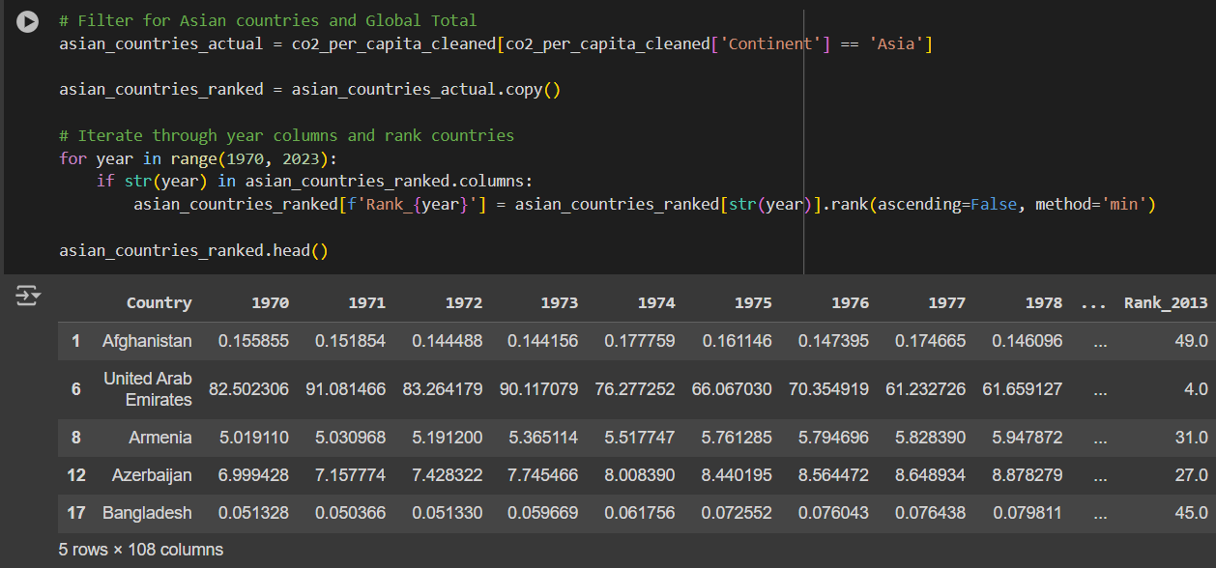
Figure 7 - snippet of filtering Asia
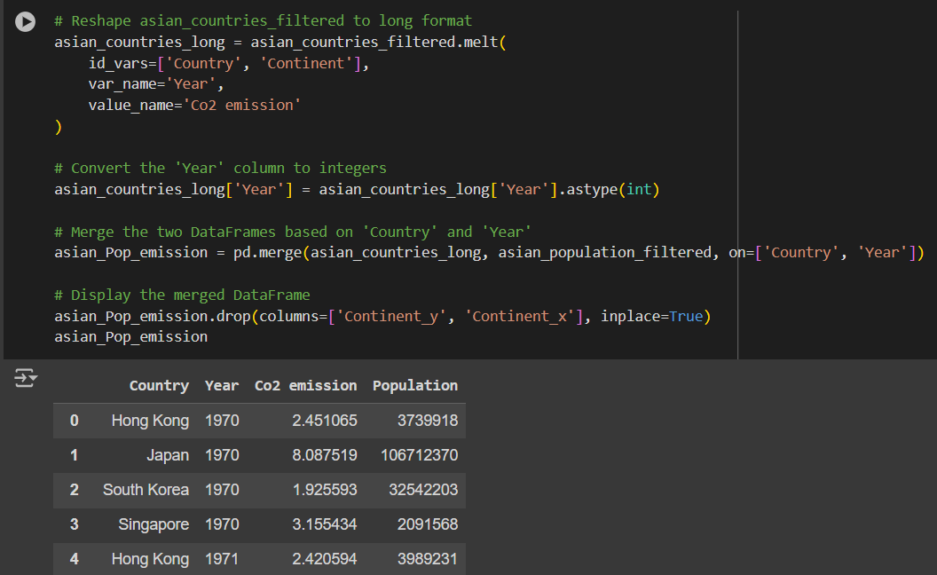
Figure 8 - snippet of merging population and CO2 per capita datasets
Q3:

Figure 9 - snippet of filtering Singapore
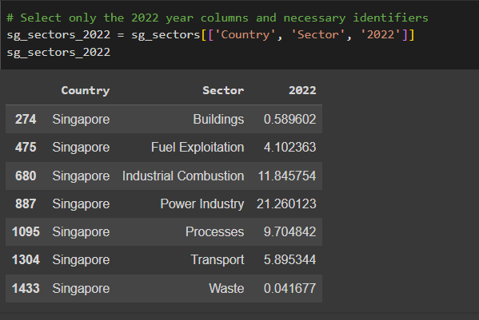
Figure 10 - Snippet of extracting relevant columns

Figure 11 - Snippet of formatting the data
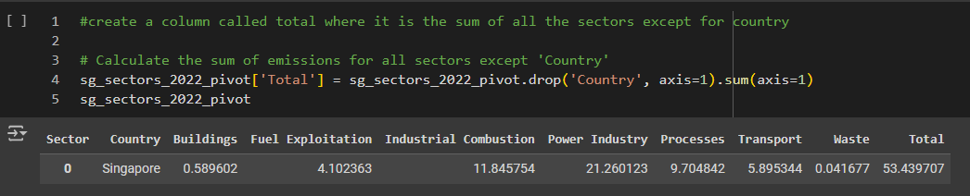
Figure 12 snippet of creating total column
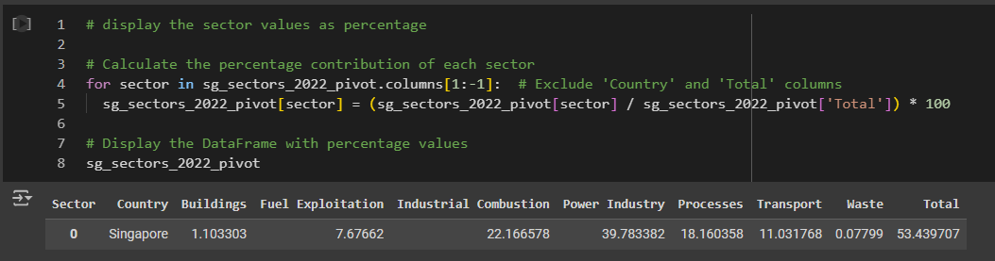
Figure 13 - snippet of displaying data as percentage
Q4:
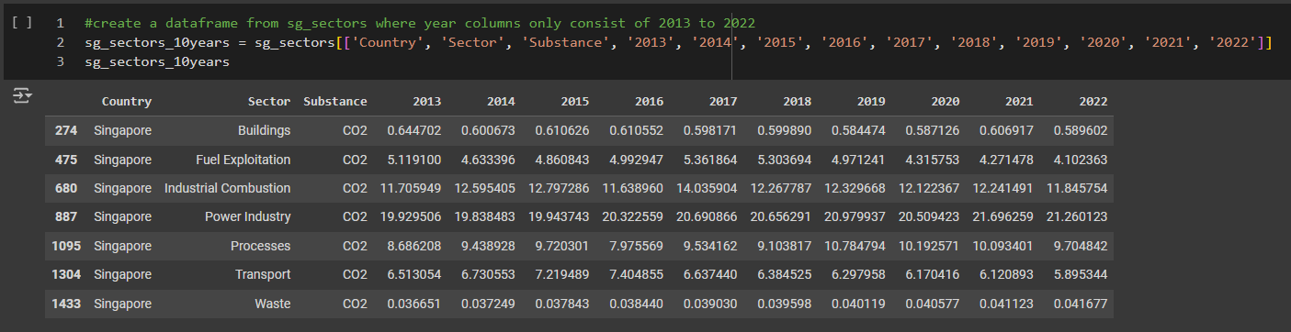
Figure 14 - snippet of extracting columns

Figure 15 - snippet of saving dataframe as CSV file

Figure 16 - snippet of saving dataframe as CSV file

Figure 17 - snippet of saving dataframe as CSV file

