**The Atlantic Forest trees: a flora on the verge of extinction**

Renato A. F. de Lima1,2*, Gilles Dauby3, André L. de Gasper4,Alexander C. Vibrans5, Alexandre A. de Oliveira2, Paulo I. Prado2, Vinícius C. Souza6, Marinez F. de Siqueira7 & Hans ter Steege1,8

1 Tropical Botany, Naturalis Biodiversity Center; Darwinweg 2, 2333 CR Leiden, The Netherlands.

2 Departamento de Ecologia, Instituto de Biociências, Universidade de São Paulo; Rua do Matão, trav. 14, 321, 05508-090, São Paulo, Brazil.

3 AMAP, Univ Montpellier, IRD, CNRS, INRAE, CIRAD; Montpellier, France.

4 Departamento de Ciências Naturais, Universidade Regional de Blumenau; Rua Antônio da Veiga, 140, 89030-903, Blumenau, Brazil.

5 Departamento de Engenharia Florestal, Universidade Regional de Blumenau; Rua São Paulo, 3250, 89030-000, Blumenau, Brazil.

6 Departamento de Ciências Biológicas, Escola Superior de Agricultura ‘Luiz de Queiroz’ – Universidade de São Paulo; Avenida Pádua Dias, 11, 13418-900 Piracicaba, Brazil.

7 Diretoria de Pesquisa Científica, Instituto de Pesquisas Jardim Botânico do Rio de Janeiro; Rua Pacheco Leão, 915, 22460-030, Rio de Janeiro, Brazil.

8 Systems Ecology, Vrije Universiteit Amsterdam; De Boelelaan 1087, Amsterdam, 1081 HV, The Netherlands.

* Corresponding author. Email: raflima@usp.br

**Abstract**

Biodiversity is declining globally, nevertheless many biodiversity hotspots still lack comprehensive conservation assessments of their biotas. We present automated assessments for 4953 tree species in the Atlantic Forest biodiversity hotspot (nearly 2000 being entirely new), based on multiple IUCN criteria and over 2 million species records from herbaria and forest inventories. About 65% of populations and 85% of endemic species were classified as threatened. We rediscovered five species previously classified as extinct, but we classified 14 endemics being possibly extinct. Uncertainty in species data influenced little the overall assessment, but the use of one or few IUCN criteria severely underestimated it. The conservation status of other tropical forests is likely worse than previously reported, with half of the world’s tree species potentially threatened.

**Short title:** Threat status of Atlantic Forest trees

**One Sentence Summary:** Over 2,000 or 85% of the Atlantic Forest’s endemic trees are globally threatened of extinction

**Introduction**

Human pressures on nature have increased in the past decades, particularly in the tropics, where most of the Earth's biodiversity resides (Lewis et al. 2015; Díaz et al. 2019). Consequently, we currently face a global biodiversity crisis, in which we do not know how many species have already gone extinct and how many will go extinct. What we do know is that we are headed for the sixth mass extinction of our planet (Ceballos et al. 2015) and that trying to reverse it is one of the most pressing challenges facing modern society. This challenge starts by classifying species according to their risk of extinction, which are then used to prioritize conservation actions and monitor threats to biodiversity (Newton et al. 2015; Bachman et al. 2019). Also known as red listing, these conservation assessments play an important part in global programs to reduce threats of human-induced extinctions, such as the International Union for Conservation of Nature (IUCN) Red List.

Red listing efforts have increased over the last decade, but there is still much to be done, particularly concerning plants (Newton et al. 2015; Brummitt et al. 2015; Bachman et al. 2019). Even for well-known life forms and regions such as trees in Europe, red listing efforts were completed quite recently (Rivers et al. 2019). One reason why only a small part of global biodiversity has conservation assessments available is the difficulty in carrying out such assessments, which mostly follow the IUCN framework (IUCN Standards and Petitions Committee 2019). They require up-to-date, detailed information on species distribution, ecology and threats, which are often not available. It also requires time and resources to apply the IUCN criteria to species individually, which are often limited (Newton et al. 2015; Bachman et al. 2019). This scenario is more complex in the tropics, where biodiversity is greater and resources are often scarcer. Therefore, automated assessments are an increasingly common and necessary alternative to the manual, species-by-species assessments (Darrah et al. 2017; Bachman et al. 2019; Lughadha et al. 2019), providing fast-track conservation assessments even for megadiverse tropical regions, such as the Amazon and tropical Africa (ter Steege et al. 2015; Stévart et al. 2019).

However, comprehensive red lists for the biota of entire tropical regions remain rare. Many unassessed tropical regions are global biodiversity hotspots, which hold most globally threatened and endemic species (Brooks et al. 2002). One of these hotspots is the Atlantic Forest in eastern South America, a mega-diverse tropical forest that shelters more than 15 thousand plant species (~5% of world total), almost half of them being endemic (Lima et al. 2020). Because 35% of South-American population lives within the Atlantic Forest borders, more than 80% of its original cover was already lost and deforestation rates remain above 10 thousand hectares per year (Rosa et al. 2021), making it one of the most threatened tropical forests in the world. Species conservation assessments are available only for a small part of the Atlantic Forest flora (ca. 20%), being conducted using few IUCN criteria (Martins et al. 2017).

Here, we present the conservation status for the entire Atlantic Forest biodiversity hotspot. We focus on its tree flora, which represents a third of the Atlantic Forest plant diversity, plays a central role in the provision of ecosystem services and has high economic and cultural value (Slik et al. 2013; Newton et al. 2015). We performed conservation assessments for nearly 5000 species using over 800,000 herbarium records and 1.3 million tree counts in 1154 hectares of forest plot inventories, as well as information on species auto-ecology, commercial uses and long time-series of forest cover. We carefully validated herbarium and plot data, and automated the assessments but keeping a strong adherence to the IUCN framework (IUCN Standards and Petitions Committee 2019), including estimates of species population decline (criteria A), geographic range (criterion B) and small and declining populations (criteria C and D). We also evaluated the influence of the number of IUCN criteria used and the uncertainty in species information and identifications in the assessment’s outcomes. We finally predict the current conservation status for other tropical forests around the world (see Materials and Methods).

**Conservation status of the Atlantic Forest tree flora**

We conducted assessments for 4953 populations of native tree species of the Atlantic Forest and found that two thirds of them can be classified as threatened following the IUCN criteria (Fig. 1A). If we consider only the species endemic to this biodiversity hotspot (about half of them), the percentage of threatened species is even higher, 85% (Fig 1B). This means that nearly 2100 endemic Atlantic Forest trees are globally threatened of extinction (supplementary materials). The overall Red List Index (RLI), which scores threat categories to quantify the overall conservation status for a set of species (Butchart et al. 2007), was 0.512 [95% Confidence Interval, CI: .504‒.520]. These figures are significantly worse than the RLI of 0.55‒1 and the 25% percentage of threatened species available for other groups of organisms (Díaz et al. 2019) and they suggest that the amount of threatened species in highly modified tropical regions, such as the Atlantic Forest, can be 2-3 times higher than the global averages.

Many iconic Atlantic Forest endemic trees were listed as threatened. The emblematic *Paubrasilia echinata* (Brazilwood), the tree that gave Brazil its name, had an estimated decline of 85% of its population size and was listed here as ‘Critically Endangered’ (CR). In addition, *Araucaria angustifolia* (Paraná pine), *Euterpe edulis* (Palm-heart) and *Ilex paraguariensis* (Yerba mate) had estimated declines of 50% or more in their wild populations, being classified here as ‘Endangered’ (EN). Well-known Atlantic Forest timber species, namely *Cariniana legalis*, *Dalbergia nigra*, *Melanoxylon brauna*, *Myrocarpus frondosus*, *Ocotea odorifera*, *Ocotea porosa*, *Parapiptadenia rigida* and *Paratecoma peroba*, also had estimated declines between 50 and 90%, being classified as EN or CR. The most frequent category of threat was EN, which was almost twice as frequent as other threat categories combined (Fig. 1).

Three quarters of all species were classified as threatened under the IUCN criterion A2, which evaluates population decline in the last three generations. Nearly 60% of the endemic Atlantic Forest trees had estimated declines above 30%, the minimum IUCN threshold for criterion A2 (IUCN Standards and Petitions Committee 2019). In contrast, 5% of the endemics had declines below 30% and only three populations of small-sized, early-successional species (0.2%) presented evidence of population increase. Another important criterion to recognize threat was B2 (27% of the cases), which relates to small areas of occupancy (AOO). But although the AOO was below the IUCN threshold of 2,000 km2 for most species (median of 208 km2), two thirds of them occurred in more than 10 locations or did not present severe fragmentation (Fig. SV and TT), which often does not indicate threat under criterion B (IUCN Standards and Petitions Committee 2019). Only eight populations were classified as threatened under the IUCN criteria C and D (Fig. ZZ), because the estimated population sizes were almost always (>97%) above the critical sizes of 10,000 mature individuals. Four species can be considered as highly threatened Atlantic Forest endemics (i.e. population declines ≥90%, population size <3000 and area of occupancy <100 km2): *Byrsonima pedunculata*, *Erythroxylum grandifolium*, *Miconia caiuia* and *Myrcia brunnea*.

**Comparison with previous IUCN assessments**

We found previous assessments for 49% and 20% of the Atlantic Forest tree flora at global (IUCN 2021) and national levels (Martins et al. 2017). Thus, here we present completely new assessments for nearly 2000 species. We rediscovered five species that were previously classified as ‘Extinct’ (EX) or ‘Extinct in the Wild’ (EW): *Campomanesia lundiana*, *Chrysophyllum januariense*, *Pouteria stenophylla*, *Pradosia glaziovii* and *Terminalia acuminata*. These species were classified as EX or EW mainly because they were only known from their type locality, with no new records been found until the year of their previous assessments (1998). Here, we found recent records (>2010) for all five species, including abundance records for *C. januariense*, *and* *P. glaziovii*. No recent and taxonomically-validated record was found *C. lundiana*, which may indicate that the species is actually EX or that there is uncertainty around the species taxonomy (i.e. need for further research). Nonetheless, all five species remained classified as threatened in the re-assessments but under lower categories of threat (VU or EN), emphasizing the importance of new information and periodic re-assessments to keep the IUCN Red List up-to-date (Newton & Oldfield 2008; Nic Lughadha et al. 2019).

Most differences between previous and new assessments were related to the up-listing from categories ‘Least Concern’ (LC), ‘Near Threatened’ (NT) and ‘Vulnerable’ (VU) to EN and from LC to VU (Fig. 2). Consequently, the RLI for the endemic Atlantic Forest tree flora deteriorated from 0.74 [CI: .72‒.76] to 0.48 [CI: .47‒.49] based on previous and new assessments, respectively. The decline in the RLI may be due to differences in the amount of information available (e.g. species occurrences), number of IUCN criteria used in the assessments or due to a genuine decline of species’ conservation status (Santini et al. 2019). To separate these causes, we compared changes for a subset of 915 endemic species assessed using only the IUCN criterion B, which is the most common criterion within previous assessments (83%). About 32% of the species in this subset had changes in their assessments, resulting in a RLI significantly better [CI: .81‒.85] than the previous one [CI: .73‒.77]. This finding is probably related to the inclusion of new occurrences which tend to classify species under lower levels of threat (Tracewski et al. 2016). Thus, the observed deterioration in the RLI between previous and up-to-date assessments is more related to the larger number of IUCN criteria used here than to a genuine decline in the Atlantic Forest conservation status (see also ‘The influence of the number of IUCN criteria’).

About 5% of the species went directly from categories LC or NT to CR, while 3% of the species previously classified as threatened were classified here as LC or NT. The first case is mostly related to species classified as LC due to their large extent of occurrence (EOO > 20,000 km2), for which we estimated population declines over 80%, the threshold to classify species as CR under IUCN criterion A2. The second case corresponded to species previously classified as threatened based on the IUCN criteria A (i.e. population decline) and/or B (i.e. geographic range) for which we found no indications of population declines ≥30%, severe fragmentation or occurrences in less than 10 locations (Fig. SV and TT), the conditions defined by the IUCN as necessary to classify species as threatened (IUCN Standards and Petitions Committee 2019). Overall, our assessments rarely resulted in the up-listing of more than two categories or the down-listing of species previously assessed as threatened, confirming that automated assessments can provide accurate pictures of species conservation statuses (Darrah et al. 2017; Santini et al. 2019; Stévart et al. 2019; Zizka et al. 2021).

**The influence of the number of IUCN criteria**

For many groups of organisms, including plants, data on population size and trends are scarce (Brummitt et al. 2015; Tracewski et al. 2016; Santini et al. 2019). Consequently, most IUCN assessments rely on species geographic range (i.e. IUCN criterion B) estimated using records from biological collections. At least 65% of the plant species in the IUCN Red List were assessed using only the criterion B (IUCN 2021). To evaluate the impact of using multiple IUCN criteria on the conservation assessment, we compared the results for a subset of species assessed using the four IUCN criteria (A, B, C, and D, Table SV). For this subset of species, we found that the overall results would be drastically different if only criterion B, C or D had been used (Table 1). For instance, assessments including only the criterion B would lead to six times less species classified as threatened and a RLI significantly better. The main explanation for this discrepancy is the fact that criterion B does not necessarily takes into account population declines due to habitat loss within species ranges. Some common endemic species with large ranges (> 30,000 km2) and population sizes (> 2,000,000 mature individuals), such as *Agarista revoluta*, *Metrodorea nigra* or *Picramnia ramiflora*, had estimated population declines above 80%, which classify them as CR under the IUCN criterion A2. Therefore, the use of just one or few IUCN criteria can severely underestimate the conservation status of regional biotas, particularly in highly-modified regions such as the Atlantic Forest.

**Uncertainty in species information**

Detailed information of species auto-ecology are necessary for the application of IUCN criteria A, C and D but they are missing for most Atlantic Forest tree species. So, we had to make generalizations of species’ generation lengths (GL) and proportions of mature individuals in the population (*p*, Table ST and SU). These generalizations were made for groups of species sharing the same combination of growth form (e.g. large trees) and ecological groups (e.g. pioneers ‒ see Supplementary Materials). To assess the possible uncertainties in the assessments caused by this generalization, we compared it with assessments using different values of GL and *p*. We found that small values of GL for tropical trees (i.e. 25 years) can change the contribution of different threat categories, but it did not alter much the overall proportion of threatened species (Fig. SWb and SX). This is due to the fact that the period of greatest habitat loss in the Atlantic Forest (i.e., 1950-2000) is more recent than the three generations time into the past (i.e. 75 years) defined by the IUCN (IUCN Standards and Petitions Committee 2019). We also found that the use of smaller proportion of mature individuals (e.g. *p*= 0.2) changed little the assessments under criteria C and D (**Fig. SY** and **SZ**), mainly because the estimated population sizes mostly remained well above the IUCN critical population sizes (<10,000). Our group-specific approach was equivalent to using a GL of 35 years and a *p* of 0.49-0.64, which are conservative values regarding tropical forest trees (Baker et al. 2014). Because we defined GL and *p* based on species information, we consider our approach to be more biologically meaningful than using fixed values for all species. And, most importantly, the use of more conservative values of GL and *p* had little impact in the overall conservation assessments of the Atlantic Forest tree flora.

**Uncertainty in species identifications**

Another source of uncertainty in conservation assessments is the confidence level of species identifications (Nic Lughadha et al. 2019), which is particularly important for the IUCN criterion B. For the Atlantic Forest tree flora, only one third of the herbarium records are vetted by taxonomic specialists, which often lead to less than 15 valid occurrences and thus less reliable assessments for many species (Rivers et al. 2011; Lughadha et al. 2019). Here, we implemented a scheme to add as many records and lose as little taxonomic confidence as possible (see Materials and Methods, Fig. SU and Table SX). We compared the results of the assessments using this scheme with those using only records validated by taxonomists, both under IUCN criterion B (Fig. SUA). The assessment using only valid records resulted in more threatened species (25%) and thus a significantly lower RLI (.855) if compared to the assessments using the above-mentioned scheme (16% and .912, respectively). We found evidence that this influence becomes more pronounced for assessments conducted with taxonomic confidence levels below 60% (Fig. SUB). These findings can be explained by a difference in the number of occurrences available, since using only taxonomic-validated records result in assessments using fewer records and thus smaller estimates of EOO and AOO (Rivers et al. 2011; Bachman et al. 2020). Another explanation is the inclusion of identifications errors per se (Nic Lughadha et al. 2019), which may increase EOO and AOO by adding occurrences outside species’ natural ranges. These two explanations are hard to disentangle, but together they mean that we may have underestimated the real threat status for species with less taxonomically valid records available.

**Endangered species in time and space**

Of the initial 3 million herbarium records found for the tree species occurring in the Atlantic Forest, only 27% had the minimum data quality required for the assessments (i.e. non-duplicated records with valid locality information) (see Methods for details). Amid these valid records, the first dates from the 17th century, but most records (79%) we found were made after the 1980s. Nevertheless, we found no valid record for 41 Atlantic Forest endemic trees over the past 50 years. Fourteen of those species are known only from their type specimens (Fig. SP), which is one of the criteria to tag threatened species as possibly extinct (IUCN Standards and Petitions Committee 2019). These are priority species for conducting new studies and target field missions capable of determining whether these results relate to a lack of occurrence data and/or up-to-date taxonomic treatment or to real extinctions in nature (IUCN Standards and Petitions Committee 2019).

The spatial distribution of the endangered trees was similar when considering all species together or only endemic ones. The western, central and northern parts of the Atlantic Forest presented the worse values of RLI (Fig. 3) and the highest proportions of endangered species (Fig. SR and SQ). The western and northern parts have lower species richness and endemism levels than the central part of the Atlantic Forest (Lima et al. 2020; Zwiener et al. 2021), but these three parts all share some of the smallest covers of remaining forest (except the Misiones region in Argentina). By contrast, the Serra do Mar and Araucaria regions, which hold some of the largest Atlantic Forest remnants, had relatively smaller concentrations of endangered species. These patterns reinforce that there are more endangered species where there has been more habitat loss and fragmentation. Therefore, *in situ* conservation actions in the Atlantic Forest should target not only at areas with high species richness and endemism (Bonn et al. 2002; Lima et al. 2020), but also those highly-deforested areas where the endangered tree species have worse chances to sustain their populations in the long term, due to low habitat quantity, quality and connectivity (Root 1998; Hanski & Ovaskainen 2002; Hodgson et al. 2011).

Regarding existing conservation actions, we found that most of the threatened Atlantic Forest endemic trees (83%) had at least one confirmed occurrence inside strictly protected areas. However, most of them had less than a quarter of their records (74%) and one-tenth of their EOO (84%) inside this type of protected areas (Fig. XX). Species classified as CR had significantly less occurrences inside protected areas than other threat categories, which can be partially explained by the smaller amount of protected areas within the EOO of these species (Fig. XX). In addition, the terrestrial area of habitat (AOH) available in 2018 was about 21% of species ranges, endangered or not, but most (74%) had less than 40% of AOH remaining. Again, endemic species classified as CR had significantly lower AOH (median= 19%) than other categories (Fig. WW). These results mean that many endangered Atlantic Forest trees have little habitat left and most of their records is concentrated in unprotected areas. So, new conservation actions able to increase habitat availability and protection (e.g. forest restoration and new protected areas) should prioritize the areas with higher concentration of endangered species (Fig. SR and SQ), but in particular the critically endangered ones (Fig. SS).

**Implications for tree species conservation**

The conservation status of the Atlantic Forest tree flora is alarming. However, it is probably worse than the reported here. That’s because our conservation assessments mostly took into account the decline in habitat amount (i.e. deforestation) and not in habitat quality (i.e. forest degradation and fragmentation). Population declines would have been greater if we had considered only the intact Atlantic Forest (3.5‒7%) (Sloan et al. 2014) instead of the overall forest cover remaining (12‒28%) (Rosa et al. 2021), particularly for late-successional, forest-interior species (Bender et al. 1998). Also, we used conservative values of generation length, proportion of mature individuals and exploitation levels for valuable species (see ‘Uncertainty in species information’), and we incorporated as much data as possible for the assessments of species with fewer occurrences (see ‘Uncertainty in species identifications’), both of which may have led to an underestimation of species threat (i.e. smaller species ranges, population declines and/or larger population sizes). Furthermore, most of the Atlantic Forest loss occurred in the last 50‒70 years, which for many tropical tree species fall within 1‒2 generation times into the past. This means that, although the Atlantic Forest deforestation is smaller today than before, the effects of past habitat loss and fragmentation on these long-lived species have not had enough time to fully express themselves, suggesting an extinction debt that is yet to be paid in the coming decades (Hanski & Ovaskainen 2002; Helm et al. 2006; Vellend et al. 2006; Kuussaari et al. 2009). Therefore, the future does not look good for the Atlantic Forest and all of its endemic tree diversity.

The status of Atlantic Forest tree flora reported here has direct implications to the Global Tree Assessment initiative (Newton et al. 2015) and for the CDB Global Strategy for Plant Conservation and the IUCN Post-2020 Global Biodiversity framework. It also highlights habitat loss as the major threat to tropical tree diversity, making us wonder what is its impact on the conservation status of other tropical forests around the world (Brooks et al. 2002; Seabloom et al. 2002; Sodhi et al. 2010; ter Steege et al. 2015). We thus used the relationship between species threat and habitat loss observed for the Atlantic Forest to infer the conservation status for 18 main tropical forest regions (Fig. ST). We found that nearly two thirds (63%) of the ca. 36,000 endemics trees from these main tropical forests are probably globally threatened due to habitat loss impacts alone (Fig. 4, Table 2 and Table SW), which represent about 39% of all the ca. 58,000 tree species in the world (Beech et al. 2017) and an average Red List Index of X.XXX. This is a considerable increase of the current estimates of 26% of globally threatened trees (REF), particularly because we only predicted threat for tropical endemic trees using the IUCN criterion A.

Our threat predictions based on 2018 habitat loss exceeded those of previous studies (Brooks et al. 2002) for all but one tropical biodiversity hotspot (i.e. Mesoamerica, Table 2), confirming that biodiversity hotspots concentrate most of the globally threatened species. Considering that temperate forests can have as much as 58% of threatened endemic trees (Rivers et al. 2019), habitat loss in woodland and shrubland biodiversity hotspots is above 40% (Sloan et al. 2014; Beuchle et al. 2015) and that it also reduces the populations of the non-endemic trees in the 18 tropical forests considered here, it is safe to say that at least 25% of the tree species not considered here (~ 22,000 species) are probably threatened as well. If this is valid, the overall proportion of globally threatened trees would be 48%, placing trees only behind cycads as the most threatened group of organisms in the world (Díaz et al. 2019). Considering the import ecological, economical and socio-cultural roles of tree species (Slik et al. 2013; Newton et al. 2015) and that tropical forests are under continued human pressures (Ceballos et al. 2015; Lewis et al. 2015; Díaz et al. 2019), combating habitat loss and effectively implementing both *in* *situ* and *ex situ* conservation must be at the center of the decision-making table, if we are to avoid human-induced extinctions of thousands of tropical tree species in the next decades.

So, species with at least one record of abundance in the forest surveys are among the commonest species in the Atlantic Forest, particularly if we consider that the available sampling effort of what’s left from the Atlantic Forest is very small (~ 0.005%). Therefore, for tree species in the Atlantic Forest the application of criteria C and D would probably be more informative for species without abundance records (see Supplementary Material for a discussion on this topic).

**References**

**Acknowledgements**

We thank H.R. Akçakaya and the former and present CNCFlora staff (Patricia da Rosa, Gustavo Martinelli, Eline Martins, Rafael Loyola, Pablo H.A. de Melo, Thaís L.B. da Cunha) for the advice on how to apply the IUCN criteria and conditions. We also thank Megan Barstow and Emily Beech (BGCI) for providing their list on commercial timber species. This research was funded by the European Union’s Horizon 2020 research and innovation program under the Marie Skłodowska-Curie grant agreement No 795114. The compilation of tree inventory data was funded the grant 2013/08722-5, São Paulo Research Foundation (FAPESP). A.C.V. and A.L.G. were supported by the grant 312075/2013-8 from the ‘Conselho Nacional de Desenvolvimento Científico e Tecnológico’ (CNPq), and the grant 2017TR1922 from the ‘Fundação de Amparo à Pesquisa e Inovação de Santa Catarina’ (FAPESC).

**Figures**

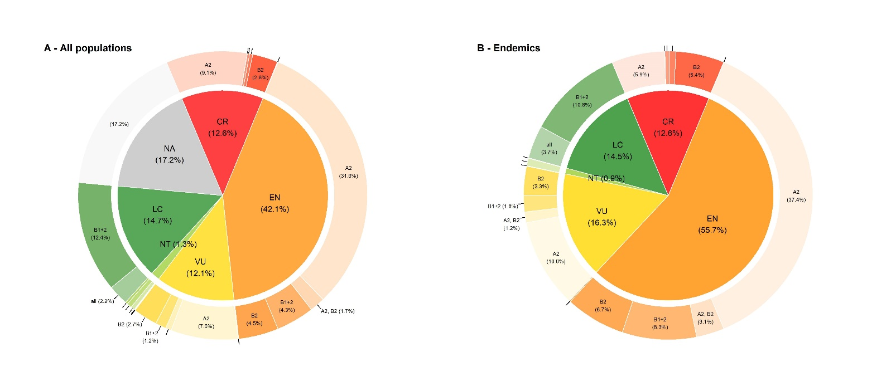

**Fig. 1.** The proportion of the populations classified under each category of threat (internal pie chart) and the corresponding IUCN criteria used to assign the categories (external donut chart) for (A) the populations of all tree species occurring in the Atlantic Forest and (B) only for the endemic species. Populations classified as ‘NA’ mainly correspond to the category ‘Not Applicable’ of IUCN regional assessments including occasional/vagrant species. Legend: NA= Not Applicable (grey); LC = Least Concern (dark-green); NT= Near Threatened (green); VU = Vulnerable (yellow); EN = Endangered (orange); and CR= Critically Endangered (red).

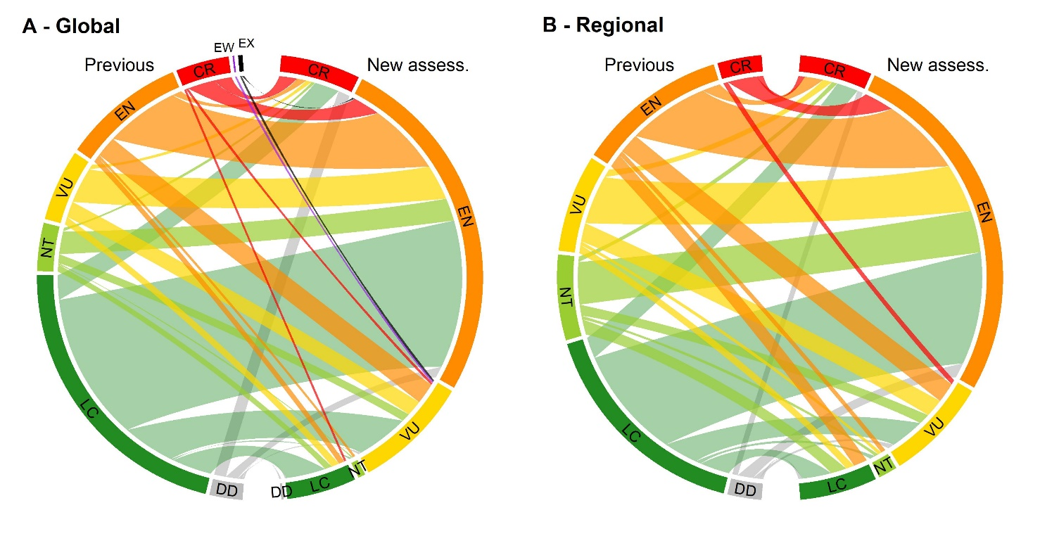

**Fig. 2.** Thecomparison between previous assessments (left arcs) and the new assessments presented here (right arcs) for the conservation assessment evaluated at (A) global and (B) regional levels. The width of the links corresponds to the proportion of species shared between categories of threat for the two assessments. Same legend from Fig. 1 plus: DD= Data Deficient (grey); EW= Extinct in the Wild (purple); and EX = Extinct (black).

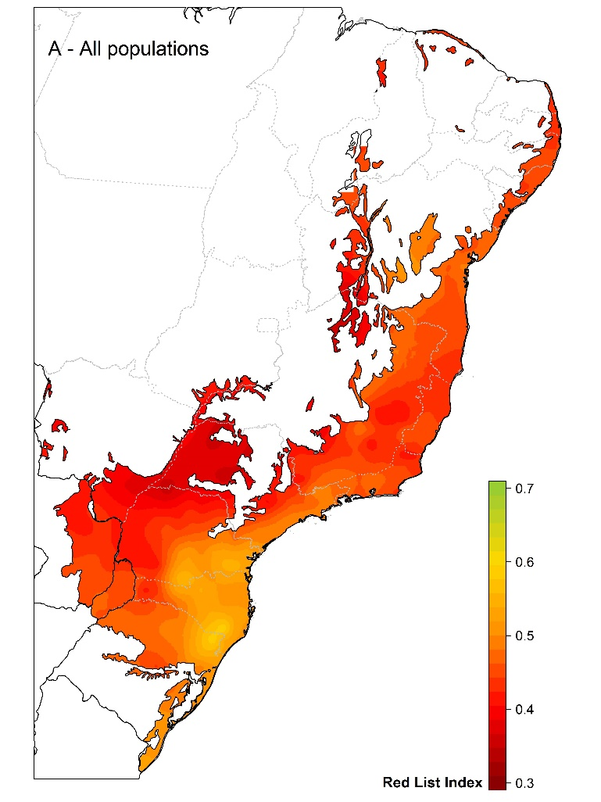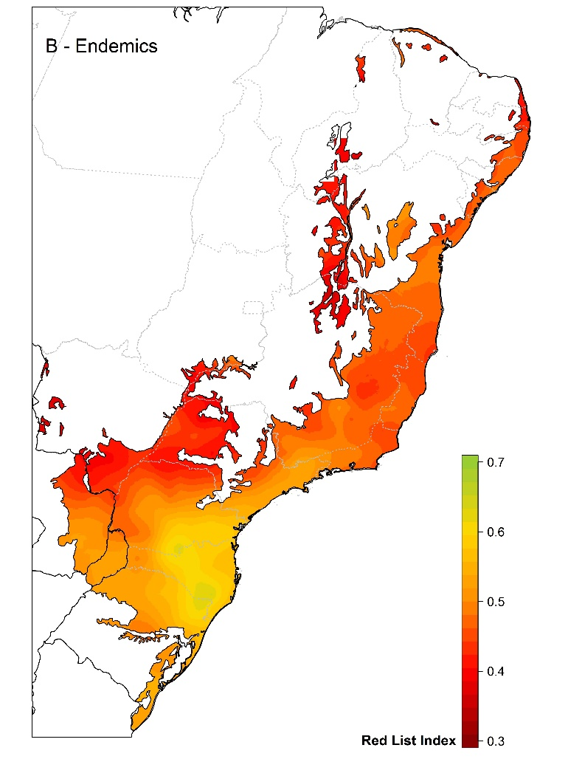

**Fig. 3.** Spatial interpolation of the Red List Index (RLI) across the Atlantic Forest biodiversity hotspot considering (A) the populations of all tree species and (B) only the endemic tree species. The RLI ranges from 0 (all species are classified as extinct) to one (all species classified as not threatened). Dark-red colours correspond to the smaller (worse) values of the RLI, while colours closer to green correspond to the higher (better) ones.

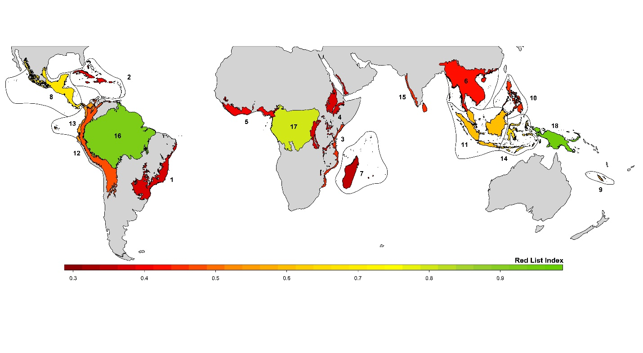

**Fig. 4.** The Red List Index (RLI) for eighteen main tropical forest areas of the world. Predictions are based on habitat loss and on population size reduction (i.e. IUCN criterion A2) inferred only for the endemic tree species of each area. Area numbers correspond to each of these tropical forests, whose full names are given in Table 2. The RLI ranges from 0 (all species are classified as extinct) to one (no species classified as threatened). Dark-red colours correspond to the smaller (worse) values of the RLI, while colours closer to green correspond to the higher (better) ones. See Materials and Methods, Table 2 and **SW** for details.

**Tables**

**Table 1.** Outcome of the assessments for the individual IUCN criteria and their comparison to the assessment using multiple IUCN criteria for the populations of all species and of endemic ones only. This comparison was conducted for a subset of the populations occurring in the Atlantic Forest that had information available to assess the IUCN criteria A, B, C and D. For the Red List Index (RLI), value in brackets represent the 95% interval around the mean estimate obtained from 50,000 bootstraps and the upper-case letters mark the differences of the RLI means among categories.

|  |  |  |  |  |
| --- | --- | --- | --- | --- |
| Criteria | All populations (*n*= 2698) | | Only endemics (*n*= 1586) | |
|  | Threatened (%) | Red List Index | Threatened (%) | Red List Index |
| A | 95.6 | 0.425 [.418‒.431]a | 93.9 | 0.463 [.454‒.471]a |
| B | 10.0 | 0.954 [.948‒.959]b | 15.1 | 0.930 [.921‒.939]b |
| C | 4.5 | 0.983 [.980‒.986]c | 4.7 | 0.985 [.981‒.988]c |
| D | 2.2 | 0.994 [.993‒.996]d | 3.0 | 0.993 [.991‒.995]d |
| A+B+C+D | 95.9 | 0.424 [.418‒.431]a | 94.3 | 0.455 [.446‒.464]a |

**Table 2.** The predictions of the proportion and number of threatened endemic tree species based on habitat loss for eighteen tropical forests. Habitat loss was obtained for 2018 based on closed and open forest cover remnants at each of the tropical forest. Previous threat values are based on the predictions of threatened and extinct species from (Brooks et al. 2002).

|  |  |  |  |  |  |
| --- | --- | --- | --- | --- | --- |
| **Tropical Forest Biodiversity Hotspots** | **Endemic treesa** | **Habitat Loss (%)** | **Threat. (%)** | **Threat.**  **(# species)** | **Previous threat** |
| 1- Atlantic Forest | 2400 | 74.8 | 90.1 | 2018‒2273 | 1144 |
| 2- Caribbean Islands | 1965 | 70.5 | 87.4 | 1587‒1821 | 882 |
| 3- Coastal Forests of E. Africa | 525 | 65.7 | 83.9 | 404‒473 | 221 |
| 4- Eastern Afromontane | 707 | 73.1 | 88.8 | 585‒665 | - |
| 5- Guinean Forests of W. Africa | 540 | 70.3 | 87.3 | 436‒500 | 295 |
| 6- Indo-Burma | 2100 | 68.6 | 86.0 | 1658‒1926 | 1112 |
| 7- Madagascar/Indian Ocean Is. | 3480 | 76.2 | 90.9 | 2956‒3313 | 1278 |
| 8- Mesoamerica | 883 | 40.9 | 59.5 | 440‒592 | 497 |
| 9- New Caledonia | 730 | 51.8 | 72.1 | 460‒581 | 209 |
| 10- Philippines | 1828 | 65.2 | 83.7 | 1399‒1638 | 1021 |
| 11- Sundaland | 4500 | 47.6 | 68.2 | 2643‒3374 | 2122 |
| 12- Tropical Andes | 4500 | 61.1 | 80.3 | 3253‒3905 | 1757 |
| 13- Tumbes‒Choco‒Magdalena | 825 | 52.9 | 73.1 | 530‒665 | 202 |
| 14- Wallacea | 450 | 42.0 | 60.8 | 231‒308 | 170 |
| 15- Western Ghats/Sri Lanka | 915 | 65.1 | 83.6 | 699‒819 | 320 |
| **Other Tropical Forests** |  |  |  |  |  |
| 16- Amazon | 6000 | 16.0 | 12.7 | 563‒1034 | - |
| 17- Central Africa | 780 | 29.7 | 39.5 | 247‒379 | - |
| 18- New Guinea | 2790 | 13.7 | 8.7 | 176‒340 | - |
| **Total** | 35,919 | 57.9 | 62.9 | 20278‒24597 | - |

aThe number of endemic trees per region was based on the number of endemic plants per region derived from different sources of published information and an average of 30% of tropical forest floras being composed by trees (see Materials and Methods for details).