First we need to Login by using UserName and Password

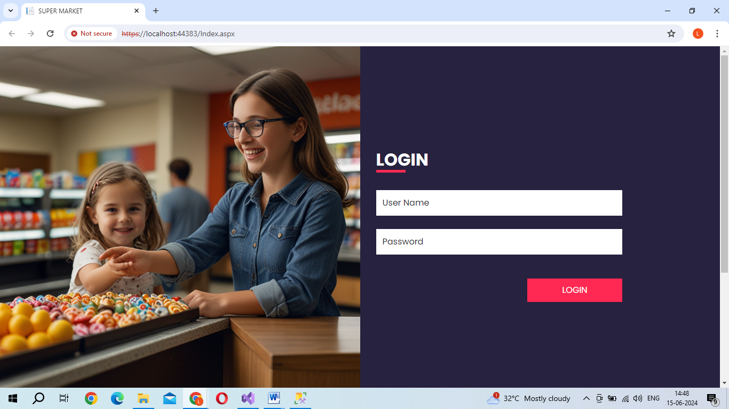

If the password and UserName is correct we are redirect to our task updation page.

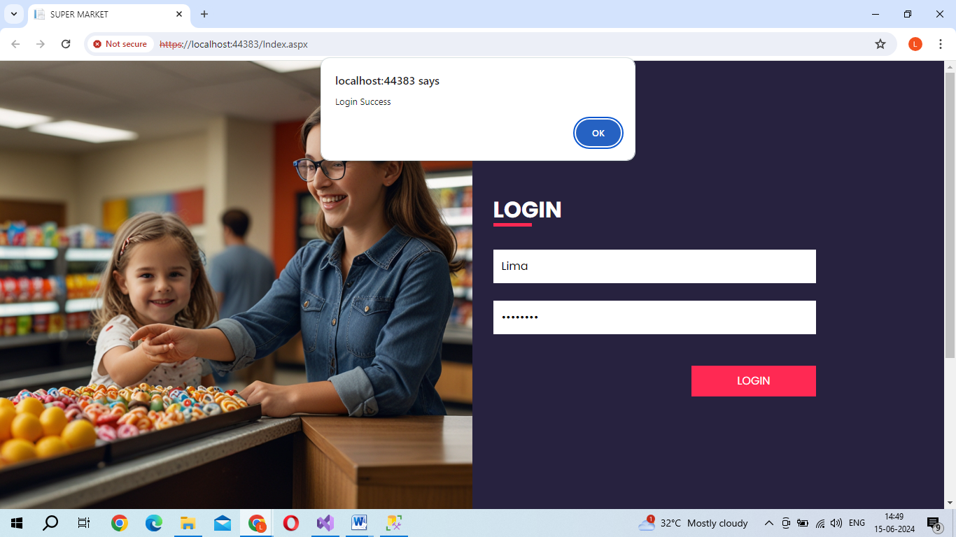

After the Login we have enter the task updation page. If we select “Add new Task” then we have an option to add new task



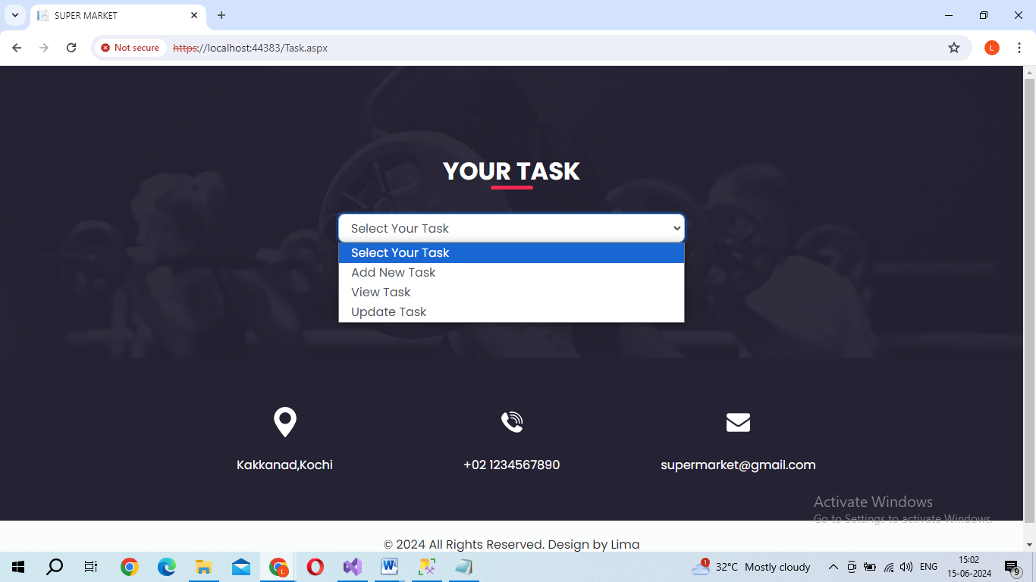

After the Task Name and Discription you should click “Add Button ” for adding the task.



When we select View task we get the table and also we get the task completed or not

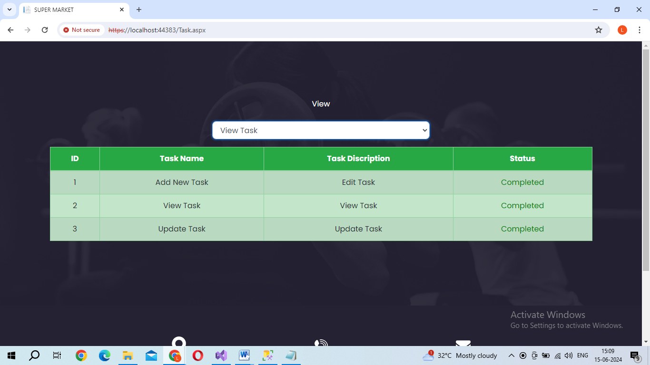

When we select the Update Task we also get the table for update the priority. We can choose the priority and click the submit button we completed the task updation.

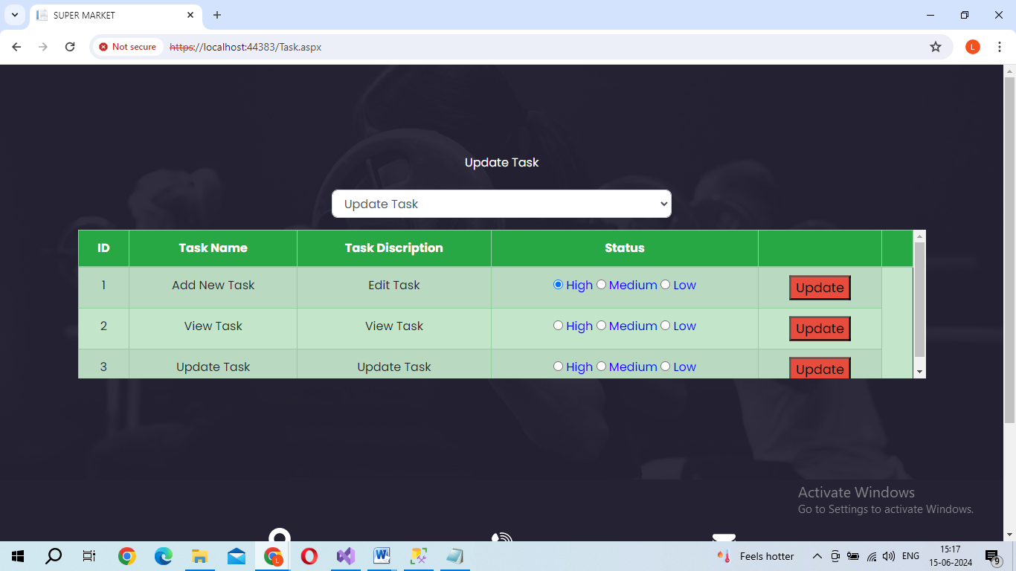

When need to the delete the task you must select the “Delete Task” in list

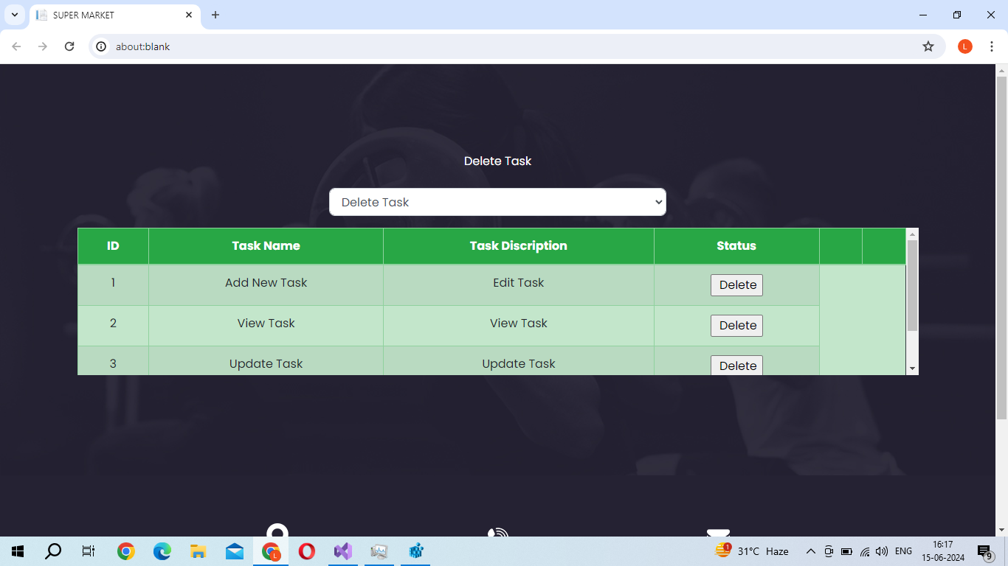

CREATE TABLE Customers (

customer_id int IDENTITY(1, 1) NOT NULL PRIMARY KEY,

customer_name varchar(25),

email varchar(25),

phone int,

address varchar(50),

city varchar(25),

country varchar(25),

);

CREATE TABLE Product_Categories (

category_id int IDENTITY(1, 1) NOT NULL PRIMARY KEY,

category_name varchar(25)

);

CREATE TABLE Products (

product_id int IDENTITY(1, 1) NOT NULL PRIMARY KEY,

product_name varchar(25),

category_id int FOREIGN KEY REFERENCES Product_Categories(category_id) ,

unit_price int,

cost_price int,

description varchar(25),

country varchar(25),

);

CREATE TABLE Orders (

order_id int IDENTITY(1, 1) NOT NULL PRIMARY KEY,

customer_id int FOREIGN KEY REFERENCES Customers(customer_id),

order_date date,

total_amount float,

region varchar(50)

);

CREATE TABLE Orders (

order_detail_id int IDENTITY(1, 1) NOT NULL PRIMARY KEY,

order_id int FOREIGN KEY REFERENCES Orders(order_id),

product_id int FOREIGN KEY REFERENCES Products(product_id),

quantity int,

unit_price float,

discoun int

);

Total Sales by Product Category

SELECT c.category_name, SUM(o.quantity * o.unit_price) AS TotalSalesAmount

FROM products p

JOIN order_details o ON p.product_id = o.product_id

JOIN categories c ON p.category_id = c.category_id

GROUP BY c.category_name;

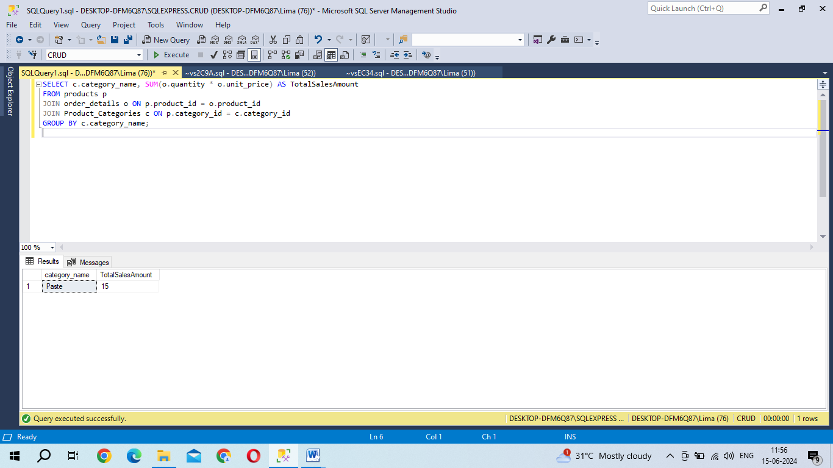

Product-wise Profit Margin

SELECT p.product_name,

SUM(o.quantity * o.unit_price) AS SalesAmount,

SUM(o.quantity * p.cost_price) AS Cost,

SUM(o.quantity * (o.unit_price - p.cost_price)) AS Profit

FROM products p

JOIN order_details o ON p.product_id = o.product_id

GROUP BY p.product_name;

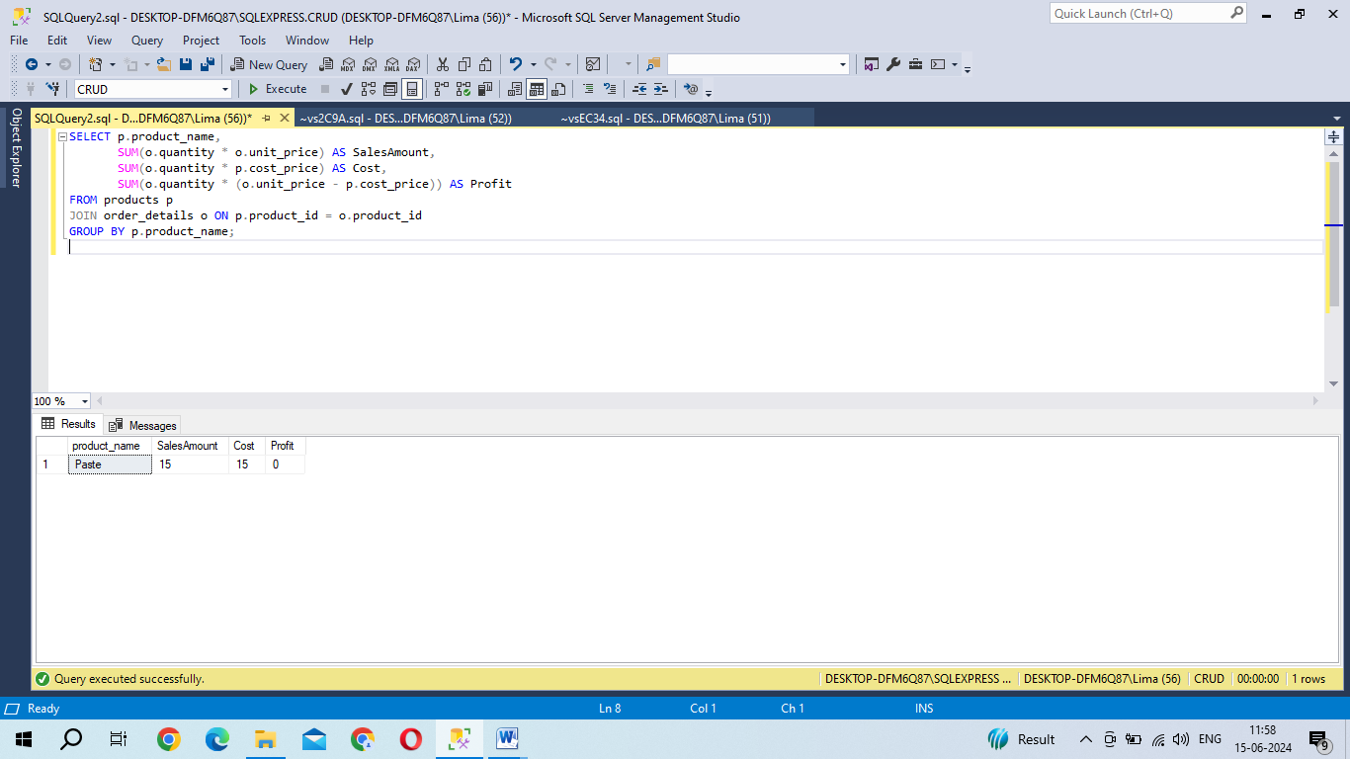

SELECT p.product_name, c.category_name,

ROW_NUMBER() OVER(PARTITION BY c.category_name ORDER BY SUM(o.quantity) DESC) AS Rank

FROM products p

JOIN order_details o ON p.product_id = o.product_id

JOIN Product_Categories c ON p.category_id = c.category_id

GROUP BY p.product_name, c.category_name

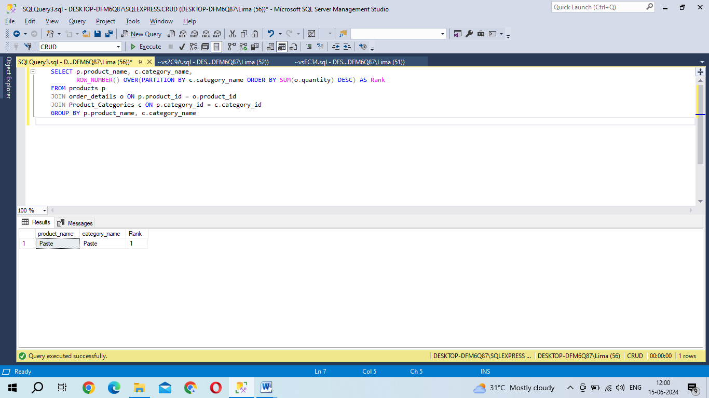

List of Products with No Sales

SELECT p.product_id, p.product_name, p.category_id,

p.unit_price, p.cost_price, p.description

FROM products p

LEFT JOIN order_details o ON p.product_id = o.product_id

WHERE o.order_id IS NULL;

