|  |  |
| --- | --- |
| A picture of a winding road and trees  Exacta Information System Design Document | Prepared by: Cole Neville, Julie Perrier, Dillon Meier, Guilherme Mello, Sufyan Jami, Ty Rawang  Prepared for: Exact One Ltd.  Instructor: Dave Watson  Capstone Project |

Table of Contents

Table of Figures 2

Preface 2

Purpose of Document 2

Documentation Standards 2

Headings 3

Sub-Headings 3

Sub-Sub Headings 3

User Requirements 3

Business Overview and Objectives 3

Project Overview 3

Project Scope 4

Web Application Dashboard: 4

Method to select specific wash bay: 4

Method to select fleet account cards: 4

Security levels for login credentials: 5

Hardware: 5

Database: 5

System Environment 5

Current System 5

System Requirements 5

Fact-Finding Methodology 5

Use Case Diagrams 6

Use Case Descriptions 7

View Bay Status 7

View Site Information 7

Send Promotional Information 7

Change Carwash Information 7

Print Site Information 7

Create Fleet Cards 7

Link Fleet Cards to a Company 7

Create Gift Cards 8

View Cards 8

Link Gift Card (To account) 8

Register for Account 8

Create Webpage and Database 8

Send Automated Fleet Card Invoice (Monthly) 8

Select State for Login 8

Class Diagram 9

S 10

Sequence Diagram 10

Non-functional Requirements 10

System Interface Requirements 10

Maintainability and Administration Requirements 11

Usability Requirements 11

Project Management 11

Schedule 11

Team Configuration 11

Project Standards and Procedures 11

Glossary 11

Index 11

Bibliography 11

# Table of Figures

Figure 1 - Exacta Creation System Use Case Diagram 6

Figure 2 - Site Information System Use Case Diagram 6

Figure 3- UML Class Diagram 9

Figure 4 - Sequence for Creating a New Gift Card 10

Figure 5 - Sequence Linking a Gift Card to an Account 10

# Preface

## Purpose of Document

The purpose of this document is to outline the system requirements for the information management system to be created for Exact One Limited. In this document a detailed list of requirements and descriptions will be discussed about the systems scope, technical requirements, client requirements, project management, and the process of gathering the information required.

## Documentation Standards

The fonts used in this document are as follows:

# Headings

* + Heading 1 in styles

## Sub-Headings

* + Heading 2 in styles

### Sub-Sub Headings

* + Heading 3 in styles

Paragraphs

* + Normal in styles
  + Will be indented from the heading above

Code

*//Comments*

* + Same font as code
  + Will start with "//" (two forward slashes)
  + Italicized

# User Requirements

## Business Overview and Objectives

Exacta’s mission is to provide electronic control systems for companies in the Car Wash and Other industries. Their purpose is to provide creative and efficient system solutions that maximize revenue for our customers. Their products run the simplest to the largest and most complex sites in operation today. [1]

## Project Overview

The purpose of this project is to create an information management system for Exacta’s (Exact One Limited) customers whom will be referred to as clients. The system will allow the owners (clients) of a car wash or multiple car wash sites to login into a web application to view site information.

This dashboard of information will include transaction summaries of the car wash site, the amount of vehicles using the wash site, and the type of washes being purchased. The dashboard will allow for more specific information about each car wash bay. The client will also be able to view and manage information regarding fleet account cards for potential customers.

These fleet account cards, also referred to as gift cards, will be unique to a potential customer of a wash site. These cards can be created, updated, and tracked with this system. Allowing the clients to view which wash customers are using, their transaction history, balance, and the ability to create a new card or delete a current one.

The dashboard will also have different levels of security and access. Managers will login with a higher level of credentials then an employee. The difference being what information is viewed and what systems can be changed. For example, a manager will be able to login into the site, and be able to change the pricing on a specific car wash, effectively changing what is shown on all Exacta devices on site. Exacta will have full access to the system if any setup is required for the potential client.

In order for a client to access this information management system, they must first register with Exact One Limited, at which time their site(s) and information will be added to the system.

## Project Scope

Given the limitations in our time, resources, funding, and skill due to our position as junior developers, the scale of our project includes an interconnected database connectable across any participating locations, a web application which alters in functionality depending on the degree of permission in order to prevent security breaches, and a series of Java systems to connect the system and make the whole system fully functional. If time and resources allow it, a possibility exists in which we will apply a mobile application variant, but regardless of whether this step is executed, it will be built with mobile adaptation kept in mind for the future.

The scope of the project involves several technical elements:

### Web Application Dashboard:

* Selection of car wash site based on location or name of site.
* General information of specific site. Transaction history over time, amount of vehicles over time, amount of fleet account cards, number of wash types being used.
* A method to select a specific device or bay on site to see similar information. Transaction history, vehicle count, number of wash types being used.
* A method to select and view all fleet accounts and information.
* A method to change wash information. Price, name of wash, the amount of washes available.
* A method to send out invoices via email.
* Graphs of information over time to be included.

### Method to select specific wash bay:

* Select specific wash bay and device to see full information.
* Similar information for the general wash site.

### Method to select fleet account cards:

* A tab in the dashboard should take the user to a page showing a list of all fleet account cards and the customers in possession of those cards for that specific company or wash site.
* Some customers may have multiple cards.
* Users can click on the fleet card and see transaction information, and the current balance for that customer.
* New cards can be created with a unique identifier.
* Cards can also be deleted by the client with customer request.

### Security levels for login credentials:

* Managers and owners of the car wash will have a higher level of credentials when logging into the system.
* Higher access for managers to change car wash device information.
* Exacta will have a full access credential to allow for proper setup of the system for the client.

### Hardware:

* Exacta devices will be linked to a centralized database.
* These control, input and output systems can be changed by managers through the system with higher login credentials.

### Database:

* Database will be on a hosted centralized server.
* Scripts will be created for the client registering to use the system.
* Scripts will create a database that will hold one specific client and populate their information.

### System Environment

There will be four specific environments for this system and its operation. The user interface will be a web based application for the main dashboard that users will interact with. The database system that links to Exacta’s hardware will be on a centralized hosted server possibly Google written with MySQL. Exacta’s electronic control systems on site customers interact with. Finally, a possible mobile application written in Java to mimic the web applications user interface.

### Current System

The current system Exacta has been using to login in and view car wash site information is an old black and white program with basic text. To use this system, a service member at Exacta would login to a wash site through the network connecting directly to the hardware allowing access to site information.

# System Requirements

## Fact-Finding Methodology

The project group participated in an introduction meeting at Exact One Limited to discuss the project, its scope, and expectations. This meeting occurred on Wednesday, September 20th 2017. The group was taken on a quick tour of Exact One Limited’s building, and was shown where Exacta’s electronic controls systems were put together. Afterward, a quick introduction and the discussion of the project in the board room.

Meeting took place with the president and CEO of the company where we were able to ask several questions about the project and develop a schedule if we needed to meet again to discuss the project. These meeting would take place on Wednesdays in the early afternoon.

## C:\Users\533925\ownCloud\SAIT\Classes\Year 2\Semester 3\System Analysis and Design\capstoneFiles\exactaSystem.pngUse Case Diagrams

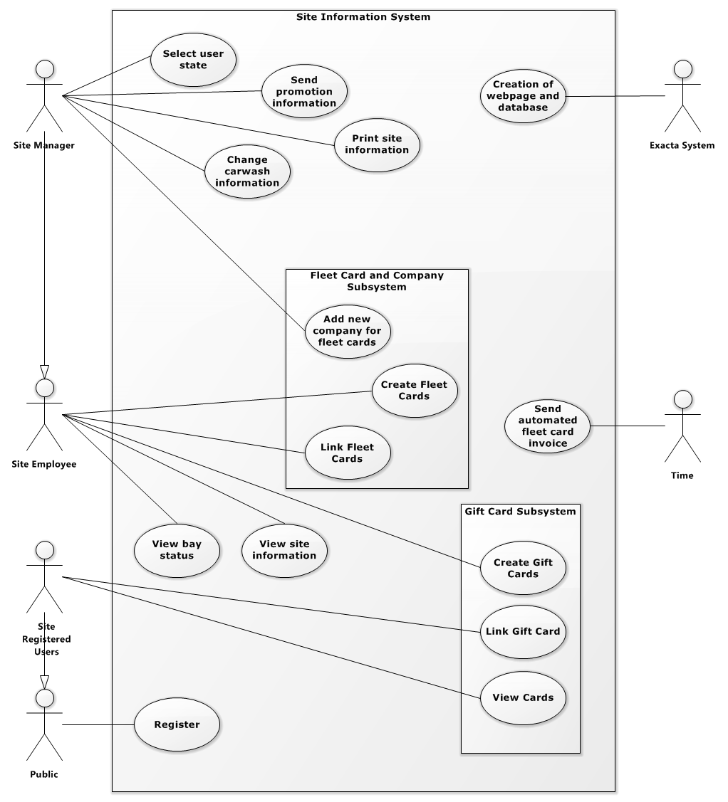Figure 1 - Exacta Creation System Use Case Diagram

Figure 2 - Site Information System Use Case Diagram

## Use Case Descriptions

### View Bay Status

The View Bay Status accesses the information of the location such as current use, and only managers will have access to this feature. After selecting the manager account, they will select view bay status from the User Interface. Once they are in view bay status, they may select a specific site. From here, it will show the vehicles and the transaction history.

### View Site Information

Managers will see site information such as

The view site information depends on if the site manager has chosen to login as an employee or a site manager. The site manager sees everything about the site and has the ability to view records such as transaction history over a long period of time. The employee would only have access to the transaction history of that day. The employee window would be very limited compared to the site manager window.

### Send Promotional Information

Send Promotional Information is a manager-exclusive feature that allows the manager to mail out information on promotional information to the mailing list, which would be anyone with a fleet account who has not opted out of receiving regular emails. It relays information on upcoming sales and promotions several weeks in advance, and unlike the automated billing information, it is sent manually from the manager.

### Change Carwash Information

Change Carwash Information is a feature exclusive to managers due to its security risk if on employee level. It is a flexible function that gives the manager the ability to adjust any and all details regarding the car wash, such as prices and hours of operation. This information is viewable to customers under specific limits, as well as employees with lesser restrictions, but only editable by the manager.

### Print Site Information

Print Site Information is allowable by the manager alone, to produce the carwash information they have created in printable form. This allows them to use this information made about the site available physical and viewable by customers in person.

### Create Fleet Cards

Create Fleet Cards allows a site employee to initiate a fleet card for a requesting customer. They input their billing information and personal details to allow the new owner of the fleet card to make purchases with the company without needing direct payment the day of the transaction, and instead be billed at the end of the month for their purchases. The inputs include credit information for billing, customer identifying information, and email address for billing over email.

### Link Fleet Cards to a Company

Link Fleet Cards is done by an employee for a customer to connect their newly purchased fleet cards to their account, and allow access to the information available on the fleet cards from their account view. This task is performed by an employee for security purposes, as adding to the fleet card database should not be allowed freely by any user. After a fleet card is registered, the customer is free to use it for purchases.

### Create Gift Cards

Create Gift Cards is a function available to employees to load the desired data onto a physical gift card upon a customer's request for purchase. The inputs required include an empty, new gift card, and the customer's chosen amount to be entered into the gift card by the employee that is selling the gift card to them. The customer is then free to insert the credit within the gift card to any participating car wash.

### View Cards

View Cards is available for customers with an existing site who already have existing, inputted gift cards. When gift cards are entered, their credit is not pooled, and instead cards are displayed separately. The user may view their previous cards entered as well as the dates the card was entered as well as each date credit off of the card was used.

### Link Gift Card (To account)

Link Gift Card allows for the user to enter a gift card they possess into their account, if they have one. This function is usable only by customers who own at least one activated gift card that contains credit they wish to enter into the database, and an account of their own. The user will be able to enter the card, and the current credit on the card will be read and stored. View Cards will be updated to contain this newly registered card entry.

### Register for Account

Register for an Account is a function available to customers and car wash owners. For customers, accounts allow for viewing gift card status and includes them in mailing lists. For owners, registering will create a dedicated database containing information retrieved from their car wash servers.

### Create Webpage and Database

Create Webpage Database is a function available to Exacta on Exacta's system. When an owner registers an account, Exacta's system creates a hosted database containing information stored in the car wash servers. It also creates a unique webpage that presents the information catered to the client's needs.

### Send Automated Fleet Card Invoice (Monthly)

Send Automated Fleet Card Invoice is a nonfunctional feature that automatically will relay an email to registered customers the details of their account at the end of every month. This will occur the final day of the month, and will require no user input to send, but can be manually adjusted, or set by the users not to send if they wish not to receive these emails. The information relayed will contain all transactions involving adding credit through a card and using it within the past month. All changes will be recorded, as well as the date of their change.

### Select State for Login

When the manager logs in to the website they are able to select to view the manager page or the employee page for protection against tailgating. The manager view lets them see extra information about the site such as

## Class Diagram

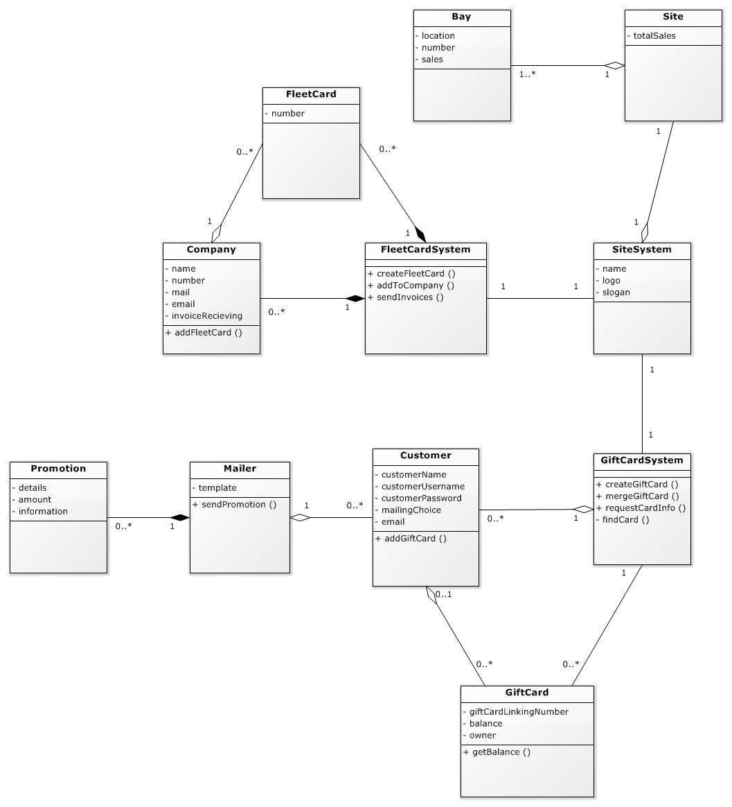

Figure 3- UML Class Diagram

## C:\Users\533925\ownCloud\SAIT\Classes\Year 2\Semester 3\System Analysis and Design\capstoneFiles\linkACardToUser.pngC:\Users\533925\ownCloud\SAIT\Classes\Year 2\Semester 3\System Analysis and Design\capstoneFiles\createGiftCards.pngSequence Diagram

Figure 4 - Sequence for Creating a New Gift Card

Figure 5 - Sequence Linking a Gift Card to an Account

## Non-functional Requirements

The non-functional Requirements for the system are:

* The user should be able to login
* Many users on the site at one time
* Able to run on a couple of systems

## System Interface Requirements

The system interface requirements for the system are:

* Clean, efficient and concise
* English speaking users

## Maintainability and Administration Requirements

## Usability Requirements

# Project Management

## Schedule

## Team Configuration

## Project Standards and Procedures

* Java 9
* MySQL
* Eclipse Oxygen
* Word Online
* Software Ideas Modeler

# Glossary

|  |  |
| --- | --- |
| Exacta | The marketing term and name for Exact One Ltd. used on all equipment and products sold. |

# Index

**No index entries found.**

# Bibliography

|  |  |
| --- | --- |
| [1] | Exact One Ltd., "Exacta," [Online]. |