Multifaceted Exploration of Spatial Openness in Rental Housing: A Big Data Analysis in Tokyo's 23 Wards

賃貸住宅における空間開放性の多面的探究：東京23区のビッグデータ分析

沖研究室 23M23456 リュ ゲン (LIU Yuan)

1. Introduction
Understanding spatial openness in residential housing is important for enhancing living quality and guiding architectural design. Traditional indicators such as floor area and room count fail to capture the nuanced spatial qualities present in interior imagery and floor plans. existing paper . This study proposes a multifaceted method to evaluate spatial openness in rental housing by analyzing large-scale data from Tokyo’s 23 wards. It extracts openness features from both 2D and 3D information, explores their variation across regions and decades, and examines correlations with rent and impression scores. The framework offers a comprehensive approach to understanding openness in residential design.
2. Methodology
Spatial openness is typically expressed through the sense of spaciousness, visual connectivity, and spatial flow within a living environment. In residential spaces, physical structural features play a crucial role in shaping people's subjective perception of openness. This chapter presents the data filtering process Figure2 dataset and a concise framework for evaluating spatial openness based on five indicators extracted from multiple dimensions.
2D openness metric is the VGA (Visibility Graph Analysis) value from floor plans, which reflects spatial connectivity.
3D openness metric is including windows ratio, ceilings ratio, floors ratio, and walls ratio. They are visual element ratios extracted from interior images,
These features are used in subsequent temporal, spatial, and correlation analyses.
2.1 LIFULL Dataset
Our dataset comprises 4004 rental properties from Tokyo’s 23 wards (1960-present), filtered for image quality and data completeness. As illustrated in Figure 2, this overview shows our methodology extracts multiple categories of spatial openness attributes through interior images, floor plan data, and property. The following
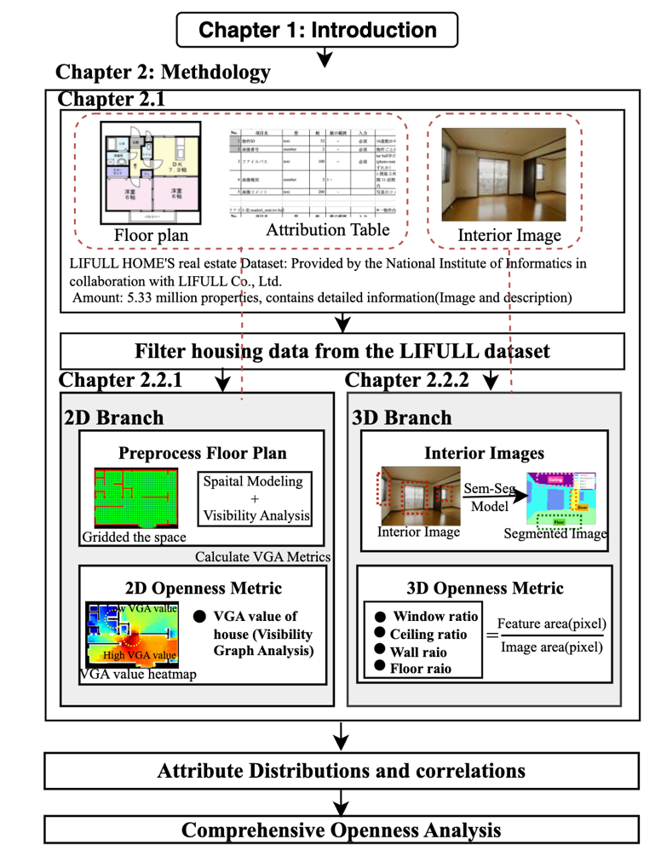
sections detail the extraction workflows for interior elements and VGA- based statistics.
room size attributes, property specifications, interior elements, and VGA-based statistics. Room size attributes and property specifications are obtained directly from the database. Interior elements are extracted through semantic segmentation of interior im- ages, while VGA-based statistics are computed from floorplan analysis to quantify spatial connectivity.
2.2 Openness Features
2.2.1 Interior-Image Based Elements(2D)
We apply Mask2Former semantic segmentation to extract wall, ceiling, floor, and window ratios from interior images, as shown in Figure 3. Each image is processed through a pre-trained segmentation model, which outputs pixel-wise masks for each architectural element. The fractions of these visual elements are then computed by dividing the number of pixels corresponding to each element by the total number of visible pixels in the image. This provides a normalized ratio (e.g., window area ratio) that reflects the visual presence of each component, as shown in Figure 3. These extracted ratios serve as quantitative indicators of perceived openness.
2.2.2 Floor Plan-Based VGA(3D)
To quantitatively assess spatial openness from floor plans, we construct a custom pipeline based on Visibility Graph Analysis (VGA). This method simulates inter-visibility among points within a space, enabling automated computation of spatial connectivity across large-scale housing data.
Semantic Segmentation of Floor Plans: Raw 2D floor plan images are fed into semseg model(reference and explanation) to classify pixels into categories such as walls, rooms, and windows.
Binarization and Contour Extraction: Based on the segmentation result, we binarize the image: pixels belonging to outer boundaries and internal walls are set to 1 (obstacle), and navigable regions are set to 0. This creates a binary analysis mask.
Standardized Scaling of Floor Plans: To ensure consistency in measurement, all floor plans are rescaled using a factor derived from each property's real floor area and its pixel area in the image. This normalization allows for comparable spatial metrics across properties.
Grid Generation and Obstacle Filtering: A uniform grid is overlaid on each plan. Grid points falling within obstacles (e.g., walls) are removed to reduce computational load and improve accuracy in the visibility calculations.
Ray Casting for Visibility Simulation: From each valid grid point, rays are emitted in multiple directions (e.g., every 1°). If a ray does not intersect with an obstacle, the target grid point is marked as visible.
VGA Score Computation: For each grid point, the number of other visible points is counted to construct a visibility matrix. The resulting VGA score reflects the degree of openness or enclosure of that point.

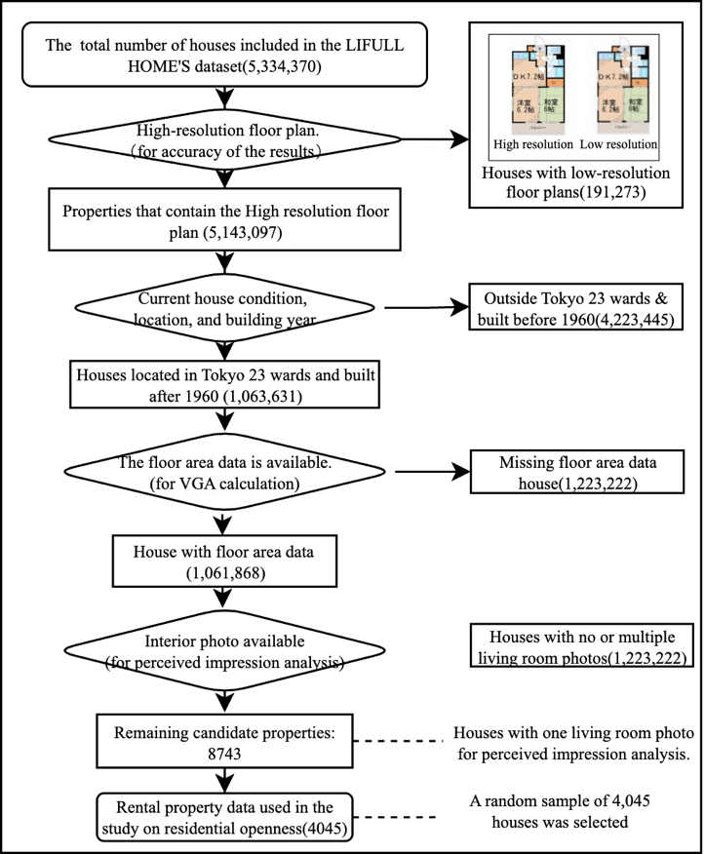

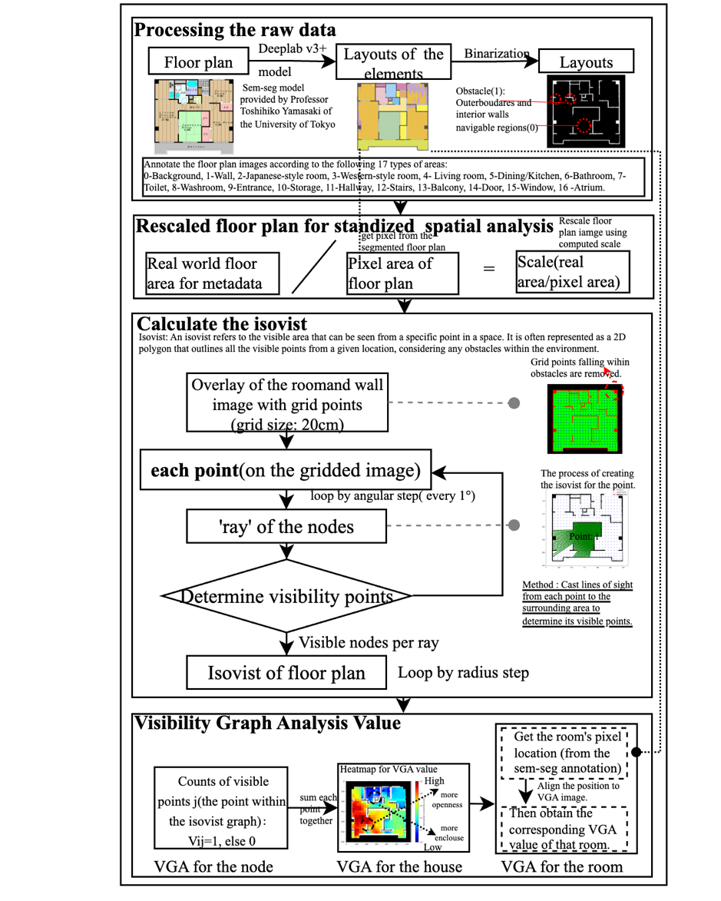
where S(i) is the visibility score at node i, and Vij = 1 if node j is visible from node i, otherwise Vij = 0. This generates a VGA heatmap that visualizes the spatial connectivity of the floor plan. 
Finally We extract summary statistics (mean, standard deviation, percentiles) from the heatmap as spatial openness features, which are then used in further analysis to examine distribution patterns and correlations with other housing attributes.
VGA score for the room of the house.
To obtain the VGA value of a specific room, we first use the semantic segmentation result to identify the pixel region corresponding to that room. By applying this mask to the VGA heatmap, we extract the visibility values within the room area. The room-level VGA value is then computed by aggregating these pixel-level values using statistical measures such as the mean or standard deviation.

3 Results
From the tabular features of the properties, we have various information, with the most interesting being construction year and geographic factors.
3.1 Temporal Analysis of Spatial Openness
We examined the distribution of VGA mean values across construction years in decades, as shown in Figure 5.
Wati one-way anova analysi

3.2 Geographic Distribution Analysis
Haven’t decided this part.

3.3 Correlation Analysis Between Openness Attributes. (Multiple Regression Analysis.)
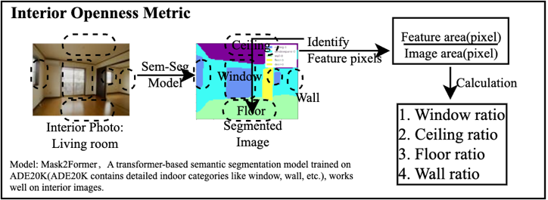

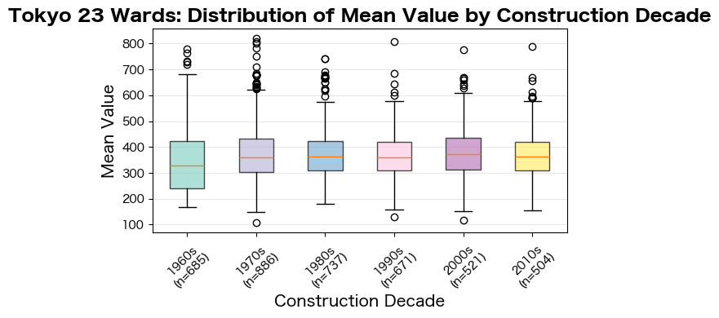
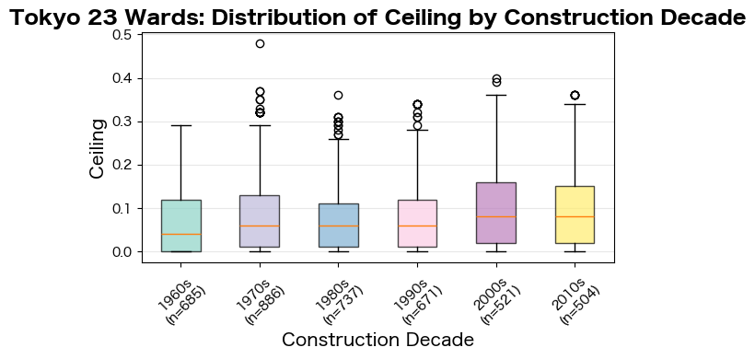
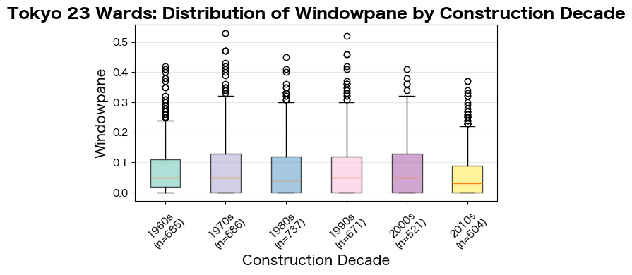
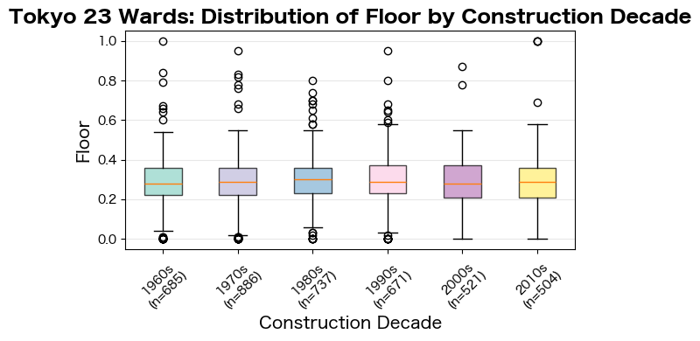
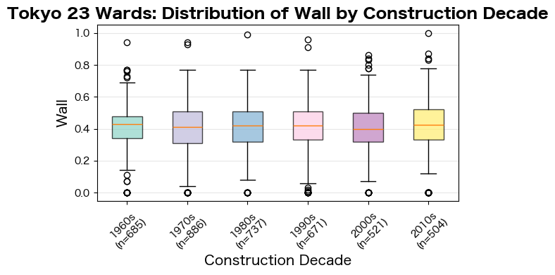
Figrue -: Distribution of five openness metric value by housing construction decade
We conducted a multiple linear regression analysis examining the relationships between VGA statistics, rent cost, and interior elements fractions to understand how different measures of spatial openness relate to each other. Figure …findings
4 Comprehensive Openness Analysis
4.1 Analysis of Impression Scores and Interior Elements
We performed core-component dependency analysis combining impression scores with interior element ratios after applying rigorous outlier filtering using a 75th percentile cutoff to ensure data quality. The cluster analysis reveals distinct groupings based on floor and ceiling visibility characteristics, with moderate negative correlations observed with impression scores, indicating that higher visibility of structural elements tends to correspond with lower perceived spatial openness, as demonstrated in Figure 8 and quantified in Table 1.

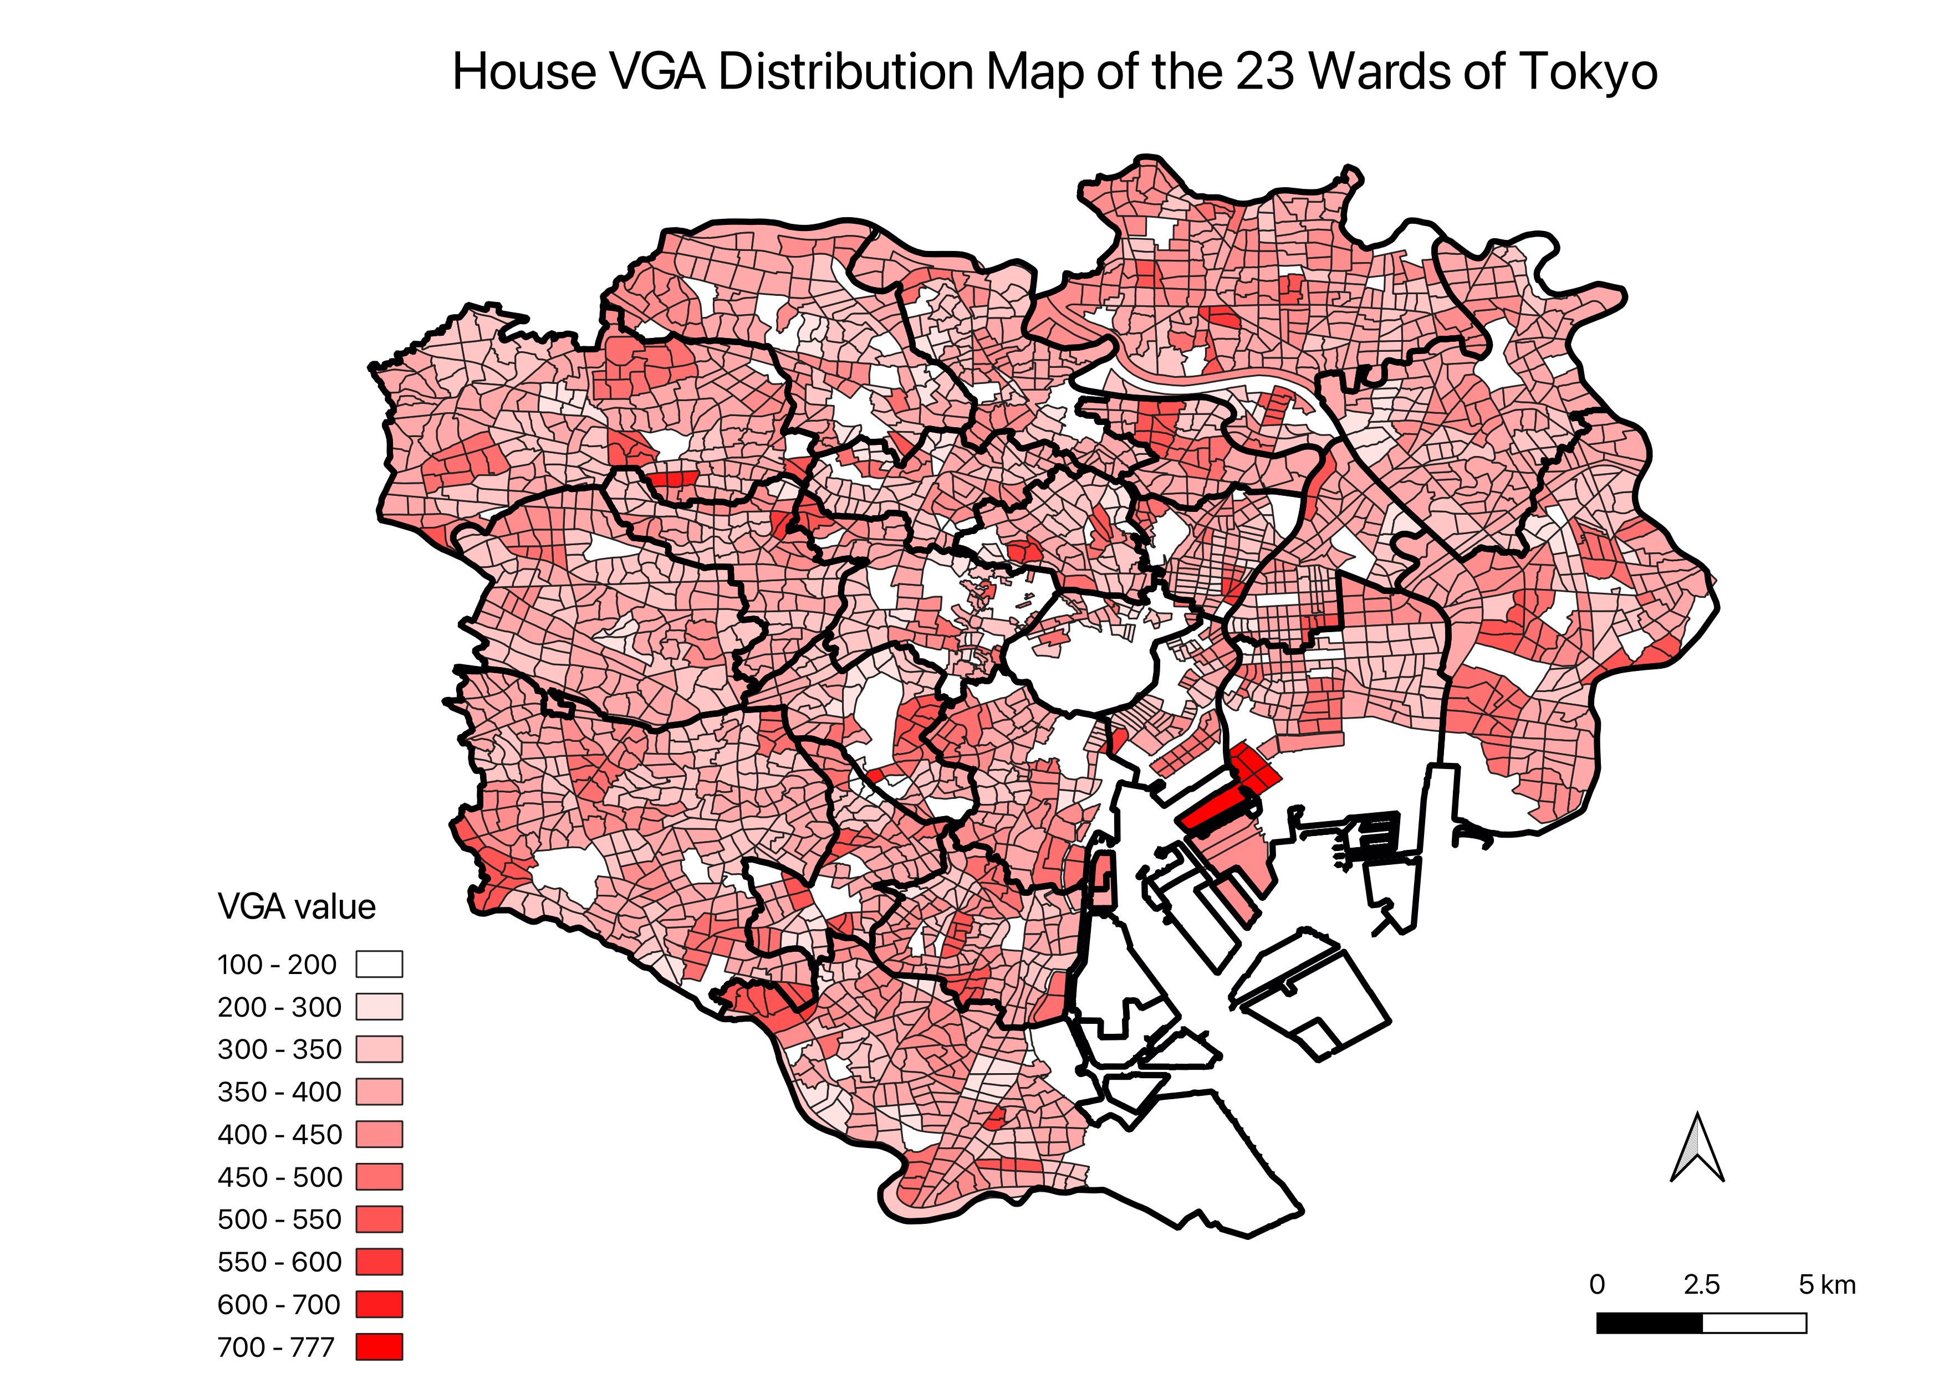
Figure 6: Geographic distribution analysis across Tokyo’s 23 special wards: VGA mean values and Window ratio, wall ratio, Ceiling ratio, Floor ratio, Floor ratio.

4.2 Regression Analysis Against Rent Cost
We performed regression analysis to predict rent cost using openness attributes. XGBoost achieved the best fit with acceptable R2 scores. Analysis reveals that standard deviation and total sum of VGA values are the most important factors for rent prediction, thus there is a possibility that larger rooms with more spatial subdivisions tend to increase rental prices in a human understandable way. The distance towards the top 2 stations falls behind the above factors slightly. Additionally, our analysis reveals that user impression scores contribute to rent price trends moderately, suggesting a meaningful relationship between subjective spatial perception and market valuation. This indicates that user-perceived spatial quality aligns with economic value assessment in the rental market. As shown in Figure 9, training and testing results demonstrate reasonable performance. Residual analysis reveals weak bias in the fit showing that the model is not overfitting.

4.3 Principal Component Analysis
To better understand the relationships between spatial features, we performed Principal Component Analysis (PCA) using VGA mean values, ceiling, wall, floor, and window visual fractions as input features. The analysis reveals the underlying structure of spatial characteristics in our dataset. The PCA plots are shown as Figure 10.
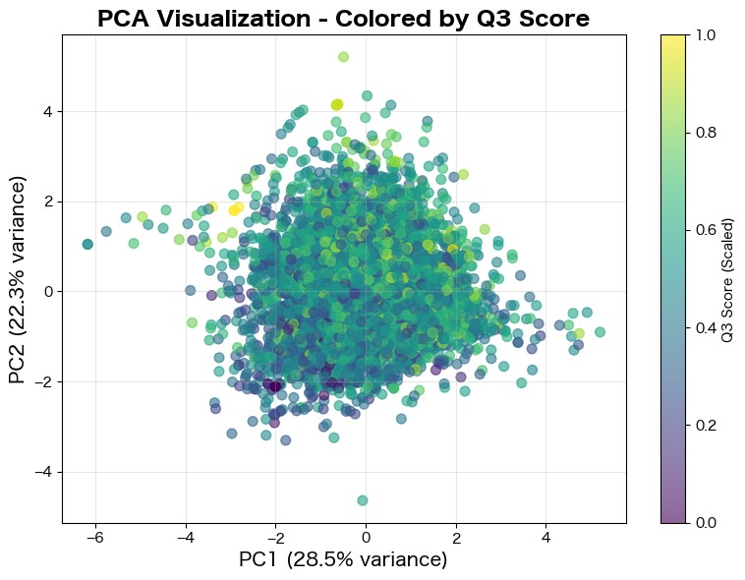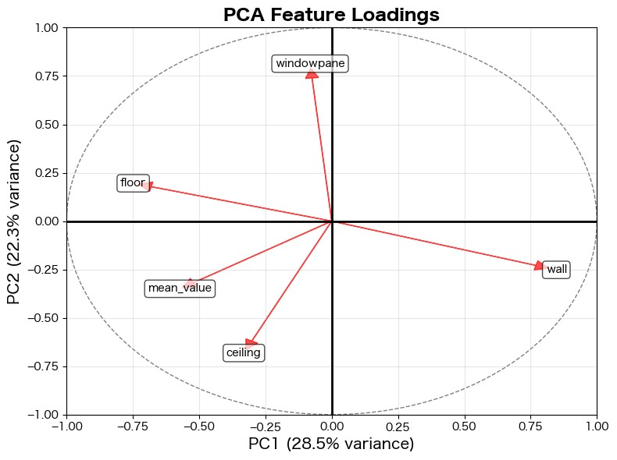
Figure 10: PCA distribution and top 2 components with raw feature axis
Table 2 presents the explained variance for each principal component. The first two components capture approximately 51% of the total variance.

Comp. | Eigenvalue | Var. % | Cum. %
PC1 | 1.42 | 28.46 | 28.46
PC2 | 1.12 | 22.33 | 50.80
PC3 | 1.07 | 21.36 | 72.16
PC4 | 0.88 | 17.57 | 89.73
PC5 | 0.51 | 10.27 | 100.00
Table 2: Principal component variance explanation
Table 3 shows the feature loadings for all principal components. PC1 is primarily dominated by wall fractions (0.65) opposing floor visibility (-0.57). PC2 captures the balance between natural lighting (window:
0.70) and ceiling prominence (-0.59).
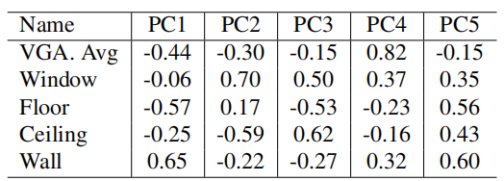
Table 3: Principal component feature loadings

5. Conclusions
This research presents a framework for analyzing spatial openness in rental housing through automated madori interpretation, visibility graph analysis, and interior semantic segmentation. Our methodology quantifies subjective spatial qualities using visual data from rental platforms. Key findings reveal weak correlations between VGA metrics and user impression scores, with excessive floor/ceiling visibility negatively impacting quality perceptions. PCA analysis reveals that the first two components capture 51% of variance, with PC1 dominated by wall-floor opposition and PC2 capturing natural lighting versus ceiling prominence. Regression analysis demonstrates that VGA standard deviation and room size are the most important factors for rent prediction. Spatial openness perception is impacted by the complex interactions between these factors. Our results identify their distinct contributions, revealing how visual effects and VGA metrics shape openness evaluation. This research provides practical tools for data-driven spatial openness analysis, which is a step towards openness-oriented housing design.
Reference:

