Multifaceted Exploration of Spatial Openness in Rental Housing: A Big Data Analysis in Tokyo's 23 Wards

賃貸住宅における空間開放性の多面的探究：東京23区のビッグデータ分析

沖研究室 23M23456 リュ ゲン (LIU Yuan)

1. Introduction
Understanding spatial openness in residential housing is important for enhancing living quality and guiding architectural design. Traditional indicators such as floor area and room count fail to capture the nuanced spatial qualities present in interior imagery and floor plans. existing paper . This study proposes a multifaceted method to evaluate spatial openness in rental housing by analyzing large-scale data from Tokyo’s 23 wards. It extracts openness features from both 2D and 3D information, explores their variation across regions and decades, and examines correlations with rent and impression scores. The framework offers a comprehensive approach to understanding openness in residential design.
2. Methodology
Spatial openness is typically expressed through the sense of spaciousness, visual connectivity, and spatial flow within a living environment. In residential spaces, physical structural features play a crucial role in shaping people's subjective perception of openness. This chapter presents the data filtering process Figure2 dataset and a concise framework for evaluating spatial openness based on five indicators extracted from multiple dimensions.
2D openness metric is the VGA (Visibility Graph Analysis) value from floor plans, which reflects spatial connectivity.
3D openness metric is including windows ratio, ceilings ratio, floors ratio, and walls ratio. They are visual element ratios extracted from interior images,
These features are used in subsequent temporal, spatial, and correlation analyses.
2.1 Dataset
Our dataset comprises 4004 rental properties from Tokyo’s 23 wards (1960-present), filtered for image quality and data completeness. As illustrated in Figure 2, this overview shows our methodology extracts multiple categories of spatial openness attributes through interior images, floor plan data, and property. The following
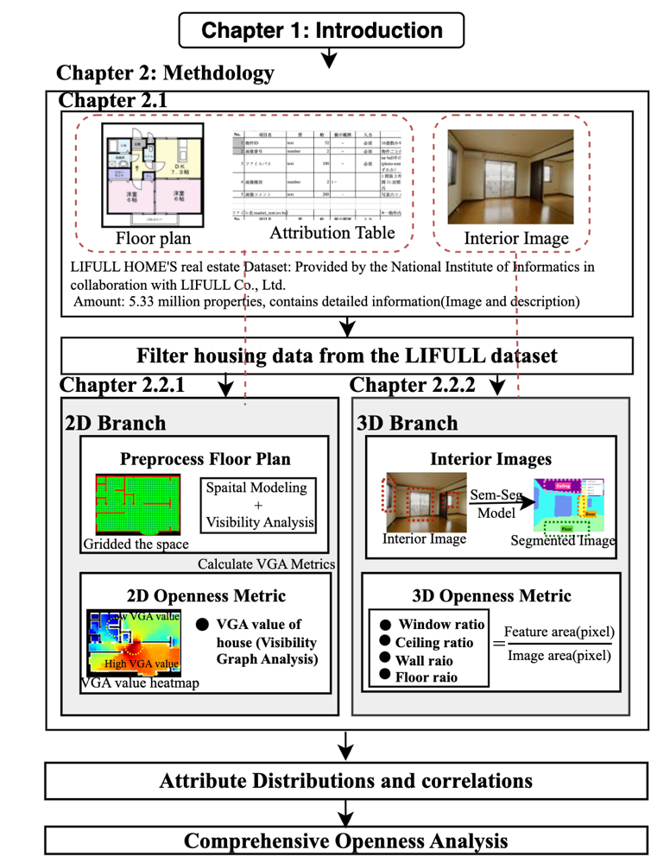
Figure1:
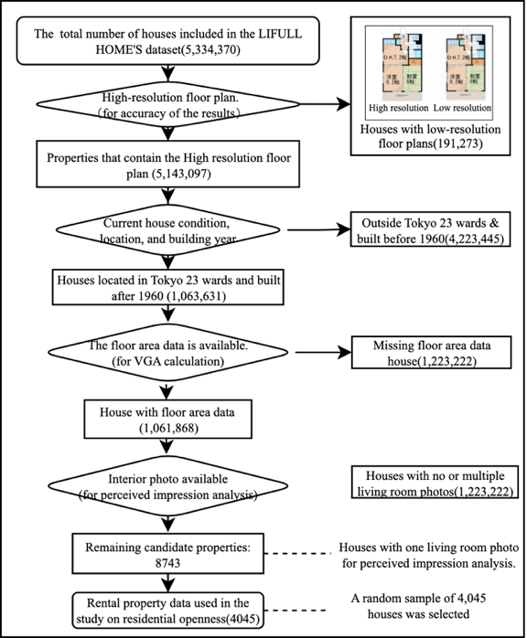

sections detail the extraction workflows for interior elements and VGA- based statistics.
room size attributes, property specifications, interior elements, and VGA-based statistics. Room size attributes and property specifications are obtained directly from the database. Interior elements are extracted through semantic segmentation of interior im- ages, while VGA-based statistics are computed from floorplan analysis to quantify spatial connectivity.
2.2 Openness Features
2.2.1 Interior-Image Based Elements(2D)
We apply Mask2Former semantic segmentation, pre-trained on the ADE20K dataset, to extract wall, ceiling, floor, and window area ratios from interior image, as shown in Figure 3. Each image is processed through a pre-trained segmentation model, which outputs pixel-wise masks for each architectural element. The fractions of these visual elements are then computed by dividing the number of pixels corresponding to each element by the total number of visible pixels in the image. This provides a normalized ratio (e.g., window area ratio) that reflects the visual presence of each component, as shown in Figure 3. These extracted ratios serve as quantitative indicators of perceived openness.
2.2.2 Floor Plan-Based VGA(3D)
To quantitatively assess spatial openness from floor plans, we construct a custom pipeline based on Visibility Graph Analysis (VGA). This method simulates inter-visibility among points within a space, enabling automated computation of spatial connectivity across large-scale housing data.
Semantic Segmentation of Floor Plans: Raw 2D floor plan images are fed into Mask2former model(reference and explanation) to classify pixels into categories such as walls, rooms, and windows.
Binarization and Contour Extraction: Based on the segmentation result, we binarize the image: pixels belonging to outer boundaries and internal walls are set to 1 (obstacle), and navigable regions are set to 0. This creates a binary analysis mask.
Standardized Scaling of Floor Plans: To ensure consistency in measurement, all floor plans are rescaled using a factor derived from each property's real floor area and its pixel area in the image. This normalization allows for comparable spatial metrics across properties.
Grid Generation and Obstacle Filtering: A uniform grid is overlaid on each plan. Grid points falling within obstacles (e.g., walls) are removed to reduce computational load and improve accuracy in the visibility calculations.
Ray Casting for Visibility Simulation: From each valid grid point, rays are emitted in multiple directions (e.g., every 1°). If a ray does not intersect with an obstacle, the target grid point is marked as visible.
VGA Score Computation: For each grid point, the number of other visible points is counted to construct a visibility matrix. The resulting VGA score reflects the degree of openness or enclosure of that point.
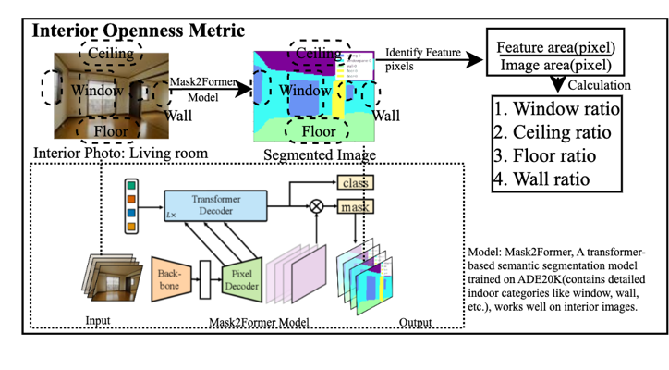

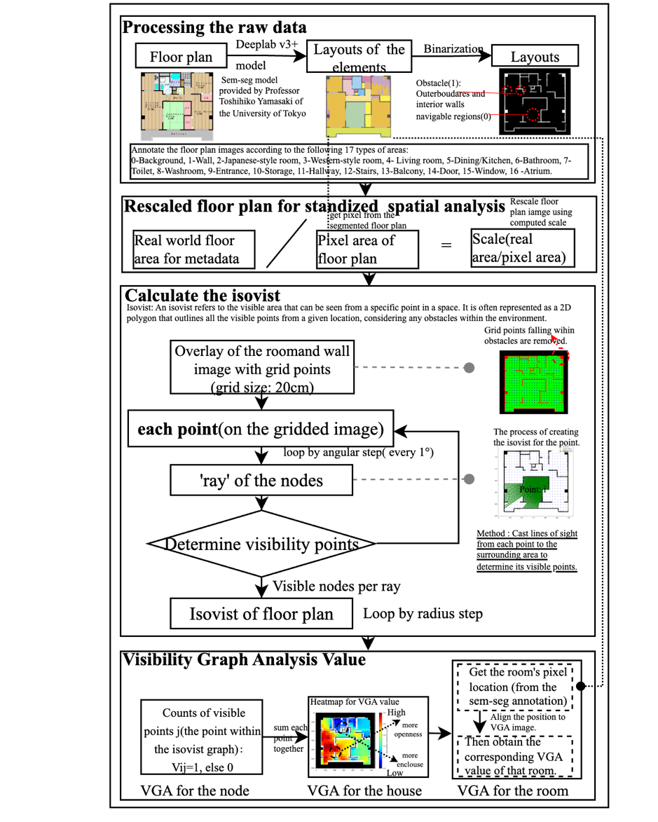

where S(i) is the visibility score at node i, and Vij = 1 if node j is visible from node i, otherwise Vij = 0. This generates a VGA heatmap that visualizes the spatial connectivity of the floor plan.
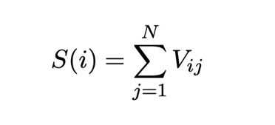

Finally We extract summary statistics (mean, standard deviation, percentiles) from the heatmap as spatial openness features, which are then used in further analysis to examine distribution patterns and correlations with other housing attributes.
VGA score for the room of the house.
To obtain the VGA value of a specific room, we first use the semantic segmentation result to identify the pixel region corresponding to that room. By applying this mask to the VGA heatmap, we extract the visibility values within the room area. The room-level VGA value is then computed by aggregating these pixel-level values using statistical measures such as the mean or standard deviation.

3 Results
From the tabular features of the properties, we have various information, with the most interesting being construction year and geographic factors.
3.1 Temporal Analysis of Spatial Openness
This chapter analyzes the impact of construction decade on the spatial openness features of residential housing, as shown in Figure 5.
Eight indicator were selected, including four 3D openness metrics based on Visibility Graph Analysis (VGA)—the mean and total values for both the living room and the entire space—and four 2D openness indicators representing the visible proportions of ceiling, walls, floor, and windows. To examine temporal trends, one-way ANOVA was conducted for each indicator, and Tukey’s HSD test was applied for post-hoc comparisons where significant differences (p < 0.05) were found.
The results indicate notable changes in spatial openness features across different decades. The VGA values of living rooms increased steadily from the 1960s to the 2000s, suggesting a gradual improvement in visual connectivity and a shift toward more open layouts. The total VGA value of the entire house peaked in the 1990s and slightly declined afterward, indicating that the openness of overall floorplans has remained relatively stable in recent decades.
Meanwhile, the ceiling proportion continued to increase over time, indicating an enhanced sense of vertical space and reflecting growing attention to vertical openness. In contrast, the window proportion declined significantly in the 2010s, possibly due to a photographic tendency to capture overall space, which reduced the visual prominence of windows in interior images.
STD Explanation

3.2 Geographic Distribution Analysis
…

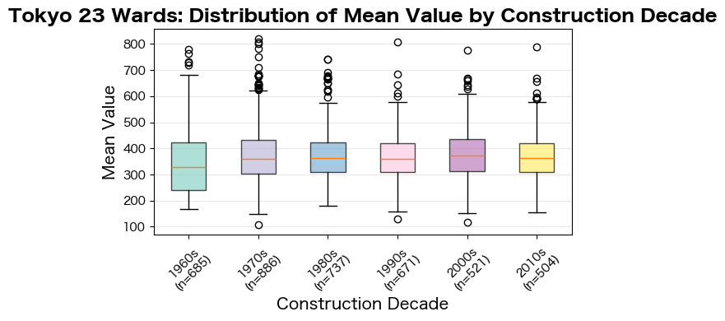
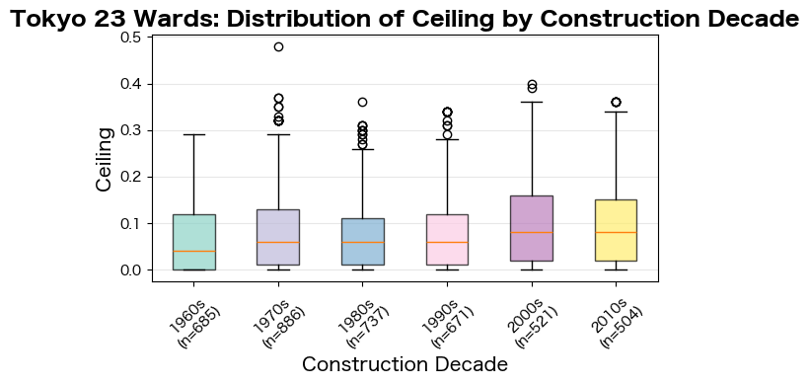
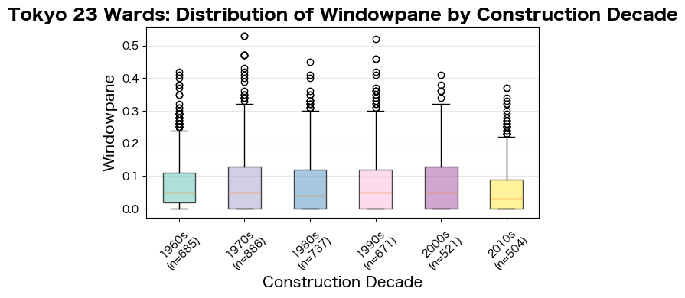
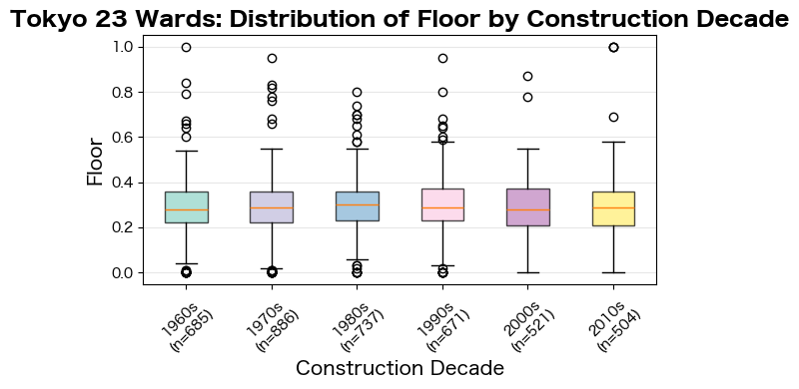
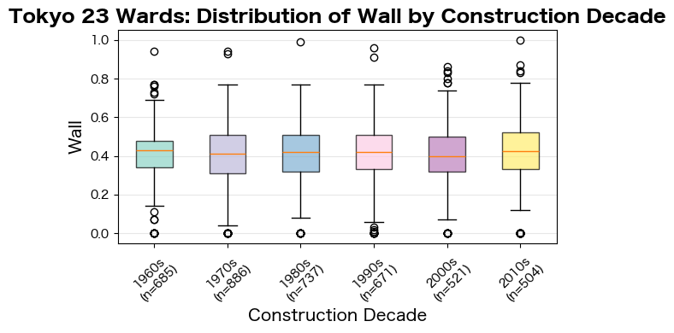
Figrue -: Distribution of five openness metric value by housing construction decade
We conducted a multiple linear regression analysis examining the relationships between VGA statistics, rent cost, and interior elements fractions to understand how different measures of spatial openness relate to each other. Figure …findings

4 Comprehensive Openness Analysis
4.1 Openness Features and Their Relationship with Rent Cost / Regression Analysis Against Rent Cost
Need to modify
This chapter explores the relationship between openness metric and cost rent. The regression model includes several quantitative openness indicators, as well as housing structure variables (such as house area) to assess the extent to which these variables explain rental levels. The results show that the R² of the model is about ***, indicating that nearly half of the variation in cost rent (including property fees) can be explained by openness features and control variables. The coefficient of house area is the largest, which is consistent with the expected fundamental effect of area on rent. In addition, 2D openness characteristics (such as VGA-based statistic metric) also show statistically significant positive coefficients, indicating that room connectivity has independent economic value. In addition, 3D spatial structural indicators (such as ceiling, floor, wall) show strong explanatory power, indicating that vertical spatial configuration and enclosure structure also affect rent. Result shows that openness features can significantly explain the difference in rental prices and openness elements have significant economic value.
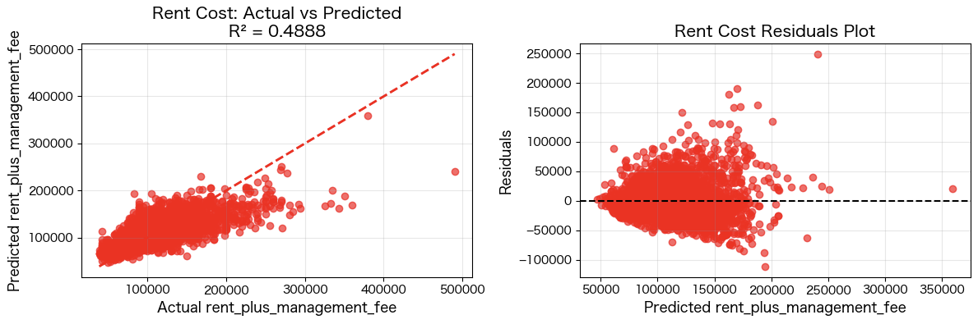
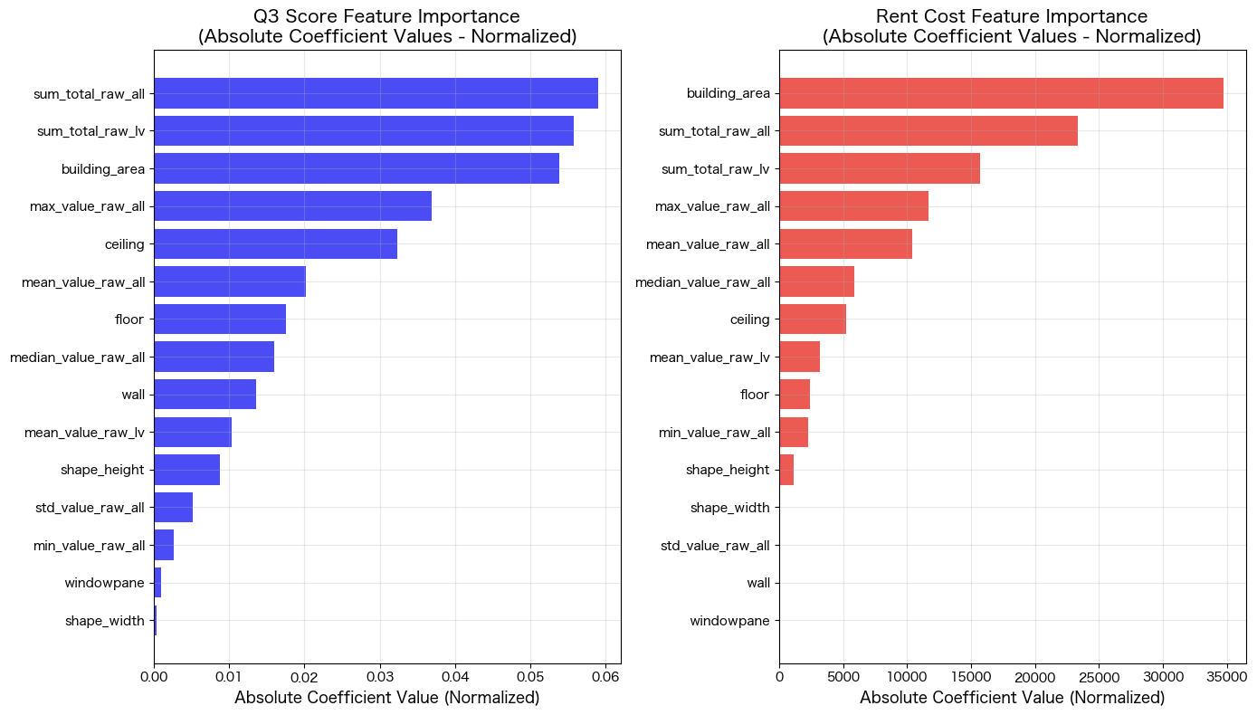
Figure :

4.2 Analysis of Openness Features
4.2.1 Image Examples by Openness feature score
4.2.2 Comparison Between 2D openness and 3D openness
…
5. Conclusions
Need to modify
This research presents a framework for analyzing spatial openness in rental housing through automated madori interpretation, visibility graph analysis, and interior semantic segmentation. Our methodology quantifies subjective spatial qualities using visual data from rental platforms. Key findings reveal weak correlations between VGA metrics and rent cost, with excessive floor/ceiling
Figure -: Distribution of five openness metric value by geographical location

visibility negatively impacting quality perceptions.
Reference:

Existing paper
Towards quantifying human experience in the built environment: A T crowdsourcing based experiment to identify influential architectural design features

Model for interior image extraction.
The model is based on Mask2Former [1], and the pretrained weights were obtained from Hugging Face (facebook/mask2former-swin-base-IN21k-ade-semantic).
[1] Cheng, B., Schwing, A., & Kirillov, A. (2022). Masked-attention Mask Transformer for Universal Image Segmentation. In CVPR.

Acknowledgements
This study utilized the "LIFULL HOME'S Dataset" provided by LIFULL Co., Ltd. through the IDR dataset provision service of the National Institute of Informatics (NII), Japan.

I would like to express my sincere gratitude to Professor Toshihiko Yamasaki and Mr. Ryodai Kitabayashi from the University of Tokyo for kindly sharing the program for performing semantic segmentation on floor plan images.

Note:
1. This dataset is provided by the National Institute of Informatics (NII) based on data received from LIFULL Co., Ltd.
It includes data on approximately 5.33 million properties across Japan, such as rent, floor area, location (municipality, postal code, nearest station, walking time), building age, layout, structure, and facilities.
It also contains image data such as floor plans and interior photographs for each property.

reference paper
下村隼生, 沖拓弥, 山崎俊彦. 賃貸物件ビッグデータとアンケートに基づく子育て世帯の住宅選好分析 その2：住宅選好予測モデルに基づく選好要因の分析, 日本建築学会大会学術講演会, 日本建築学会大会学術講演梗概集, 情報システム技術, pp. 31-32, Sept. 2023.

T. Narahara and T. Yamasaki, "Subjective Functionality and Comfort Prediction for Apartment Floor Plans and Its Application to Intuitive Online Property Search," in IEEE Transactions on Multimedia, vol. 25, pp. 6729-6742, 2023, doi: 10.1109/TMM.2022.3214072.
keywords: {Floors;Task analysis;Crowdsourcing;Feature extraction;Predictive models;Metadata;User experience;Attractiveness prediction;crowdsourcing;graph analysis;real estate floor plans},

