SC2107 Lab1 Assignment Sheet (to be submitted to NTULearn before next lab)
Note that answers that suggest data dump from GenAI agent response will have partial marks deducted. Summarize your understanding when providing answers.

Name: Lin Ziqi Lab Group: SCE3 Date: 02/09/2026

- Section 7.4. Write one C statement to set bit 7 and 5 of P1SEL0 register, keeping the rest of the bits in the register unchanged.

P1->SEL0 |= 0xA0;

- Section 7.4. Write C statement(s) to extract bit 4 and 3 of variable ‘x’ and right align these two bits. Masked off all other bits in variable ‘x’. e.g. if ‘x’ has a value 1101 0111b initially, it should have a value of 0000 0010b after executing the C statement.

x = (x >> 3) & 0x03;

- Section 7.4. Why do we need to declare the P1IN register, the register that contains the status of the processor Port1 GPIO input pin logic with a ‘volatile’ keyword qualifier?

We use the volatile keyword to prevent the C compiler from over-optimizing the variable access. Because P1IN holds the real-time status of external GPIO pins (e.g., hardware switches), its value can change independently and at any time due to external physical events. Without the volatile keyword, the compiler's optimizer may mistakenly assume the value never changes within a loop, choosing to cache it in a register or completely delete the memory read instructions. This would cause the program to freeze or ignore any new hardware inputs.

- Section 7.5. Explain which division instruction (SDIV or UDIV) should we use when calculating the Distance D? Or it doesn’t matter?
We should use SDIV (Signed Division); it definitely matters. The formula is D = 1198372 / (n - 1085). If the input ADC value n is less than 1085, the denominator (n - 1085) evaluates to a negative number. UDIV (Unsigned Division) treats negative two's-complement numbers as very large positive integers, which would produce completely invalid results. Therefore, SDIV is strictly required to ensure correct calculation across all input ranges.

- Section 7.5. What is saved into the LR register when the calling routine calls “BL Convert”? What command is used to return from the sub-routine to the calling routine?

The return address (the memory address of the next instruction immediately following BL Convert, specifically LDR R1, [R11], #4 in the calling routine) is saved into the LR (Link Register). The command used to return from the sub-routine is BX LR;

- Section 7.5. Describes the exploration and analytical steps taken by the Antigravity IDE agent to derive the code for convert function.

First, the agent analyzes the context and recognizes that the Convert routine is used for the IR sensor distance calculation.
Second, it extracts the conversion formula D = 1198372 / (n - 1085) and identifies boundary/saturation conditions (e.g., clamping the distance output when ADC values are below the valid threshold).
Third, it examines the main routine's test vectors to verify input/output register conventions under AAPCS (passing ADC value n in R0, and returning distance D in R0).

- Section 7.6. If a function has 4 input parameters, which registers does the calling routine used to pass these parameters to the function according to AAPCS?

According to the ARM Architecture Procedure Call Standard (AAPCS), the 4 input parameters are passed sequentially using the low General Purpose registers: R0, R1, R2, and R3. (Any additional parameters beyond the first four would be pushed onto the stack).
- Section 7.7. The Memory Section “MAIN” correspond to the On-Chip Flash Memory in MSP432. How much on-chip flash memory is available for future code development? Cut and paste the screen shot of the relevant content in the map file and highlight where you extract your answer from. Hint: Check the map file.

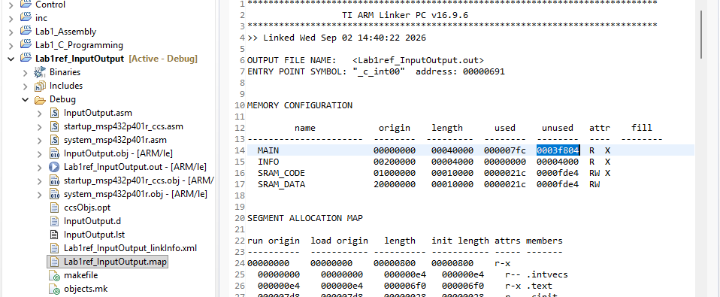

According to the MEMORY CONFIGURATION table in the map file, there are 0x0003f804 bytes (260,096 bytes, or approximately 254 KB) of unused on-chip flash memory available in the MAIN memory section for future code development. This value is extracted directly from the unused column corresponding to the MAIN memory row.

- Section 7.7. Which software section is program code allocated to by default? Which file consumes the largest code size in this project? Hint: check the map file.

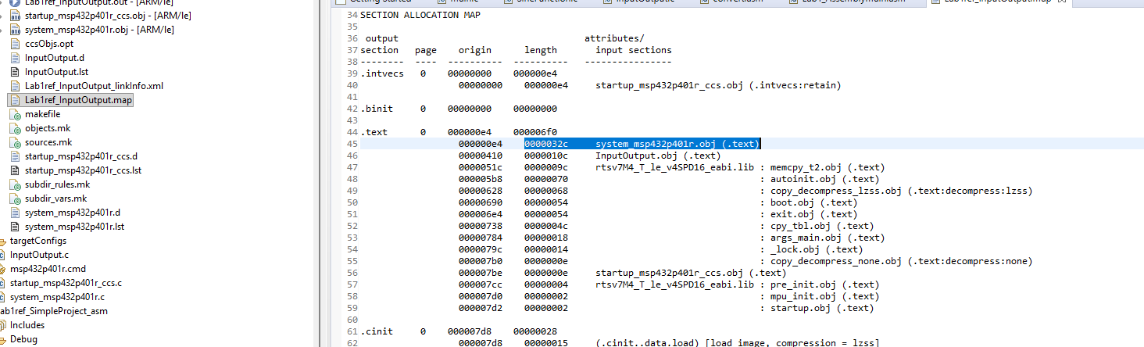

By default, program code is allocated to the .text section.
Looking at the SECTION ALLOCATION MAP in the map file, the file that consumes the largest code size in this project is system_msp432p401r.obj, which occupies 0x0000032c bytes (812 bytes) in length within the .text section.

- Section 7.7. From the map file, what is the starting address of Port2_Init()? Compare with the address you see in the Disassembly Window, are they the same? If not, why?

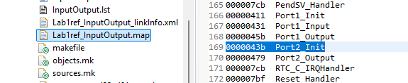

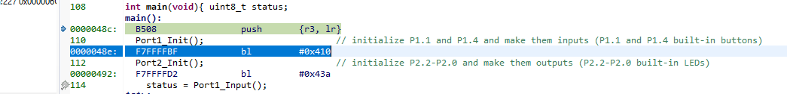

- Address in map file: 0x0000043b
- Address in Disassembly Window: 0x0000043a (as indicated by the branch instruction bl #0x43a)
- Comparison and Reason: They are not the same; the address in the map file is greater by 1.
This difference occurs because the ARM Cortex-M processor executes the Thumb instruction set. In ARM architecture, the Least Significant Bit (LSB / bit 0) of a branch target address is used to indicate the processor state. An LSB of 1 specifies that the target routine executes in Thumb mode. Therefore, the linker map file reflects this Thumb-state indicator by adding 1 (0x0000043b), whereas the Disassembly window displays the actual even, halfword-aligned physical memory location (0x0000043a).

