Trajectory Rewards Are Not Token Credit
Advantage estimator fidelity for long-horizon post-training
Limes Labs Research Workstream | Public draft | 2026-06-18

Abstract
We compare PPO-style critic/value-model advantage estimation with GRPO-style group-relative advantages for long-horizon post-training, while situating OPD/OPSD as complementary distillation tools rather than policy-gradient replacements. In a multi-seed toy matrix with known oracle advantages, critic-style TD has the higher mean correlation in 17/18 fixed regimes; a confidence-interval reading gives 16 clear critic-favorable cases, 1 near tie, and 1 clear group-favorable counterexample. Additional audits test anchor-action contrast, coverage-gated credit, and tabular closed-loop training. The conclusion is conditional: PPO-style critics look better when temporal state information is observable and learnable; GRPO remains attractive when reward contrast is reliable and critic coverage/cost is poor.

Key Results
Seeds | Cases | Clear critic | Near tie | Clear group | Mean delta r
20 | 18 | 16 | 1 | 1 | 0.420

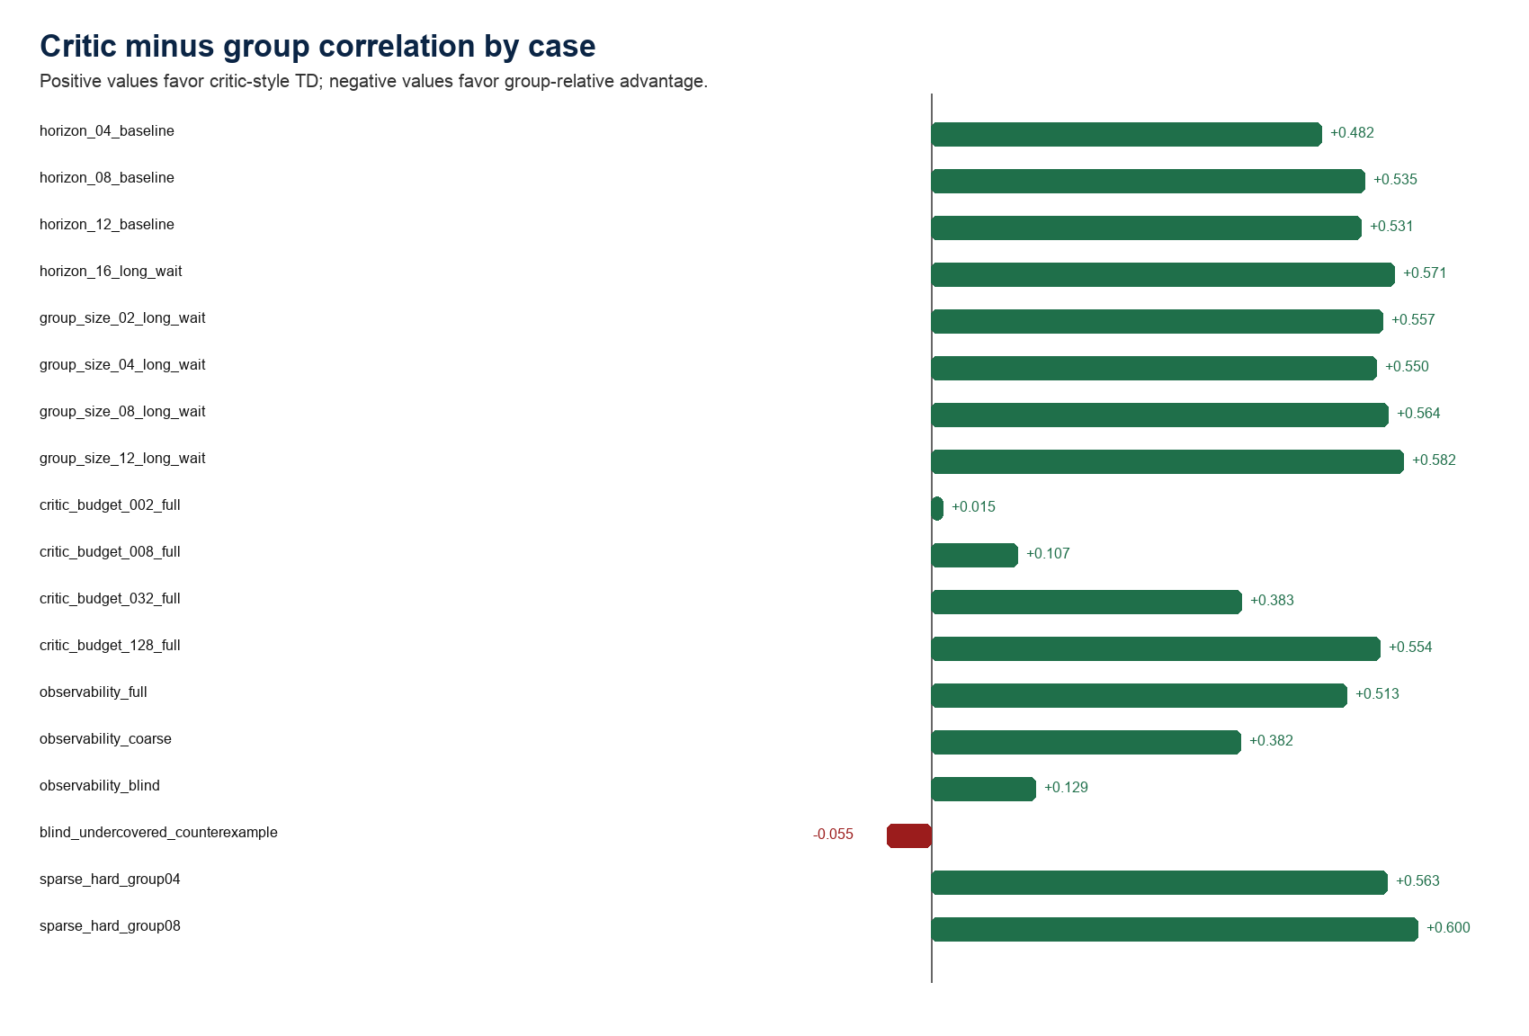
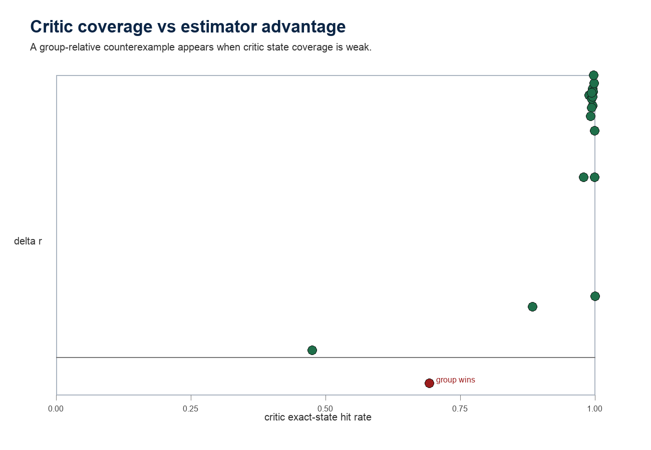

Methods
The toy environment has variable-length trajectories with help, harm, and wait actions. A terminal verifier supplies a sparse success reward; known finite-state dynamics provide an oracle state-action advantage. The group-relative estimator normalizes terminal returns within a prompt group and broadcasts the scalar to every token. The critic estimator fits a tabular value model from returns-to-go and computes one-step TD advantages.

Deep Matrix Results
Case | Axis | Mean | CI read | Group r | Critic r | Delta r | 95% CI
horizon_04_baseline | horizon | critic | critic_clear | 0.495 | 0.977 | 0.482 | +/- 0.011
horizon_08_baseline | horizon | critic | critic_clear | 0.390 | 0.925 | 0.535 | +/- 0.015
horizon_12_baseline | horizon | critic | critic_clear | 0.335 | 0.866 | 0.531 | +/- 0.012
horizon_16_long_wait | horizon | critic | critic_clear | 0.293 | 0.865 | 0.571 | +/- 0.013
group_size_02_long_wait | group | critic | critic_clear | 0.213 | 0.771 | 0.557 | +/- 0.022
group_size_04_long_wait | group | critic | critic_clear | 0.301 | 0.851 | 0.550 | +/- 0.014
group_size_08_long_wait | group | critic | critic_clear | 0.346 | 0.910 | 0.564 | +/- 0.011
group_size_12_long_wait | group | critic | critic_clear | 0.358 | 0.940 | 0.582 | +/- 0.007
critic_budget_002_full | budget | critic | near_tie | 0.352 | 0.367 | 0.015 | +/- 0.027
critic_budget_008_full | budget | critic | critic_clear | 0.352 | 0.459 | 0.107 | +/- 0.027
critic_budget_032_full | budget | critic | critic_clear | 0.352 | 0.735 | 0.383 | +/- 0.021
critic_budget_128_full | budget | critic | critic_clear | 0.352 | 0.906 | 0.554 | +/- 0.017
observability_full | observe | critic | critic_clear | 0.352 | 0.864 | 0.513 | +/- 0.020
observability_coarse | observe | critic | critic_clear | 0.356 | 0.738 | 0.382 | +/- 0.015
observability_blind | observe | critic | critic_clear | 0.353 | 0.482 | 0.129 | +/- 0.017
blind_undercovered_counterexample | counter | group | group_clear | 0.510 | 0.455 | -0.055 | +/- 0.015
sparse_hard_group04 | sparse | critic | critic_clear | 0.283 | 0.846 | 0.563 | +/- 0.014
sparse_hard_group08 | sparse | critic | critic_clear | 0.310 | 0.910 | 0.600 | +/- 0.008

Interpretation
The evidence supports the PPO-favorable hypothesis in this controlled toy: when progress state is observable and value coverage is adequate, critic-style TD advantages track oracle token credit far better than response-level group scalars.
The counterexample matters. When the critic is blind and undercovered, terminal group-relative outcome information can be more useful than a poor value table.
Z.ai's GLM-5.2 report is a useful industry case study because it describes compacted, variable-length long-horizon agent rollouts and reports moving from group-wise optimization to critic-based PPO with token-level advantages. It is not independent causal evidence for PPO over GRPO.

Cost, Safety, and Caveats
Fair comparisons must charge critic memory and training, reward/verifier calls, group sampling, teacher/self-teacher compute, anti-hacking filters, LLM judges, sandboxing, blocked-call handling, and trajectory storage.
Coding-agent RL with pass/fail rewards can incentivize shortcuts. Online tool-call monitoring and invalid-action handling should be treated as part of the training protocol, not merely post-hoc evaluation.
The toy has an oracle and tabular critic. Real systems add neural approximation, KL controllers, stale policies, reward-model error, tool failures, and distributed rollout infrastructure.

Selected References
[1] Schulman et al. Proximal Policy Optimization Algorithms. 2017.
[5] Shao et al. DeepSeekMath: Group Relative Policy Optimization. 2024.
[6] DeepSeek-AI. DeepSeek-R1. 2025.
[13] Zhao et al. Self-Distilled Reasoner: OPSD. 2026.
[19] Z.ai. GLM-5.2: Built for Long-Horizon Tasks. 2026. https://z.ai/blog/glm-5.2

