***Group No: ?***

***Introduction***

This program is designed to be helpful to the scientists who will be using it, asking them to input depths, checking whether the are valid field results, aka above 0; and then going throw a secondary verification process of confirming with them the value they input. the program will then inform the scientists the period the bullet spent in the medium, and then the average times over the 3 materials the bullet spent in the medium.

***Question 1***

*Introduction: functionality of the program*

1. *any special instructions or warnings to the user (or assessor!) such as in which case code does not work ,*

* Any value other than a numerical, point or comer and it will output an “Unhandled Exception:”, complaining about not being able to convert the inputted string to type double. This means the end user should not input any units after the numerical data; having converted to standard SI units (metres) beforehand. (evidence in bellow screenshot)

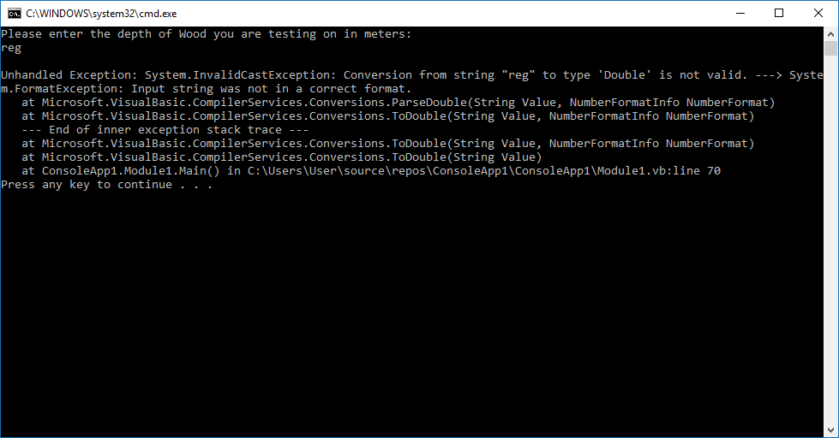

* One should also note that a comer may be excepted, but is removed during this string to double type conversion, thusly the calculated for time will take the depth as inputed without the commer (evidence in bellow screenshot)

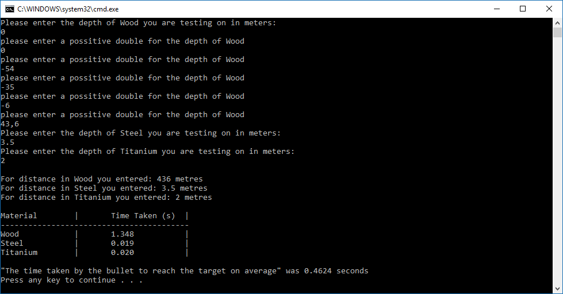

* The user must input a depth greater than 0, other wise they will be asked to input another value which is above 0/a positive double (evidence in above screen shot)

*e.g.* ***Any user input validation***

***e.g. Any limitation of the program***

*e.g.* ***Evidence: Tested by the user input …. and the result is ….***

1. *or to draw attention to any aspects of the program that you are particularly proud of (i.e. reusability, maintainability aspects of the code.)*

***e.g. use of variables and why , what functions are used and why..***

*Conclusion:*

*e.g. all/ essential/ core/ a few required functions of the question 1 are successfully implemented.*

*use of functions /are challenging /makes it easy /…..*

***Question 2:***

*---------------------*

***Question 3:***

*---------------------------*

***Question 4:***

*----------------------------*

***Overall Conclusion***

*e.g.*

*all/ essential/ core/ a few/ required functions of CW are successfully implemented. There is some initial problems with ….. However later it has been …….*

*use of functions /makes it easy to develop/ cause many problems*

***Word count***