

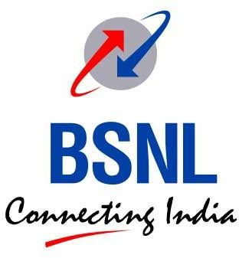
Bharat Sanchar Nigam Limited

Acceptance Testing Test Cases document for Block Router as per BSNL Bharatnet Tender No. MM/BNO&M/BN-III/T-791/2024 issued on 15.02.2024

Table of Contents

- Introduction
- Acceptance Testing Network Diagram
- Acceptance Memorandum
- Acceptance testing test cases
  - Verification of Router BOM as per RFP Requirements
  - Hot Swappable Power supply unit redundancy checking
  - A Hot Swappable fans for high availability
  - 1G/10G Ethernet link bring up (as applicable)
  - Loopback interface tests
  - iBGP/eBGP
  - BFD (Fast failure detection)
  - Jumbo Frames / MTU tests
  - SSH/Telnet, FTP/SCP support
  - TACAS testing
  - LLDP Neighbour Discovery
  - VLAN based sub-interfaces
  - ISIS/OSPF
  - ISIS/OSPF MD5 authentication
  - MPLS LDP ping and traceroute
  - LDP MD5 authentication
  - BGP MD5 authentication
  - VRF configuration & L3VPN
  - L2 VPN
  - Segment routing (SR-MPLS)

Introduction
This document outlines the Acceptance Testing (A/T) procedures for IP/MPLS Block Routers, Type-A and Type-B, in accordance with the requirements of BSNL BharatNet Tender No. MM/BNO&M/BN-III/T-791/2024 dated 15.02.2024.

It covers the applicable test cases in line with industry best practices, relevant specifications and standards, and includes the acceptance testing template for quality assurance in accordance with the requirements specified in the RFP.

Acceptance Testing Network Diagram
The following topology will be used for the AT test cases execution:
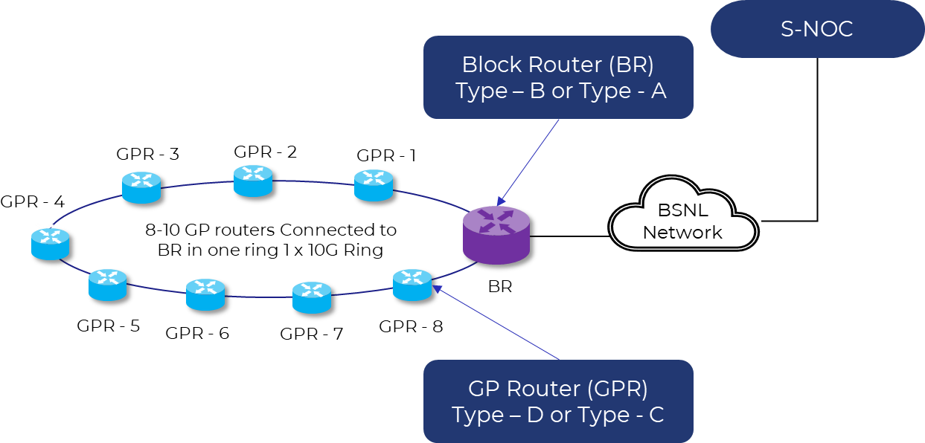

Note: The IP addresses and network diagram in Section 4 are for illustration only. All test scenarios will be executed using the actual network configuration.

Acceptance Memorandum
  - Equipment description :
  - Site Name with LGD code :
  - Site Address :
  - Router hostname :
  - Router WAN interface, loopback0, southbound interface, IPaddress:
  - Block network diagram along with rings and child-rings
  - QR code

Date & Time :

We hereby declare that all tests in this form were successfully completed. Note (if any):

PIA Representative’s Sign off  Representative Name: Designation:  Date:  Signature | IE Representative’s Sign off  Representative Name: Designation:  Date:  Signature | BSNL Representative’s Sign off*  Representative Name: Designation:  Date:  Signature

*Note:

- For first time AT of Block Router, GP Router, Block Rack, GP Rack, Route and Ring, one BSNL person may be kept mandatorily and his/her signatures are required on the AT document.
- For subsequent ATs, BSNL may assign person on need basis or as requested by any PIA. Decision regarding the same shall be taken by BharatNet State Head on case-to-case basis.

Certification verification

TEC/GR 48050:2022 with  latest amendments if any | Declaration
TSEC Certificate | Date of TSEC
QA Certificate | Date of QA
QR Code, logo | Photo evidence
OEM approval of BSNL
Documentation requirements | Test 1: The contractor shall provide following documents:  - System description documents  - Installation, Operation and Maintenance documents  - Training document  - Repair manual  Test 2: All technical documents shall be in English language both in CD- ROM and in hard copy.  All necessary interfaces, connectors, connecting cables and accessories required for satisfactory installation and convenient operations shall be supplied. Type of connectors, adapters to be used  shall be in conformity with the interfaces defined in this GR.  *All the above documents are to be handed over only once per model no.

Acceptance Testing Test Cases
Following basic checks are to be done before starting the Router AT:

4(a): Router serial number and it’s TSEC and QA certificate:
- Check whether TSEC is available for this model number of Router.
- Check whether QA certificate is available for the Router serial number.

Result

4(b): Check whether the following condition is qualified – “If the items mentioned herein are not dispatched within 15 days from the date of Dispatch Advice, they shall be re-offered for inspection to BSNL-QA.”

Result

4(c): Check whether the Router has the latest OS (TSEC Version or higher). If not, then first get the OS upgraded to the latest version (TSEC Version or higher). OEM Undertaking for higher version complying to all RFP requirements need to be submitted. The latest version would be displayed on SNOC.

Result

4(d): All installed and configured ports of the Router should be up and active. Check through Command Line Interface (CLI).
Result

4(e): Videos and photos of the Router installation as per RFP should be available. Check PIA PM tool.

Result

4(f): Whether the product qualifies the ‘Trusted products’ as mandated by DoT vide File no- 20-271/2010 AS-I (Vol-III) dated 10.3.2021, along with its amendments, issued from time to time. The certificate can be provided once for one model number.

Result

4(g): Whether OEM undertaking as per para 10.2 and 10.3 of Section-I of RFP regarding originality of hardware and software is submitted?

Result

4(h): Whether undertaking as per S.No. 18 of Table – “Technical Specifications for Routers” regarding software updates/bug is submitted?

Result

4 (i): Whether the PIA has done Pre-AT and the Block availability in last one week is more than 99.5%.?

- (j): Activation/Deactivation of Router through a CLI command from SNOC should be available.

*The above checks/tests are pre-requisite before proceeding to the actual AT tests. If any of the above is not qualified and/or not available, then AT cannot proceed.

  - Verification of Router BOM as per RFP Requirements

Test No | 1
Test Details | Verification the router BOM as specified in the RFP.
Test Instruments Required | Router, PC
Test Setup | 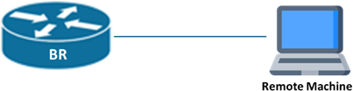
Test Procedure | - Verify the BOM, by physical inspection and through CLI
Test Configuration
Test Limits | NA
Expected Results | - Verified the Router BOM as per RFP
Test Results
Status | Pass / Fail

S/N | Requirement | Observation
i | The router can be Chassis based for Type A with Control plane & Data plane redundancy. Routers shall be as per requirement of chasis and non chasis router defined in GR 48050:2022. Router should support switching capacity of minimum 800 Gbps.  The router should be enabled with the following configuration: 4 ports of 100G (with 40km pluggable)  12 ports of 10 G (with 40km pluggable)  4 ports of 1G/10G (All ports should be usable for both 1G as well as 10G as per plugged SFP)  Clarification No. 450 of 08-May-2024 in RFP:  Query - As per Section IV-C, the router can be Chassis based for Type A with Control plane & Data plane redundancy but shall be of non-chassis based 1RU form-factor for Type B.  Clarification received: The redundancy shall have to be same as prescribed for non-chassis-based router type A, irrespective of

 | the router type A being chassis based or non-chassis based
ii | The router shall be of non-chassis based 1RU form-factor for Type B. Routers shall be as per requirement of chassis and non-chassis router defined in GR 48050:2022. Router should support switching capacity of minimum 300 Gbps.  The router should be enabled with the following configuration: 2 ports of 100G (with 40km pluggable)  8 ports of 10G (with 40km pluggable)  4 ports of 1G/10G (All ports should be usable for both 1G as well as 10G as per plugged SFP)

Hot Swappable Power Supply Unit Redundancy Checking

Test No | 2
Test Details | Redundancy – PSU
Test Instruments Required | Routers, SFPs, Fibre Cables, PCs
Test Setup | 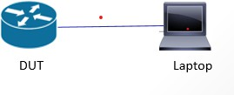
Test Procedure | - Run the extended ping command between Router and laptop (from site/SNOC workstation)  - Remove 1 PSU, Observe the ping  - Re-insert the PSU. Observe the ping  - Repeat by removing the other PSU  - Check if the alert is visible in EMS/NMS
Test Configuration
Test Limits | NA
Expected Results | - Ping should continue while removing and re-inserting the PSU.
Test Results
Status | Pass / Fail

A Hot Swappable fan redundancy – high availability

Test No | 2A
Test Details | Redundancy – Fan
Test Instruments Required | Routers, SFPs, Fibre Cables, PCs
Test Setup
Test Procedure | - Remove 1 fan module  - Check if routers reboot. (Router must not reboot)  - Insert the removed module  - Repeat for the other fans  - Check if the alert is visible in EMS/NMS at SNOC
Test Configuration
Test Limits | NA
Expected Results | - Check through CLI commands
Test Results
Status | Pass / Fail

1G/10G Ethernet Link Bring Up (As Applicable)

Test No | 3
Test Details | 1G/10G/100G Ethernet Link Bring-Up (As Applicable),
Test Instruments Required | Routers, SFPs, Fibre Cables, PCs
Test Setup

 | 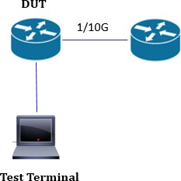
Test Procedure | - Connect the physical port of routers using fiber.
Test Configuration
Test Limits | NA
Expected Results | - Verify that link comes up on both routers. In case of Block router, the other router can be BSNL Router providing ILL/DCN  - Link status should show 'up' and speed as 1G /10G.  - Check if the link status up / down is visible in EMS/NMS
Test Results
Status | Pass / Fail

Loopback interface Tests

Test No | 4
Test Details | Loopback interface Tests
Test Instruments Required | Routers, SFPs, Fibre Cables, PCs
Test Setup
Test Procedure | - Configure loopback interfaces on routers.  - Configure the IP Address on physical interfaces.  - Add to IGP for loopback reachability

Test Configuration
Test Limits | NA
Expected Results | - Loopbacks are reachable from CLI command locally or SNOC.  - Ping is successful.
Test Results
Status | Pass / Fail

iBGP / eBGP

Test No | 5
Test Details | iBGP / eBGP
Test Instruments Required | Routers, SFPs, Fibre Cables, PCs
Test Setup | 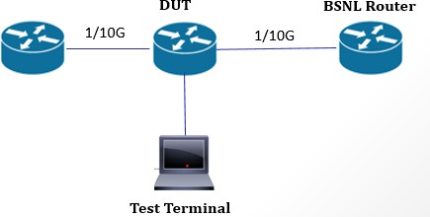
Test Procedure | - Configure IP addresses on physical interfaces.  - Configure the loopback and assign the IP address.  - Configure BGP neighbour-ship. BSNL ILL/DCN Router can be used for this purpose.  - Set local/remote AS numbers.
Test Configuration
Test Limits | NA
Expected Results | - iBGP/eBGP neighborship is established.  - Routes are exchanged successfully.
Test Results

Status | Pass / Fail

BFD (Fast Failure Detection)

Test No | 6
Test Details | BFD (Fast Failure Detection)
Test Instruments Required | Routers, SFPs, Fibre Cables, PCs
Test Setup
Test Procedure | - Configure IP addresses.  - Configure the loopback and assign the IP address.  - Configure the IGP protocol and advertise the interfaces.  - Enable BFD for all ISIS/OSPF interfaces.
Test Configuration
Test Limits | NA
Expected Results | - BFD session come up.
Test Results
Status | Pass / Fail

Jumbo Frames / MTU Tests

Test No | 7
Test Details | Jumbo Frames / MTU Tests

Test Instruments Required | Routers, SFPs, Fibre Cables, PCs.
Test Setup
Test Procedure | - Configure interfaces to support jumbo frames (9600 bytes).  - Send large ICMP packets (e.g., 9000 bytes).
Test Configuration
Test Limits | NA
Expected Results | - Ping with large size is successful.
Test Results
Status | Pass / Fail

SSH/Telnet, FTP/SCP support

Test No | 8
Test Details | The Router shall support SSH/Telnet access to the LAN and FTP/SCP  access to its configuration/ boot files.
Test Instruments  Required | Routers, PC and Ethernet cable.
Test Setup | 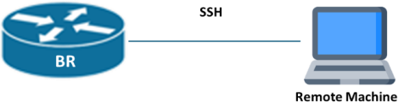
Test Procedure | - Enable SSH/telnet access to the router.  - Enable FTP/SCP access.

Test Configuration
Test Limits | NA
Expected Results | - Verify router supports SSH/Telnet access.  - Verify router supports FTP/SCP access.
Test Results
Status | Pass / Fail

  - TACACS Testing

Test No | 9
Test Details | Integration with TACACS server & Login using TACACS user and fall-back user
Test Instruments Required | Routers, PC and Ethernet cable.
Test Setup | 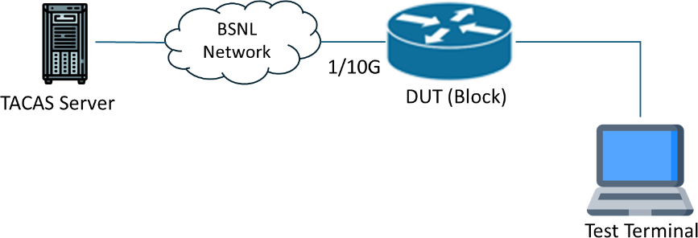
Test Procedure | Configure the IP address on the router  Configure the routing protocol make TACACS reachable from DUT Configure the TACACS
Test Configuration
Test Limits | NA
Expected Results | Verify Local admin user is Unable to login and same is recorded in AAA Server.  Verify TACACS user is able to login and same is recorded in AAA Server.
Test Results
Status | Pass / Fail

The following tests can be performed at the time of Ring AT

  - LLDP Neighbour Discovery

Test No | 10
Test Details | LLDP Neighbour Discovery
Test Instruments Required | Routers, SFPs, Fibre Cables, PCs
Test Setup
Test Procedure | - Connect the physical port of routers using fiber.  - Enable LLDP globally  - Enable LLDP on interfaces
Test Configuration
Test Limits | NA
Expected Results | - LLDP neighborship is established.  - Neighbor details are visible in LLDP table
Test Results
Status | Pass / Fail

VLAN-based Sub-interfaces

Test No | 11
Test Details | VLAN-based Sub-interfaces
Test Instruments Required | Routers, SFPs, Fibre Cables, PCs
Test Setup

Test Procedure | - Create VLAN sub-interfaces on both routers.  - Assign IP addresses to VLAN interfaces.
Test Configuration
Test Limits | NA
Expected Results | - VLAN interfaces are up.  - Ping between VLAN interfaces is successful.
Test Results
Status | Pass / Fail

ISIS/OSPF

Test No | 12
Test Details | ISIS/OSPF
Test Instruments Required | Routers, SFPs, Fibre Cables, PCs
Test Setup

Test Procedure | - Configure IP addresses on interfaces.  - Enable ISIS/OSPF and advertise interfaces.  - Configure the LDP/RSVP and bind the LDP/RSVP under interfaces.
Test Configuration
Test Limits | NA
Expected Results | - ISIS /CLNS (or) OSPF neighbour must be up.  - Routing table should reflect learned prefixes.  - Ping across ISIS /OSPF routers should be successful.
Test Results
Status | Pass / Fail

ISIS /OSPF MD5 Authentication

Test No | 13
Test Details | ISIS/OSPF MD5 Authentication
Test Instruments Required | Routers, SFPs, Fibre Cables, PCs
Test Setup
Test Procedure | - Configure the IP under the interfaces.  - Configure the ISIS / OSPF and advertise the interfaces.  - Enable MD5 on ISIS/ OSPF interfaces.  - Use matching keys on both sides.
Test Configuration
Test Limits | NA

Expected Results | - ISIS/ OSPF adjacency forms successfully with MD5 authentication
Test Results
Status | Pass / Fail

MPLS LDP/RSVP Ping & Traceroute

Test No | 14
Test Details | MPLS LDP/RSVP Ping & Traceroute
Test Instruments Required | Routers, SFPs, Fibre Cables, PCs
Test Setup | 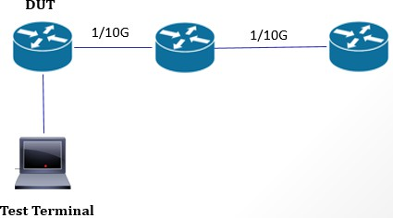
Test Procedure | - Configure the IP under the interfaces.  - Configure the Loopback and assign the interfaces.  - Configure the IGP protocol and make the Loopback reachable.  - Configure the LDP/RSVP  - Enable MPLS and LDP/RSVP under the interfaces.  - Check the MPLS LDP/RSVP ping & Traceroute the path.
Test Configuration
Test Limits | NA
Expected Results | - MPLS LDP/RSVP ping & traceroute should work.
Test Results

Status | Pass / Fail

LDP MD5/ Authentication

Test No | 15
Test Details | LDP MD5 / Authentication
Test Instruments Required | Routers, SFPs, Fibre Cables, PCs
Test Setup | 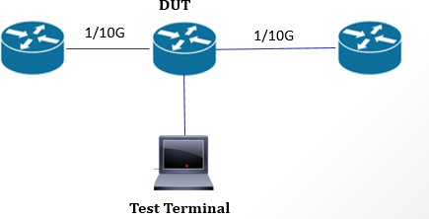
Test Procedure | - Configure the IP under the interfaces.  - Configure the Loopback and assign the interfaces.  - Configure the IGP protocol and make the Loopback reachable.  - Configure the LDP/RSVP  - Enable MPLS and LDP/RSVP on interfaces.  - Enable LDP/RSVP authentication with keys.  - Verify both routers use same credentials.
Test Configuration
Test Limits | NA
Expected Results | - LDP sessions form securely.
Test Results
Status | Pass / Fail

BGP MD5 Authentication

Test No | 16
Test Details | BGP MD5 Authentication
Test Instruments Required | Routers, SFPs, Fibre Cables, PCs
Test Setup
Test Procedure | - Configure IP addresses on physical interfaces.  - Configure the loopback and assign the IP address.  - Configure BGP neighbours.  - Set local/remote AS numbers.  - Configure MD5 keys on both BGP peers.
Test Configuration
Test Limits | NA
Expected Results | - Session only comes up with the correct keys.
Test Results
Status | Pass / Fail

VRF Configuration & L3VPN

Test No | 17
Test Details | VRF Configuration / L3VPN
Test Instruments Required | Routers, SFPs, Fibre Cables, PCs
Test Setup

 | 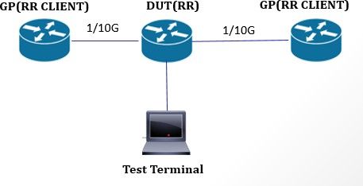
Test Procedure | - Configure the IP address and assign under interfaces.  - Configure the Loopback and assign the IP address.  - Configure the IGP protocol and advertise under interfaces.  - Configure the BGP and established the neighbour ship  - Create VRFs on both routers.  - Bind the VRF under the physical interfaces.  - Advertise the L3VPN and VRF’s under BGP.
Test Configuration
Test Limits | NA
Expected Results | - VPNv4 routes are exchanged.  - Ping the VRF IP address.
Test Results
Status | Pass / Fail

L2 VPN

Test No | 18
Test Details | L2 VPN
Test Instruments Required | Routers, SFPs, Fibre Cables, PCs.
Test Setup | 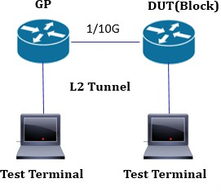

Test Procedure | - Configure the IP address and assign under interfaces.  - Configure the Loopback and assign the IP address.  - Configure the IGP protocol and advertise under interfaces.  - Configure the LDP globally  - Enable the LDP under the interfaces.  - Configure the L2VPN and bind under interfaces.
Test Configuration
Test Limits | NA
Expected Results | - L2VPN comes up is UP.  - END to END ping work fine btw test terminal.
Test Results
Status | Pass / Fail

Segment Routing (SR-MPLS)

Test No | 20
Test Details | Segment Routing (SR-MPLS)
Test Instruments Required | Routers, SFPs, Fibre Cables, PCs.
Test Setup | 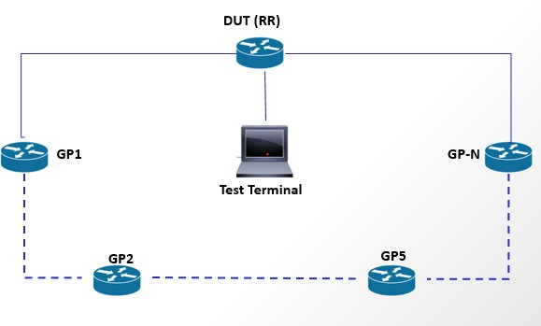
Test Procedure | - Configure the IP address and assign under interfaces.  - Configure the Loopback and assign the IP address.  - Configure the IGP protocol and advertise under interfaces.  - Configure SRGB and SIDs on routers.

 | - Enable IS-IS/OSPF with SR extensions.
Test Configuration
Test Limits | NA
Expected Results | - SR-Ping returns the expected SID path.  - SR-Traceroute shows correct segment hops.
Test Results
Status | Pass / Fail

Additional Tests
    - If any additional features/design parameters are being followed in any package and approved in LLD, the same may be included as additional test cases by the IEs.

EMS | Test 1: Single EMS of adequate capacity is to be supplied for all routers in the offered package. eMS will be as per Section 3.22 of TEC- GR 48050:2022 dated on March 2022 or its latest version.  Test 2: Requirement of EMS network redundancy and network elements as per RFP  Test 3: Category and Type of Server, Type of Storage, Requirement of Optional EMS features, Scalability requirements for the SLA Management system like no.of business customers, maximum leads per customer etc  may be provided, North Bound interface required towards NMS, Requirement of Optional Features  EMS tests to be taken care at the time of SNOC AT/validation

