http://www.cgsoso.com/forum-211-1.html

CG搜搜 Unity3d 每日Unity3d插件免费更新 更有VIP资源！

CGSOSO 主打游戏开发，影视设计等CG资源素材。

插件如若商用，请务必官网购买！

daily assets update for try.

U should buy the asset from home store if u use it in your project!

**MainMenu scenes**

Setup first in game.

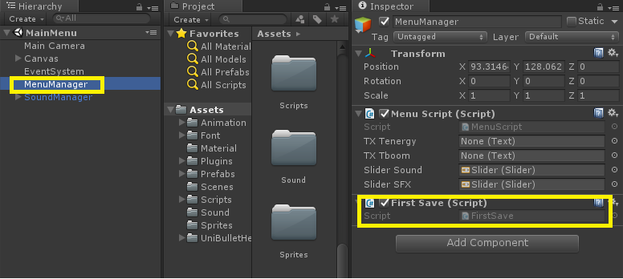

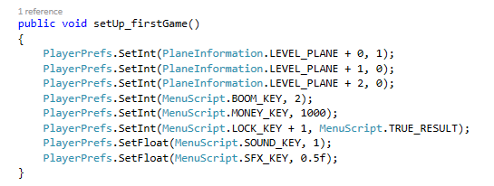

**Map scenes**

Add button play game.

* Duplicate level -> edit numberlevel

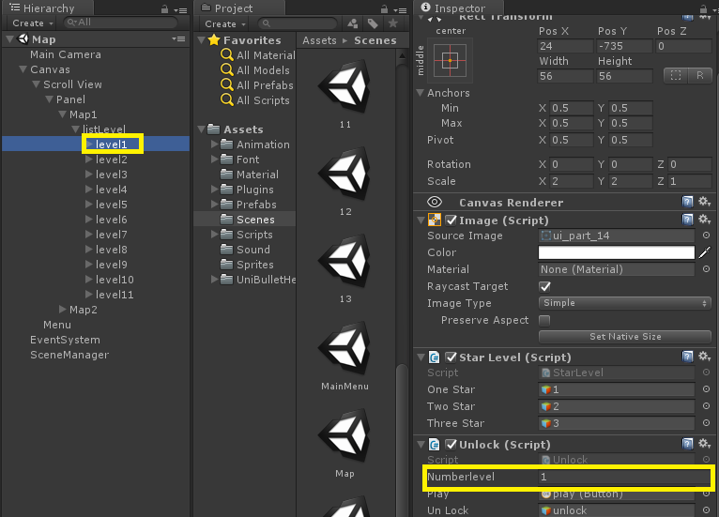

**Store scenes**

Add plane in store

* Duplicate plane -> edit level_plane (edit icon)
* Informtion plane -> speed_base, armor_bass, attack_base.

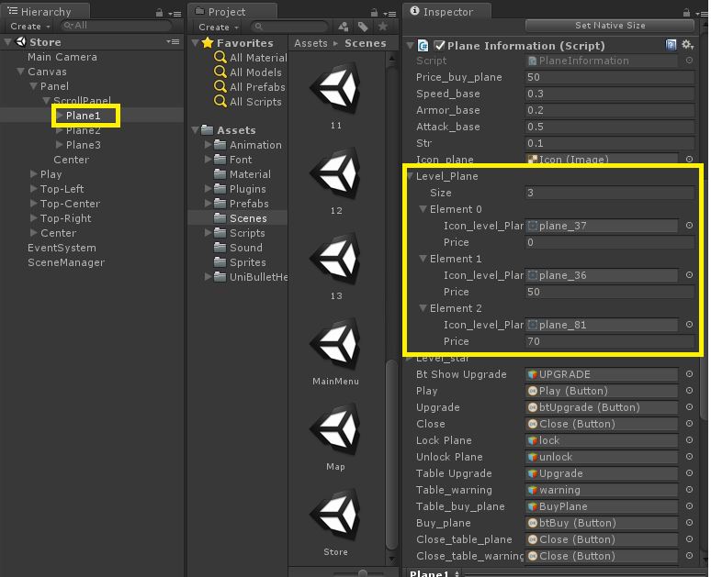

**GamePlay scenes**

*Name gameplay scene* = *numberleve*l in *“map scene”*

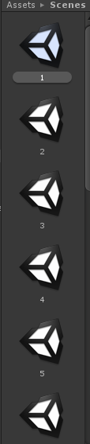

**How to gen Enemy?**

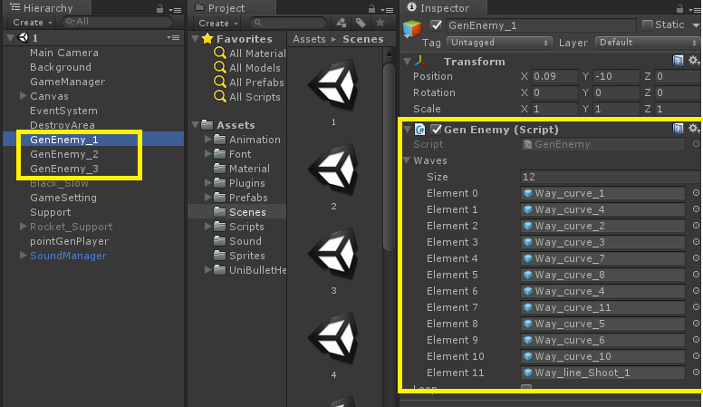

Way

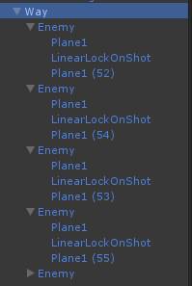

And setting plane on way.

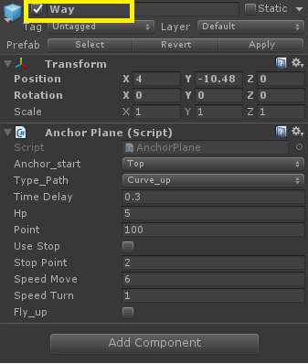

**How to Enemy can shoot**

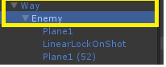

You have to add “Ubh shot Ctrl” and drag “shot Obj”

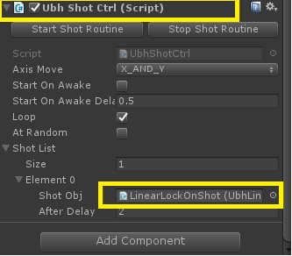

Here is “shot Obj”, you can find them in prefabs.( have a lot of)

