HW 3:

Adam Ross

*adro4510@colorado.edu*

**Abstract**

*This paper discusses and analyzes the underlying mechanisms of the Parallel Broadcast and Reduce operations with additional relation to machine organization and optimization. First I will discuss the correctness and implementation of my broadcast and reduce algorithms. Then I will analyze optimization of these algorithms including timing, network topology context and algorithm bit transversal.*

**1. Introduction**

Often in parallel programming it is needed to aggregate data between processing nodes or maybe it is needed that all nodes synchronize the same data at some point in processing. It is worth investigating the algorithms that accomplish these tasks and exploring the resulting subtleties as to optimize performance. I begin by supporting the correctness of my implementation by picking apart the procedure and output. Latency calculations are then done for each of the procedures and then related to network topology.

**2. Overview**

To accomplish broadcast and reduce we use a fan in and fan out methods. To reduce we use fan in to aggregate the data to a single process and the opposite for broadcast to make all the processes have the same data. The fan transversal can be done with bit-masks in a high to low or low to high fashion that dictates data flow between processes which is displayed in the following 4 diagrams.

Fig 2.1 High to Low bit transversal Broadcast

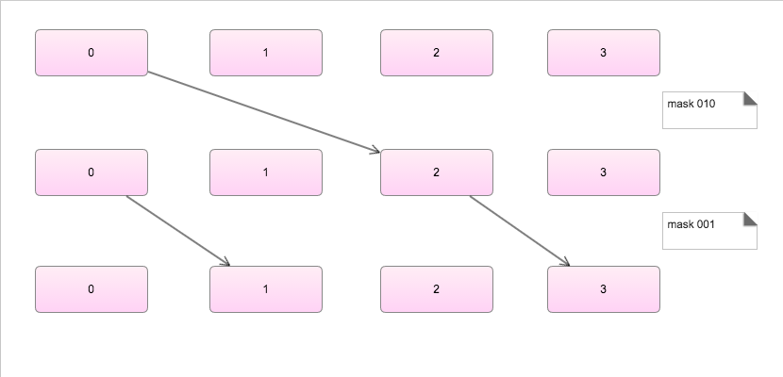

Fig 2.2 Low to High bit transversal Broadcast

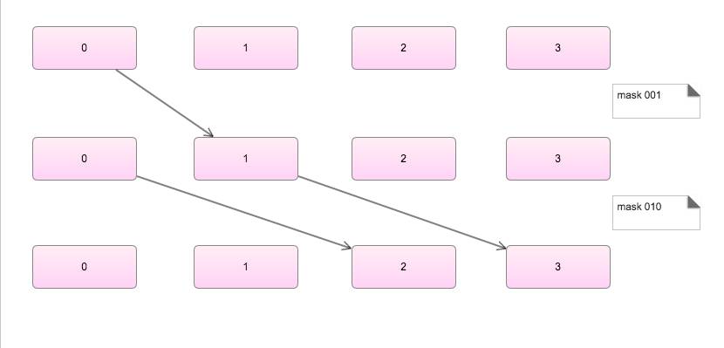

Fig 2.3Highto Low bit transversal Reduce

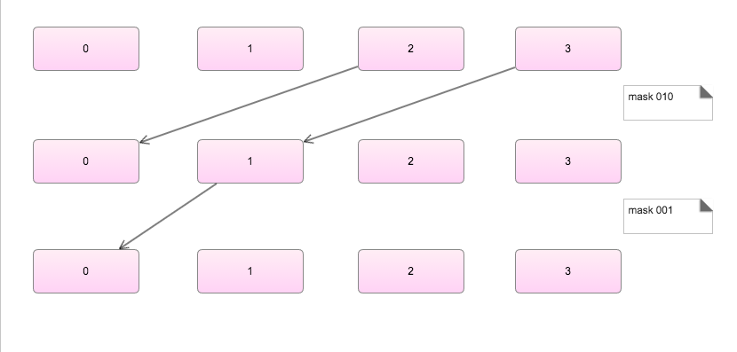

Fig 2.4 Low to High bit transversal Reduce

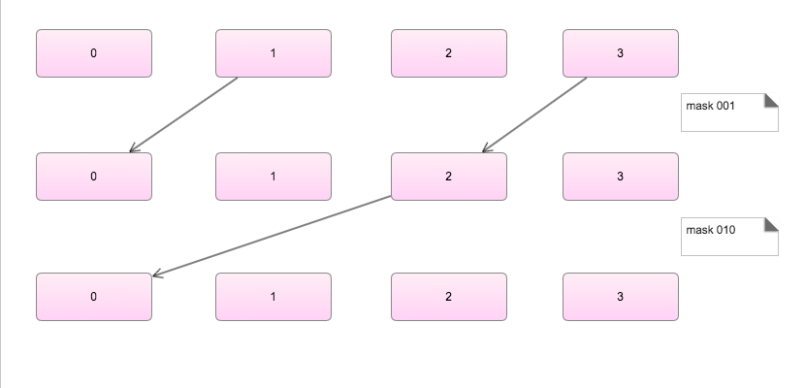

The Code Below describes the logic for a high to low bit transversal Broadcast.

*for (int stage = 0; stage < log2(p); stage++) {*

*current_mask = 1 << stage;*

*if (my_rank < current_mask) {*

*dest = my_rank | current_mask;*

*// send*

*MPI_Send(buffer, count + 1, MPI_DOUBLE, dest, 0, comm);*

*} else if ((my_rank >= current_mask) && (my_rank < (current_mask * 2))) {*

*// recv*

*source = my_rank - current_mask;*

*MPI_Recv(buffer, count + 1, MPI_DOUBLE, source, 0, comm, &status);*

*}}*

This and the other three logical operations can be derived from the diagrams above to solve for the operations of each of the transversal and fan in and fan out combinations.

**3. Verification**

The output below is from each of the 4 operations to verify the correct behaviour as described in the diagrams above. The reduce operation performs a sum as the aggregation step.

Fig 3.1 - High to Low Broadcast(process 0 given data = 3, p > 0 given 0):

My rank is 0 - Stage is: 0 - Sending to 2

My rank is 1 - Stage is: 1 - Receiving from 0

My rank is 2 - Stage is: 0 - Receiving from 0

My rank is 3 - Stage is: 1 - Receiving from 2

My rank is 0 - Stage is: 1 - Sending to 1

+ My rank is 0 and the buffer contained 3.000000

+ My rank is 1 and the buffer contained 3.000000

My rank is 2 - Stage is: 1 - Sending to 3

+ My rank is 2 and the buffer contained 3.000000

+ My rank is 3 and the buffer contained 3.000000

Fig 3.2 - Low to High Broadcast(process 0 given data = 3, p > 0 given 0):

My rank is 0 - Stage is: 0 - Sending to 1

My rank is 0 - Stage is: 1 - Sending to 2

My rank is 1 - Stage is: 0 - Receiving from 0

My rank is 1 - Stage is: 1 - Sending to 3

My rank is 2 - Stage is: 1 - Receiving from 0

My rank is 3 - Stage is: 1 - Receiving from 1

+ My rank is 0 and the buffer contained 3.000000

+ My rank is 1 and the buffer contained 3.000000

+ My rank is 2 and the buffer contained 3.000000

+ My rank is 3 and the buffer contained 3.000000

Fig 3.3 - High to Low Reduce(all processes given data = 3):

My rank is 0 - Stage is: 0 - Receiving from 2

My rank is 1 - Stage is: 0 - Receiving from 3

My rank is 1 - Stage is: 1 - Sending to 0

My rank is 2 - Stage is: 0 - Sending to 0

+ My rank is 2 and the total is 3.000000

My rank is 3 - Stage is: 0 - Sending to 1

+ My rank is 3 and the total is 3.000000

My rank is 0 - Stage is: 1 - Receiving from 1

+ My rank is 0 and the total is 12.000000

+ My rank is 1 and the total is 6.000000

Fig 3.4 - Low to High Reduce(all processes given data = 3):

My rank is 0 - Stage is: 0 - Receiving from 1

My rank is 0 - Stage is: 1 - Receiving from 2

My rank is 1 - Stage is: 0 - Sending to 0

+ My rank is 1 and the total is 3.000000

My rank is 2 - Stage is: 0 - Receiving from 3

My rank is 2 - Stage is: 1 - Sending to 0

My rank is 3 - Stage is: 0 - Sending to 2

+ My rank is 3 and the total is 3.000000

+ My rank is 0 and the total is 12.000000

+ My rank is 2 and the total is 6.000000

**4. Analysis**

Let us now assume sending a single message takes 0.7 us, below is a table of each algorithm's expected execution time is.

|  |  |  |  |  |  |  |
| --- | --- | --- | --- | --- | --- | --- |
| Algorithm | High to Low Broadcast | Low to High Broadcast | High to Low Reduce | Low to High Reduce | All Reduce | All to One  All Reduce |
| 4 nodes | 1.4 us | 1.4 us | 1.4 us | 1.4 us | 2.8 us | 4.2 us |

* I know these are completely wrong. I have run out of time and need to submit.

Knowing a network's topography should very much influence algorithm design. We are two consider two situations: 1. Our nodes are set up in a 2d Torus Network. 2. Our nodes are set up in a Fat Tree Network. Given the nature of a 2d torus network where the rows and columns of node are connected the bit transversal is less relevant because the mesh is fairly strongly connected, you have at most sqrt(n) hops to any given node. Comparatively, a fat tree network is much better suited to a high to low broadcast and high to low reduce. This is because the opposite algorithms result in more cross tree messages, and fewer local which is less ideal.

Bit traversal order does matter in some situations given the layout of your network if you are pushing for complete optimization. It makes sense to match the opposite bit transversal broadcast and reduce methods together because they are organized similarly, just reverse of each other. I.e. if you follow 001 -> 010 -> 100 forward to reduce it makes sense to traverse backwards during the broadcast to follow the same path.