Student: Alim Khamraev (19B030127)

Fit (IS), 4 course

Discipline: Backend for high load environment

**Report for Assignment #2**

**Creating docker compose for all project services**

**Project: Online courses platform**

In this assignment, I created a docker-compose for the services in my project.

First, I will show the architecture of services:

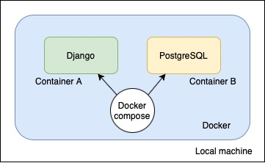

In general, nothing complicated, there will be two services - a backend (django) and a database (postgres). Docker will be used, more convenient and flexible launch of our services with one command will be implemented through docker compose

Now let's move on to docker compose itself.

Here are the instructions for launching our services. In this case, we have two of them - web (django) and db (database). Next, if necessary, we specify the base image. We create volumes to connect the container files with the files of the local machine. We open ports. If necessary, create environment variables. For django, we set the command to start the server, for the database we specify the name of the database, the username and password. It is very important to start the database before django, so we have included the web service dependency on the db. That is, the web will start only after the db is launched. This completes our docker compose file.

In order for everything to work and Django can use postgres as a database, you need to change one configuration in the settings.

Now we are ready to start the services. To do this, simply write the "docker-compose up command", after which all containers will be created automatically and the project will work.

Now in your terminal you will see the output of each of the services, they are given their own names, so about

This completes this second task of our final project.