Part 2 milestone project

- Project Description
This project focuses on analyzing a bank marketing dataset to understand how customer employment and personal circumstances influence financial decisions, specifically housing loans and personal loans. The dataset includes key variables such as job type, marital status, housing loan status, personal loan status, and other demographic and financial attributes. In this analysis, I will explore whether certain job categories are more likely to have housing loans or personal loans, and how marital status may influence borrowing behavior. The goal is to identify patterns between employment type, relationship status, and financial decisions made by clients .
- Business Case
I chose this topic because it reflects real-world financial behavior and can reveal how employment stability and personal life situations impact borrowing decisions. This project is relevant to data analysis because it involves exploring categorical relationships, identifying trends, and drawing insights that can be useful in banking, credit risk analysis, and customer segmentation.
This project aims to analyze how employment type (job category) and marital status influence a customer’s likelihood of having a housing loan or a personal loan. The purpose is to identify patterns that may suggest which types of clients brought houses based on their jobs or if they’re married.
The dataset is suitable for this analysis because it includes key variables such as age, job, marital status, and housing loan status. These variables allow for comparison across different customer segments and support meaningful pattern discovery. The insights from this analysis can be useful in banking and financial services for understanding customer risk profiles, improving loan targeting strategies, and supporting credit decision-making.
Business Rule
- 1. A customer can only have one job
- 2.Clients may or may not have a loan
- 3.Clients financial sets like balance and loans are required and recorded for analysi
- 4.Clients martial law are used to assessing their profiles
- 5. Clients age, job, and marital status is used to understand housing patterns
- 6. Married and single clients can both have loans but likelihood may differ based on other facts like age, or housing
- 7. Client can only have 1 relationship with campaign since a client can only have one campaign interaction once
- 8. Hierarchy is already made in month to day

Dataset Link:
https://www.kaggle.com/datasets/janiobachmann/bank-marketing-dataset

- Semantic
1. The dataset was normalized into three main tables to reduce redundancy and improve data organization. The Clients table stores demographic information, the Financial Profile table contains financial attributes, and the Campaign Interactions table records marketing campaign outcomes.
The ERD shows the structure of the semantic model including all tables, columns, and relationships between entities.
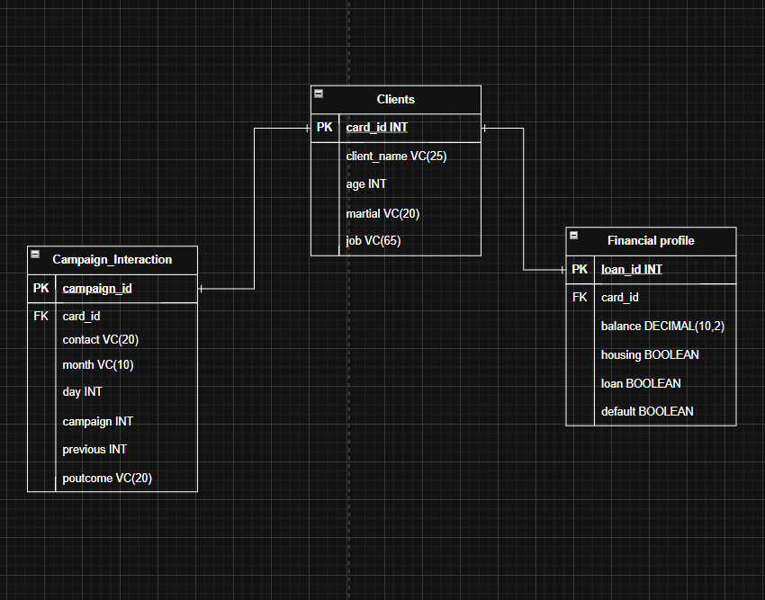
3. for date table it already goes inside the campaign interactions table like month, and day
4. hierarchy + calculated column +measure is already in campaign interactions MONTH to day
5. Calculated column is age row inside clients
6, Assumptions /Business rules
- Each client has unique ID
- Each campaign belongs to one client
- Each client belongs to one financial profile

- Analysis
So this project will focus on analyzing between clients and how their finance affect their behaviours using our bank dataset. The main goal is to explore how each factors such as job type and marital status influence wether a client has a house or a personal loan. The analysis will have grouping clients by job categories and martial status then comparing between other clients like if one client has blue collar job or if another client is entrepreneur
- Power BI Report and Dashboard Design
Power BI Report and Dashboard Design The Power BI report will be organized into two main pages to clearly present both high-level insights and detailed analysis. The first page will act as an overview dashboard, displaying key metrics related to client loans and financial behavior. This will include KPI cards showing total number of clients, percentage of clients with housing loans, and percentage with personal loans. A Line chart will compare loan distribution across different job categories, while a donut chart will show the proportion of clients by marital status. A slicer for job category will be included to filter multiple visuals on the page, allowing users to quickly focus on specific employment groups.
The second page will provide a deeper analysis of relationships between variables. A clustered column chart will compare housing and personal loan counts across marital status groups. A matrix will display job category against loan status to highlight patterns across segments. A scatter plot will be used to explore the relationship between age and balance, helping identify trends in financial behavior. A tree map will visualize the distribution of clients across different job types. Additionally, a Multi row card visual will highlight key insights such as the job group with the highest loan rate.
Interactive elements will include a mandatory slicer that filters at least two visuals (such as job or marital status), along with additional slicers like age group or loan type to refine the analysis. Tooltips will be enabled to provide additional context when hovering over visuals. The dashboard in Power BI Service will include the most important visuals from the report, such as KPI cards, the Line chart, and the matrix, giving a clear and concise summary of the findings in a single view.

Visualizations | Title | Insight Communicated | Pinned
Line Chart | Housing and Loan Trends by Age | Shows how housing and loan patterns change between different age groups | Yes
Scatter Chart | Age vs Account Balance | Shows the relationship between a client age and their balance so helping identify trends or outliers | No
Matrix | Marital Status vs Loans | Compares how both marital status and loans influence the likelihood of having house or personal loans | Yes
Multi-row card | Loan Metrics Overview | Provides a quick summary of total clients, percentage with housing loans, and percentage with personal loans | Yes
Treemap | Client Distribution by Job | Visualizes the proportion of clients across different jobs, helping identify dominant employment groups in datasets | No

