COURSE CODE/TITLE: | CPE 010 |  | SECTION: | CPE21S2
DATE PERFORMED: | July 24, 2026 |  | DATE SUBMITTED: | July 29, 2026
NAME: | Ramelissa Melith V. Limpio |  | INSTRUCTOR: | Engr. Jimlord Quejado

HOA 3.1 | Linked Lists
1. PROCEDURE OUTPUT
Screenshot | 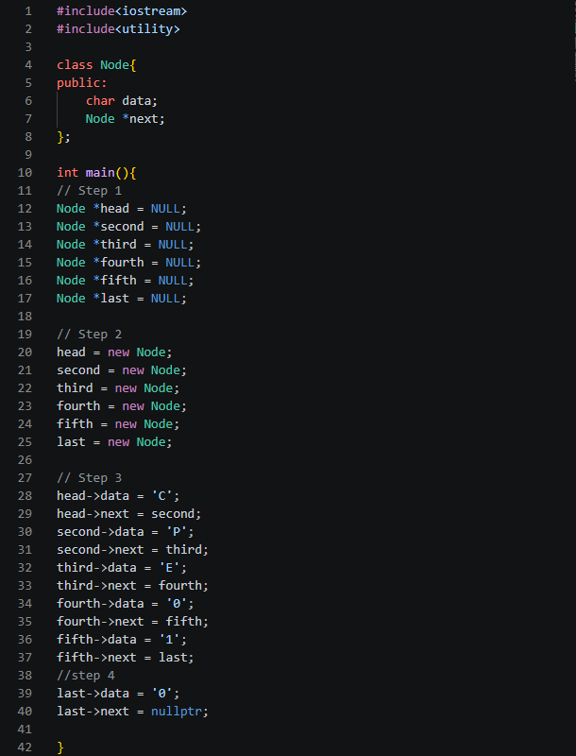
Discussion | The code builds a singly linked list of characters, node by node, all six pointers are created and initialized to null. Each node gets a character and is linked to the next one, when printing, it spells out C > P > E > 0 > 1 > 0 > NULL
Table 3-1. Output of Initial/Simple Implementation

Operation | Screenshot
Traversal | 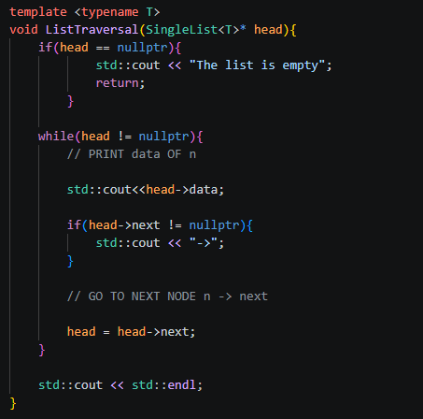
Insertion at head | 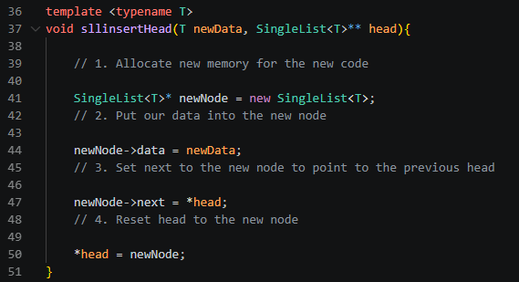
Insertion at any part of the list | 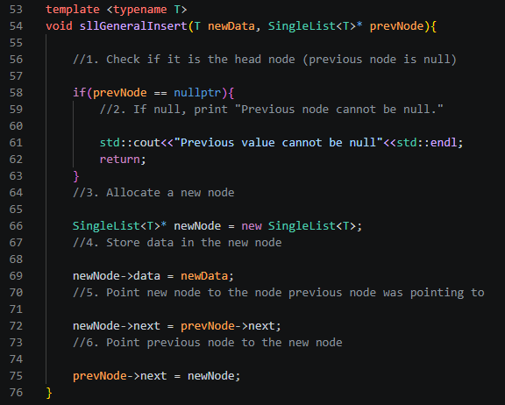
Insertion at the end | 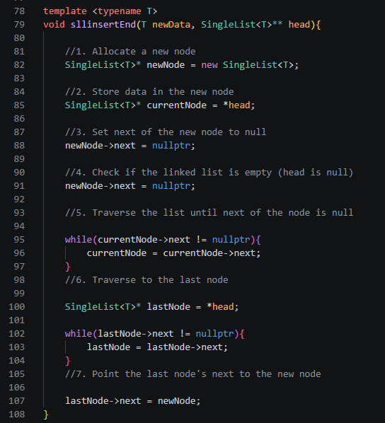
Deletion of a node | 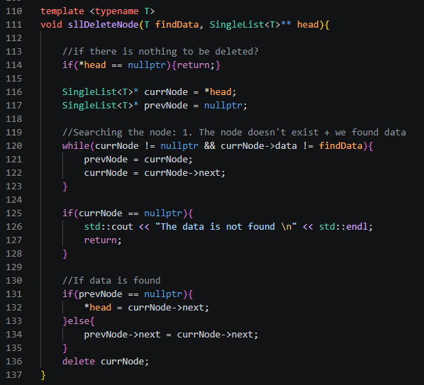
Table 3-2. Code for the List Operations

a. | Source Code | 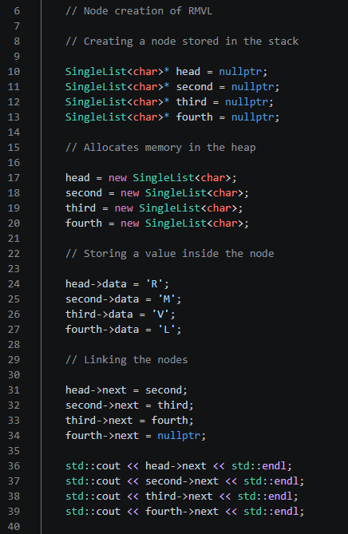
a. | Console | 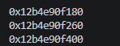
b. | Source Code | 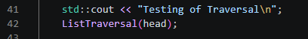
b. | Console | 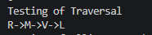
c. | Source Code | 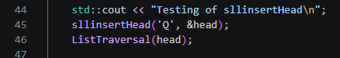
c. | Console | 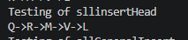
d. | Source Code | 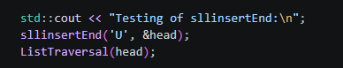
d. | Console | 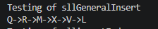
e. | Source Code | 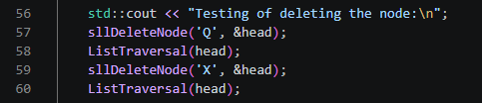
e. | Console | 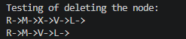
f. | Source Code | 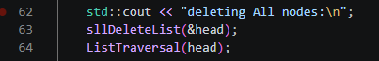
f. | Console | 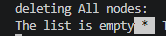
Table 3-3. Code and Analysis for Singly Linked Lists

Screenshot(s) | Analysis
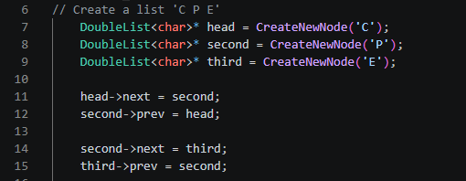 | Manually builds a double linked list with three notes containing the letters C, P and E.
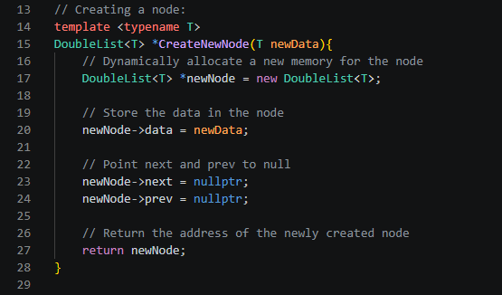 | Allocates a single new node on the heap, stores the given value into data.
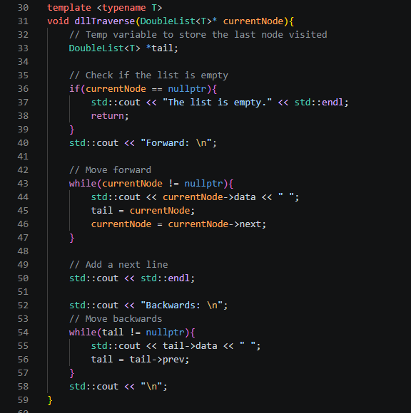 | Takes the head of the list and prints it twice, once forward and once backward. Uses next and tail.
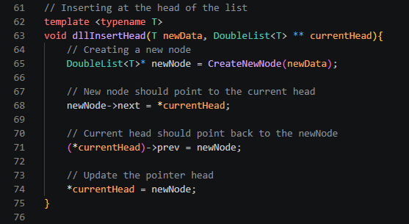 | Adds a new node to the front of the list. Creates the node and points its next at the current head, points the current head’s prev back at the new node.
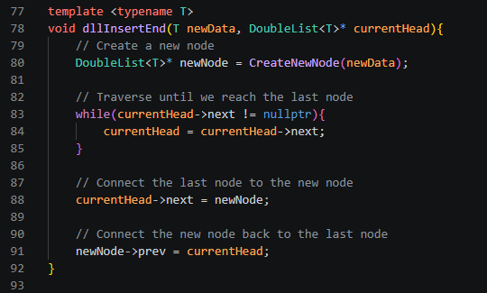 | Adds a new node to the back of the list. Walks forward first from the given head until it finds the node whose next is nullptr.
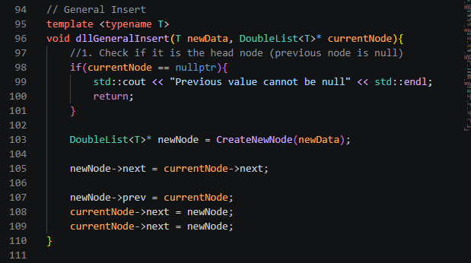 | Insert new node right after a specified node, check first if the given node isn’t nullptr.
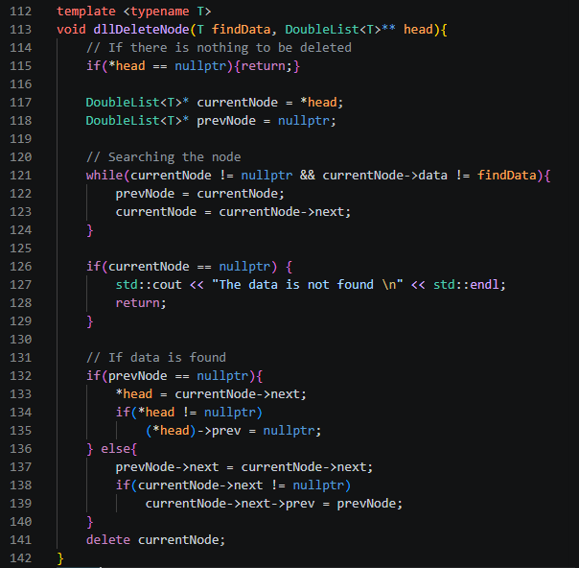 | Removes a node that matches the given value, walks from head with a currentnode and prevnode pair, searching for a match. If nothing matches it reports the data is not found.
Table 3-4. Modified Operations for Doubly Linked Lists

2. ANSWERS TO SUPPLEMENTAL ACTIVITY
Problem Title: Implementing a Song Playlist using Linked List
Source: Packt Publishing

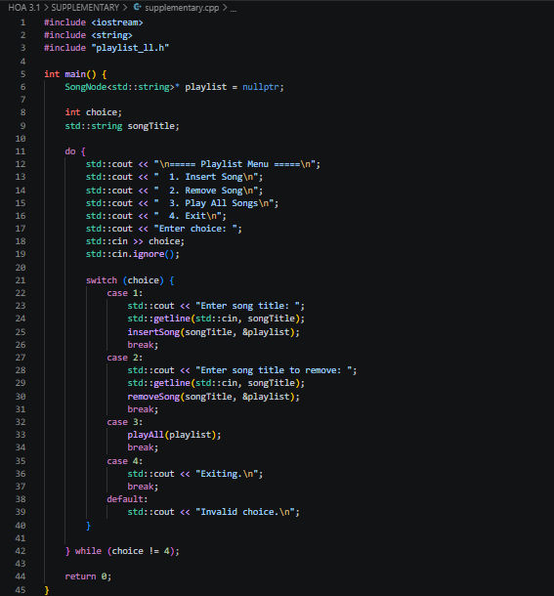
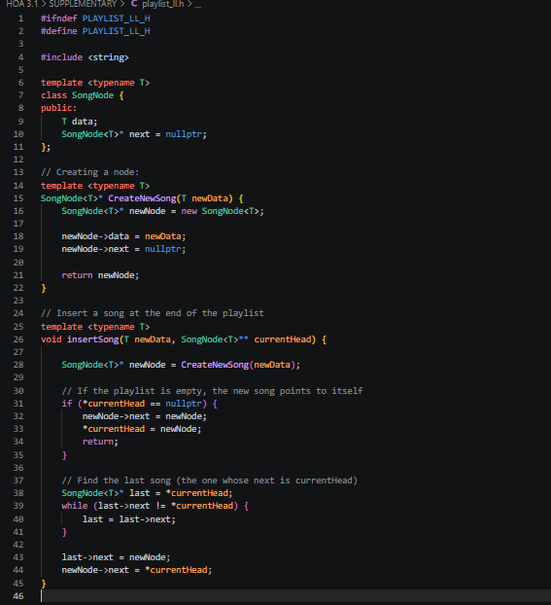
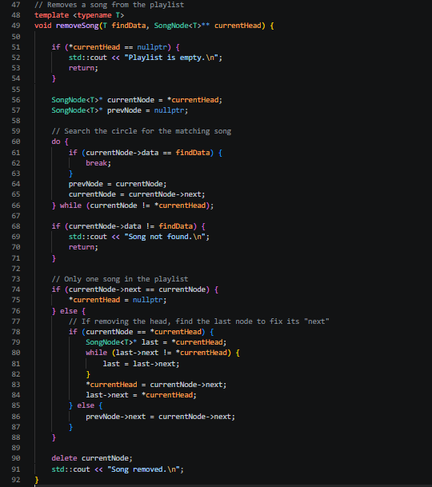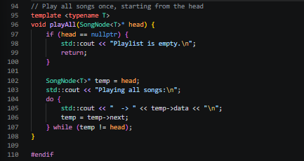
Figure 1-1. Code for Supplementary Activity
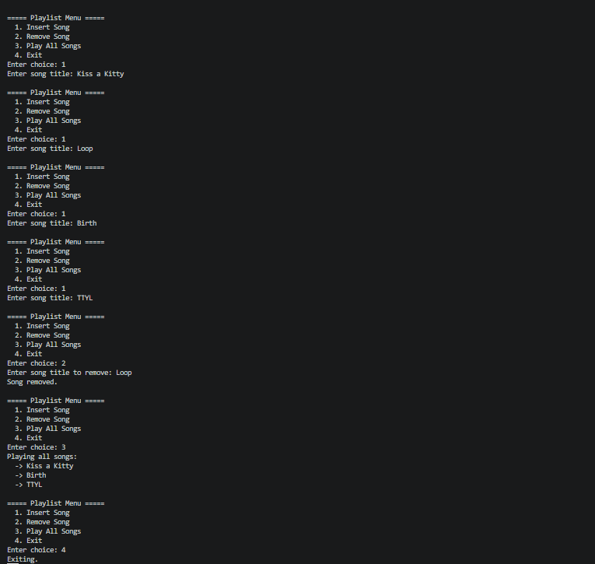
Figure 1-2. Output for Supplementary Activity

Conclusion
Working through simple lists, singly linked lists and doubly linked lists showed how the chain of nodes holding data changes based on how much connection information you keep. A singly linked list only remembers the way forward (next) which limits you to one direction of traversal. A doubly linked list adds a prev pointer which makes it possible to move backward. You can manipulate the said nodes and lists and build flexibility like the playlist in the supplementary activity.
I think I did well in this activity, as following along at first in creating the singly and doubly linked list gave me enough information to understand how the linking works, and to implement it in the code by myself. An area I should improve on is keeping track of where my pointers are pointing at.

3. ARTIFICIAL INTELLIGENCE (AI) USE DISCLOSURE STATEMENT
I hereby declare that artificial intelligence (AI) tools were used, if applicable, in the preparation of this academic work. The following indicates the nature and extent of AI assistance:

Tools Used:
Examples: ChatGPT, Microsoft Copilot, Grammarly, QuillBot, etc.

Purpose of Use:
Examples: grammar correction, idea generation, formatting, summarization, code assistance, explanation of concepts, etc.

Extent of Use:
Explain how AI was used and confirm that it did not replace original thinking, analysis, authorship, or completion of the required work.

By submitting this activity, I affirm that my use of AI complies with T.I.P.’s AI usage policy and does not exceed the permitted limits for similarity, automated content generation, or academic assistance.

I understand that any false, incomplete, or misleading disclosure may be subject to investigation in accordance with due process and may result in sanctions for violation of existing T.I.P. policies.

Lab activities, templates, and related instructional materials shall not be reuploaded, reproduced, distributed, or shared with external organizations or third parties without the prior express written permission of the Technological Institute of the Philippines.

