COURSE CODE/TITLE: | CPE 010 |  | SECTION: | CPE21S2
DATE PERFORMED: | August 5, 2026 |  | DATE SUBMITTED: | August 5, 2026
NAME: | Ramelissa Melith V. Limpio |  | INSTRUCTOR: | Engr. Jimlord Quejado

HOA 4.1 | Stacks
1. PROCEDURE OUTPUT
ILO A

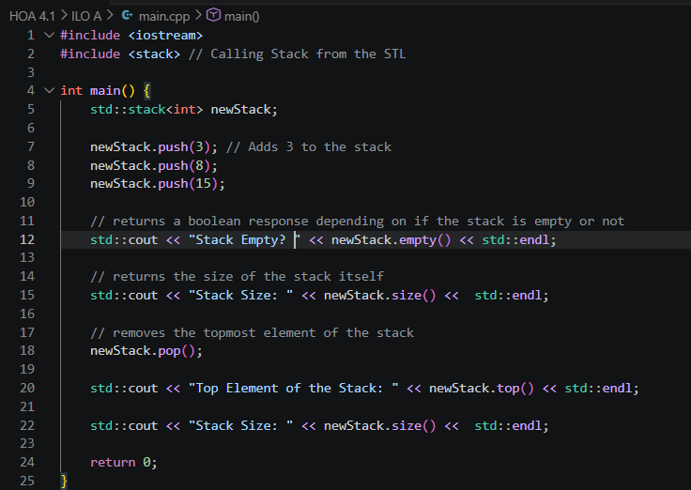
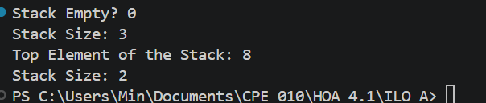

ILO B.1
Output
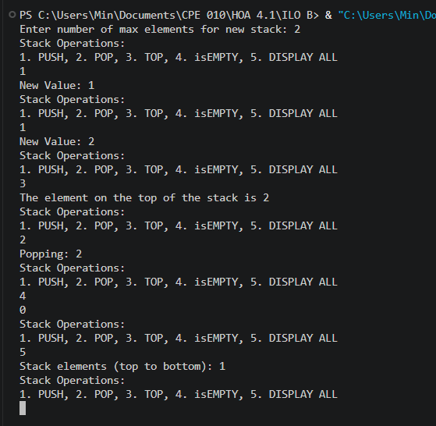
Operations used:
push() - Adds a new element to the top of the stack. First checks if the stack is full (top == i - 1, and i is user-defined capacity). If full, it prints a “Stack Overflow” message, otherwise it prompts the user for a value.
pop() - Removes the element currently at the top of the stack. First check whether the stack is empty using isEmpty(). If empty, it prints a “Stack Underflow” message. Otherwise, it displays the value being removed and decrements top.
Top() - Only displays the element currently at the top of the stock. It will print a message saying stack is empty if it is.
isEmpty() - A boolean function that checks whether the stack has any elements, returns true if top = -1 (or no elements in the stack) and false otherwise.
displayAll() - Displays every element currently in the stack, ordered from the top element to the bottom.

ILO B.2
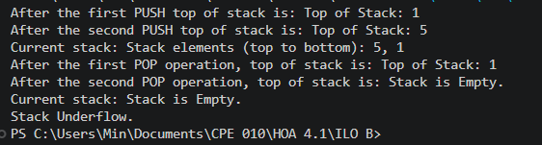
Operations
push(int newData) - Adds a new element to the top of the stack, dynamically allocates a new Node and stores the given value, then links it in the front of the current head. If the stack was empty, the new node becomes both head and tail. Otherwise, the new node becomes the new head, and the previous head becomes its next.
pop() - Removes and returns the element at the top of the stack. First checks whether the stack is empty and if so, it prints “Stack Underflow”, otherwise it saves a pointer to the current head, saves its data value, moves head to the next node then deletes the old head node.
Top() - Displayed the value of the element currently at the top of the stack.
displayAll() - Displays every element currently in the stack, ordered from the top (head)D down to the bottom.

2. ANSWERS TO SUPPLEMENTAL ACTIVITY
Expression | Valid? (Y/N) | Output (Console Screenshot) | Analysis
(A+B) + (C-D) | Y | 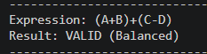 | Two independent () pairs, each opened in a sequence before the next begins. Every push has a matching pop of the same time, and the stack is empty at the end, meaning it’s balanced.
((A + B) + (C-D) | N | 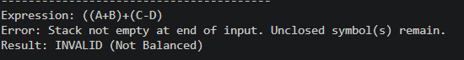 | Three ( are pushed but only two ) appear to close them, the very first ( is never popped resulting to invalid.
((A + B) + [C-D]) | Y | 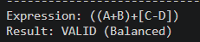 | Brackets are properly nested and mixed. Every pop matches the correct opening type, and the stack ends empty.
((A + B] + [C - D]} | N |  | The second ( is incorrectly closed by ] instead of ). When ] is encountered the stack pops but because of the isMatchingPair function returns false, implying that it’s a type mismatch.

Tools analysis
The array-based and linked list stacks behave identically from the outside, with the same push, pop, isEmpty and same balance-checking results, but the internal representations are different in multiple ways. Firstly, memory allocation, in the array stack it reserves a fixed block of memory upfront, whether it’s used or not. The linked list stack allocates one node at a time as the elements are pushed, and frees each node as it’s popped. Meaning that the array based stack can waste memory; Second is the capacity limits, the array version has a maximum ceiling (maxCap) and must be explicitly checked for “Stack Overflow” before pushing. The linked-list version has no built-in ceiling, meaning it can keep growing until the system runs out of memory. Lastly, disregarding the disadvantages of the array-based stack, it is simpler to write and reason about, while the linked list requires understanding pointers, node creation and pointer relinking.

Conclusion
This HOA activity reinforced that a stack’s core value is LIFO or Last-in-First-out discipline, and that this discipline maps naturally onto problems involving nested or paired structures.

In the procedure, adding displayAll() function required thinking about traversal order, for the array, iterating from top down to 0 was a simple index loop. For the linked list, it involved walking node-to-node via next pointers starting at the head. It was useful because it made the difference between arrays and linked list, more comprehensible than the push/pop operations alone.

For the supplementary activity, the program followed a comprehensible procedure, which was a balance-checking algorithm. Scan the expression character by character, ignore anything that isn’t bracket/parenthesis, push openers and pop and compare on closer brackets.

Overall, this activity for me has been helpful in understanding both array and linked list applications of stack. For me one area of improvement is proof reading or checking my code as my errors are not in the logic but always occurred in the typos.

3. ARTIFICIAL INTELLIGENCE (AI) USE DISCLOSURE STATEMENT
I hereby declare that artificial intelligence (AI) tools were used, if applicable, in the preparation of this academic work. The following indicates the nature and extent of AI assistance:

Tools Used:
Examples: ChatGPT, Microsoft Copilot, Grammarly, QuillBot, etc.

Purpose of Use:
Examples: grammar correction, idea generation, formatting, summarization, code assistance, explanation of concepts, etc.

Extent of Use:
Explain how AI was used and confirm that it did not replace original thinking, analysis, authorship, or completion of the required work.

By submitting this activity, I affirm that my use of AI complies with T.I.P.’s AI usage policy and does not exceed the permitted limits for similarity, automated content generation, or academic assistance.

I understand that any false, incomplete, or misleading disclosure may be subject to investigation in accordance with due process and may result in sanctions for violation of existing T.I.P. policies.

Lab activities, templates, and related instructional materials shall not be reuploaded, reproduced, distributed, or shared with external organizations or third parties without the prior express written permission of the Technological Institute of the Philippines.

