COURSE CODE/TITLE: | CPE 010 |  | SECTION: | CPE21S2
DATE PERFORMED: | July 17, 2026 |  | DATE SUBMITTED: | July 17, 2026
NAME: | Ramelissa Melith V. Limpio |  | INSTRUCTOR: | Engr. Jimlord Quejado

HOA 2.1 | ARRAYS, POINTERS AND DYNAMIC MEMORY ALLOCATION
1. PROCEDURE OUTPUT
Screenshot | 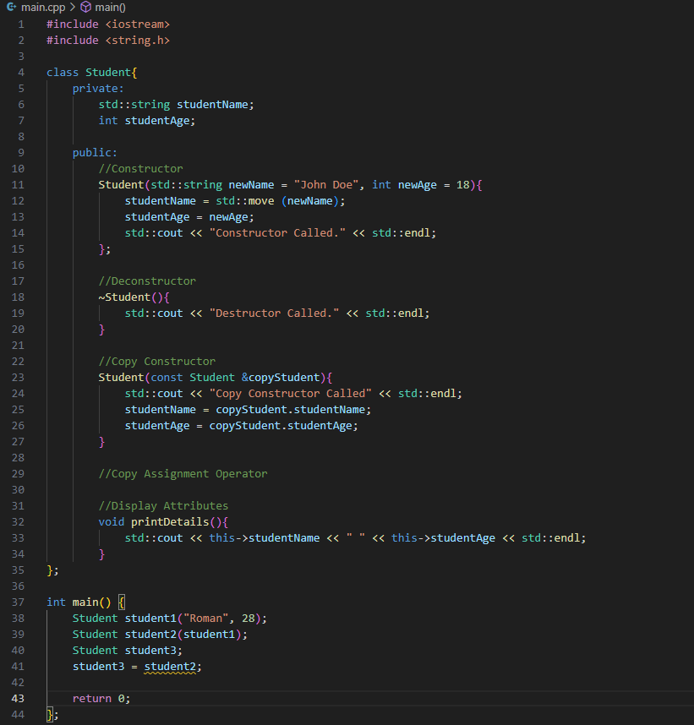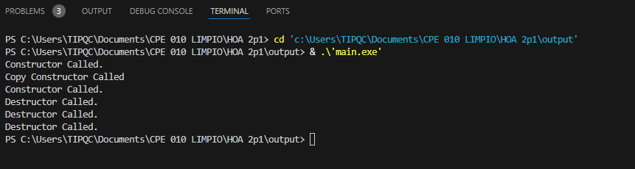
Observation | In the initial driver, we declared a class named Student that has constructor, deconstructor and copy constructor. In main, we used a constructor for “Roman”, 28, afterwards it used a copy constructor as it copied another member’s data, then made another member and copied from another member’s data.
Table 2-1. Initial Driver Program

Screenshot | 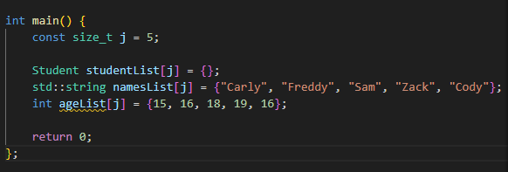  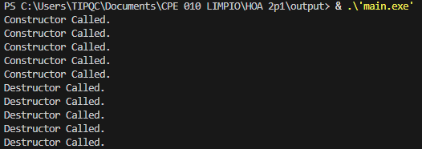
Observation | In the modified driver program, the previous main code was only replacing the “John Doe” data inside the array but not printed out, resulting in none of the data in the student’s list being displayed, only showing if a constructor or destructor is called.
Table 2-2. Modified Driver Program with Student Lists

Loop A | 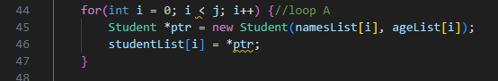
Observation | Since the array initialized in the class has a default of “John Doe” and age of 18, in loop A it is then replaced by the data copied from the arrays nameslist and agelist.
Loop B | 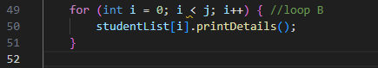
Observation | Loop B, the second loop after loop A are used to print the details of the array studentList, which contains the students’ name and age.
Output | 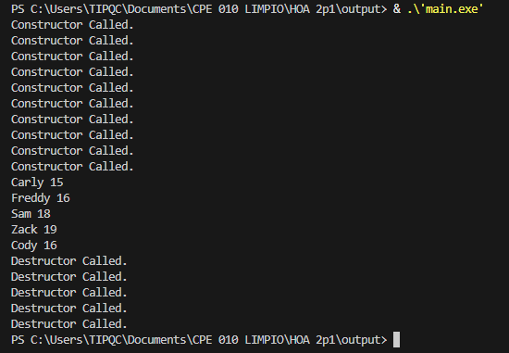
Observation | After adding loop A and loop B, after the constructor is called, all students with their name and age are displayed, and the destructor is used afterwards.
Table 2-3. Final Driver Program

Modifications | 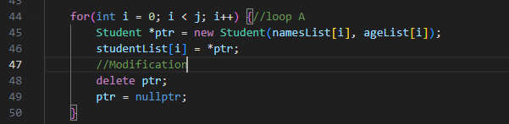
Observation | The modifications that were done in the code compared to the Final program was adding the delete ptr to avoid memory leak.
Table 2-4. Modifications/Correction Necessary
2. ANSWERS TO SUPPLEMENTAL ACTIVITY
Problem 1: Create a class for the fruit and the vegetable classes. Each class must have a constructor,
deconstructor, copy constructor and copy assignment operator. They must also have all relevant attributes
(such as name, price and quantity) and functions (such as calculate sum) as presented in the problem
description above.
Problem 2: Create an array GroceryList in the driver code that will contain all items in Jenna’s Grocery List.
You must then access each saved instance and display all details about the items.
Problem 3: Create a function TotalSum that will calculate the sum of all objects listed in Jenna’s Grocery List.
Problem 4: Delete the Lettuce from Jenna’s GroceryList list and de-allocate the memory assigned

#include <iostream>
#include <string.h>

// Problem 1 - Create a class for fruit and vegetables
class Fruits {

private:
std::string name;
double price;
int quantity;

public:

// Constructor
Fruits(std::string fName = "", double fPrice = 0, int fQuan = 0) {
name = fName;
price = fPrice;
quantity = fQuan;

std::cout << "Fruit Constructor Called\n";
}

// Destructor
~Fruits() {
std::cout << "Fruit Destructor Called\n";
}

// Copy Constructor
Fruits(const Fruits &copy) {
std::cout << "Fruit Copy Constructor Called\n";

name = copy.name;
price = copy.price;
quantity = copy.quantity;
}

//Copy Assignment Operator
Fruits& operator=(const Fruits &copy) {

if (this != &copy) {
std::cout << "Fruit Copy Assignment Called\n";

name = copy.name;
price = copy.price;
quantity = copy.quantity;
}

return *this;
}

//For problem 3 - calculate total grocery cost
double totalSum() const {
return price * quantity;
}

void printDetails() const {

std::cout << "Fruit: " << name
<< "\n\tPrice: " << price << " PHP"
<< "\n\tQuantity: " << quantity
<< "\n\tTotal: " << totalSum()
<< std::endl;
}
};

class Vegetables {

private:
std::string name;
double price;
int quantity;

public:

//Constructor
Vegetables(std::string vName = "", double vPrice = 0, int vQuan = 0) {

name = vName;
price = vPrice;
quantity = vQuan;

std::cout << "Vegetable Constructor Called\n";
}

//Destructor
~Vegetables() {
std::cout << "Vegetable Destructor Called\n";
}

// Copy Constructor
Vegetables(const Vegetables &copy) {

name = copy.name;
price = copy.price;
quantity = copy.quantity;

std::cout << "Vegetable Copy Constructor Called\n";
}

//Copy Assignment Operator
Vegetables& operator=(const Vegetables &copy) {

if (this != &copy) {
std::cout << "Vegetable Copy Assignment Called\n";

name = copy.name;
price = copy.price;
quantity = copy.quantity;
}

return *this;
}

double totalSum() const {

return price * quantity;
}

void printDetails() const {

std::cout << "Vegetable: " << name
<< "\n\t Price: " << price << " PHP"
<< "\n\t Quantity: " << quantity
<< "\n\t Total: " << totalSum()
<< std::endl;
}
};

//For problem 3 - Calculate grocery total cost
double TotalSum(Fruits* fruits[], int fQuan,
Vegetables* vegetables[], int vQuan) {

double total = 0;

for(int i = 0; i < fQuan; i++) {
if(fruits[i] != nullptr)
total += fruits[i]->totalSum();
}

for(int i = 0; i < vQuan; i++) {
if(vegetables[i] != nullptr)
total += vegetables[i]->totalSum();
}

return total;
}

int main() {

Fruits *apple = new Fruits("Apple", 10, 7);
Fruits *banana = new Fruits("Banana", 10, 8);

Vegetables *broccoli = new Vegetables("Broccoli", 60, 12);
Vegetables *lettuce = new Vegetables("Lettuce", 50, 10);

// Problem 2 - Array for Grocery List
Fruits* fruits[] = {apple, banana};
Vegetables* vegetables[] = {broccoli, lettuce};

std::cout << "\n==========================\n|| Jenna's Grocery List ||\n==========================\n";

//Display all fruits
for(int i = 0; i < 2; i++) {
fruits[i]->printDetails();
}

//Display all vegetables
for(int i = 0; i < 2; i++) {
vegetables[i]->printDetails();
}

//Problem 3 - Total Sum of all grocery
std::cout << "\nTotal Amount = PHP "
<< TotalSum(fruits, 2, vegetables, 2)
<< std::endl << std::endl;

//Problem 4 - Delete Lettuce
delete vegetables[1];
vegetables[1] = nullptr;

std::cout << "\nAfter deleting Lettuce\n\n";

std::cout << "Updated Total = PHP "
<< TotalSum(fruits, 2, vegetables, 2)
<< std::endl << std::endl;

delete apple;
delete banana;
delete broccoli;

return 0;
}
Figure 3. Supplementary Activity
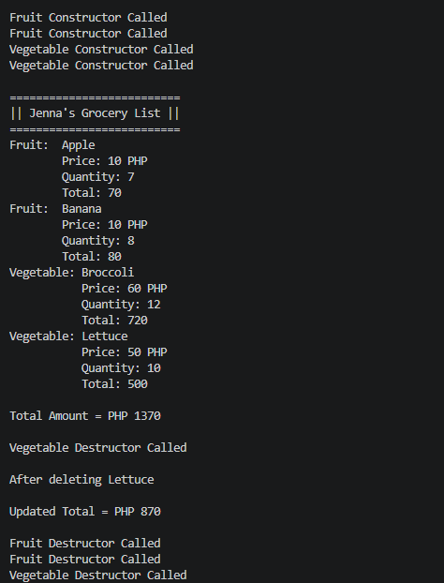
Figure 4. Output of the Supplementary Activity
Conclusion:
In this activity I was able to practice my skills in arrays, pointers and dynamic memory allocation. I struggled a bit when doing the supplementary activity as the many lines of code was confusing me, and I had to go back and forth multiple times to check what the error in my code.

3. ARTIFICIAL INTELLIGENCE (AI) USE DISCLOSURE STATEMENT
I hereby declare that artificial intelligence (AI) tools were used, if applicable, in the preparation of this academic work. The following indicates the nature and extent of AI assistance:

Tools Used:
Examples: ChatGPT, Microsoft Copilot, Grammarly, QuillBot, etc.

Purpose of Use:
Examples: grammar correction, idea generation, formatting, summarization, code assistance, explanation of concepts, etc.

Extent of Use:
Explain how AI was used and confirm that it did not replace original thinking, analysis, authorship, or completion of the required work.

By submitting this activity, I affirm that my use of AI complies with T.I.P.’s AI usage policy and does not exceed the permitted limits for similarity, automated content generation, or academic assistance.

I understand that any false, incomplete, or misleading disclosure may be subject to investigation in accordance with due process and may result in sanctions for violation of existing T.I.P. policies.

Lab activities, templates, and related instructional materials shall not be reuploaded, reproduced, distributed, or shared with external organizations or third parties without the prior express written permission of the Technological Institute of the Philippines.

