

ANL317
Business Forecasting
Application of Forecasting Models on Gross Domestic Product (GDP) in East Asia and the Pacific

Word count: 2352

Literature Review 3
Application of Exponential Smoothing in GDP Forecasting 3
Application of Extreme Learning Machine (ELM) and Double Exponential Smoothing (DES) in GDP forecasting 3
Key insights 3
Data Preparation 4
Data Collection & Structure 4
Data Formatting 4
Time Series Object 4
Handling Missing Values 5
Detecting Outliers 5
Time Series Exploration 6
Autocorrelation Analysis 7
Normality Test 8
Scatter Plot 8
Seasonality 9
Irregularities 10
Moving Average 11
Appropriate models used for smoothing and forecasting 12
Conclusion 15
References 16

Introduction
This report examines the application of time series forecasting techniques to analyse trends and patterns in East Asia and the Pacific's Gross Domestic Product (GDP). This report focuses on the GDP variable using time series analysis techniques to provide insights into forecasting methodologies to find the correlation between GDP growth (major series) and population (minor series).

Literature Review

Application of Exponential Smoothing in GDP Forecasting
Huang (2023) analysed the usage of exponential smoothing by using historical GDP data from the National Bureau of Statistics of China. Subsequently, an exponential smoothing model is applied to forecast the GDP from 2023 to 2025.

Huang’s findings revealed a steady increase trend in China’s GDP over the forecast period. It is driven by the three major industries (primary, secondary, and tertiary sectors). The study confirmed the effectiveness of simple exponential smoothing (SES) for GDP forecasting. However, it acknowledges potential external factors such as global economic fluctuations and trade policies which could impact accuracy. Therefore, the research emphasised the importance of continual monitoring and methodological improvements to refine forecasting models using complementary models and dynamic economic conditions.

Application of Extreme Learning Machine (ELM) and Double Exponential Smoothing (DES) in GDP forecasting
Bria, et.al (2025) explored the use of ELM and DES forecasting models. The models forecasted Indonesia’s GDP and compared the effectiveness of both methods in generating accurate forecasting using Mean Absolute Percentage Error (MAPE). The models utilised Indonesia's historical GDP data from 2010 to 2023 with secondary data obtained from Badan Pusat Statistik (BPA).

- DES yielded a MAPE of 0.0242%
- ELM produced a MAPE of 0.0949%

These results suggest that while ELM can model nonlinear patterns in GDP data, DES provides a more reliable forecast due to its ability to capture the underlying trend and smooth out random fluctuations. Bria et al. (2025) concluded that DES is the better method for forecasting Indonesia’s GDP due to the lower forecasting error. The paper emphasises on the importance of selecting suitable forecasting techniques based on the dataset’s characteristics to improve forecasting accuracy.

Key insights
Huang (2023) states the computational efficiency of SES and Bria et al. (2025) analysis of DES outperformed other models forecasting accuracy. Therefore, both SES and DES are viable options for this project.

Data Preparation

Data Collection & Structure
Upon importing the population and GDP dataset using the read.csv function, the head() function was used to preview the first few rows of the data frame.

Figure 1. 1 A snippet of Population data frame preview
Figure 1.2 A snippet of GDP data frame preview

In Figure 1.1 and 1.2, the data structure is displayed in “wide” format. To facilitate further analysis and enhance readability, the data is pivoted into the “long” format. The pivot_longer and mutate function are used to ensure that the data under the Year column only consists of the four numeric numbers. After which, both datasets were merged based on “Year” for further data exploration.

Data Formatting
The next step involved the conversion of the Year and variable columns into date and decimal points respectively. The pivot_longer function inherently transforms both the GDP and Population variables into decimal points hence only Year is required for adjustment. The as.Date() function was applied to convert the Year column in both data frames into a time series format.

This is a univariate time series format as it includes the time in the form of Year and a singular target variable, GDP. The data is observed and recorded throughout the years in sequential order.

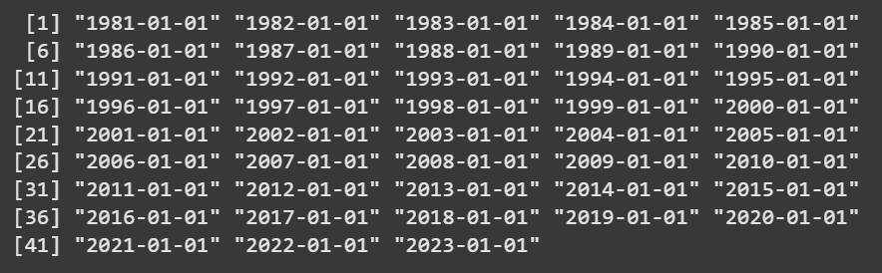
Figure 1.3 A snippet of the Date column

Time Series Object
The next step of data preparation would be to convert the data frames into time series. This is achieved by using the ts() function with the frequency set to 1 (annual data structure). Since the dataset consists of yearly observations, frequency 1 ensures representation. This conversion will ensure compatibility with the following time series analysis function in R.

Handling Missing Values
This can be achieved by using the is.na() function. The output will return ‘TRUE’ if there is a missing value within the data table. Both population and GDP columns return ‘FALSE’ which signifies that there is no missing value within the table.

Figure 1.4 A snippet of both population and GDP missing value results

Detecting Outliers
Detecting outliers was achieved by utilising the formula, 1.5 x interquartile range to calculate the lower and upper bound. The value of the interquartile range is derived through the quantile() function to calculate the 25th and 75th quantiles. Afterwhich, the 75th percentile value is subtracted from the 25th percentile value. Afterwards, calculate the lower [Q1 - (1.5 x IQR)] and upper bound [Q3 + (1.5 x IQR)] and identify if GDP data have outliers that fall outside of the range. Based on the result, there are no outliers detected for both GDP and Population data.
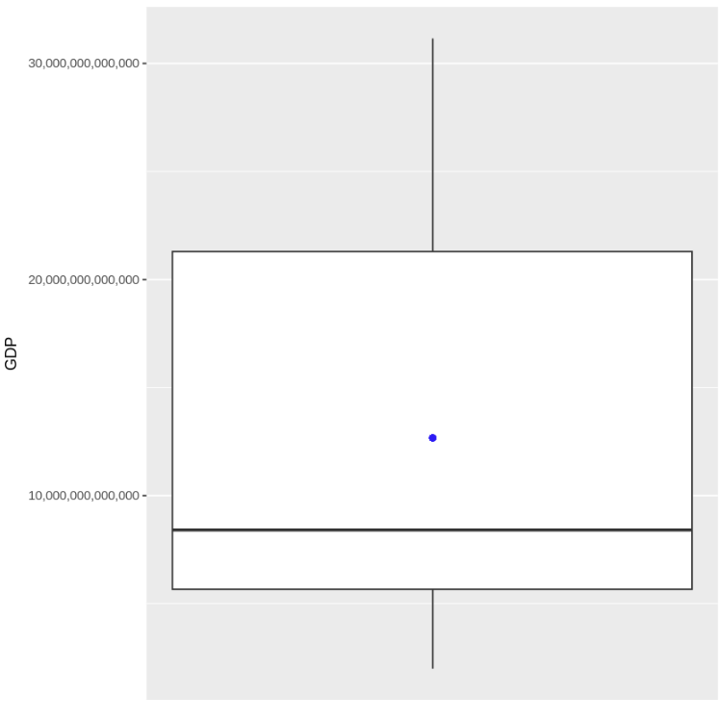
Figure 1.5 Boxplot: GDP data

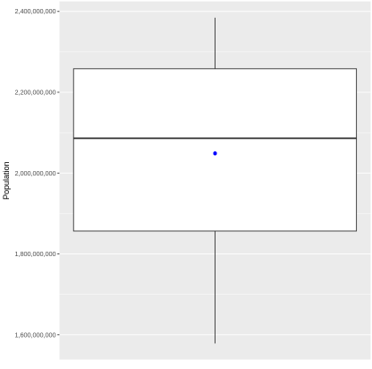
Figure 1.6 Boxplot: Population data

Time Series Exploration
The summary statistics provide insights into the distribution and variability of GDP from 1981 to 2023. In Figure 2.0, the mean GDP is 12.67 trillion while the median GDP is 8.41 trillion, which indicates a right-skewed distribution. (Figure 2.1) This suggests that for most years, GDP values were relatively low but a few higher values increased the mean.
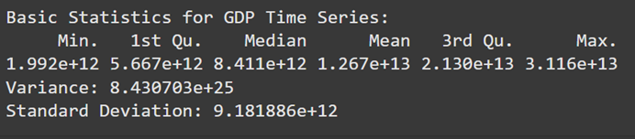
Figure 2.0 Summary Statistics of GDP

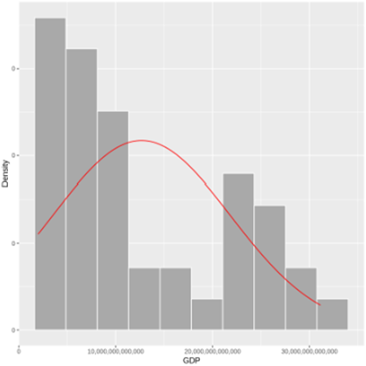
Figure 2.1 Histogram distribution of GDP across the period 1981 to 2023

The minimum GDP recorded was 1.99 trillion, while the maximum reached 31.16 trillion, which indicates a significant economic gap. A linear regression trendline is employed to assess the growth pattern over time.
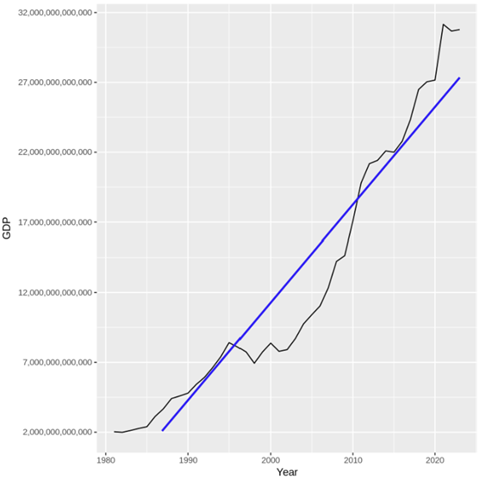
Figure 2.2 Linear regression trendline analysis of GDP across the period 1981 to 2023

The black line in Figure 2.2 represents the actual GDP growth which indicates an overall upward trend despite fluctuations. Similarly, the blue line represents the linear trend in GDP over time, showing an upward trend. Some interesting insights from Figure 2.2 are that there is a possible economic slowdown during the 2008 period as shown in the slow increase in the chart. Additionally, there has been a drop in GDP in recent years which may be attributed to the COVID-19 pandemic which affected the global economy (Maliszewska et al., 2020).

Autocorrelation Analysis
The autocorrelation function normalizes and understands the relationship between GDP and its past by detecting trends and persistence (Djellouli, 2023). Figure 2.3 indicates the autocorrelation value decreases with increasing lag and only falls under the confidence interval after lag 3, showing its statistical significance. It indicates that at least three periods of prior data are necessary for effective forecasting of future GDP.

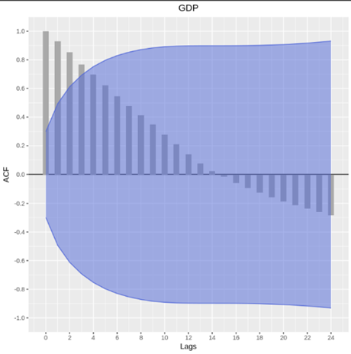
Figure 2.3 Autocorrelation function plot of GDP data

Location test
The location test compares the median of the GDP sample to the mean of the GDP data. The one-sample t-test determines whether the observed mean is significantly different from the given reference value.
As the p-value of 0.004028 is smaller than 0.05, the null hypothesis of the median equal to the mean is rejected, which suggests that the true mean GDP is significantly different from 8.41 trillion.

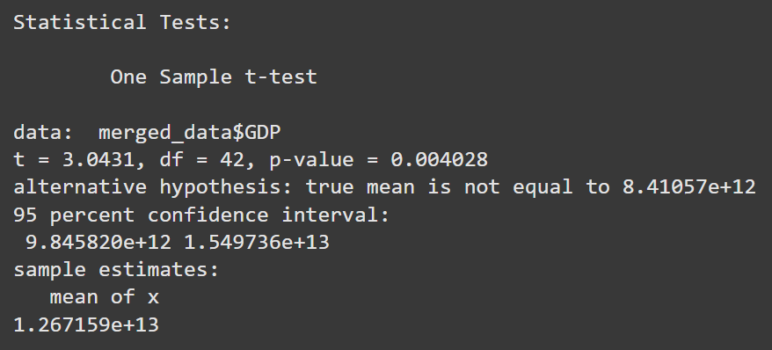
Figure 2.4 Location test (t-test) output of GDP data

Normality Test
The Shapiro-Wilk normality test determines if the GDP dataset is normally distributed (Shapiro, n.d.). Given the p-value result of 0.0003749 is smaller than 0.05, the null hypothesis will be rejected, further validating that the GDP data is not normally distributed. The QQ plot shows the comparison between the GDP sample quantiles (black dots) to the normal distribution (red line). In Figure 2.5, there are deviations from the red line at the lower and upper tails which suggest skewness and non-normality.

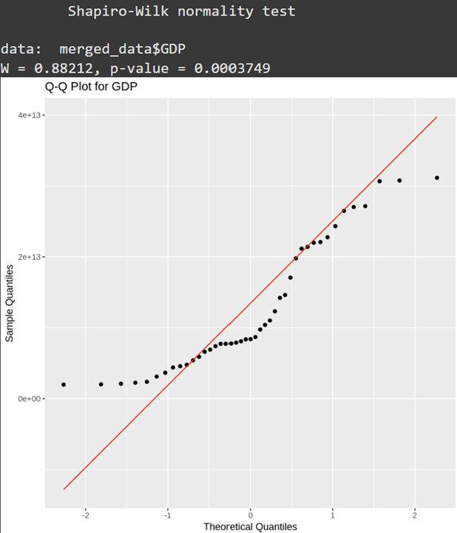
Figure 2.5 Shapiro-wilk normality test output and QQ plot of GDP data

Scatter Plot
The scatter plot depicts the relationship between Population (x-axis) and GDP (y-axis). It shows a positive correlation where the GDP increases as the population increases. From Figure 2.6, the GDP growth appears to accelerate at higher population values which indicates a possible exponential relationship. Some possible reasons for the accelerated growth could be economic policies or industrialisation that are likely to influence the GDP growth rate relative to the population size.
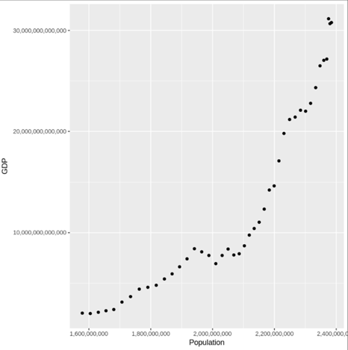
Figure 2.6 Scatter plot of GDP and Population data

The linear regression model is used to evaluate the correlation between Population and GDP. The p-value of 2.2 x${10}^{-16}$ is lower than 0.05. Therefore the null hypothesis will be rejected and validate the stance that GDP is a statistically significant forecaster of Population and prove to have a strong relationship.

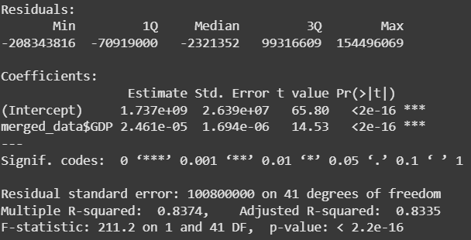
Figure 2.7 Numerical exploration for the relationship between “Population” & “GDP”

Seasonality
According to the Bureau of Economic Analysis (BEA), common GDP business seasonality is typically evaluated over a 10 or 30 years period. Given that the dataset spans only 42 years, the 10-year interval would be used to examine the seasonality (Moulton & Cowan, 2016).

Since the data is collected in annual format, the linear regression model was applied to test for seasonality. The p-value of 0.9998 indicates that the seasonal component is not statistically significant, suggesting that the model fails to reject the null hypothesis (seasonality affects GDP).

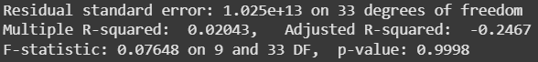
Figure 2.8 p-value of seasonality test (10 years)

Correspondingly, this report will not incorporate the Seasonal Exponential Smoothing (Holt-Winters) method for forecasting as seasonality is not a significant factor. (Bolarinwa, 2021).

Many observed decreases are due to one-time events, like the COVID-19 pandemic, which seasonality cannot account for as they are not seasonal trends. Hence, its limitations in dealing with unexpected, non-recurring events make it not useful to include for forecasting (Huah, 2005).

Irregularities
Conversely, irregularities are random with no fixed patterns. This makes it challenging to classify. Thus, it should be removed for more accurate forecasting.

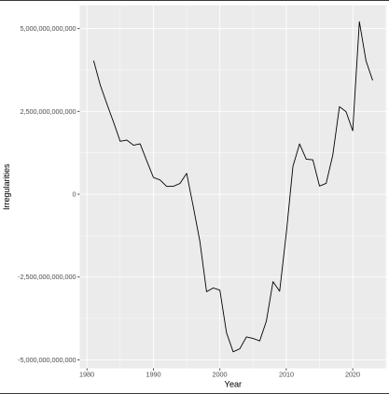
Figure 2.9 Irregularity chart

Positive values indicate an increase in irregularities while negative values indicate a decrease in irregularities.

A sharp decline was observed in the early 2000s, reaching its lowest point which can be attributed to the financial crisis (Ross, 2023). A steady increase may be linked to economic expansion and technological advancements (Orecchio, 2023). The decrease after 2020 could be due to the recent COVID-19 pandemic.

Moving Average
To identify the trends for moving average (MA), computation of MA with different year sizes (3, 5 and 7) is used to capture the fluctuations around the MA.

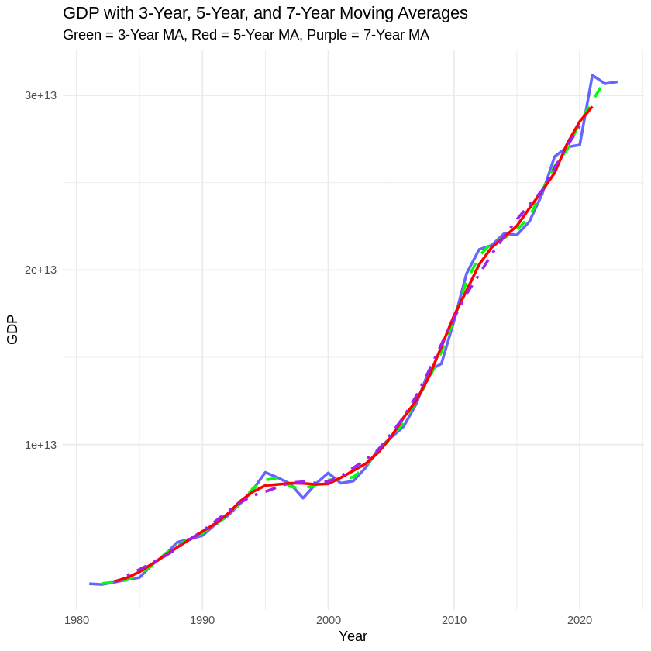
Figure 3.0 Comparing GDP with the different averages

The graph illustrates the GDP trend with three MAs to smooth short-term fluctuations and understand long-term trends. The blue line shows the actual GDP values with periodic fluctuations. The 3-year MA (green) captures short-term fluctuations while following the GDP closely. The 5-year MA (red) balances responsiveness and stability while the 7-year MA (purple) showcases the most stable depiction of GDP by filtering short-term noise yet reacting slowly to economic changes.

Since the objective of this report is to forecast GDP for years 2023 and 2024, the 3-years MA should be employed to better capture small fluctuations in the forecasted time series to generate more accurate results.

Appropriate models used for smoothing and forecasting
In the analysis, two models were used, SES and DES.

SES is a forecasting method that applies exponentially decreasing weights to past observations while emphasising recent data (Ostertagova & Ostertag, 2012). This method is suited for short-term time-series data without seasonality, therefore it was selected for our dataset.
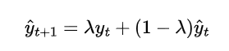
DES is a forecasting method used to handle data exhibiting trends by applying another layer of SES on top of the simply exponential smoothed values to avoid biases. This model is appropriate as the dataset exhibits trends as evidenced in Figure 3.1 and is also appropriate for datasets without any seasonality (Booranawong, 2017).
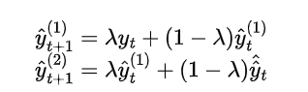

From Figure 3.1, we observe that the SES model follows the historical GDP values closely but shows a flat forecast model beyond 2022. As SES uses the weighted average of past observations, it does not take into account trends. As a result, the forecasted GDP stayed in a constant state beyond 2022, failing to capture any ongoing GDP growth. The confidence interval is narrow which suggests that there is low uncertainty in the model. Therefore, SES provides a stable and simplified forecast but does not reflect GDP fluctuations.

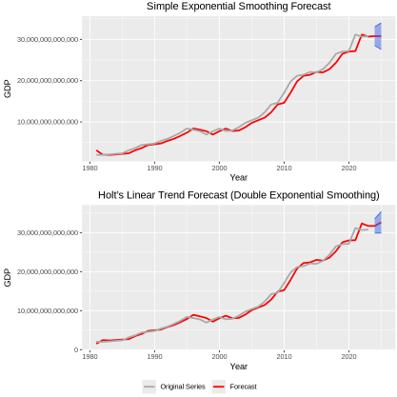
Figure 3.1 Forecasted chart for both smoothing models

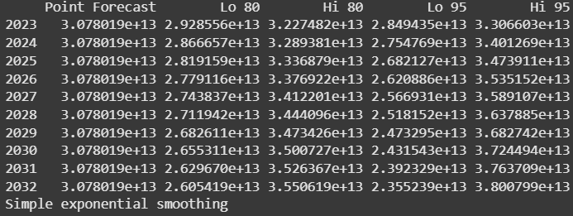
Figure 3.2 Output of SES model

In contrast, the DES model indicates an upward trend in the forecasted GDP. DES accounts for the trend component of the forecasting method, allowing it to project GDP growth based on historical patterns. This results in the upward trend shown in the graph. The confidence interval is also wider compared to the SES model, which indicates higher uncertainty as the forecast progresses into the future. Hence, although, DES model can effectively capture trends, it also produces greater variability in its forecasts.

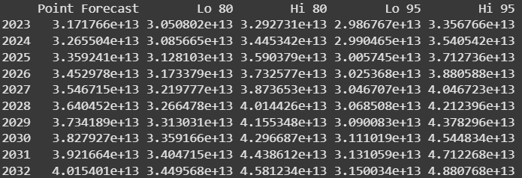
Figure 3.3 Output of DES model
From Figure 3.4, it shows that SES provides a forecasted value that is closer to the actual value for 2023 compared to DES. This outcome aligns with the nature of SES which is designed for short-term forecasting. It gives greater weight to recent data points to forecast more immediate future values. However, as GDP is typically forecasted long-term, DES will be a more viable forecasting model as it includes trends and also has an overall lower AIC value compared to SES. Hence, while SES yields a more accurate forecast for the immediate single year, DES is more suitable for longer years of forecasting GDP.

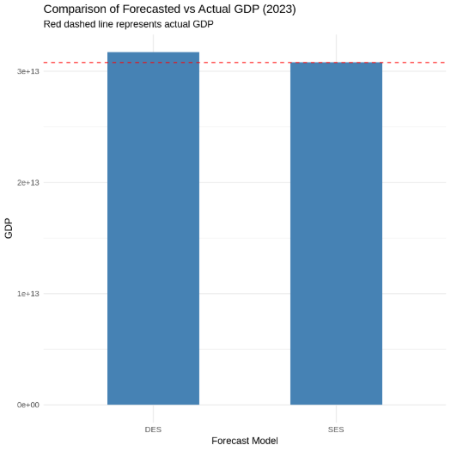
Figure 3.4 Comparison of Forecasted vs Actual GDP (2023)
Both the SES and DES models were evaluated using the Mean Absolute Deviation (MAD), Mean Squared Deviation (MSD), Root Mean Squared Error (RMSE), Mean Absolute Percentage Error (MAPE) and Akaike Information Criterion (AIC) statistical metrics.

Model | MAD | MSD | RMSE | MAPE | AIC
SES | 10683313 | 1.14 x ${10}^{14}$ | 10683313 | 3.47 x ${10}^{-5}$ | 2555.18
DES | 937464188152 | 8.79 x${10}^{14}$ | 937464188152 | 3.05 | 2538.84

The SES model appears to have greater overall accuracy compared to the DES model, based on the table above. This is shown by SES having a lower MAD, lower MSD, lower RMSE and an extremely low MAPE compared to DES. These metrics suggest that SES has very minimal forecast errors, potentially making it more accurate. However, the unrealistically low MAPE indicates that SES may be overfitting the historical data and thus may not provide accurate forecasting.

Although SES outperformed DES in terms of error metrics, SES has a higher AIC. It suggests that DES's model provides a better statistical fit. Since DES includes a trend component, it is more effective in capturing the overall GDP growth pattern, as evidenced by the upward trend in the graph. However, despite its better fit, the higher MAD and RMSE in Holt indicate that it may have a tendency to overestimate GDP values.

Overall, DES is the preferred model in this situation, as SES’s extremely low MAPE suggests possible overfitting and DES provides a better balance between accuracy and trend modeling. While DES may slightly over-forecast GDP, its ability to capture long-term trends makes it a more reliable choice for forecasting GDP.

Conclusion
The report explored the applications of time series forecasting to analyse trends in the GDP of East Asia and the Pacific’s GDP to population growth. This is done through assessing the usefulness of the SES and DES model in forecasting GDP values.

The findings show that DES outperforms SES in forecasting due to its inherent ability to capture trends. Although SES produced lower error metrics, it has an extremely low MAPE value which suggests overfitting and unreliable long-term forecasts. In contrast, the DES model demonstrates a more nuanced approach to forecasting by implementing trend adjustments while maintaining an acceptable accuracy level.

The graphical analysis indicates that SES provides a stable yet overly simplistic forecast failing to take into account economic fluctuations, while DES was able to effectively capture the trends in GDP while slightly overestimating 2023 values. The bar graph comparing forecasted to actual GDP further supports this, as DES is far closer to the actual GDP values compared to SES.

Overall, DES is the recommended model to forecast GDP as it delivers a steady balance between accuracy and trend estimation.

References

Bolarinwa, I. A., & Bolarinwa, B. T. (2021). Understanding features of time series through exponential smoothing. International Journal of Advanced Academic Research, 7(8). https://www.ijaar.org

Booranawong, T., & Booranawong, A. (2017). Simple and double exponential smoothing methods with designed input data for forecasting a seasonal time series: In an application for lime prices in Thailand. Suranaree Journal of Science & Technology, 24, 301–310.

Bria, A. Y., Miswanto, M., Biyanto, F., & Siregar, B. (2025). Forecasting Indonesia's gross domestic product using extreme learning machine and double exponential smoothing. Indonesian Journal of Contemporary Multidisciplinary Research (MODERN), 4(1), 11–18. https://doi.org/10.55927/modern.v4i1.13265

Brent R. M., Benjamin.D. C. (2016). Residual Seasonality in GDP and GDI. Bureau of Economic Analysis: https://apps.bea.gov/scb/pdf/2016/07%20July/0716_residual_seasonality_in_gdp_and_gdi.pdf

Djellouli, A. (2023, July 17). Autocorrelation function in time series analysis. Retrieved from https://adamdjellouli.com/articles/statistics_notes/time_series_analysis/autocorrelation_function

Huah, C. J., Economic Accounts Division, & Singapore Department of Statistics. (2005). Seasonal adjustment of time series. In Statistics Singapore Newsletter. https://www.singstat.gov.sg/-/media/files/publications/reference/ssnsep05-pg11-14.pdf

Huang, Y. (2023). The Application of Exponential Smoothing in GDP Forecasting. Frontiers in Business, Economics and Management, 11(3), 102-106. https://doi.org/10.54097/fbem.v11i3.13196

Maliszewska, M., Mattoo, A., & Dominique, V. D. M. (2020, April 10). The potential Impact of COVID-19 on GDP and trade: A preliminary assessment. https://papers.ssrn.com/sol3/papers.cfm?abstract_id=3573211

Orecchio, A. (2023, October 24). Will the 2010s be viewed as a period of global growth and stability? NIESR. https://niesr.ac.uk/blog/will-2010s-be-viewed-period-global-growth-and-stability

Ostertagova, E., & Ostertag, O. (2012). Forecasting using simple exponential smoothing method. Acta Electrotechnica et Informatica, 12(3), 62–66. https://doi.org/10.2478/v10198-012-0034-2

Shapiro, H. S. (n.d.). Lecture notes on applied linear algebra [PDF]. Massachusetts Institute of Technology. https://math.mit.edu/~rmd/465/shapiro.pdf

Zheng, F., & Wu, K. Y. K. (2025). ANL317 Business forecasting. Singapore University of Social Sciences.

Appendix

Link to R code: ANL317GBA_updated.ipynb

