HeartBeater

Intro
Heartbeater is a PureData path created to simulate the heartbeat sound.
It allows to range the heartbeat frequency (BPM) among 30 and 200 beats per minute.

The patch can be controlled via keyboard or via MIDI.

License
HeartBeater patch is released under GPL Version 3 license. Copyright (C) 2016 Nicola Ariutti.
This manual is released under GNU Free Documentation License Version 1.3 license.

If you need more information about licenses, please consult the LICENSE files within the patch folder. If you need more information please visit the www.limulo.net webpage or contact me: nicola[at]limulo.net

Quickstart
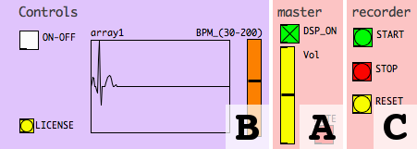
- Click on the Master section DSP_ON toggle to activate audio computation. Click on the MUTE toggle to deactivate mute on master output, eventually adjust the master output volume via Vol vertical slider (A);
- Click on the ON-OFF toggle from Controls section to start sound reproduction (B);
- Change the BPM vertical slider position to change the heartbeat frequency (B).

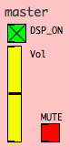
Master section
The Master section allows you to start the DSP computation, master output mute and volume.

Click on DSP_ON toggle to activate/deactivate DSP computation.

Adjust the master output volume by dragging the Vol vertical slider cursor.

Click on the MUTE toggle to mute/unmute master audio output. You can use the spacebar instead.

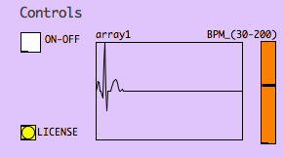
Controls
Controls module allows you to start or stop heartbeat pulses generation and to manage the heartbeat frequency regulation.
After DSP computation has been turned-on, you can act on the ON-OFF toggle to start or stop the heartbeat continuos pulses generation.
To change heartbeat frequency, act on the BPM vertical slider cursor position. You will hear the sound pulses frequency gradually varying among 30 and 200 beats per minute. The time it takes for the virtual heart to change its frequency to the chosen one is 4000ms.
The sound waveform is shown inside the array and it will be updated on each new beat.
Click on LICENSE button to read license information.

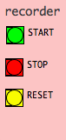
Record section
The Record section allows you to record the patch audio output on audio files.

These files will be .wav audio files with these characteristics:

 | name | ch. | description
file 1 | #_mono.wav | mono | the heartbeat sound.

where, “#” sign stands for a number that is the progressive id of the recording.

Before starting the recording, be shure you have created the “sounds” folder at the same level of the heartBeater patch in your file-system.

Sampling rate of the recorded files will be the same as the DSP one.

Click on the START button to start a new recording.

Click on the STOP button to stop the recording and consequentely to create the corresponding audio files inside the “sounds” folder.

In case you want to create consecutive recordings it suffices to click the START button several times: the START button will actually stop the previous recording, automatically creatiting the corresponding audio files, and starting a new recording at the same time.

Use the RESET button to reset the recordings counter to 0.

Note: Pay attention and always backup you recording before resetting because a new recording, started just after a reset can overwrite other audio files with corresponding names inside the “sounds” folder.

Note: recording volume will not be influenced by the the Vol control in the Master section, this is a listen control only.

Key control
It it possible to start and stop the heartbeat sound generation by pressing the spacebar.

MIDI control
HeartBeater can be controlled via MIDI protocol.

Any NOTE_ON message will start heart beat sound reproduction while a NOTE_OFF message will deactivate it.
MIDI modulation CC messages will change the BPM value of the heartbeat sound.
# CC | Parametro synth
1 (modulation wheel) | heart BPM

You can modify the MIDI behaviour by editing the MIDI subpatch, within the Main section.

