J.a.g.s.
just another granular synth

Intro
J.a.g.s. (just another granular synth) is a PureData patch useful if you need to create new and interesting sounds using granular synthesis techniques.
It grants great flexibility allowing the control of every fundamental synthesis parameter.

J.a.g.s. can also be controlled via MIDI.

Licenses
J.a.g.s. is released under GPL Version 3 license. Copyright (C) 2016 Nicola Ariutti.
This manual is released under GNU Free Documentation License Version 1.3 license.

If you need more information about licenses, please consult the LICENSE files within the patch folder. If you need more information please visit the www.limulo.net webpage or contact me: nicola[at]limulo.net

Quickstart
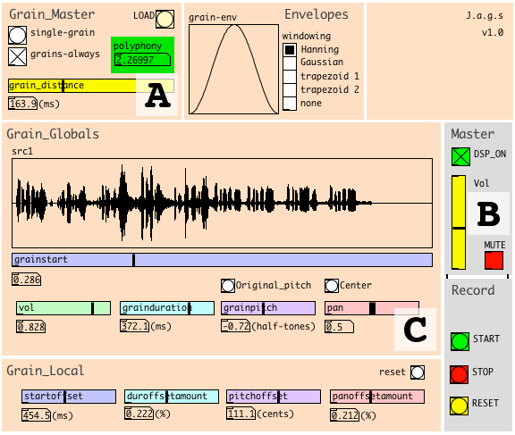
- Load a new file by clicking the LOAD button, in the upper right corner of the Grain Master section (A), then select grain_always play mode by clicking on the related toggle;
- Click on the Master section DSP_ON toggle to activate audio computation. Click on the MUTE toggle to deactivate mute on master output, eventually adjust the master output volume via Vol vertical slider (B);
- In the Grain Gloabals section ( C), use the horizontal grainstart slider to change the playhead position.

Grain Master section
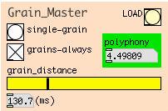
J.a.g.s. is a granular synthetizer that provides the possibility to create and record new sounds starting from an already existing sound.

To load a new sound from which to start granular synthesis, just click on the LOAD button located in the upper right corner of the Grain Master section: you can select an audio file (.wav, .aiff, mono or stereo) to be loaded browsing your file system.
Note: if the file you've selected is stereo, only the left channel will be used.

The just loaded sound file waveshape will appear in Grain Globals section inner array.

J.a.g.s. has two different playback modes:
- single-grain: use this mode to reproduce a single grain at time. To play a grain just click on the button;
- grain-always: click on the related toggle if you want the synth to play grains endlessly. In this mode it is possible to select the time interval between grains by adjusting the graindistance horizontal slider cursor position. Values between 3ms and 500ms are allowed.

J.a.g.s. is capable of at most 128 voices polyphony, that is, the synth can manage a maximum of 128 overlapping grains. For this reason this synth is equipped with a useful polyphony indicator.
It will assume one of three different colors according to the scenarios showed in the following table:

color | scenario
green | actual grain parameters involve less than 86 grains to overlap;
orange | overlapping of grains is included between 86 and 128;
red | grain overlapping is beyond synth maximum capacity.

If the time interval between grains is short and the grain duration is long, this causes the polyphony to be high and the synth will need a high number of indipendent voices to be able to reproduce the requested grade of grain overlapping.

If this number exceeds 128 it will be necessary to act in one of these two way in order to lower it below the 128 threshold.:
- increase time interval between grains;
- decrease the duration of the single grain (see Grain Global section);

Envelopes section
In this section it is possible to modify the windowing evelope used to shape every single grain.

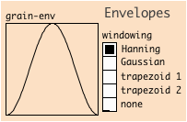
To set a particular windowing curve simply click one of the windowing radio-button positions.
The related windowing curve will be showed inside the grain-env array.

Here's the list of all the possible windowing shape:
- Hanning: Hanning window;
- Gaussian: Gaussian window;
- Trapezoid 1: with 100% corresponding to the grain entire duration, this curve creates a 30% duration time fade-in and a 30% duration time fade-out.;
- Trapezoid 2: the same as “Trapezoid 1” whit a 15% duration time fade-in and out;
- none: no windowing envelope;

Grain Globals section
In this section it is possible to see the audio file waveshape and to set up every fundamental grain parameters.

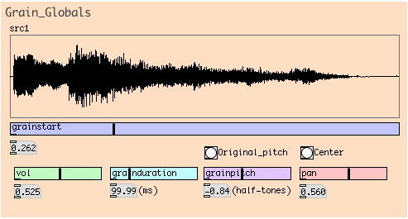
Available controls are:
- grainstart: adjusting this slider cursor will select the audio file point from which to extract the grain;
- vol: a volume control for the grain; it effects the grain volume after the occurance of the envelope windowing. In high polyphony contexts it is reccomended to lower this control to avoid possible volume distortion on master output;
- grainduration: this parameter allows you to change the duration of grains. Values between 1ms and 500ms are allowed;
- grainpitch: a pitch control for the grain. Grain pitch can be globally changed in a range between -6 and +6 half-tones Original pitch can be quickly restored by clicking the Original pitch button;
- pan: use this control if you want to place the output sound inside stereo panorama. Center position can be quickly restored by clicking the Center button.

Grain Local section
In addition to global settings, every grain can be individually modified by this set of locals controls.

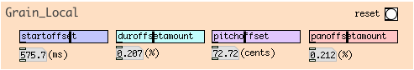
These controls are:
- startoffset: this control creates a relative modification of the grain starting position inside the audio file. For example, with the control at its maximum value of 1000ms, the actual grain starting point inside the audio file can be choosen randomly between the global starting point plus and minus 1000ms;
- duroffsetamount: this control sets a relative offset on grain duration. Its position sets the maximum amount of modification that will be applied on the global grain duration value to calculate the actual grain duration. For example, if global grain duration is 100ms and local grain duration indicates 50%, actual grain duration will be choosen randomly between 50ms and 150ms.
- pitchoffset: this control sets a pitch offset, in addition to global pitch setting, that will be used to playback the grain. The maximum value of this offset is equal to 200 cents.
- panoffsetamount: this control sets the maximum variation percentage (50%), related to the global pan value, by which the grain actual stereo position will be randomly calculated.

All local control positions can be resetted by clicking the reset button.

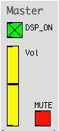
Master section
The Master section allows you to start the DSP computation, master output mute and volume.

Click on DSP_ON toggle to activate/deactivate DSP computation.

Adjust the master output volume by dragging the Vol vertical slider cursor.

Click on the MUTE toggle to mute/unmute master audio output.

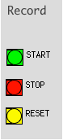
Record section
The Record section allows you to record the patch audio output on audio files.

These files will be .wav audio files, one mono and one stereo, saved respectively as “X_mono.wav” e “X_stereo.wav” where, “X” stands for a number that is the progressive id of the recording.

Before starting the recording, be shure you have created the “sounds” folder at the same level of the J.a.g.s. patch in your file-system.

Sampling rate of the recorded files will be the same as the DSP one.

Click on the START button to start a new recording.

Click on the STOP button to stop the recording and consequentely to create the corresponding audio files inside the “sounds” folder.

In case you want to create consecutive recordings it suffices to click the START button several times: the START button will actually stop the previous recording, automatically creatiting the corresponding audio files, and starting a new recording at the same time.

Use the RESET button to reset the recordings counter to 0.

Note: A new recording, started just after a reset, could overwrite other “0_mono” or “0_stereo” named audio files inside the “sounds” folder.

Note: recording volume will not be influenced by the the Vol control in the Master section, this is a listen control only.

MIDI control feature
J.a.g.s. can be controlled via MIDI protocol.
This table indicates the correspondences between MIDI Continuos Controls and synthetizer parameters:
# CC | Parametro synth
14 | Master: grain distance
17 | Globals: start
7 | Globals: volume
15 | Globals: duration
pitch bending | Globals: pitch
10 | Globals: pan
18 | Local: start
16 | Local: duration
1 (modulation wheel) | Local: pitch
8 | Local: pan

In addition to CC, you can use NOTE-ON MIDI messages between 48 and 72 (octaves 4 and 5) to change the global grain start position inside the audio file.

You can modify the MIDI behaviour by editing the MIDI subpatch, within the Grain Master section.

