LovelyHeart
heartbeat sound synthetizer

Intro
LovelyHeart is a PureData procedural synthetizer patch useful if you need to simulate the heartbeat sound.
LovelyHeart can also be controlled via keyboard or via MIDI.

Licenses
LovelyHeart is released under GPL Version 3 license. Copyright (C) 2016 Nicola Ariutti.
This manual is released under GNU Free Documentation License Version 1.3 license.

If you need more information about licenses, please consult the LICENSE files within the patch folder. If you need more information please visit the www.limulo.net webpage or contact me: nicola[at]limulo.net

Quickstart
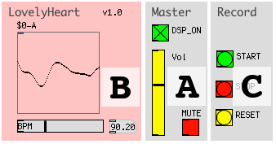
- Click on the Master section DSP_ON toggle to activate audio computation. Click on the MUTE toggle to deactivate mute on master output (you can also press the spacebar), eventually adjust the master output volume via Vol vertical slider (A);
- In the LovelyHeart section (B), use the horizontal BPM slider to change the heartbeat frequency.

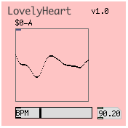
Main section
In this section you can control the heartbeat beat per minute frequebcy (BPM) and see the output sound waveform.
Use the BPM horizontal slider to modify the heartbeat frequency. You can vary it from a minimum value of 50 BPM up to 180 BPM.
In the array you can preview the ouput waveform.

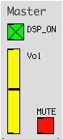
Master section
The Master section allows you to start the DSP computation, master output mute and volume.

Click on DSP_ON toggle to activate/deactivate DSP computation.

Adjust the master output volume by dragging the Vol vertical slider cursor.

Click on the MUTE toggle to mute/unmute master audio output. You can use the spacebar instead.

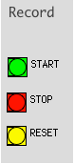
Record section
The Record section allows you to record the patch audio output on audio files.

These files will be .wav audio files with these characteristics:

 | name | ch. | description
file 1 | #_mix.wav | mono | the heartbeat sound made up of its two sound components: beats and murmur.
file 2 | #_beats.wav | mono | only beats component
file 3 | #_murmur.wav | mono | only murmur

where, “#” sign stands for a number that is the progressive id of the recording.

Before starting the recording, be shure you have created the “sounds” folder at the same level of the LovelyHeart patch in your file-system.

Sampling rate of the recorded files will be the same as the DSP one.

Click on the START button to start a new recording.

Click on the STOP button to stop the recording and consequentely to create the corresponding audio files inside the “sounds” folder.

In case you want to create consecutive recordings it suffices to click the START button several times: the START button will actually stop the previous recording, automatically creatiting the corresponding audio files, and starting a new recording at the same time.

Use the RESET button to reset the recordings counter to 0.

Note: Pay attention and always backup you recording before resetting because a new recording, started just after a reset can overwrite other audio files with corresponding names inside the “sounds” folder.

Note: recording volume will not be influenced by the the Vol control in the Master section, this is a listen control only.

MIDI control feature
LovelyHeart can be controlled via MIDI protocol.
This table indicates the correspondences between MIDI Continuos Controls and synthetizer parameters:
# CC | Parametro synth
1 (modulation wheel) | heart BPM

You can modify the MIDI behaviour by editing the MIDI subpatch, within the Main section.

