Answer

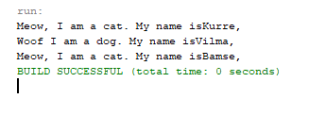Q1)

Q2) Polymorphism is an object-oriented programming concept that refers to the ability of a variable, function or object to take on multiple forms. A language that features polymorphism allows developers to program in the general rather than program in the specific.

Q3) Cat and Dog store instances in an array ofparent class which is Animal. This is called upcasting since we're casting the child classes into their parent class.

Q4) introduceYourself() method from the Animal class doesn't run because its child classes, Cat and Dog class have overriden the method with their own implementation of the same method. When called, we'll use the child version of the method since we called the method using the subclass instances (which was upcasted into Animal).

Q5) An *array* is a container object that holds a fixed number of values of a single type. The length of an array is established when the array is created. After creation, its length is fixed. You have seen an example of arrays already, in the main method of the "Hello World!" application. This section discusses arrays in greater detail. Each item in an array is called an *element*, and each element is accessed by its numerical *index*. As shown in the preceding illustration, numbering begins with 0. The 9th element, for example, would therefore be accessed at index 8.

Q6) Both cat n dog

Q7) It can run well

Q8) it help us to store data in the index starting from 0.

Q9) By using a for loop, we can reduce the length of the code and avoid using additional variables.

for (int i = 0; i != allAnimals.length; i++) {

allAnimals[i].introduceYourself();

}