Name: 임준상 Lin Chenxiang

Student Number: 2017320215

**Problem 1 - RSA:**

PR = {d, n} = {9178373396735665477, 9943237852845877651}

M = 5

The function find_pq() will take a lot of time, I used C language to run it. Other parts are run by Python.

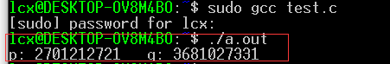

p: 2701212721 q: 3681027331

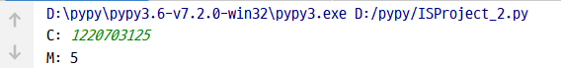

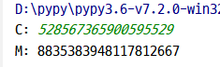 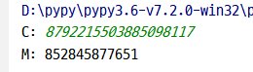

Both of source code of C language and python will be upload.

**Problem 2 - ElGamal:**

