  - How Far Can Compact Encoders Go on Natural Language Inference?
A Controlled Study of Efficiency, Calibration, and Failure Modes on SNLI.
Polina Chudinova
Russian State Agrarian University - Moscow Timiryazev Agricultural Academy, Moscow, Russia
Email: polina_chudinova01@mail.ru
Abstract. This work examines how far an encoder-only Transformer can be compressed before semantic performance on natural language inference deteriorates in practically important ways. I present a controlled comparison between a compact Transformer encoder trained from scratch and a fine-tuned BERT baseline on SNLI under a shared tokenization, truncation, checkpoint selection, and evaluation protocol. The analysis goes beyond aggregate accuracy to include calibration, diagnostic slices, exploratory architectural ablations, and a three-seed verification for the compact model. BERT remains the stronger model overall, reaching test macro-F1 0.9070 versus 0.7919 for the compact encoder, but the compact model is 10.94x smaller and 18.37x faster in the measured inference benchmark. The performance gap is concentrated in diagnostically harder regions, especially the neutral class, low-overlap pairs, and examples containing negation. Post-hoc temperature scaling improves confidence estimates for both models, and the compact model shows moderate variance across seeds (macro-F1 0.7914 ± 0.0056). Rather than claiming architectural novelty, the study contributes a practical map of where compactness remains viable and which failure modes emerge first when efficiency constraints dominate.

1. Motivation and research question
Encoder-only Transformers remain important for classification, retrieval, and latency-sensitive NLP systems, even as decoder-centric models dominate public attention. Recent encoder-focused work such as ModernBERT and NeoBERT suggests that this family is still evolving rather than fading away. At the same time, NLI remains a useful stress test for semantic discrimination, precisely because strong average metrics can coexist with shortcut behavior and brittle generalization. This motivates a more practical question than “which model is better overall”: what is lost first when a bidirectional encoder is made substantially smaller?

This work is positioned as a controlled empirical study of model simplification rather than as a proposal of a new architecture. I compare a compact encoder-only Transformer with BERT under matched data, tokenization, selection, and evaluation choices, and I use this setup to characterize the practical boundary at which efficiency gains stop justifying semantic degradation.

2. Experimental setup
The experiments use SNLI. After removing examples with invalid labels or empty fields, the final dataset contains 549,367 training examples, 9,842 validation examples, and 9,824 test examples. Class proportions remain close to uniform, making macro-F1 a suitable primary metric. Both models use the same bert-base-uncased tokenizer and a maximum sequence length of 64 tokens. This cutoff is empirically justified rather than arbitrary: truncation is negligible on validation and test, so the shorter context window reduces cost without materially altering the task.
The compact model uses 4 encoder blocks with hidden size 256, 4 attention heads, FFN size 512, learnable positional embeddings, and CLS pooling, for a total of 10.01M trainable parameters. It is trained from scratch. The baseline is bert-base-uncased fine-tuned for three-way classification, with 109.48M trainable parameters. In both cases, the best checkpoint is selected by validation macro-F1 rather than loss, ensuring that model selection is aligned with the main evaluation target. In addition, the compact model was verified across three seeds (42, 52, 62).
Table 1. Main comparison on SNLI test.
Model | Params (M) | Test macro-F1 | Neutral F1 | Throughput (items/s)
Compact encoder | 10.01 | 0.7919 | 0.7377 | 6031
BERT | 109.48 | 0.9070 | 0.8702 | 328

3. Results
The main comparison yields a clear quality-efficiency trade-off. BERT remains the stronger model in absolute predictive quality, reaching test macro-F1 0.9070, whereas the compact encoder reaches 0.7919. However, the compact model delivers substantial efficiency gains: it is 10.94x smaller and 18.37x faster in the measured inference benchmark. A three-seed verification for the compact model yields macro-F1 0.7914 +/- 0.0056, indicating moderate variance around the main run. This makes it a meaningful baseline for scenarios where memory footprint, throughput, or deployment simplicity are first-order constraints rather than secondary considerations.
Calibration analysis adds an important second dimension to the comparison. Raw expected calibration error is similar for the two models, but BERT is clearly stronger in NLL and Brier score, indicating better probabilistic quality overall. After temperature scaling, calibration improves for both models, with compact ECE decreasing to 0.0319 and BERT ECE to 0.0347. This matters because deployment decisions often depend not only on correctness, but on whether confidence estimates remain reliable under uncertainty.
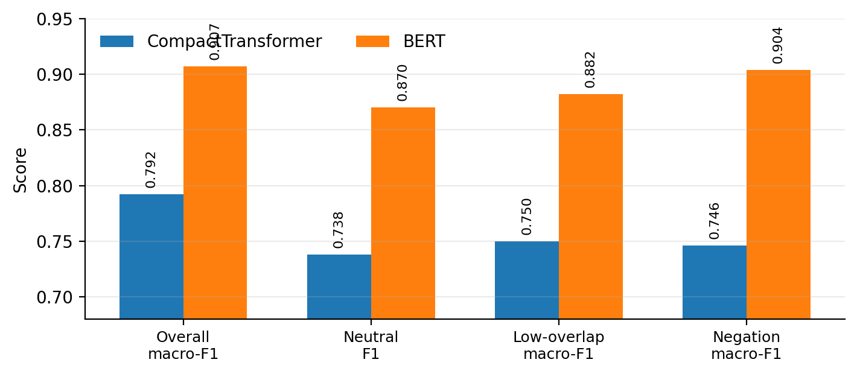
Figure 1. BERT gains are concentrated in diagnostically harder regions, indicating that compactness degrades fine-grained semantic discrimination before it affects simpler slices.
4. Diagnostics, exploratory ablations, and limitations
The most informative result of the study is not simply that BERT wins overall, but where the compact encoder loses ground first. The degradation is concentrated in diagnostically harder regions: the neutral class, low lexical-overlap pairs, and examples containing negation. By contrast, slice differences by sequence length are comparatively modest. This pattern suggests that the compact model is limited less by input span than by the need for finer semantic discrimination beyond surface similarity.
I also conducted a reduced-budget ablation study within the compact architecture to test whether design choices beyond parameter count materially affect behavior. Under this exploratory protocol, sinusoidal positional encoding performed better than the default learned variant, while deeper and alternative pooling configurations did not improve quality under the same budget. These results should be interpreted as directional rather than definitive, but they indicate that compact encoder performance is sensitive to internal design decisions and not determined by size alone.
The study has several limitations. The compact model was additionally verified across three seeds, but the cross-model comparison still relies on a single BERT run, so full variance estimates remain incomplete. The analysis is also centered on SNLI; adding HANS or MNLI would strengthen claims about out-of-distribution behavior. Finally, the comparison is intentionally practical rather than perfectly factorized: BERT benefits from large-scale pretraining, whereas the compact encoder is trained from scratch. Even so, the study supports a concrete conclusion: compact encoders remain viable when efficiency is the primary objective, but the first losses appear in precisely those regions that require stronger semantic discrimination and more reliable uncertainty estimates. This makes them useful not as drop-in replacements for BERT, but as efficiency-oriented baselines with clearly identifiable failure modes.

References
[1] Vaswani, A., Shazeer, N., Parmar, N., et al. Attention Is All You Need. In Proceedings of the 31st International Conference on Neural Information Processing Systems (NeurIPS), 2017.
[2] Devlin, J., Chang, M.-W., Lee, K., and Toutanova, K. BERT: Pre-training of Deep Bidirectional Transformers for Language Understanding. In Proceedings of the 2019 Conference of the North American Chapter of the Association for Computational Linguistics: Human Language Technologies (NAACL-HLT), 2019.
[3] Jiao, X., Yin, Y., Shang, L., et al. TinyBERT: Distilling BERT for Natural Language Understanding. In Findings of the Association for Computational Linguistics: EMNLP 2020, 2020.
[4] Warner, B., Chaffin, A., Clavié, B., et al. Smarter, Better, Faster, Longer: A Modern Bidirectional Encoder for Fast, Memory Efficient, and Long Context Finetuning and Inference. In Proceedings of the 63rd Annual Meeting of the Association for Computational Linguistics (Volume 1: Long Papers), 2025.
[5] Le Breton, L., Fournier, Q., El Mezouar, M., Morris, J. X., and Chandar, S. NeoBERT: A Next-Generation BERT. arXiv preprint arXiv:2502.19587, 2025.
[6] McCoy, R. T., Pavlick, E., and Linzen, T. Right for the Wrong Reasons: Diagnosing Syntactic Heuristics in Natural Language Inference. In Proceedings of the 57th Annual Meeting of the Association for Computational Linguistics (ACL), 2019.
[7] Geng, J., Cai, F., Wang, Y., Koeppl, H., Nakov, P., and Gurevych, I. A Survey of Confidence Estimation and Calibration in Large Language Models. In Proceedings of the 2024 Conference of the North American Chapter of the Association for Computational Linguistics: Human Language Technologies (Volume 1: Long Papers), 2024.
[8] Bowman, S. R., Angeli, G., Potts, C., and Manning, C. D. A Large Annotated Corpus for Learning Natural Language Inference. In Proceedings of the 2015 Conference on Empirical Methods in Natural Language Processing (EMNLP), 2015.

