When Compact Encoders Should Abstain: Selective Prediction and Calibration under Distribution Shift in NLI
Polina Chudinova
Abstract
This project studies whether calibration and selective prediction can make a compact encoder useful under distribution shift in natural language inference (NLI). I compare an 11.0M-parameter Transformer encoder trained from scratch on SNLI with a fine-tuned 109.5M-parameter BERT-base baseline. Evaluation covers in-domain SNLI and shifted MNLI matched, MNLI mismatched, and HANS. Temperature scaling is fit on SNLI validation data, and abstention is analyzed through calibrated fixed-coverage prediction. The compact encoder is reasonably calibratable in-domain, reaching 0.751 accuracy and 0.027 ECE on SNLI after calibration, while offering roughly 10x fewer parameters and 22.9x higher throughput than BERT-base. However, under shift it drops to 0.440-0.447 accuracy on MNLI and 0.494 on HANS, with abstention providing little practical rescue outside the training distribution. The results suggest that compact encoders can be useful as fast in-domain filters or routing models, but should not be treated as reliable standalone decision-makers under shift without stronger pretraining, OOD-aware training, or explicit reject-option objectives.
1. Setup and evaluation protocol
The compact model uses token and positional embeddings, 4 Transformer encoder layers, hidden size 256, 4 attention heads, feed-forward width 1024, mean pooling, and a linear classifier. BERT-base-uncased is fine-tuned as the strong baseline. All runs use a maximum sequence length of 128 and are repeated across three seeds (17, 42, 73).
Training uses SNLI train, model selection uses SNLI validation, and final in-domain testing uses SNLI test. Distribution shift is measured on MNLI matched and mismatched, while HANS provides a targeted heuristic stress test. For HANS, three-way NLI predictions are collapsed into binary entailment vs non-entailment. The main metrics are accuracy, macro-F1 or binary F1, NLL, Brier score, and expected calibration error (ECE). Selective prediction is evaluated with calibrated confidence and fixed target coverage levels of 95%, 90%, 80%, and 70%.
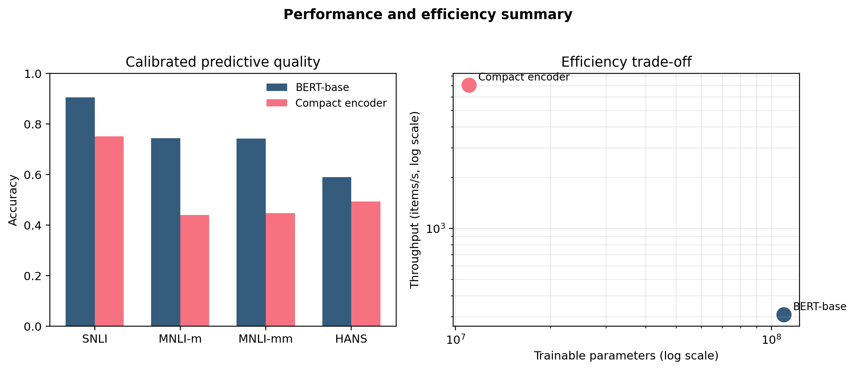
Figure 1. Calibrated quality across evaluation splits (left) and the efficiency trade-off between trainable parameters and throughput (right).
2. Results
The compact encoder is plausible in-domain but weak out-of-domain. After temperature scaling, it reaches 0.751 +- 0.008 accuracy, 0.750 +- 0.007 macro-F1, and 0.027 +- 0.002 ECE on SNLI. BERT-base remains much stronger on the same split with 0.905 +- 0.003 accuracy and 0.025 +- 0.002 ECE.
Under shift, the gap widens sharply. On MNLI matched and mismatched, the compact model falls to 0.440 +- 0.014 and 0.447 +- 0.017 accuracy, while BERT-base reaches 0.744 +- 0.007 and 0.742 +- 0.012. Relative to calibrated SNLI performance, the compact model loses about 0.31 accuracy on MNLI, nearly twice the degradation seen for BERT-base (about 0.16). On HANS, the compact model reaches only 0.494 +- 0.005 accuracy, close to chance, versus 0.589 +- 0.022 for BERT-base.
Calibration metrics alone do not solve the operational problem. On HANS, the compact model has lower post-hoc ECE than BERT-base (0.253 vs 0.324), yet it remains the weaker classifier by a large margin. This matters because a deployment policy needs both accurate predictions and a confidence ranking that correctly separates safe from unsafe cases.
Numerical takeaway. The compact encoder uses 11.0M trainable parameters and processes 7085.5 items/s, compared with 109.5M parameters and 309.3 items/s for BERT-base. The efficiency gain is real; the reliability cost under shift is also real.
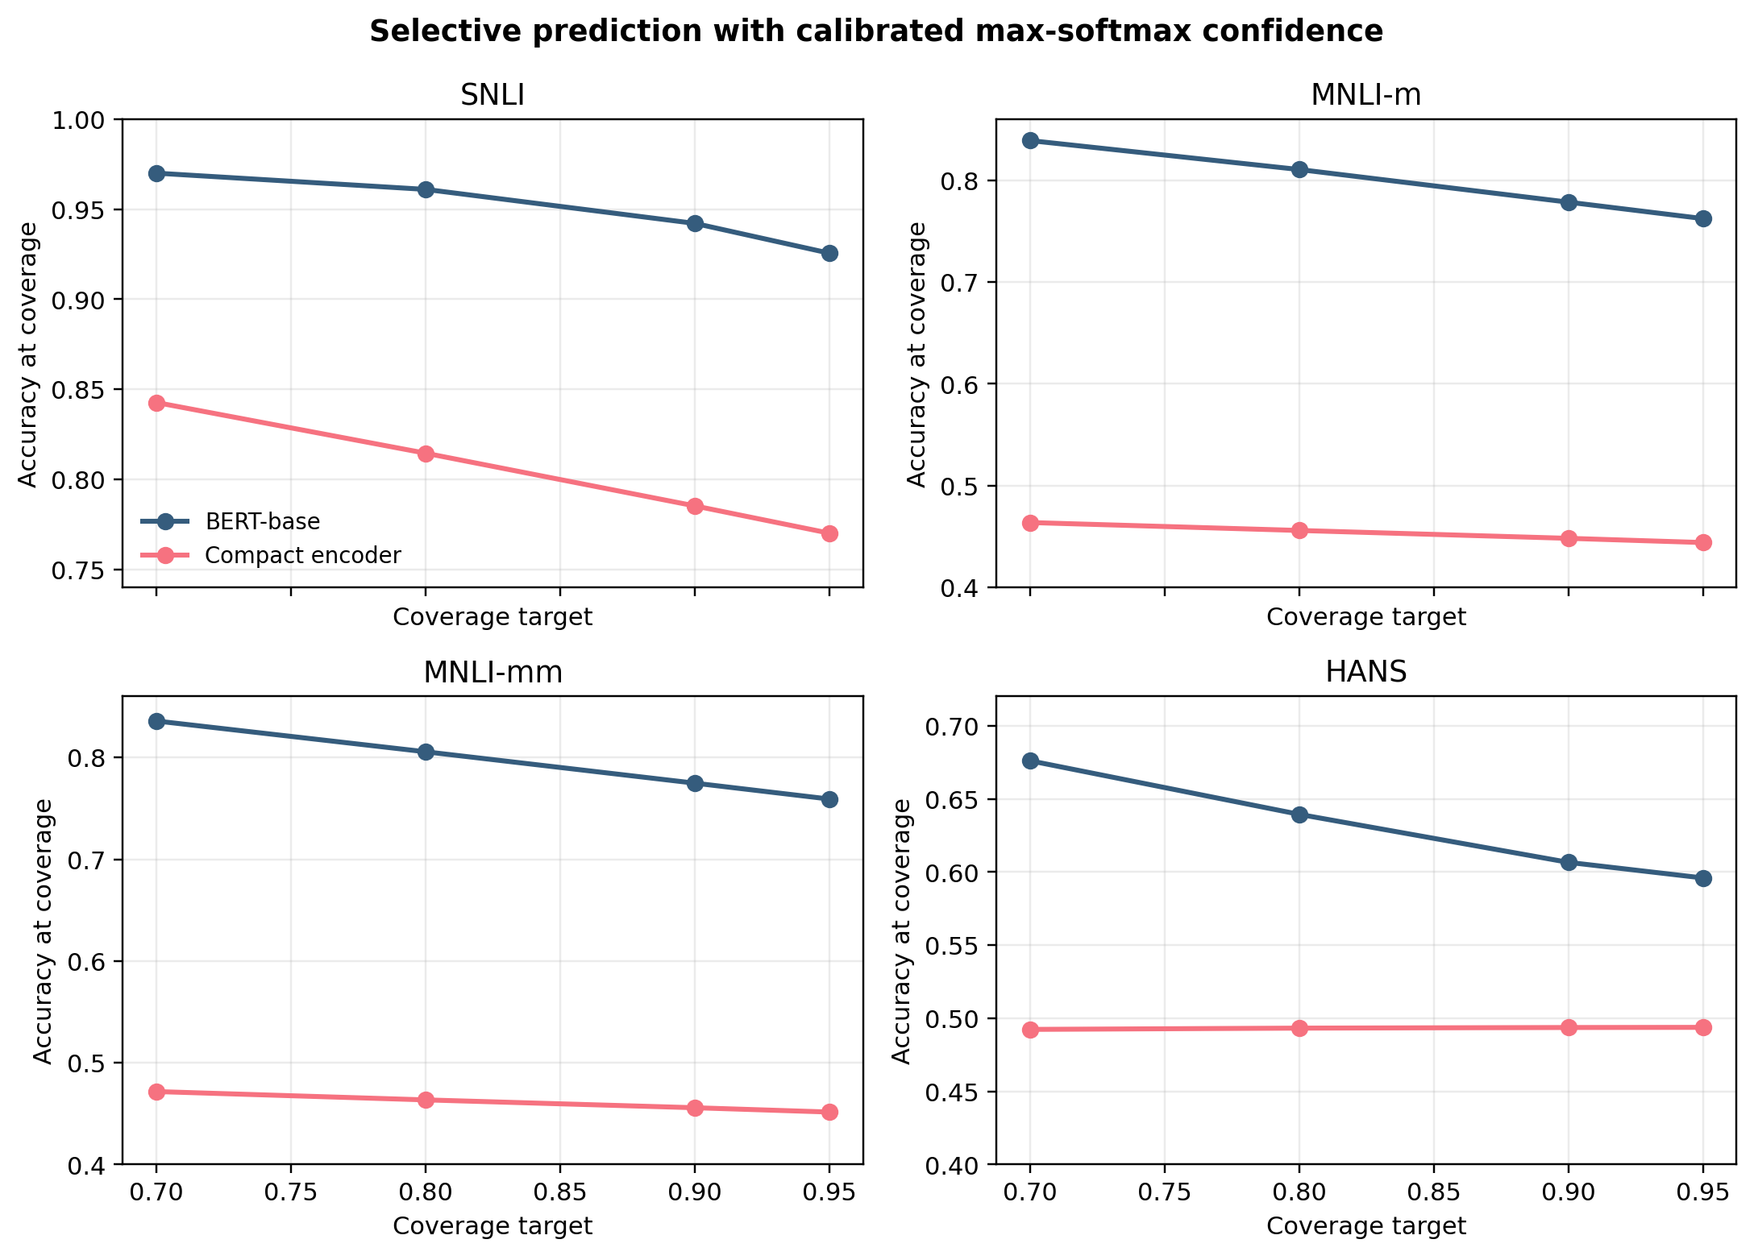
Figure 2. Accuracy at fixed target coverage under calibrated max-softmax abstention. Abstention helps the compact encoder on SNLI, but its advantage nearly vanishes on MNLI and HANS.
3. Interpretation and next steps
Figure 2 shows the central operational result. On SNLI, the compact encoder improves from 0.770 accuracy at 95% coverage to 0.843 at 70% coverage, so abstention is genuinely useful in-domain. On MNLI the same strategy barely helps, moving only from about 0.444-0.452 to 0.464-0.472. On HANS the curve is nearly flat at about 0.49. In other words, under shift the compact encoder is not only wrong more often, but also poor at recognizing which cases it should avoid answering.
The main limitation is that the compact encoder is trained from scratch rather than pretrained at scale, so this is not a blanket verdict on all small encoders. Instead, it is a controlled result about a strong efficiency-first baseline. The next step is to test pretrained compact encoders, shift-aware training, explicit reject-option objectives, and cascade policies in which the small model abstains to a stronger backbone or a human reviewer.
Conclusion. Compact encoders can be reasonably calibrated and selectively useful in-domain, but in this study they remain unreliable standalone decision-makers under distribution shift. The practical lesson is to give them an abstain-or-escalate role, not unconditional authority.
References
- Bowman, S. R., Angeli, G., Potts, C., & Manning, C. D. (2015). A large annotated corpus for learning natural language inference. EMNLP.
- Williams, A., Nangia, N., & Bowman, S. R. (2018). A broad-coverage challenge corpus for sentence understanding through inference. NAACL.
- McCoy, T., Pavlick, E., & Linzen, T. (2019). Right for the wrong reasons: Diagnosing syntactic heuristics in natural language inference. ACL.
- Guo, C., Pleiss, G., Sun, Y., & Weinberger, K. Q. (2017). On calibration of modern neural networks. ICML.
- El-Yaniv, R., & Wiener, Y. (2010). On the foundations of noise-free selective classification. Journal of Machine Learning Research.

