First start the server(port:8888)

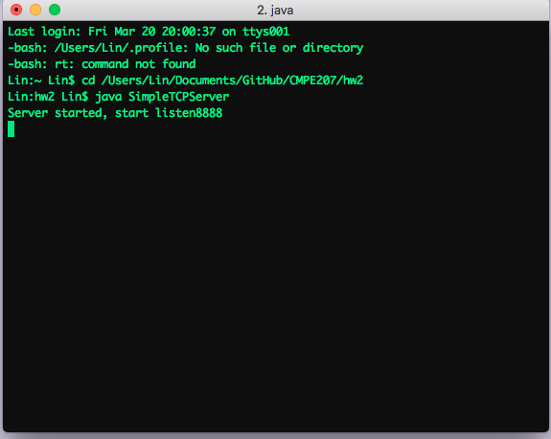

Use a client and connect to the server and get “Hello World”

