HW3 ----- Group Luxury

<https://github.com/LinCong0416/CMPE207/tree/master/hw3>

$ pip install tornado

Localhost:9000

1. Broadcast a message to connected users when someone connects or

disconnects

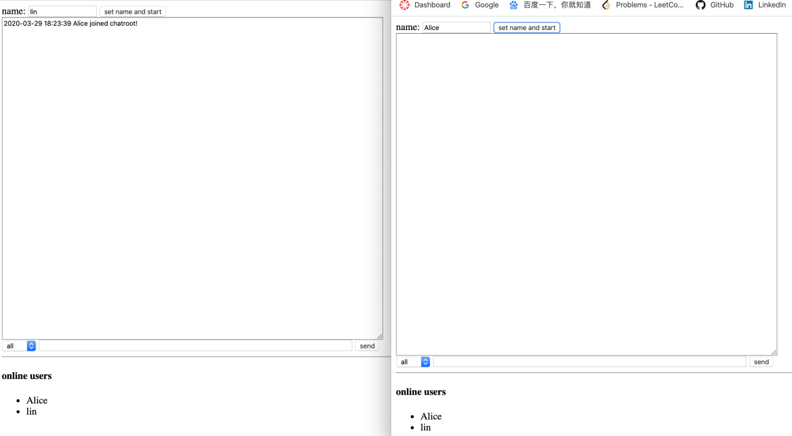

1. Add support for nicknames



1. Don’t send the same message to the user that sent it himself. Instead, append the message directly as soon as he presses enter

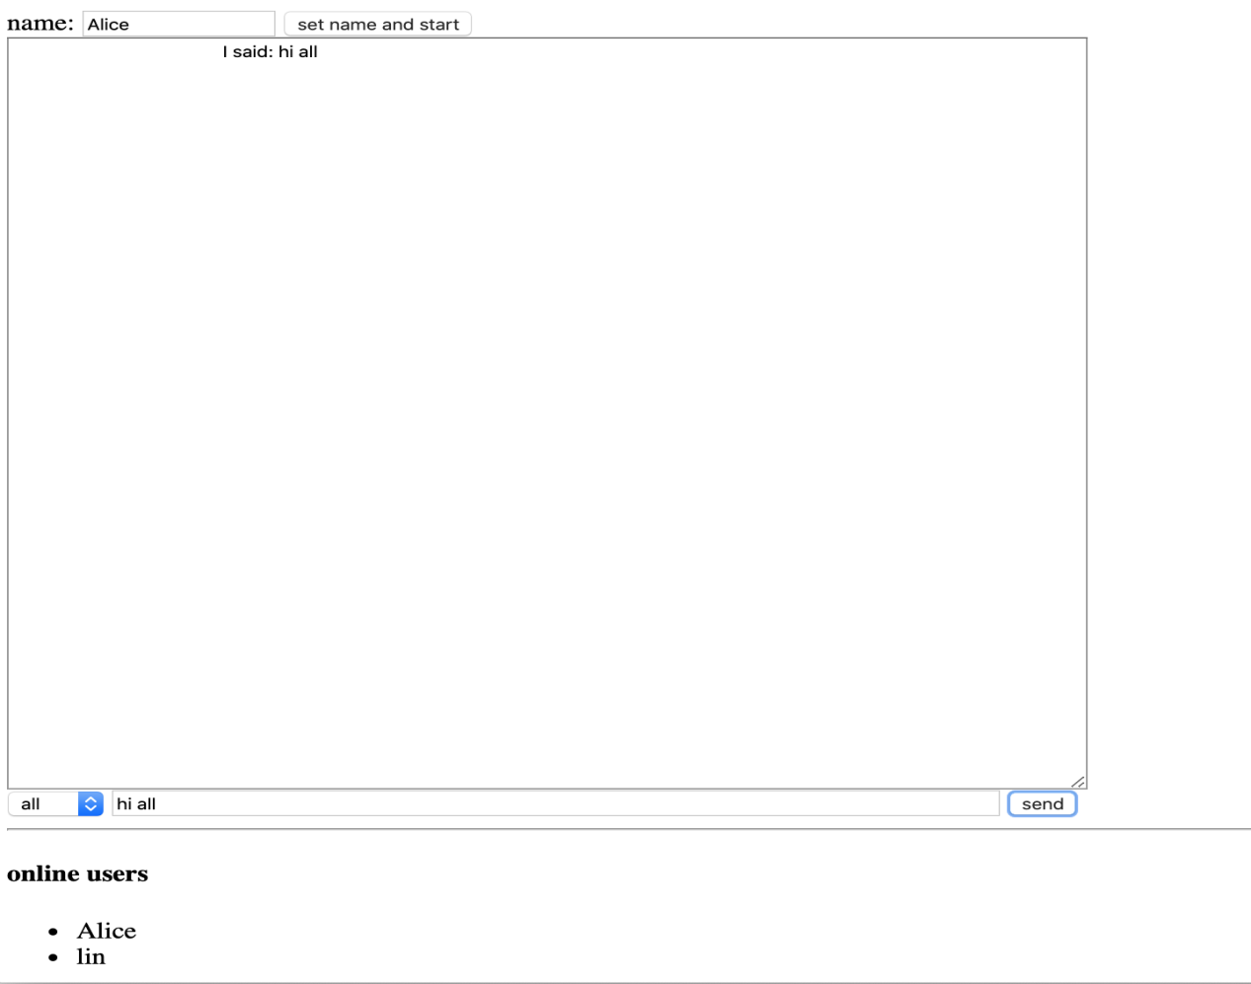

1. Add “{user} is typing” functionality

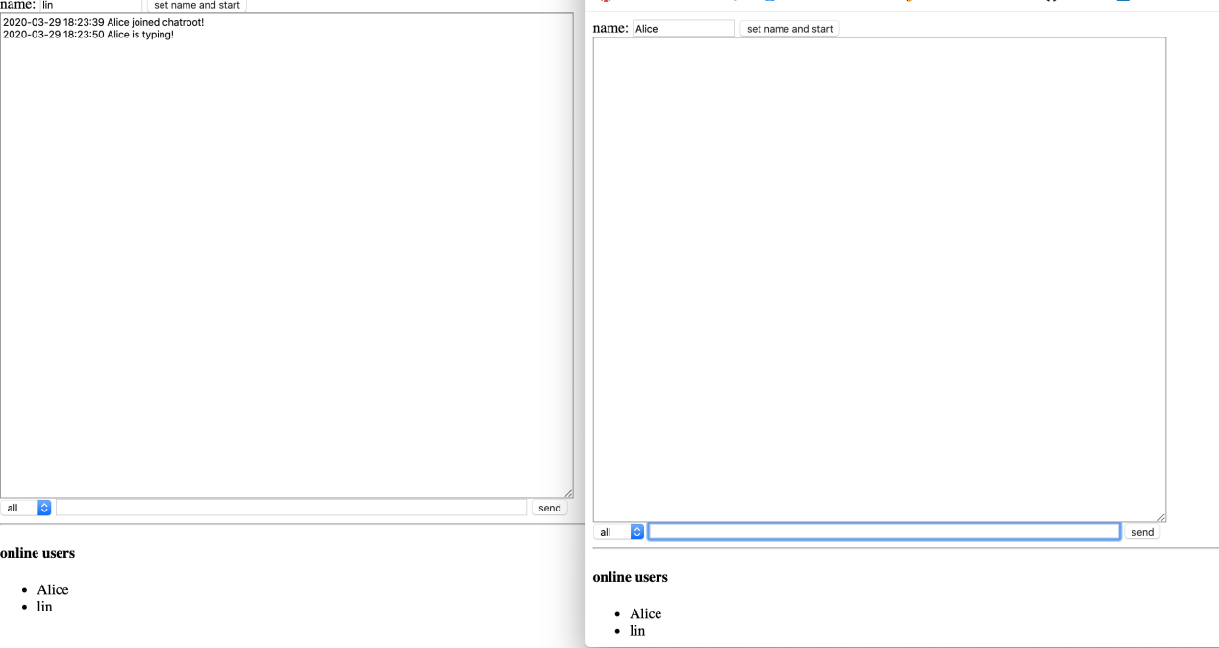

1. Show who’s online

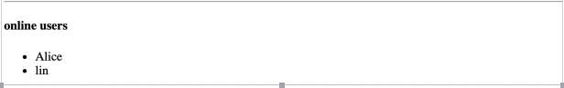

1. Add private messaging

