**HW #5 Microservice using Lambda and API Gateway**

**Group : Luxury**

1. **GET: scan table and return all items**

Scan the dynamodb table and get all the items in json format

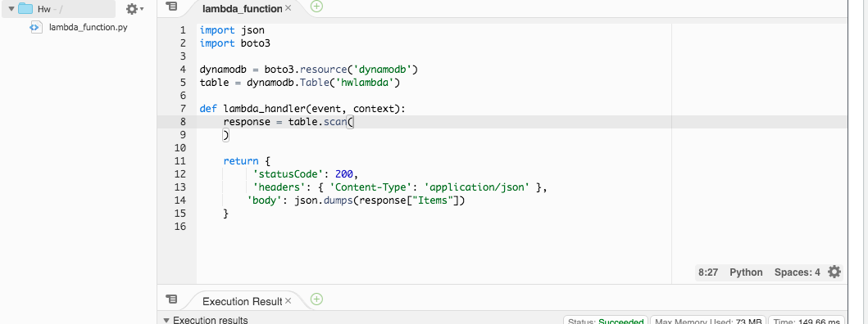

Shows in gateway api

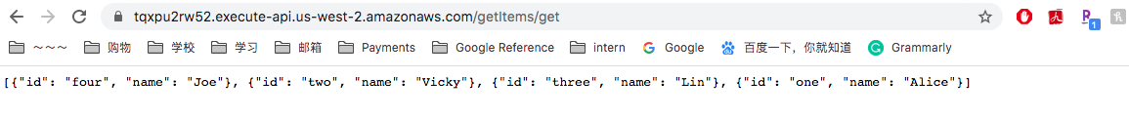

And in dynamodb

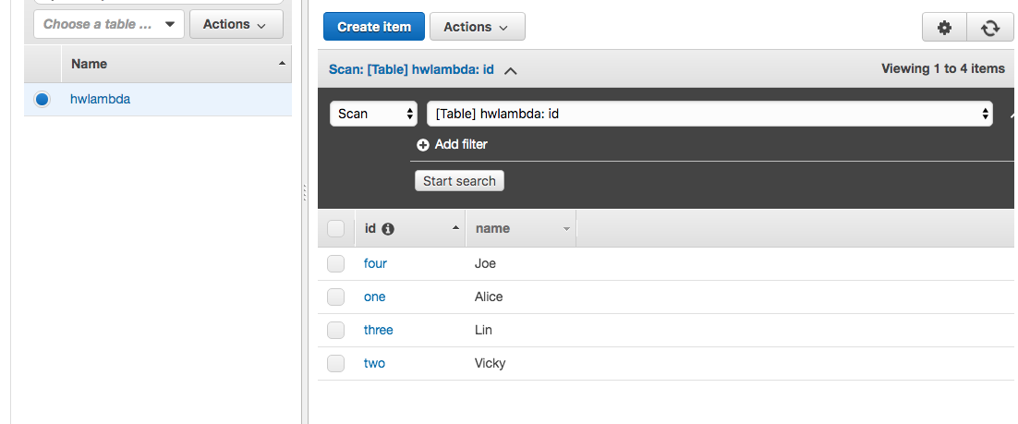

1. **POST: Create an item (e.g. to a DynamoDB table)**

Create an item in dynamodb table and return all the items in json format

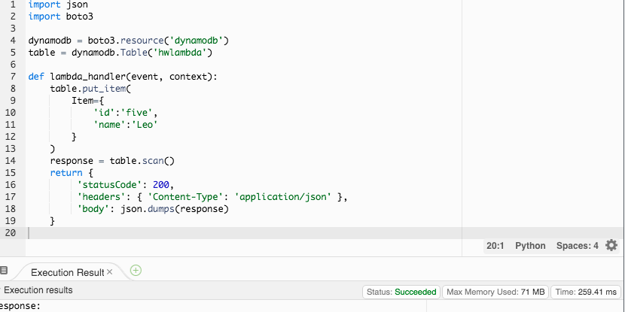

Shows in gateway api



Which ‘Id = five’ added

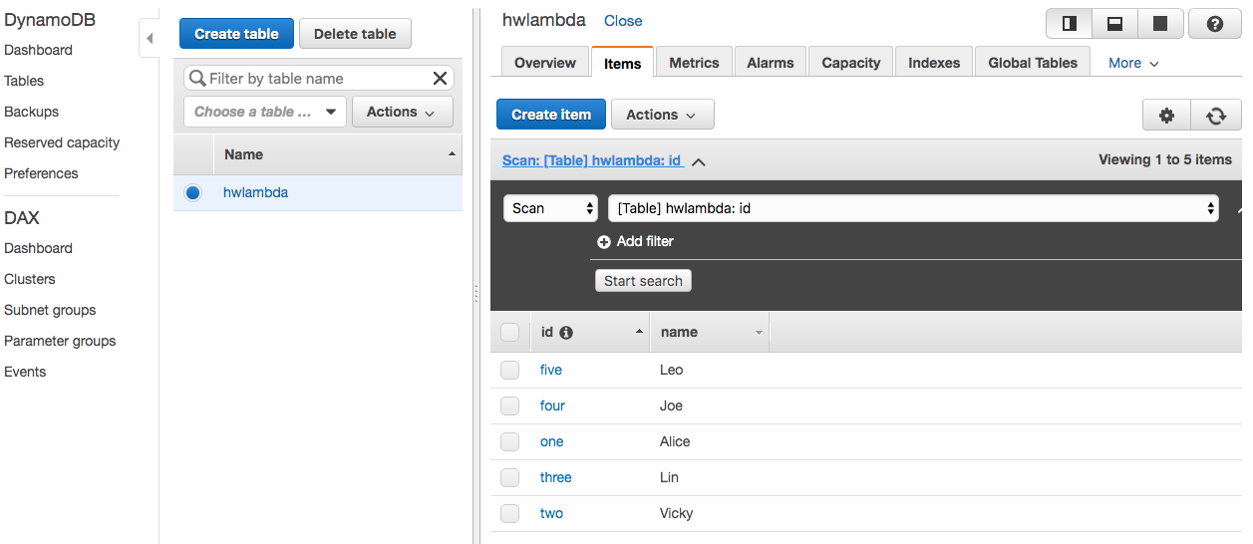

1. **DELETE: delete an item**

Delete an item in dynamodb table and return all the items in json format

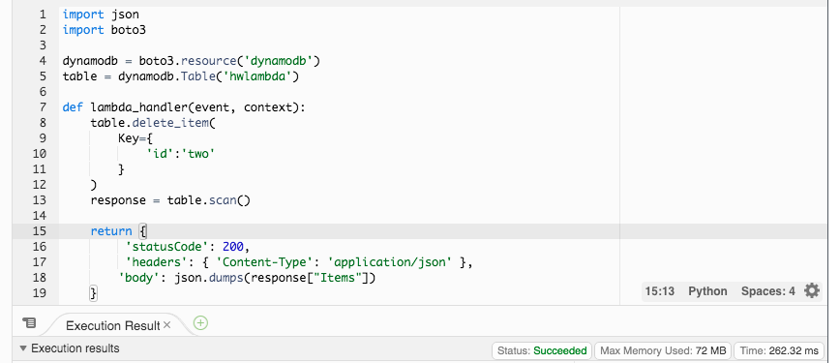

Shows in gateway api

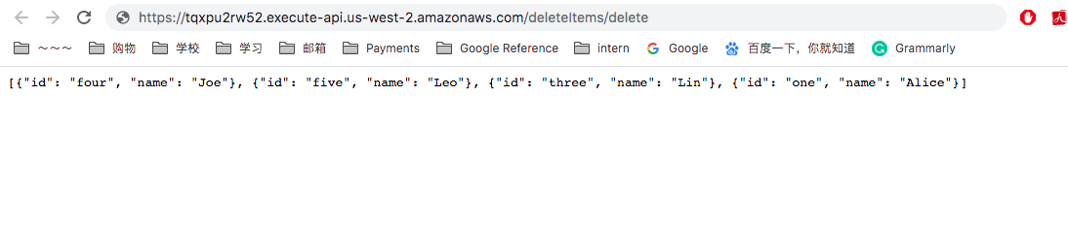

Which ‘Id = two’ deleted

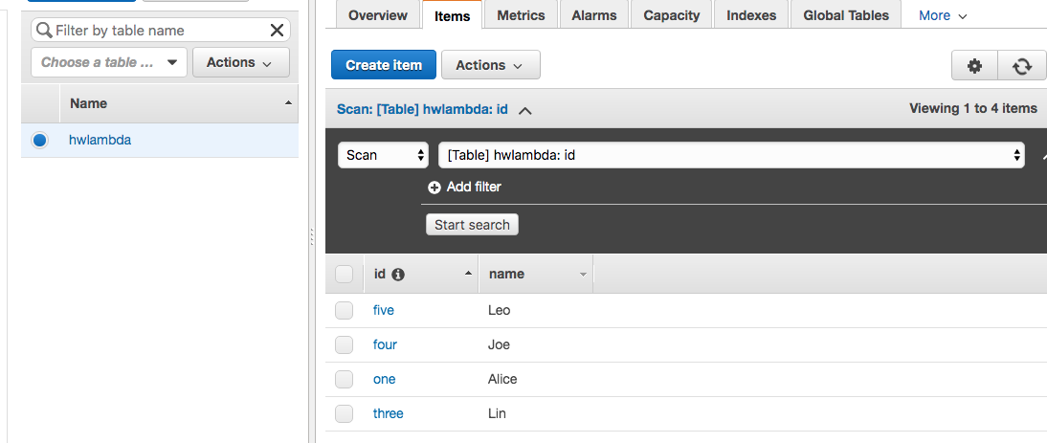

1. **PUT: Update an item**

Delete an item in dynamodb table and return all the items in json format

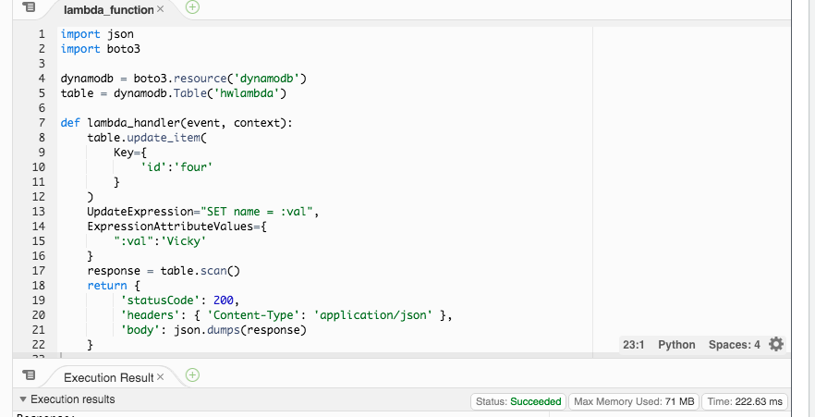

Shows in gateway api

