2022.2.21

1.

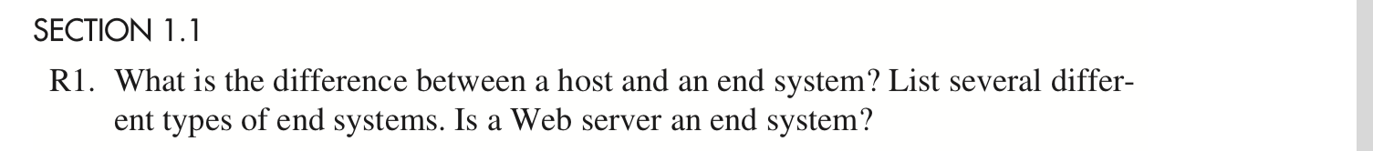

No difference between them. They are different names for devices that are connected together by a network of communication links and packet switches.

2.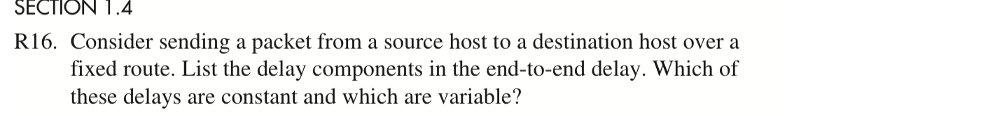

Delay: processing delays, transmission delays, propagation delays, queuing delays.

Only queuing delays are variable and other delays are constant.

3.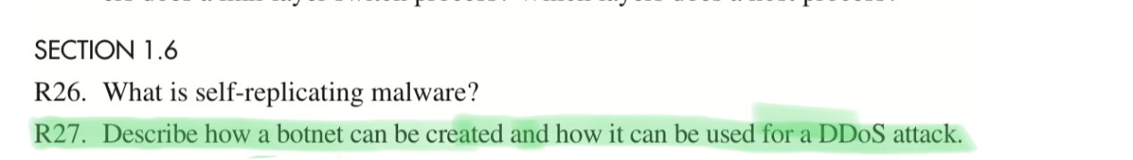

When a virus or worm infects multiple devices in a network and forms a local network controlled by it, a botnet is obtained. In distributed denial of service attacks, botnets use multiple hosts to launch attacks at the same time. Its basic principle is that the attack of a single host is easy to be seen through and shielded, but the distributed attack makes it difficult to identify the attack source.