**3TB4 Lab 1 Report**

**Lin Fu ful10 400234794**

**Keyin Liang liangk10 400236736**

D flip-flop simulation:

D flipflop with active low synchronous reset:

D flipflop with active low synchronous reset and active low enable:

D latch:

Multiplexer:

Counter:

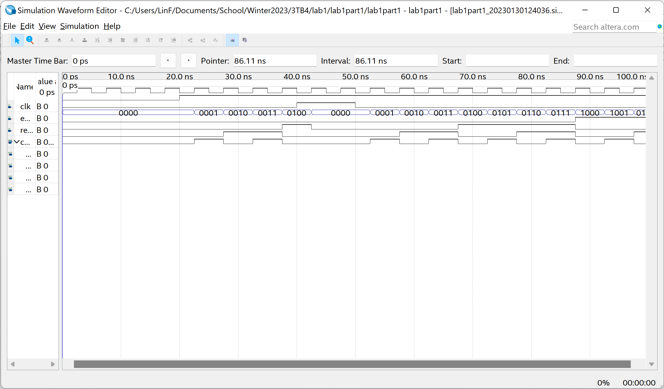

Lab1part3 RTL view:

Lab1part3 Pin Planner:

Lab1part3 complication report:

Answers to lab questions:

1. The DE1-SoC.qsf file includes all the available pin assignments on the DE1-SoC board. By importing this file to the Assignment Editor, it automatically assign pins with names pre-defined in the file, it simplifies the pin assignment process during the lab so we don’t have to assign every pin manually.

2.

• Total number of logic elements used by your circuit: 24

• Total number of registers: 38

• Total number of pins: 22

• The maximum number of logic elements that can fit on the FPGA you used: 32,070

Code for lab1part3:

