**Exercise 1. Relational algebra**

We have the following relation: R(A, B, C)

|  |  |  |
| --- | --- | --- |
| **A** | **B** | **C** |
| U | 3 | 2 |
| V | 6 | 3 |
| V | 9 | 4 |
| U | 3 | 5 |
| V | 9 | 5 |
| U | 12 | 2 |
| U | 12 | 4 |

Compute the results of the following expressions in paper and give the results:

a) γB,avg(C)(R)

b) γA,SUM(B) δ (ΠA,B R)

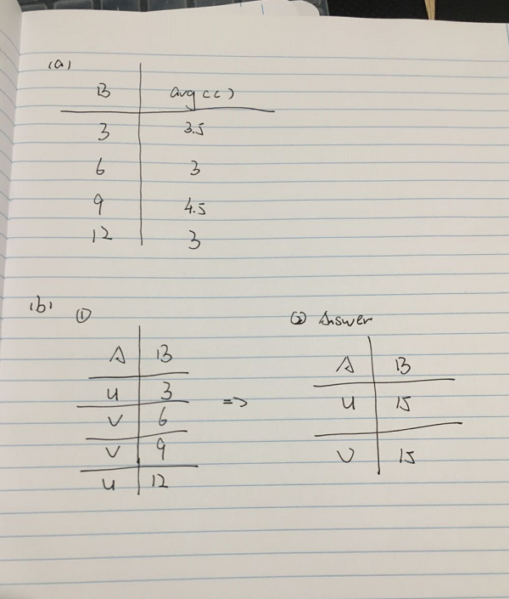

**Exercise 3. Recursion in SQL (**Tables needed: nikovits.edge)

We have a relation EDGE(Orig, Dest, Weight) which contains the edges and their weights in a directed graph. Write a recursive SQL query which gives the minimal costs of the routes from node ‘A’ to all the other nodes **(‘A’, Dest, Min_Cost)**. The output should contain node ‘A’, the destination node, and the cost of the minimal cost route from A to the destination, for example (‘A’, ‘B’, 20).

create table edge as select * from nikovits.edge;

select * from edge;

WITH reaches(orig, dest,weight) AS

(

select orig , dest , weight from edge where orig = 'A'

union all

select reaches.orig, edge.dest, edge.weight + reaches.weight from edge ,reaches

where reaches.orig <> edge.dest and reaches.dest = edge.orig

)

cycle orig,dest SET cycle_yes TO 'Y' DEFAULT 'N'

select orig,dest,min(weight) Min_Cost from reaches group by orig,dest;

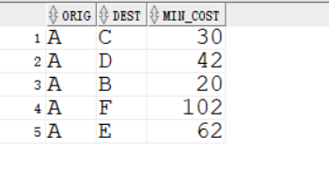

**Exercise 5. Normal Forms**

Let R(A,B,C,D) be decomposed into relations R1={A,B}, and R2={B,C,D}.

For the following FD's {B -> C, C -> D} use the chase test to tell whether the decomposition of R is lossless. If not lossless, give an example of an instance of R that returns more than R when projected onto the decomposed relations and rejoined.

My Answer :

Lossless join

We can say the C are very same in R1 and R2 because we have B->C. And we also have C->D rule so we know d are also same.

