# Project: StartupsVIS

## Basic Info

Title: StartupsVIS

Groups Members (sort in alphabetical order):

* Joris Gahéry, u1178638, u1178638@utah.edu
* Lin Jia, u1091732, [janicelin1103@gmail.com](mailto:janicelin1103@gmail.com)
* Yaodong Zhao, u1054985, yaodong.zhao@utah.edu

Project Repo: <https://github.com/LinJia00/2017-dataviscourse-project>

## Background and Motivation

Aangelist has [a database of 342 thousand](https://angel.co/companies) startups located in the United States. However, it doesn't provide us any visualization of it. So, our idea is visualizing these startups' features such as location, focused market, employee numbers, stage and total raised money. We believe that our project can not only extract fascinating insights and exciting visual effects but also it will be very useful for market analysis, job finding and recruiting.

## Project Objectives

Primary question we want to answer:

* How is the trend of these companies growing? (For Users)
* what is the high chance market and location to get a job?(For Users)
* What is the best visualization for this dataset ( For Ourselves)

We want to learn and accomplish:

By this project, we hope to represent to users information hidden in the abstract data with appropriate visualization. And, with editable parameters such as filters, we provide user a basic tool to explore the data. And We want to learn more ways to do better designs and how to let data show specifically to the users.

## Data

We will obtain our data from [Angelist's Database](https://angel.co/companies) and there is an API for this purpose.

## Data Processing

The data from Angelist is clean. However, we may need to filter out the companies lack the key attributes such as location, the number of employees and market.

## Visualization Design

We think this final design for this project can show all important attribute clearly. And it will give users an overall view of these companies features.

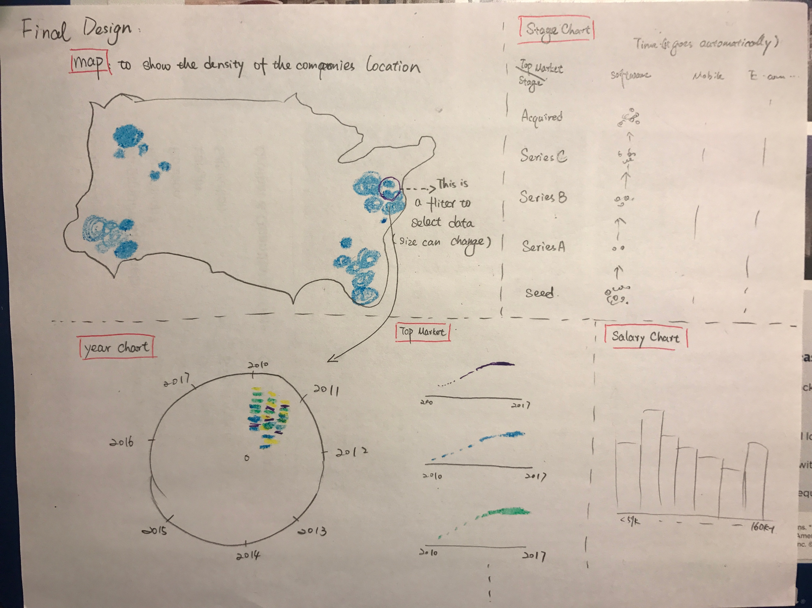

## Must-Have Features

* Top Market: It has several popular markets can be selected, such as education, mobile, healthcare, enterprise software, games, etc. So that gives users a specific career direction.
* Location: It can show a map located these companies which mean it is easy to make the area selection when the users want to find a job.
* Salary: The important factor when people want to find a job.
* Role: It can search job by role, such as hardware engineer, developer, customer service, human resources, etc.
* Time transition: It will give us an overall view of these companies.

## Optional Features

* Total raised money: Some time it doesn't matter for people who want finding a job.
* Stage(seed, seriesA, seriesB, seriesC): People may not concern about it.
* Employee Number: The company scale cannot represent its good or not.

## Project Schedule

Week 1(October 27): Discuss and design the visualization, project proposal due.

Week 2(November 3): Peer feedback. Clean up and sort the dataset, set the skeleton of class structure for the interface.

Week 3(November 10): Setup the website. Project milestone due.

Week 4(November 17): Finish every single chart.

Week 5(November 24): Link well for every chart connection and transition.

Week 6(December 1): Final Project due.