Lin Martin

August 22, 2021

IT FDN 110 A

Assignment 06

<https://linmartinn7.github.io/IntroToProg-Python-Mod06/>

# Python Functions

## Introduction

In the sixth week of Foundations of Programming: Python, our class was tasked with modifying an existing script. This script serves as an enhanced version of the previous To Do List assignments, utilizing functions in Python to perform its desired tasks. Two new elements to this assignment are using processing functions and class IO (input/outputs). These functions still process data based on the user’s input commands. As before, this script will be capturing a to do task and the item’s priority from the user using an interactive menu.

## Setting up the Script

Our class was provided a starter script to use for this assignment, similarly to last week, to continue giving us experience working with code that had been created by another developer. After downloading the Module06 zip file and extracting it to my One Drive folder, I copied the Assignment06_Starter file to the _PythonClass folder on my C Drive. I opened the file in PyCharm and updated the header to reflect my information. Lastly, I saved the file and renamed it to Assignment06_LMartin.py.

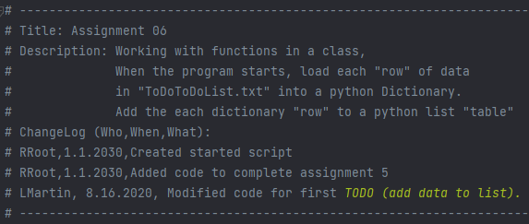

***Figure 01: Adding information to existing header for Assignment06_Starter.py.***

## Creating To Do List File

I noticed in the data variable section of the script that the ToDoFile.txt was being referred to as an existing item. This was further substantiated when I examined the code under the read_data_from_file section of the script, which is reading the existing code within the file. I created the ToDoFile.txt item in PyCharm so the script would have a file to read/write to for this assignment.

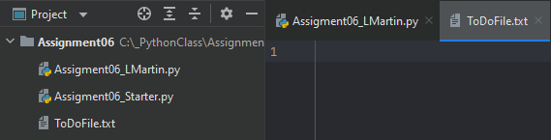

***Figure 02: Creating ToDoFile.txt in PyCharm under Assignment06 folder.***

## Processing Script

In the processing script section of the file, there were three TODO sections that needed to be completed. The first pertained to adding data to a list, the second with removing data from the list, and the third was writing data to a list.

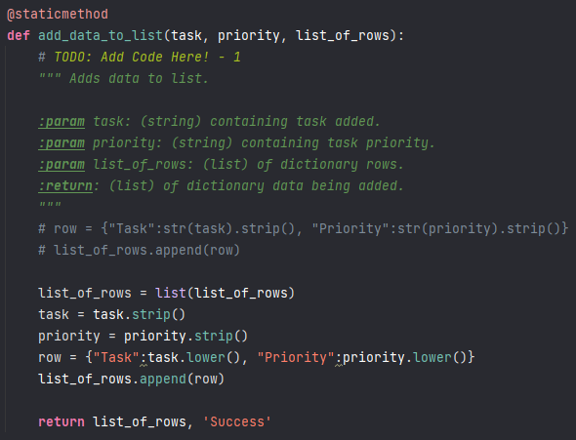

***Figure 03: Adding data to the list.***

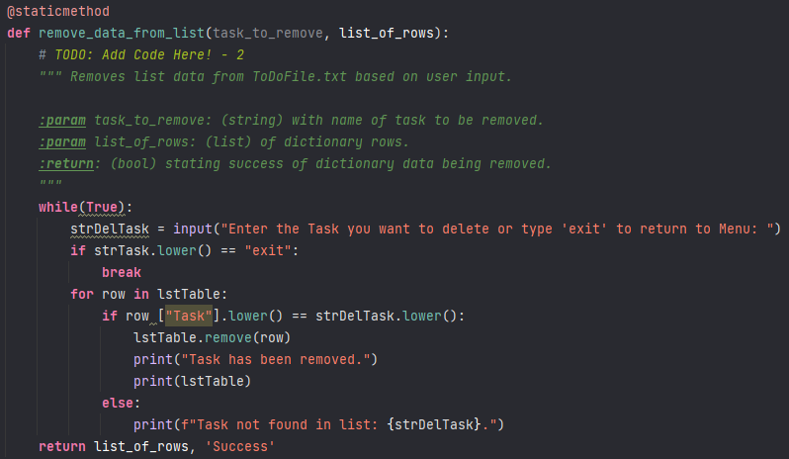

***Figure 04: Removing data from the list.***

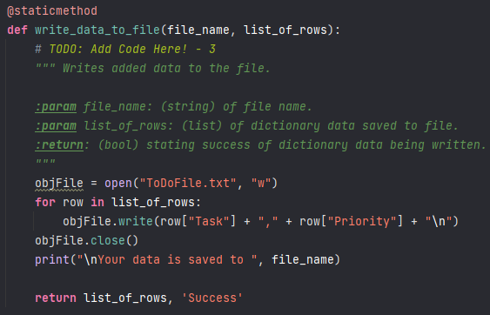

***Figure 05: Writing data to the list.***

One feature I really liked about these functions was defining the variables that were being used in the calculations. This script text automatically populating once a *“””* was added to the script was a feature I really enjoyed.

## Presentation Script

In the presentation script section of the file, there were two TODO sections that needed to be updated. The first was for inputting a new task and priority for the code (Figure 06) while the second pertained to the input for removing tasks (Figure 07).

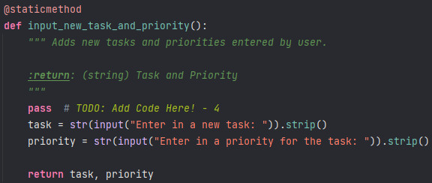

***Figure 06: Adding code for inputting new tasks and priorities.***

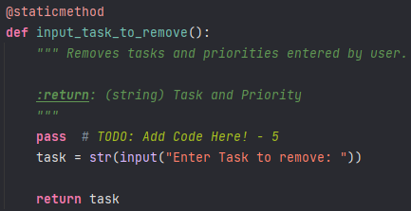

***Figure 07: Adding code for removing tasks that have been entered by users.***

These sections of the script were small and fairly straight forward. Writing these lines within the script felt very comfortable for me because it was familiar to what we have done in previous assignments.

## Main Body of Script

In the main body section of the script, there were four sections of code that needed to be updated. I went into each TODO section and added in the necessary components for each section.

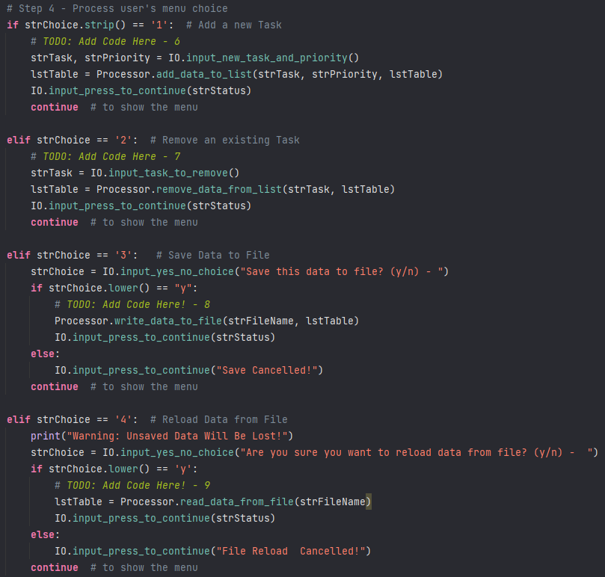

***Figure 08: Adding supplemental script reloading data from a file.***

## Testing the Script

As I began to test the different menu options of the script, I realized I had multiple errors in the script file. Something that made the troubleshooting process worse for me was having errors appearing in multiple spots within the code. By using grouped functions in this assignment, the code for each process is broken up into multiple places within the code. This made the troubleshooting process even more confusing for me, due to the errors coming from multiple places. For the specific example below, I would review the two areas of code and attempt to fix the issue, but I struggled to see where I had gone wrong with the scripts.

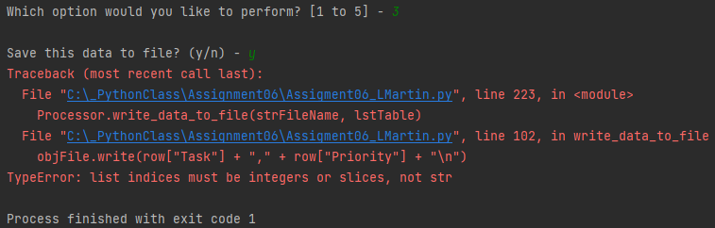

***Figure 09: Example of error when saving file.***

After much time and failed attempts at fixing my script, I decided that I should review the course videos again. As I continued to struggle with the assignment, I decided to watch the instructional video Professor Root had posted under Module 06’s review documents meant to help people who may be struggling. After watching the video, I could see where some of my code was similar to the examples, but I continued to struggle with understanding where I had gone wrong and how to improve my script.

At this point, I decided to review the answer key file that was uploaded to the review files and the second review video. The code within the file appeared to be different than the code being shown in the review videos, which confused me even further. I continued to review the videos and answer key but failed to understand where I was going wrong with the assignment.

## Creating a GitHub Page

To create a new GitHub page, I accessed my GitHub account and created a new repository for Assignment06. To create the actual site page, I created a new file by making a *docs* folder and made a landing page, *index.md*. I added a theme to the page by accessing the settings, allowing the site to look more user friendly. With the page created, I added some supplemental text and links to the two documents that were being uploaded to the site.

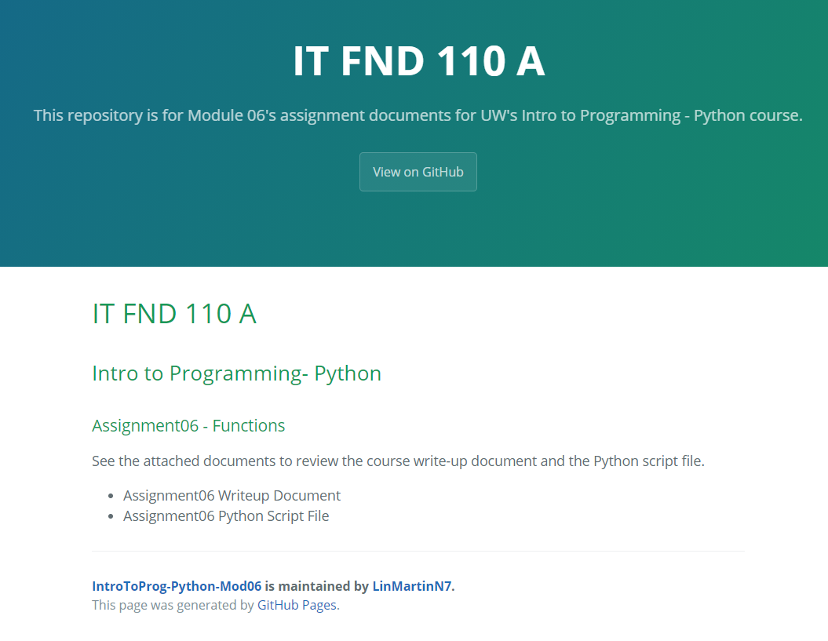

***Figure __: GitHub page created for Assignment 06***

## Summary

I have realized one of the cons of working with an existing code is that a programmer must work with code that is organized in a way that may not necessarily make the most sense to them. While working on this assignment, I kept getting confused on where I needed to add code and what step I was on. I decided to update the TODO lines in the code with numbers, making each step more easily identifiable. This also had an added benefit with the change log in the code, allowing me to document what I had worked on in a more concise manner.

Assignment 06 proved to be quite a struggle for me due to personal life barriers. The week of this assignment, I had travelled to Georgia for a family event and became ill. Due to the quick and intense onset of my symptoms, I feared I had been exposed to COVID-19, but my tests were negative for the virus. Due to the lasting symptoms of my illness, I was unable to keep up with the coursework and have struggled with comprehending the material.

After multiple hours of failing to understand how I could fix the errors with my Assignment 06 script, I decided to prioritize moving forward with Assignment 07. At this point, I feel it is more important to not fall further behind in class. I understand the importance of storing functions in a script so they can be called on later. I think this is a useful feature that can reduce a lot of redundant code when utilizing larger scripts performing complex processes. With Assignment 06, I feel I have failed to understand how to properly implement this practice but hope I can understand it in the future.