1. CF

* <https://kknews.cc/tech/mn89m66.html>
* <http://debussy.im.nuu.edu.tw/sjchen/BigData/Applications.pdf>
* <http://thuir.thu.edu.tw/bitstream/310901/29864/1/105THU00394028-001.pdf>
* <https://codertw.com/%E7%A8%8B%E5%BC%8F%E8%AA%9E%E8%A8%80/600214/>
* <https://www.itread01.com/content/1555155007.html> (UserCF程式)

1. CB

<https://www.twblogs.net/a/5c8a47e6bd9eee35fc14b19f>

<https://blog.csdn.net/u013207865/article/details/52373105>

<https://codertw.com/%E7%A8%8B%E5%BC%8F%E8%AA%9E%E8%A8%80/600209/>

<https://kknews.cc/zh-tw/tech/rq84a6r.html>

<https://zhuanlan.zhihu.com/p/98295397> (含程式)

1. **混合推薦**

<http://ir.lib.pccu.edu.tw/bitstream/987654321/25055/2/KM12.pdf>

1. 冷啟動問題解決方案

* <https://www.jianshu.com/p/03bf81f9f6d9>

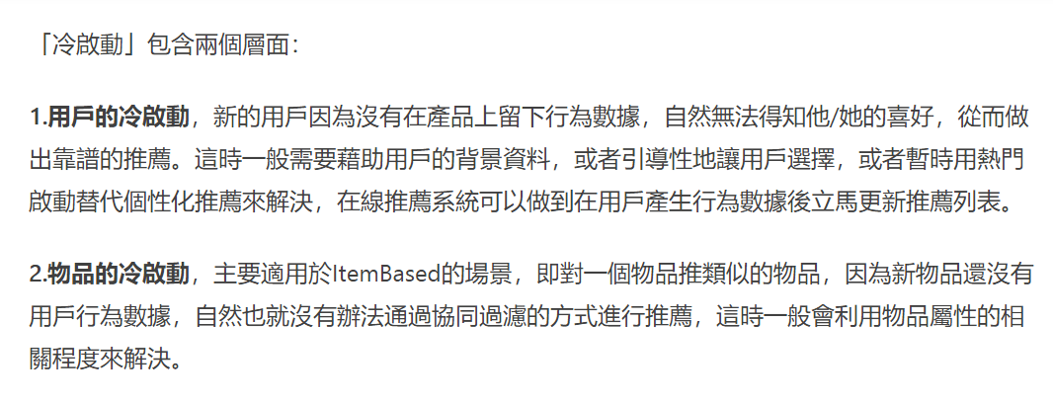

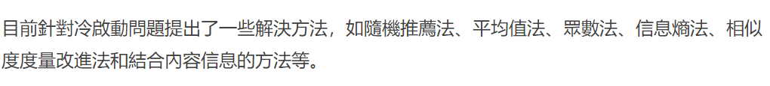

* <https://kknews.cc/zh-tw/news/826qool.html>

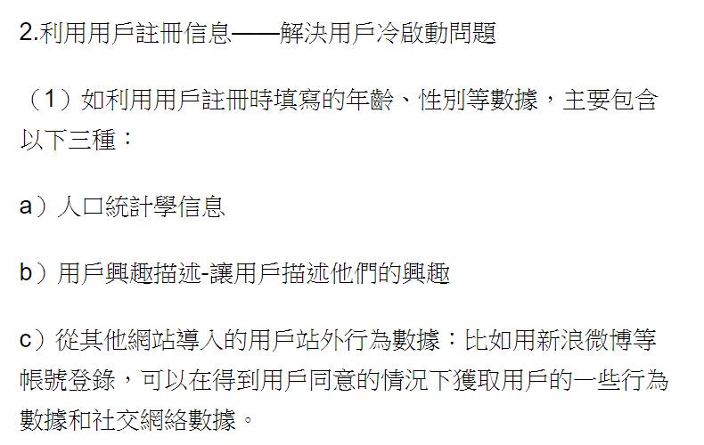

* <https://kknews.cc/tech/zbkongl.html> (較難施行)
* <https://zhuanlan.zhihu.com/p/47371859> 有圖片
* <https://twgreatdaily.com/Wrt_5W0BMH2_cNUgtfOo.html>
* 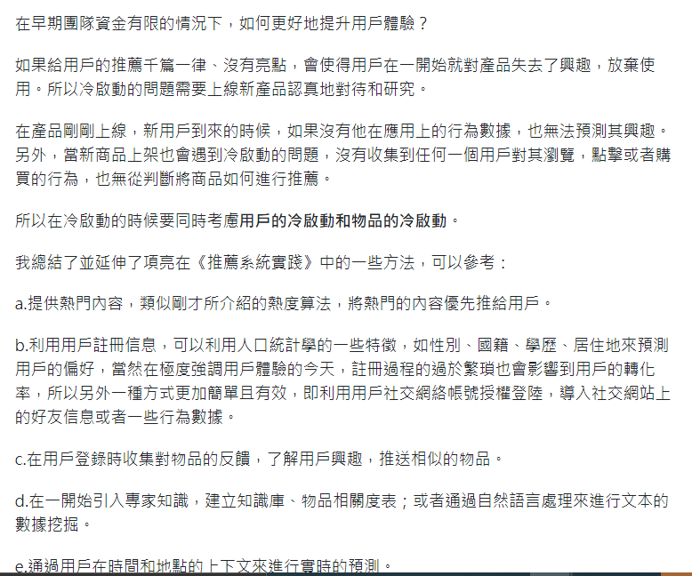
* <http://www.mis.ttu.edu.tw/ezfiles/72/1072/img/322/45934657.pdf>

複合推薦 可解決 CF 矩陣稀疏等問題

* 所有演算法介紹
  + <https://kknews.cc/tech/9vl9vlb.html>
  + <https://nccur.lib.nccu.edu.tw/bitstream/140.119/101253/1/101901.pdf>
  + <https://highscope.ch.ntu.edu.tw/wordpress/?p=80099>
  + file:///C:/Users/ntp92/Downloads/etd-0113117-153742.pdf
  + <http://www.mis.ttu.edu.tw/ezfiles/72/1072/img/323/409698579.pdf>
  + <https://zhuanlan.zhihu.com/p/53648248>
  + <http://www.ipshop.xyz/10227.html>
  + <https://www.itread01.com/content/1549737543.html>
  + <https://www.cnblogs.com/zhengzhicong/p/12817941.html#_label0_2> 非常詳細
  + <https://blog.xuite.net/metafun/life/131996342-Recommendation+Systems%E5%92%8C%E5%8D%94%E5%90%8C%E9%81%8E%E6%BF%BE%28CF%29%E7%B0%A1%E4%BB%8B> 很詳細

1. 程式碼

* <https://www.itread01.com/content/1545858572.html>

1. 推薦系統優缺點

