# Design Document

# To Do List



Subject

INT3052-F19-M

Cross-platform Applications

Prepared by

Lin shun 7236

## **Summary of the app**

This to do list app is helpful to users to keep track of various tasks simply and quickly. This application does not require users to login, add categories or some other complex steps, it just requires users to input the event name, and take a picture to remind users what the task is. And people can change the background image by taking a background picture.

## **Audience**

The audiences of to do list app is the people who want to organize their tasks and people who feel they are forgetful. To do list can help people to organize their tasks, make everything become manageable and make people feel grounded, and they can check the progress of their tasks on the to-do list, so people who want to organize their tasks is the audience of the app. The people who feel they are forgetful are the target audience of the app as well. To-do lists are a useful external memory aid, people can record all the tasks on the to- do list, then as long as they do not forget to look at their to-do list, they will never lose anything that they have recorded on it.

## **The Experience**

This to-do list app is extremely easy, people can add task, delete task, mark task as done by some simple steps. Without all the complex steps like other to-do list, people can use this app to focus on their tasks at ease.

## **How The App Will Be Used**

Example 1:

A user need to plan a party and need to quickly make a list of items to buy.The user can launch the app then add items needed and take photos of items quickly. When the users go shopping, he can check the items he needed. After he bought the items, he can mark the items as done or remove the items out of the to-do list, then he can focus on the items he has not bought.

Example 2:

A user need to do an assignment, the user can break the assignment into some tasks, then the user can launch the app and record all the tasks,after that, he can check all the tasks and any time and track the progress of the assignment.

## **Main Features**

1. People can add task by inputting the name of tasks on the text box, then click the add button to take a picture to describe the task.

2.When a task has been completed, the task can be marked as done by a simple click,then the task background color will change to dark grey, a check mark will be added to the left of the task and the task will be marked with strikethrough text.

3. People can click the close button and the end of the task to remove completed task.

4. People can click the take a background image to change the background image of this app.

## **Wireframes**

1. Main screen

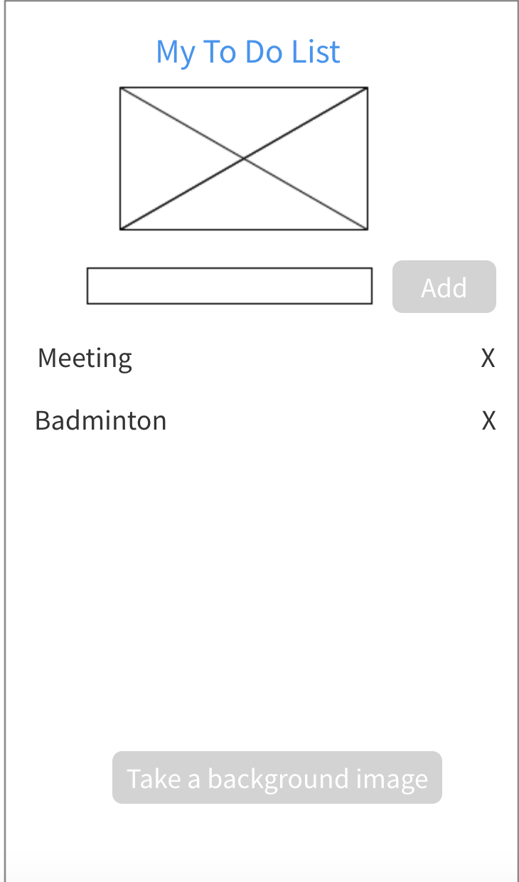

1. Add tasks

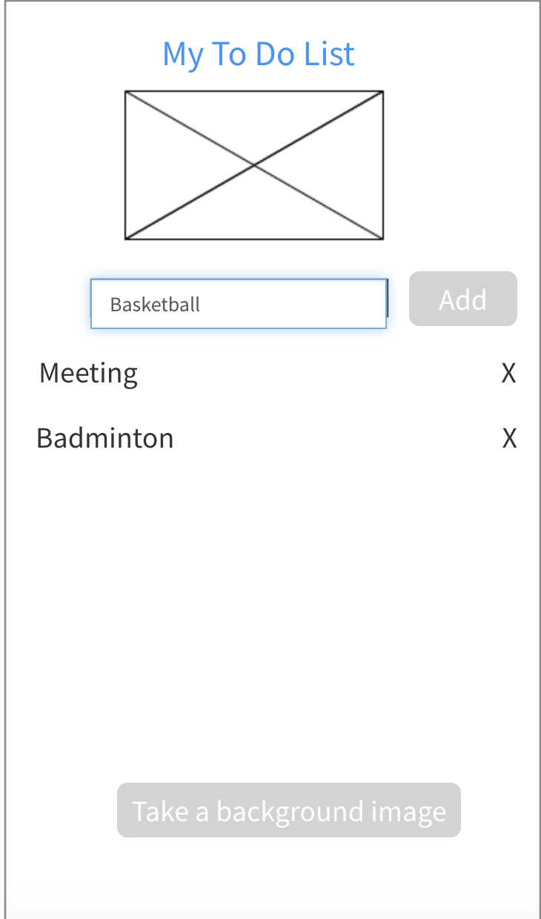

1. Mark task as done

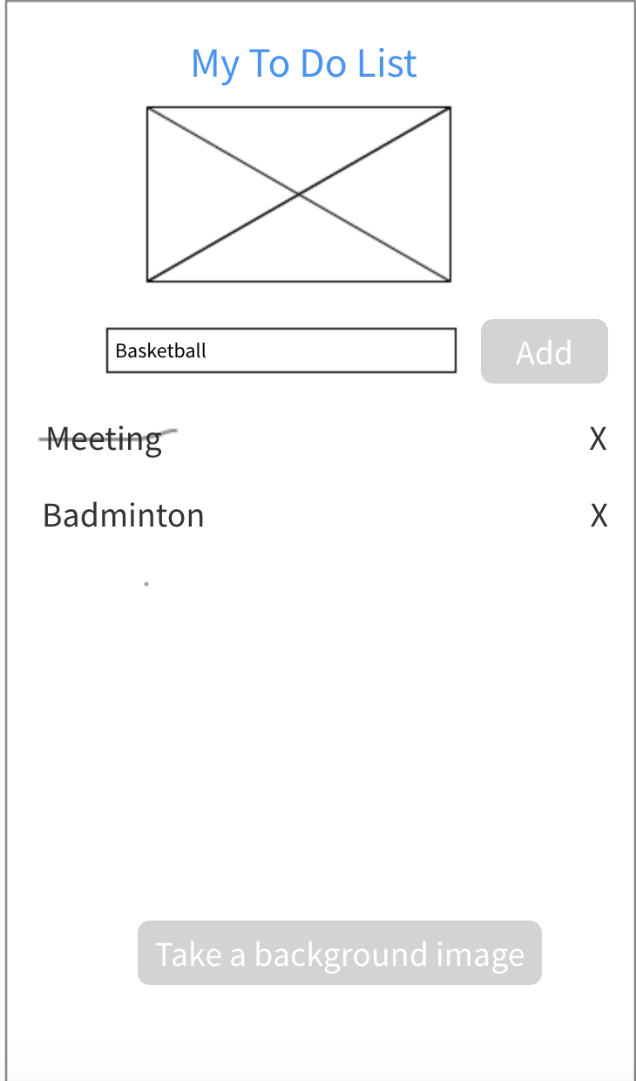

1. Remove task

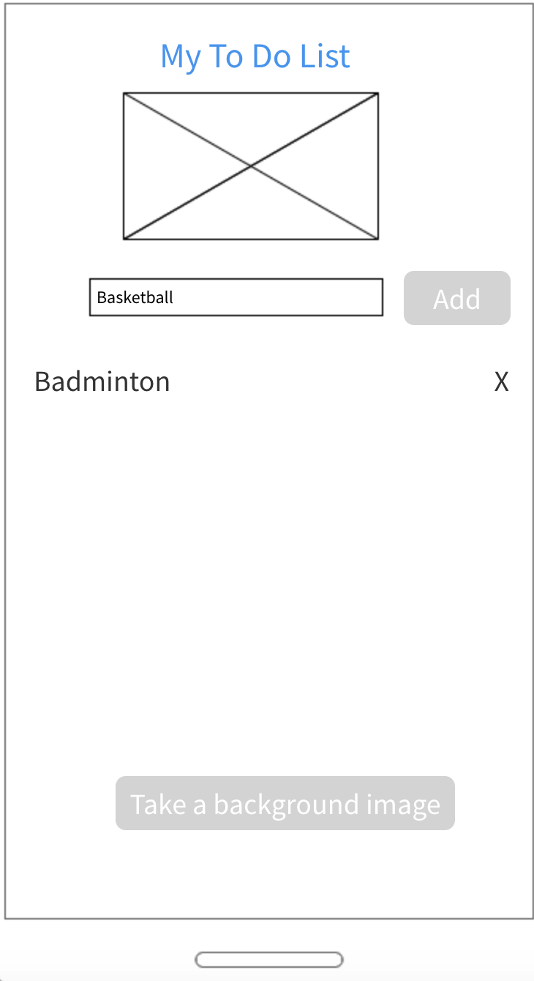

### **7. Workflow**

Some basic functions of this app are shown below.

1. Add task

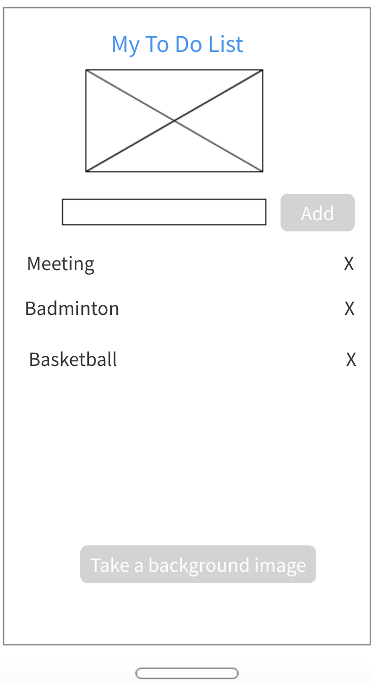

1. Delete task

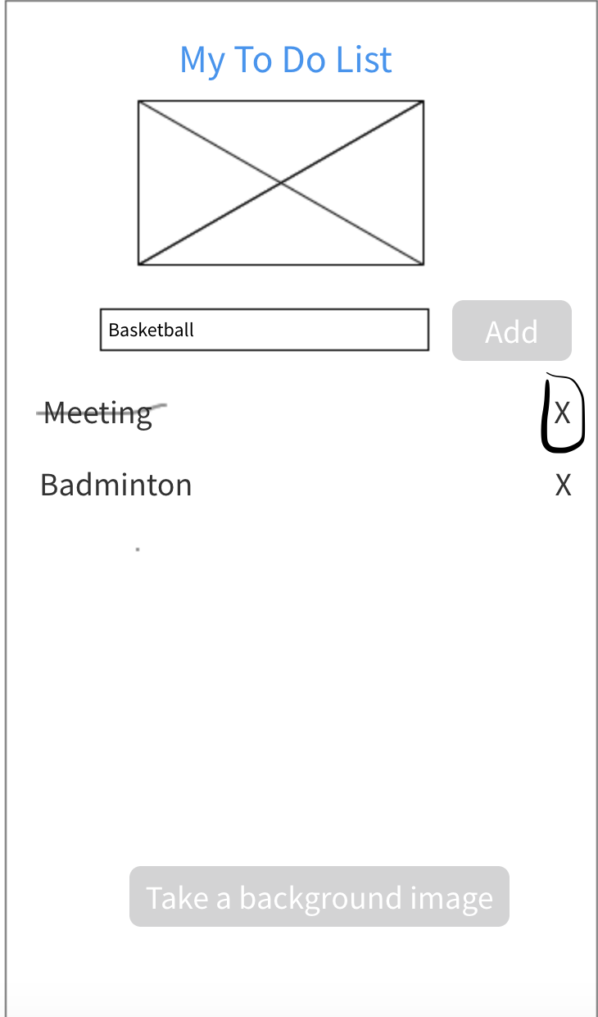

## **8. Mockup**

1. Main screen

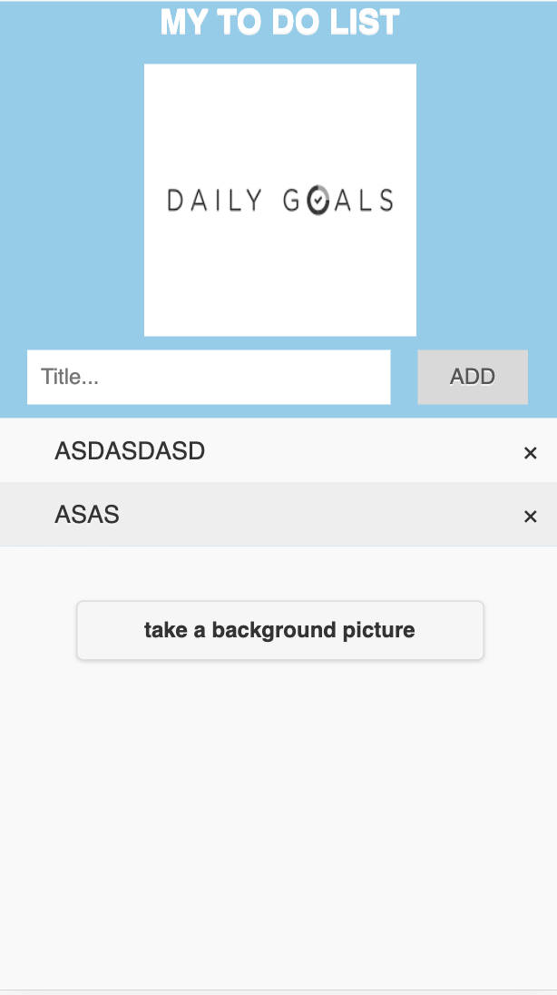

1. Entering a new task

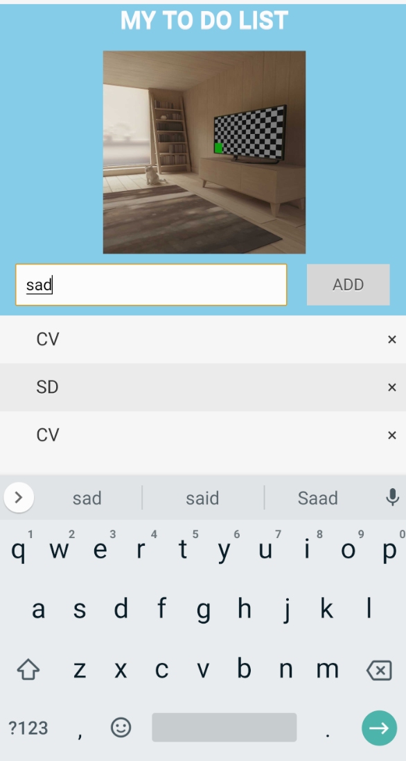

1. Remove task

