Antimicrobial Peptides Sequence Data Analysis - Results & Visualizations

# 1. Sequence Length Distribution

The distribution of sequence lengths shows a right-skewed pattern with a majority of peptides below 40 amino acids. Total sequences analyzed: 15,413. The longest sequence has 190 residues.

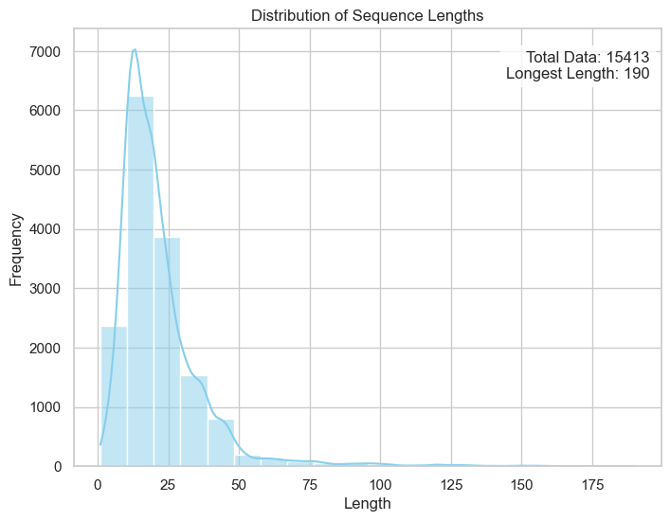

# 2. Boxplot of Sequence Lengths

The boxplot reveals the interquartile range of peptide lengths and highlights the presence of significant outliers beyond 100 residues.

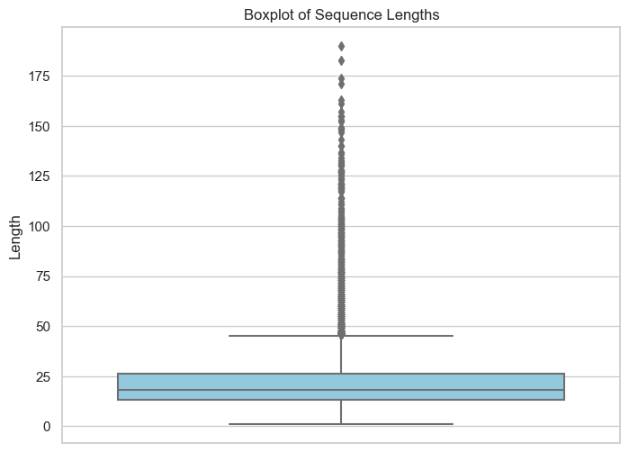

# 3. Violin Plot of Sequence Lengths

The violin plot shows the density distribution of peptide lengths, reinforcing the concentration around shorter sequences.

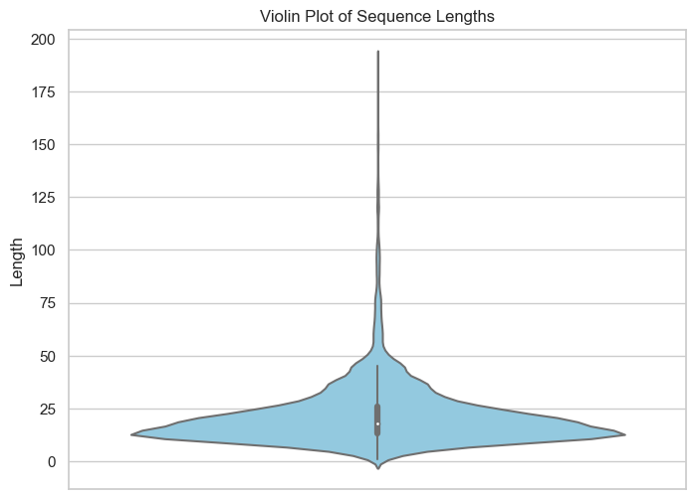

# 4. Amino Acid Composition

Lysine (K), Leucine (L), and Arginine (R) are the most frequent amino acids in the AMP dataset, indicating their importance in antimicrobial functionality.

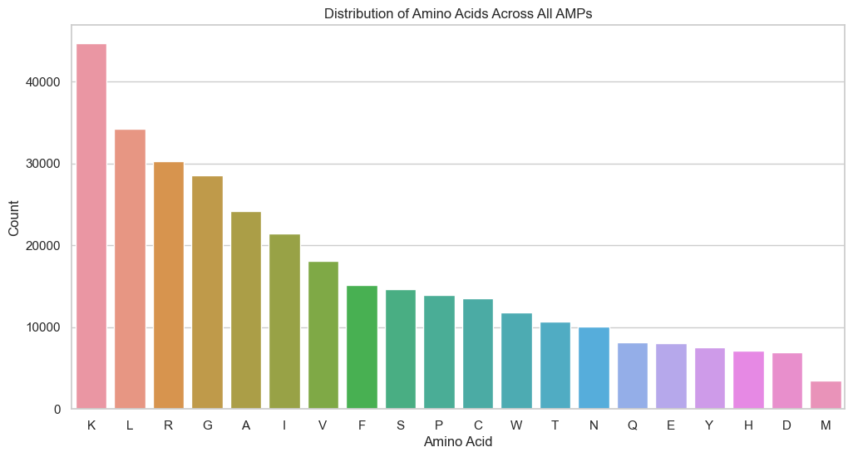

# 5. Descriptor Correlation Matrix

The correlation matrix reveals strong positive correlations between molecular weight (MW) and sequence length, as well as between charge-related properties.

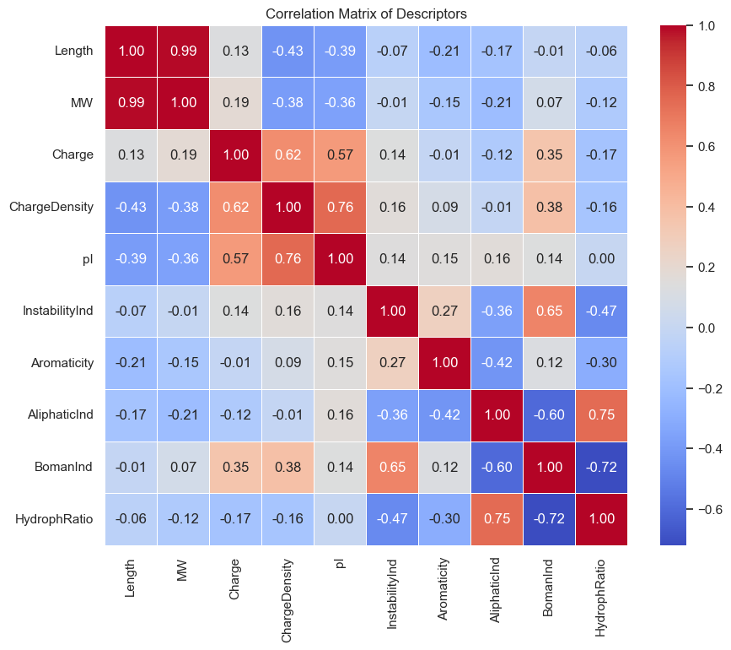

# 6. Comparative Descriptor Analysis Between Libraries

This summary of descriptor comparisons between two peptide libraries shows variations in amino acid composition, global charge, hydrophobicity, and hydrophobic moment.

