深圳大学考试答题纸
(以论文、报告等形式考核专用)
二○二四～二○二五 学年度第 一 学期
课程编号 | 1500370003 |  | 课程名称 |  | 数据库系统 |  | 主讲教师 |  | Basker George | 评分
学号 | 2022150064  2022150130 |  | 姓名 | 陈诺  林宪亮 |  | 专业年级 |  | 22级软件工程（腾班）  22级计算机科学与技术（国际班）
教师评语：The mark obtained for different categories as per the grading policy are as follows

序号 | 评分点 （分值） | Marks Obtained成绩
(1) | 第一部分 : Requirements Analysis（10分）
(2) | 第二部分: ER Diagram/ Nomalization and Convert to Relations (20分）
(3) | 第三部分: SQL DDL/ All the different kinds of DML query from PPT （30分）
(4) | 第四部分: Application System Demonstration （20分）
(5) | 第五部分: Report is completed as per the requirement and PPT（20分）
合计 100



Basker George
10 January 2025

题目： |  | Online Watch Shopping Platform

组员个人总分权重分配表：
排序 | 姓名 | 学号 | 项目个人权重 | 个人最后得分 | 评分人
1
2
3

任务分工及所完成的状况。
（2人总分为200% *教师评分, 3人总分为270% *教师评分）
个人总分权重分配表
（1人总分为100%，2人为190%, 3人为270%）

排序 | 姓名 | 学号 | 项目个人权重
1 | 陈诺 | 2022150064 | 100%
2 | 林宪亮 | 2022150130 | 100%
3 |  |  | %

我组成员总共_2_名，权重总和为：200%

- 数据库大作业 Report
- Project Objectives
- User Roles and Requirements
Buyers: They are required to be able to register accounts and log in to the platform. It should be convenient for them to browse various watches, view watch details (such as price, specifications, descriptions, etc.), add their favorite watches to the shopping cart, place orders for purchase, conduct payment operations, and also check the status of their own orders and historical order records.

Sellers: They need to be able to register stores, log in to the management backend, put watches on the shelves (fill in watch information, upload pictures, etc.), manage watch inventories, and handle orders (ship goods, view order details, etc.).

Administrators: They are responsible for the overall management of the platform, such as reviewing sellers' registration information, handling user complaints, managing watch classifications, modifying the main page, managing products, viewing orders, viewing user feedback, viewing user information, extracting recharge cards, viewing sold-out products, and viewing the administrator list information.

- Functional Requirements
The platform has a precise watch search function, enabling users to quickly find the watches they want.

Users can add watches to the shopping cart and check several of them for settlement. The platform will display the price of each checked watch and the total price on the shopping cart page.

The order query section includes orders to be shipped, orders to be received, and orders that have been received.

In the watch classification section, users can click on the corresponding watch icons to view specific watch information and make purchases.

In the personal center, users can see their own favorited and listed watches, browsing history, as well as their own order information (all orders, orders to be shipped, orders to be received, orders already received), and manage receiving addresses. There are also functional buttons such as "Contact Customer Service", "Feedback", and "About Us".

- Database Design and Implementation Process
- Logical Data Model
The Logical Data Model (LDM) designed for the online watch shopping platform consists of several entities and their corresponding relationships, which are detailed as follows:

- Entities
- User: Stores user-related information and has associations with multiple other entities. For example, a user can create multiple orders, add several shipping addresses, post multiple reviews, and favorite various watches.

- Watch: Contains all kinds of attribute information about watches. It can appear in multiple orders, multiple shopping cart records, be favored by multiple users, and have multiple reviews related to it.

- Order: Records details of orders. It belongs to a specific user, may contain multiple watches, corresponds to a certain shipping address, and is associated with a specific shop (the sender).

- Cart: Reflects the information of watches added to the shopping cart by users, including the quantity, etc. It has connections with both the user and the watch entities.

- Review: Holds the content and rating of reviews given by users regarding watches, and is linked to specific users and watches.

- Favorite: Records the situation of users' watch collections, demonstrating a many-to-many relationship between users and watches.

- Shop: Contains information about shops owned by sellers. One seller corresponds to one shop, and a shop can receive multiple orders and is related to multiple listed watches.

- Category: Used for classifying watches. Each watch belongs to one category, and a category can include multiple watches.

- Admin: Responsible for platform management operations and has management associations with entities like users, shops, and product categories (the many-to-many relationship reflects management operations).

- Address: Holds users' shipping address information. One user can have multiple addresses, and each address corresponds to one user.

- Relationships and Cardinality Constraints
One-to-One Relationship:
- Shop and Seller: In the model, a shop can only have one seller, and a seller can only own one shop. This one-to-one relationship is represented by a foreign key. For instance, the seller_id in the Shop table is linked to the user_id of the seller in the User table.

One-to-Many Relationships:
- User and Order: A user can create multiple orders, while an order belongs to only one user. The user_id in the Order table is set as a foreign key referencing the user_id in the User table.

- User and Address: One user can have multiple addresses, and an address corresponds to only one user. The user_id in the Address table is associated with the user_id in the User table.

- Shop and Order: A shop can receive multiple orders, and an order corresponds to only one sending shop. The shop_id in the Order table is added as a foreign key referring to the shop_id in the Shop table.

- Watch and Cart: A watch can appear in multiple users' shopping carts, and each shopping cart record corresponds to one watch. The watch_id in the Cart table is related to the watch_id in the Watch table.

Many-to-One Relationships:
- Order and Watch: An order can include multiple watches, but from the order's perspective for a specific watch, it's a many-to-one relationship. This is achieved through an intermediate table (like order_detail with fields like order_id and watch_id), where the watch_id in the order_detail table references the watch_id in the Watch table.

- Review and Watch: A watch can have multiple reviews, but a review corresponds to only one watch. The watch_id in the Review table is linked to the watch_id in the Watch table.

- Favorite and Watch: A watch can be favored by multiple users, while a favorite record corresponds to only one watch. The watch_id in the Favorite table is associated with the watch_id in the Watch table.

Many-to-Many Relationships:
- User and Review: A user can post multiple reviews, and a review is posted by only one user, but overall, it's a many-to-many relationship. This is implemented by an intermediate table (such as user_review with user_id and review_id fields), where the user_id and review_id in the user_review table reference the corresponding fields in the User and Review tables respectively.

- User and Favorite: A user can favorite multiple watches, and a watch can be favored by multiple users. Similar to the above, an intermediate table (like user_favorite) is used to connect them with the relevant fields referencing the main tables.

- Admin and User, Shop, Category: An admin can manage multiple users, shops, and product categories, and vice versa. Multiple admins can also manage the same user, shop, or category depending on specific management rules. This many-to-many relationship is represented by respective intermediate tables (like admin_user, admin_shop, admin_category), where the corresponding fields in these tables reference the fields in the main tables.

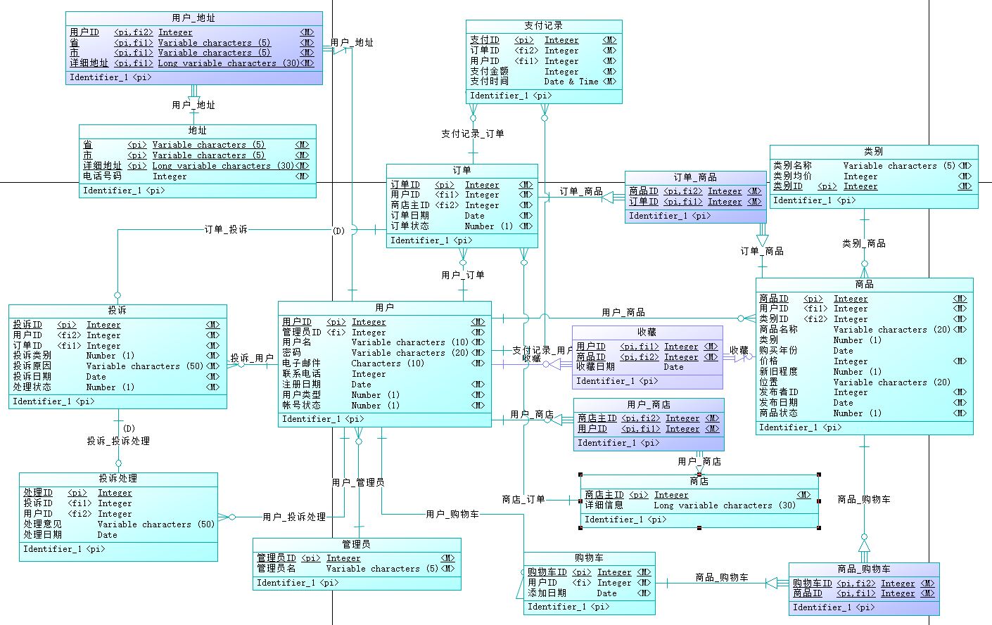
Figure 1 Logical Data Model

This LDM provides a clear framework for understanding the data structure and relationships in the online watch shopping platform, laying a solid foundation for subsequent database design and system development.
- Physical Data Model
When transforming the Logical Data Model (LDM) into the Physical Data Model (PDM) with considerations for MySQL's characteristics, several optimization approaches are adopted as follows:
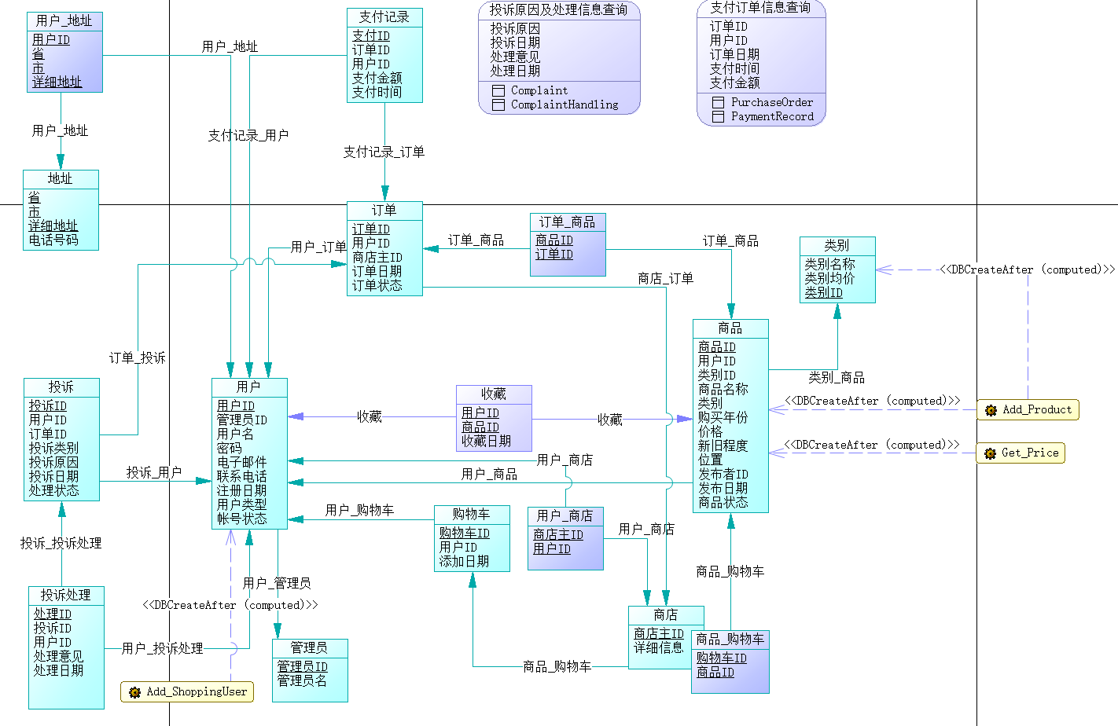
Figure 2 Physical Data Model

Table Structure Design
- Separate Entities: Each entity is represented by an independent table. For instance, user information is stored in the users table, watch details in the watches table, and so on. This separation helps avoid data redundancy and maintain data integrity by establishing relationships via foreign keys.

Stored Procedures and Functions
- For online platforms, registering new users and adding new products by users are relatively frequent operations. Therefore, stored procedures for adding new users and adding new products have been designed. The corresponding SQL code is as follows.
In this way, when there is a need to add new users or new products in multiple places, the same stored procedure can be reused, avoiding code duplication. Meanwhile, stored procedures are compiled and executed on the database server, reducing network communication overhead. Especially in the case of frequently adding users, it can significantly improve performance.

- In an online shopping platform, when a user has excessive violation records, the administrator should freeze the user's account. Therefore, it is important to view the user's violation records and record the number of violations. And users may tend to sort products by price, so it is also important to view the product price. The following Get_ViolationRecord and Get_Price stored functions are designed.
It can be seen that by specifying the user ID, the statistical information on the number of user violations can be obtained; by specifying the product ID as a parameter, the product price information can be obtained.
In this way, the designed stored functions can be called multiple times in different places, reducing code duplication. Meanwhile, stored functions are compiled and executed in the database, reducing network transmission and application processing overhead and improving query efficiency.
Index Design
- Create Indexes on Key Fields: Indexes are created on fields frequently used in query conditions. For example, an index is set on the username field in the users table to facilitate user login and other related queries. Similarly, indexes are established on fields like the brand field in the watches table for quick watch searches by brand, and composite indexes are created on multiple relevant fields (such as user_id and order_status in the orders table) to accelerate specific query operations related to orders and other entities.

These optimization strategies in the PDM are aimed at improving the performance of the database in MySQL, ensuring efficient data storage, retrieval, and manipulation to support the smooth operation of the online watch shopping platform.

- MySQL Script Generation
We obtain the SQL Script through generating the Physical Data Model (PDM) and converting it. The SQL Script contains the definitions of creating tables, adding foreign key constraints, stored procedures, stored functions and so on. We show some of the code as follows.
- Table Creation
/*==============================================================*/
/* Table: Cart */
/*==============================================================*/
create table Cart
(
CartID int not null,
UserID int not null,
AddDate date not null,
primary key (CartID)
);
/*==============================================================*/
/* Table: Complaint */
/*==============================================================*/
create table Complaint
(
ComplaintID int not null,
UserID int not null,
OrderID int not null,
ComplaintType numeric(1,0) not null,
ComplaintReason varchar(50) not null,
ComplaintDate date not null,
HandleType numeric(1,0) not null,
primary key (ComplaintID)
);
/*==============================================================*/
/* Table: ComplaintHandling */
/*==============================================================*/
create table ComplaintHandling
(
HandleID int not null,
ComplaintID int not null,
UserID int not null,
HandleComment varchar(50) not null,
HandleDate date not null,
primary key (HandleID)
);

- Foreign Key Constraints
alter table Cart add constraint FK_User_Cart foreign key (UserID)
references ShoppingUser (UserID) on delete restrict on update restrict;

alter table Complaint add constraint FK_Complaint_User foreign key (UserID)
references ShoppingUser (UserID) on delete restrict on update restrict;

- Stored Functions and Procedures
DELIMITER //
-- Create a stored procedure named 'Add_ShoppingUser' to insert new user records into the 'ShoppingUser' table
-- It takes several parameters for the new user's information
CREATE PROCEDURE Add_ShoppingUser (
IN p_userid INT,
IN p_username VARCHAR(10),
IN p_password VARCHAR(20),
IN p_email CHAR(10),
IN p_phonenumber INT,
IN p_registerdate DATE,
IN p_usertype NUMERIC(1),
IN p_accountstatus NUMERIC(1)
)
BEGIN
-- Insert a new record into 'ShoppingUser' table using the passed parameters
INSERT INTO ShoppingUser (UserID, Username, Password, Email, PhoneNumber, RegisterDate, UserType, AccountStatus)
VALUES (p_userid, p_username, p_password, p_email, p_phonenumber, p_registerdate, p_usertype, p_accountstatus);
END;//
DELIMITER ;
-- Set the global variable to allow creation of stored functions (depending on the database environment)
SET GLOBAL log_bin_trust_function_creators = 1;
DELIMITER //
-- Create a stored function named 'Get_Price' to get the price of a specified product
-- It takes a product ID as a parameter and returns the corresponding product price as an integer
create function Get_Price (f_productid INT) RETURNS INT
BEGIN
DECLARE price INT;
-- Query the price of the product with the given product ID from the 'Product' table and assign it to the 'price' variable
SELECT Price INTO price FROM Product
WHERE f_productid = Product.ProductID;
-- Return the queried product price
RETURN price;
END;//
DELIMITER ;

- Data Insertion
-- Insert data into the ShoppingUser table (As the base user table which many other tables are related to, insert data into it first)
INSERT INTO ShoppingUser (UserID, Username, Password, Email, PhoneNumber, RegisterDate, UserType, AccountStatus)
VALUES
(1, 'user1', 'pass1', '1@x.com', 123456, '2024-11-01', 1, 1),
(2, 'user2', 'pass2', '2@x.com', 234565, '2024-11-15', 2, 1),
(3, 'user3', 'pass3', '3@x.com', 789675, '2024-12-01', 1, 1);

-- Insert data into the Product table (It may be related to the ShoppingUser table, so insert data into it after inserting data into the ShoppingUser table)
INSERT INTO Product (ProductID, UserID, ProductName, Category, PurchaseYear, Price, ProductCondition, Location, PublisherID, PublishDate, ProductStatus)
VALUES
(101, 1, 'Patek Philippe', 1, '2024-01-01', 5000, 1, 'Beijing', 1, '2024-11-01', 1),
(102, 2, 'Audemars Piguet', 1, '2024-02-15', 8000, 1, 'Shanghai', 2, '2024-10-15', 1),
(103, 1, 'Omega', 2, '2024-03-20', 300, 1, 'Shenzhen', 1, '2024-11-10', 1);

- Single-Table Query
-- Query the product information whose price is greater than 100
SELECT *
FROM Product
WHERE Price > 100;

- Join Query – Inner Join, Outer Join, Self Jion
-- Inner Join: Query the paid orders and the corresponding user information (using inner join on `PurchaseOrder` and `ShoppingUser` tables)
SELECT po.OrderID, su.Username
FROM PurchaseOrder po
JOIN ShoppingUser su ON po.UserID = su.UserID;

-- Left Outer Join: Query all users and their complaint information (display users even if they have no complaints, using left outer join on `ShoppingUser` and `Complaint` tables)
SELECT su.Username, c.ComplaintID
FROM ShoppingUser su
LEFT JOIN Complaint c ON su.UserID = c.UserID;

-- Self Join: The `PublisherID` in the `Product` table points to the `ProductID` of another product, query different products under the same publisher
SELECT p1.ProductName, p2.ProductName
FROM Product p1
JOIN Product p2 ON p1.PublisherID = p2.ProductID;

- Aggregate Functions with GROUP BY and ORDER BY Clause
-- Count the number of complaints for each user and sort them in descending order by the number of complaints
SELECT UserID, COUNT(ComplaintID) AS ComplaintCount
FROM Complaint
GROUP BY UserID
ORDER BY ComplaintCount DESC;

- Date and Time Functions
-- Query the order information placed within this week
SELECT *
FROM PurchaseOrder
WHERE YEARWEEK(OrderDate) = YEARWEEK(CURDATE());

- Subqueries
-- Simple Subqueries
-- Query the product information whose price is higher than the average price
SELECT *
FROM Product
WHERE Price > (SELECT AVG(Price) FROM Product);
-- Correlated subqueries
-- Query the most expensive product purchased by each user
SELECT po.UserID, p.ProductName, p.Price
FROM PurchaseOrder po
JOIN Order_Product op ON po.OrderID = op.OrderID
JOIN Product p ON op.ProductID = p.ProductID
WHERE p.Price = (
SELECT MAX(Price)
FROM Product p2
JOIN Order_Product op2 ON p2.ProductID = op2.ProductID
WHERE op2.OrderID = po.OrderID
);

- Set Operations - UNION, INTERSECT, EXCEPT
-- UNION (Union): Query the user IDs of those who have purchased products or filed complaints
SELECT UserID
FROM PurchaseOrder
UNION
SELECT UserID
FROM Complaint;
-- INTERSECT (Intersection): Query the user IDs of those who have both purchased products and filed complaints
SELECT UserID
FROM PurchaseOrder
WHERE UserID IN (SELECT UserID FROM Complaint);
-- EXCEPT (Difference): Query the user IDs of those who have purchased products but haven't filed complaints
SELECT UserID
FROM PurchaseOrder
WHERE UserID NOT IN (SELECT UserID FROM Complaint);

- Multi-Table Join Query
-- Query the comprehensive information containing order details (product, user, payment information, etc.), which is achieved by joining multiple tables
SELECT po.OrderID, su.Username, p.ProductName, pr.PaymentPrice, pr.PaymentTime
FROM PurchaseOrder po
JOIN ShoppingUser su ON po.UserID = su.UserID
JOIN Order_Product op ON po.OrderID = op.OrderID
JOIN Product p ON op.ProductID = p.ProductID
JOIN PaymentRecord pr ON po.OrderID = pr.OrderID;

- Division Query
-- Query the users who have purchased all products with a price greater than 100
SELECT UserID
FROM (
SELECT UserID, ProductID
FROM PurchaseOrder po
JOIN Order_Product op ON po.OrderID = op.OrderID
) AS temp
WHERE NOT EXISTS (
SELECT ProductID
FROM Product
WHERE Price > 100
AND ProductID NOT IN (
SELECT ProductID
FROM (
SELECT UserID, ProductID
FROM PurchaseOrder po
JOIN Order_Product op ON po.OrderID = op.OrderID
) AS sub_temp
WHERE sub_temp.UserID = temp.UserID
)
)
GROUP BY UserID;

We demonstrate some of the SQL query results as follows.
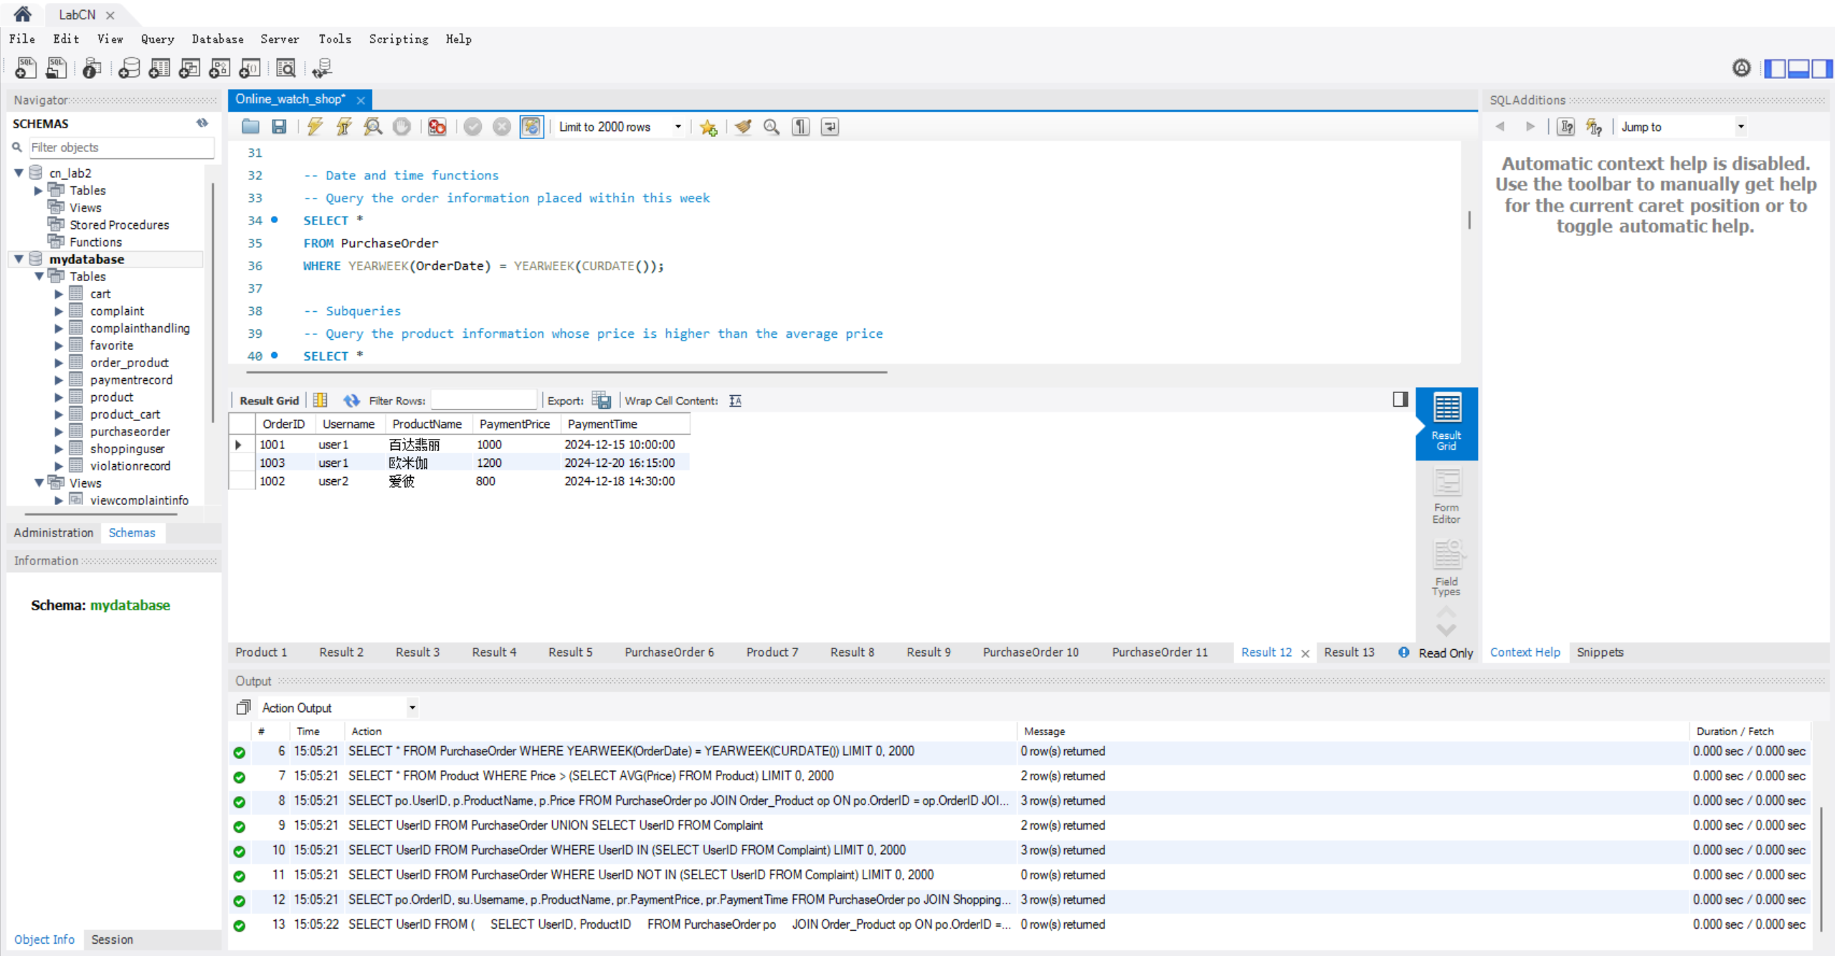
Figure 3 SQL Query Results

- The implementation of the front end and back end
- Front-end Development
Page Design and Layout:
Use WXML (similar to HTML) provided by WeChat Mini Programs to build the page structure and determine the layout and element positions of each page.
Employ WXSS (similar to CSS) to design the styles, including fonts, colors, spacing, backgrounds, etc., in order to achieve an aesthetically pleasing interface that conforms to the brand image.

Implementation of Interaction Logic:
Write the interaction logic in JavaScript files to respond to users' operations, such as clicks, swipes, inputs, and so on.
Utilize the APIs of WeChat Mini Programs to implement interactive functions like page jumps, data transmission, and animation effects.
Validate forms to ensure the legality and completeness of users' inputs.

Data Display and Update:
Send requests to the back-end server through JavaScript code to obtain data, such as product lists, user information, etc.
Use data binding to dynamically display the obtained data on the page. When the data is updated, the page can be automatically updated and displayed as well.

- Back-end Development
Database Management:
Utilize the database provided by WeChat Mini Program Cloud Development. Define collections (similar to tables in traditional databases) according to different business entities, like "users", "products", etc. For example, when creating a collection for "products", determine the fields such as "product_name", "price", "description", etc. to store relevant product information. Use methods like "add" to insert new data into the collections, "update" to modify existing data, and "get" to query specific data based on certain conditions. For instance, when a new product is added in the front end, the back end uses the "add" operation to store its details in the "products" collection.

Cloud Function Implementation:
Develop cloud functions to handle various business logics. For user authentication, create a cloud function that receives the user's input credentials from the front end, verifies them against the user data stored in the database, and returns the authentication result to the front end. Another example is for handling orders. There can be a cloud function to create a new order record in the database when the front end initiates an order placement action. It also updates related data such as inventory reduction in the "products" collection and records the user's order history in the "users" collection.

Data Interaction with Front End:
Establish clear interfaces for data exchange with the front end. Define the format of the data to be sent and received, in JSON format. When the front end sends a request for product list data, the back end retrieves the corresponding data from the database through appropriate queries and packages it into a JSON object to send back to the front end. Similarly, when the front end submits user feedback, the back end receives it via a cloud function and stores it in a dedicated "feedback" collection for further processing.

- Functions of the Web Application and User Interaction
Firstly, on the home page of the program, we can see pictures of popular recommended wristwatches. In the middle are navigation items, and at the bottom there are four sections: Home, Categories, Shopping Cart and Mine.
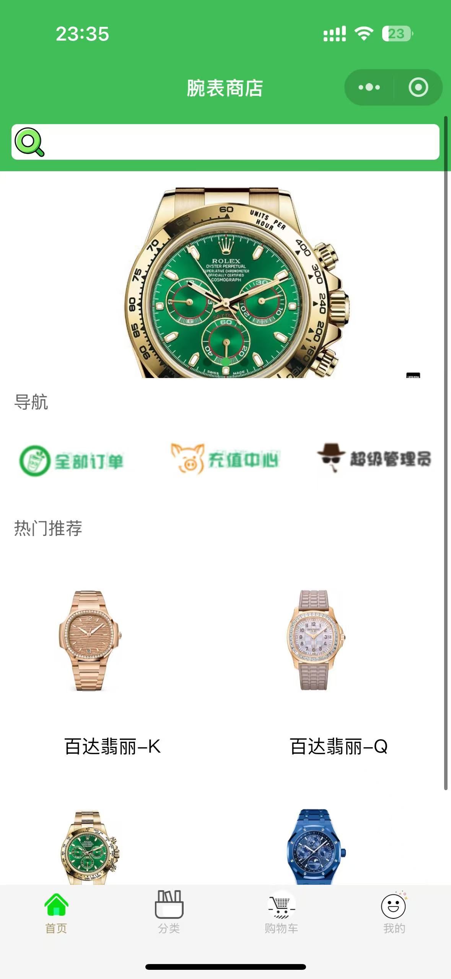
Figure 4 Home Page of The Program

Then, in the Categories section, we can see the display of wristwatch categories such as Rolex, Patek Philippe and so on. Users can click on the pictures of wristwatches to obtain detailed information further.
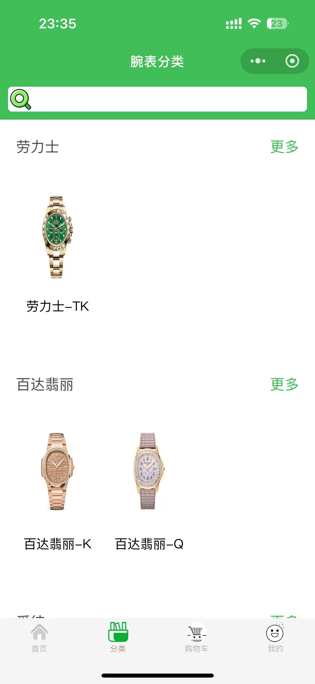
Figure 5 Categories Page of The Program

In the Shopping Cart section, we can see that the detailed information of the consignee is displayed at the top of the page. There are three items added to the shopping cart in the middle. Users can check the corresponding items for settlement, and the program will calculate the price after settlement.
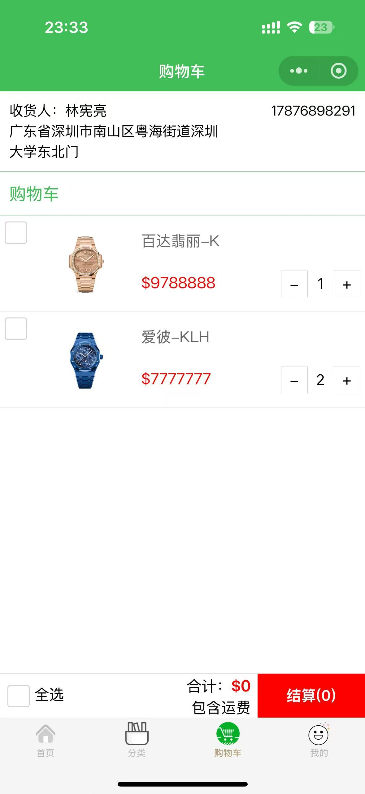
Figure 6 Shopping Cart Page of The Program

On the personal center page, we can see content such as the user's balance, browsing history, collected items, and order information. Meanwhile, it also includes sections like "Contact Customer Service" and "Feedback", allowing users to give their feedback.
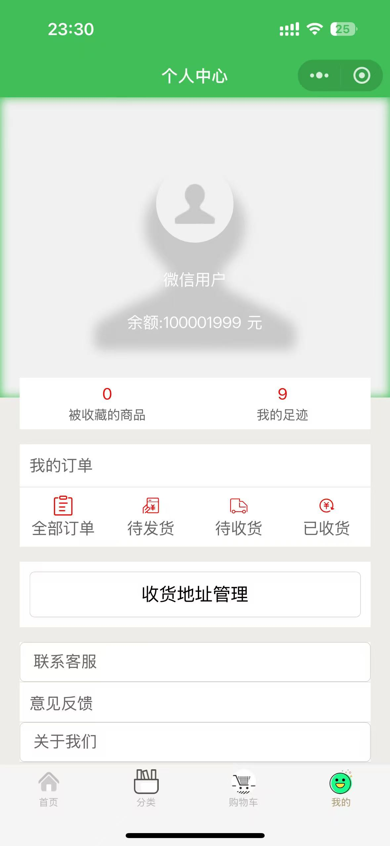
Figure 7 Personal Center Page of The Program

On the order inquiry page, we can inquire about corresponding information such as the order number, price, date and so on, which facilitates users to manage the orders of their own transactions.
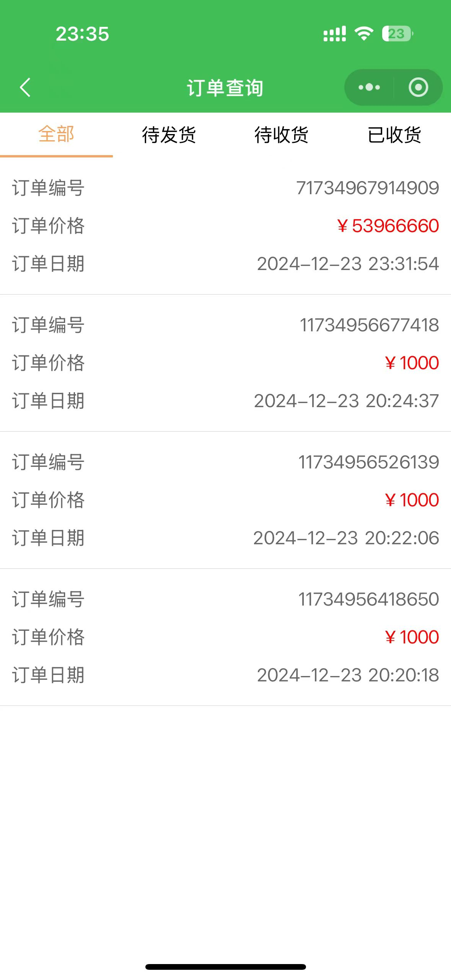
Figure 8 Order Inquiry Page

On the product management page, users can upload the products they want to put on the shelves. There are options like product categories, uploading cover images, and uploading graphic details for users to choose from.
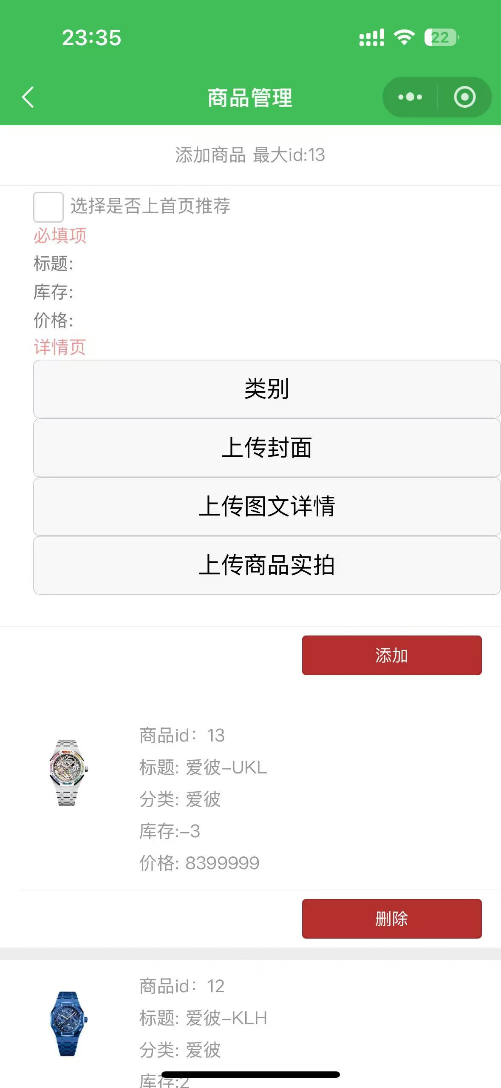
Figure 9 Product Management Page

After the administrator logs into the system, a prompt saying "Welcome, administrator" will be displayed. And there are functions such as modifying the main page, managing goods, checking orders, handling user feedback and viewing user information.
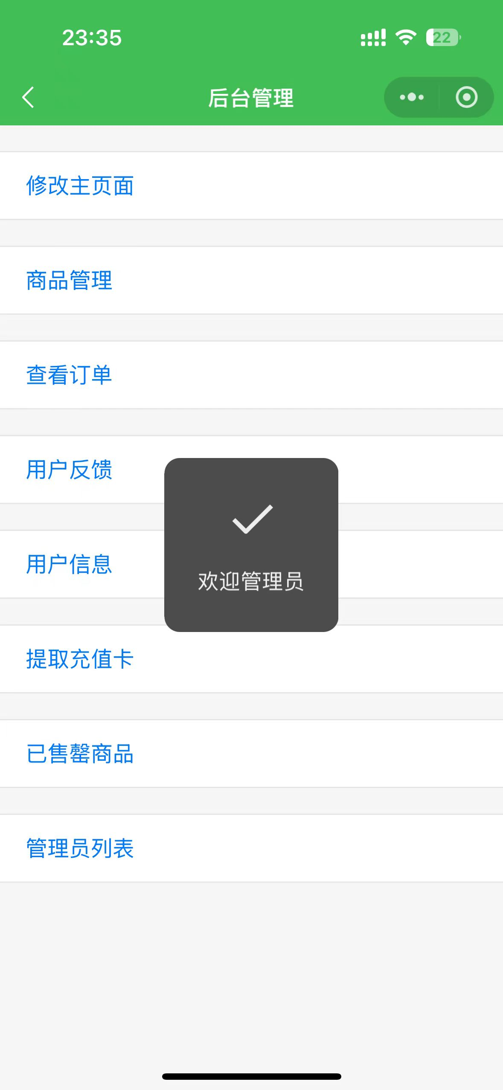
Figure 10 Administrator Page
Featured Functional Highlights
- Precise Search: The search bar intelligently recognizes keywords. Whether it's a brand, model, or specific function, it can accurately locate the target watch, saving search time.
- Shopping Cart Interaction: The shopping cart is not only a temporary storage place for products. The real-time price display during checkout allows buyers to always control their consumption amount and make informed decisions.
- Watch Category Selection: The watch category section has a clear layout and intuitive icon guidance. Users can click to learn more about the details of each watch and easily compare and select.
- Convenient Personal Center Management: The personal center gathers key user information. The browsing history retraces the shopping journey, the order information is updated in real-time, the shipping address management is convenient, and there are also thoughtful function buttons such as contact customer service, feedback, and about us, satisfying users' diverse needs in one stop.

二、诚信承诺：
本人郑重承诺在该课程论文完成的过程中不发生任何不诚信现象，一切不诚信所导致的后果均由本人承担。
Integrity Commitment:
I/We solemnly promise that I/we have not plagiarized during the completion of this course paper, and all the consequences caused by plagiarism will be borne by me/us.

签名拍照附件:
Name and Digital Signature of all students in the group


Date: 2024.12.28

