**Fetching the Data from Bluetooth Device**

**Lin Yang**

**Introduction**

Bluetooth is a wireless technology standard for exchanging data over short distances from fixed and mobile devices, and building personal area networks. In this demo, we try to explore how to exchange data between two devices based on Bluetooth technology.

There have two devices, one is server device, and another is client device. First, we run the server program. Server program will start the Bluetooth service and set up an UUID, and then Server is waiting for the connection signal that is from Client. Second, the client program will run and try to connect to server. Client program will open Bluetooth device and scan the others. If Client can find other devices which also opened Bluetooth, Client will try to pair the server. Final, if the pair is successful, the socket between Server and Client will be built and data will be transferred.

This demo uses Java as programming language and uses NetBeans and Android Studio as IDE to develop an Android APP.

**Processing**

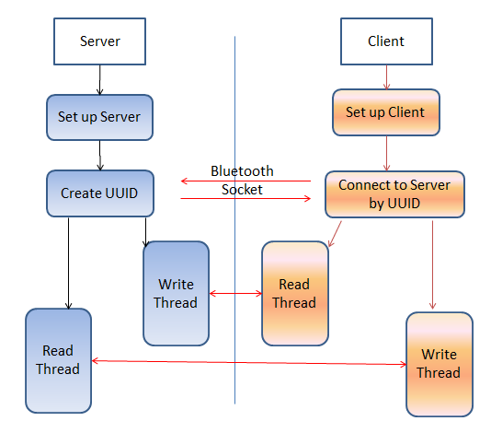

Figure 1: Programing Process

1. Server
2. Set up server
3. Create host and UUID.
4. Waiting for client to connect.
5. If client connects to server, server will run two threads, one is writing thread that writes data to client and another one is reading thread that listen client’s writing thread.
6. Client
7. Set up client
8. Send signal to server and connect to server.
9. If client successful connected to server, client will create a socket pipeline.
10. Client run two threads: writing thread and read thread.

**How does client connect to server?**

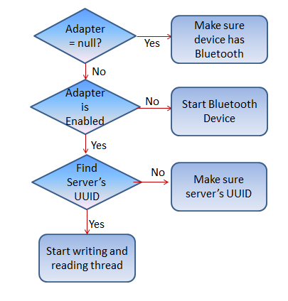

Figure 2: Client processing

1. When client program starts, the program will check if the client has Bluetooth. In the figure 2, program will create an adapter and check if adapter equals to null. If the client didn’t include a Bluetooth device, the program cannot run.
2. Check if Bluetooth on the client has opened.
3. Scan and look for the server. If server program has run, try to get server’s UUID and set up a socket pipeline.
4. If socket has been created, start to run two threads to listen from server and write to server.

**Future work**

1. Using Object-C to develop iOS version.
2. Develop BLE (Bluetooth Low Energy) version.