The Hong Kong Polytechnic University
Department of Computing

COMP4913 Capstone Project
Final Report

Dual-Pivot Quicksort

Student Name: | LIN Zhanzhi
Student ID No.: | 22097456D
Programme-Stream Code: | 61435-FCS
Supervisor: | Dr CAO Yixin
Co-Examiner: | Dr LI Bo
2nd Assessor: | Dr LOU Wei
Submission Date: | 10th April 2026

Abstract
Sorting is a fundamental operation in critical computing systems. While the industry-standard C++ std::sort relies on a single-pivot Introsort strategy, recent theoretical computations suggest that multi-pivot approaches can better exploit the memory hierarchies of modern superscalar processors. This project implements a generic, standard-compliant Dual-Pivot Quicksort library in C++23 to evaluate whether the cache-efficiency gains observed in Java's dual-pivot implementation translate to the native C++ environment.
The developed library features a robust 3-way partitioning scheme with "Median-of-5" pivot selection and a Work-Stealing thread pool for parallel execution. Extensive benchmarking against GCC's std::sort reveals consistent performance advantages: the sequential implementation achieves a 10-15% speedup on random data and massive gains of up to 27x on structured patterns (e.g., "Organ Pipe" distributions) via adaptive run-merging. Parallel scalability testing demonstrates a 5.24x speedup on 16 threads, successfully identifying Memory Bandwidth saturation as the effective limit for future optimization. These results confirm that Dual-Pivot Quicksort is a superior candidate for next-generation C++ standard libraries.

Table of Contents
1. Abstract 2
2. Table of Contents 3
3. List of Tables and Figures 6
3.1. List of Tables 6
3.2. List of Figures 6
4. Introduction 7
4.1. Background 7
4.1.1. The Dual-Pivot Innovation 7
4.1.2. The State of C++ std::sort 7
4.2. Problem Statement 8
4.2.1. Lack of a Modern, Standard-Compliant Implementation 8
4.2.2. Uncertainty of Translation to C++ Performance 9
4.3. Objectives 9
4.3.1. Implement a Robust, Generic Dual-Pivot Quicksort 9
4.3.2. Develop a Benchmarking Framework for Destructive Testing 10
4.3.3. Comparative Performance Analysis 10
4.3.4. Memory Strategy & Bottleneck Analysis 11
4.4. Scope 11
4.4.1. In-Scope 11
4.4.2. Out-of-Scope 12
5. Literature Review 13
5.1. Classical Quicksort & Introsort 13
5.1.1. Classical Quicksort (Hoare, 1962) 13
5.1.2. Introsort (Musser, 1997) 13
5.2. Dual-Pivot Quicksort 14
5.2.1. Yaroslavskiy's Partitioning Scheme 14
5.2.2. Complexity Analysis (Aumüller & Dietzfelbinger) 15
5.3. Memory Hierarchy and Sorting 15
5.3.1. The "Scanned Elements" Model 15
5.3.2. The "Memory Wall" 16
6. Methodology & System Design 17
6.1. Development Environment 17
6.2. Algorithm Implementation Details 17
6.2.1. Generic Interface 17
6.2.2. Partitioning Logic 18
6.2.3. Fallback Mechanism (Introsort Strategy) 19
6.2.4. Optimizations 19
6.3. Benchmarking Framework Design 20
6.3.1. Justification 20
6.3.2. Metrics 20
6.3.3. Sampling Strategy 21
6.3.4. Test Patterns 21
7. Results and Achievements 22
7.1. Implementation Status 22
7.1.1. Generic Dual-Pivot Quicksort (Sequential) 22
7.1.2. Benchmarking Infrastructure 23
7.1.3. Parallel Prototype (Thread Pool) 23
7.2. Performance Analysis: Sequential Algorithms 23
7.2.1. Baseline Efficiency (Random Permutations) 24
7.2.2. Algorithmic Intelligence: Pattern Detection 25
7.3. Performance Analysis: Parallel Architectures 28
7.3.1. Strong Scaling Analysis 28
7.3.2. Bottleneck Analysis: The "Memory Wall" 30
7.3.3. Overhead Investigation 30
7.4. Key Findings & Achievement Summary 31
8. Discussion & Future Improvements 32
8.1. Parallelization Refinement 32
8.2. Advanced Optimizations 32
9. Conclusion 34
10. References 35

List of Tables and Figures

List of Tables
Table 7.2.1 Baseline sorting performance on random data: execution time and speedup of Dual-Pivot Quicksort versus std::sort for input sizes 10³–10⁷. 24
Table 7.3.1 Strong-scaling benchmark results for Dual-Pivot Quicksort on 10⁷ integers: execution time, speedup, and efficiency for 1–16 threads. 29

List of Figures
Fig. 7.2.1 Execution time vs input size on random data, showing Dual-Pivot Quicksort consistently 10–15% faster than std::sort across 10³–10⁷ elements. 24
Fig. 7.2.2 Execution time vs input size on random, sorted, and reverse-sorted data, illustrating linear-time behavior on ordered inputs and a major advantage for Dual-Pivot on reverse-sorted arrays. 25
Fig. 7.2.3 Execution time vs input size on random and Organ Pipe patterns, where Dual-Pivot achieves order-of-magnitude speedups by exploiting two large monotone runs. 26
Fig. 7.2.4 Execution time vs input size on random and Sawtooth patterns, showing near-linear performance and up to ~8× speedup over std::sort at N = 10⁷. 27
Fig. 7.2.5 Execution time vs input size for random and duplicate-heavy inputs, highlighting invariant performance of Dual-Pivot across duplication levels and its lead over std::sort. 28
Fig. 7.3.1 Strong scaling of parallel Dual-Pivot Quicksort on 10⁷ integers: near-linear speedup up to 4 threads, then saturation around 5× beyond 8 threads. 29

Introduction

Background
Sorting is one of the most fundamental operations in computer science, serving as a critical building block for databases, search engines, and data processing systems. For decades, Quicksort, originally proposed by C. A. R. Hoare in 1961 [1], has maintained its dominance in system libraries due to its efficient $O(N\log{N})$ average-case time complexity, minimal memory footprint as an in-place algorithm, and excellent cache locality on modern hardware.

The Dual-Pivot Innovation
Theoretical analysis traditionally suggested that increasing the number of pivots in Quicksort—partitioning an array into more than two segments—would degrade performance because the additional computational cost of comparing elements against multiple pivots outweighed the reduction in recursion tree height [2]. However, in 2009, Vladimir Yaroslavskiy challenged this assumption research by introducing a Dual-Pivot Quicksort algorithm [3].
Yaroslavskiy’s approach employs two pivots ($P_{1}$ and $P_{2}$) to partition the array into three regions: elements smaller than $P_{1}$, elements between $P_{1}$and $P_{2}$, and elements larger than $P_{2}.$While this method requires more comparisons per element than single-pivot Quicksort, it drastically reduces the total number of memory accesses. In modern hardware architectures, where CPU speed vastly outpaces memory bandwidth—a phenomenon known as the "Memory Wall"—reducing cache misses often yields greater performance gains than minimizing instruction counts. Following rigorous empirical testing that demonstrated significant speedups, Yaroslavskiy's Dual-Pivot Quicksort was adopted as the standard sorting algorithm for primitive types in Oracle's Java Development Kit (JDK) 7 in 2011 [4].

The State of C++ std::sort
Despite the success of Dual-Pivot Quicksort in the Java ecosystem, the C++ Standard Template Library (STL) largely continues to rely on single-pivot strategies. The current industry standard for C++ sorting is Introsort (Introspective Sort), introduced by David Musser in 1997 [5]. Introsort is a hybrid algorithm that begins with Quicksort but switches to Heapsort if the recursion depth exceeds a logarithmic threshold ($2\log{N}$), thereby guaranteeing worst-case $O(N\log{N})$ performance.
Most major C++ standard library implementations—including GCC’s libstdc++, LLVM’s libc++, and Microsoft’s MSVC—implement std::sort using a highly optimized single-pivot Introsort [6]. While these implementations are mature and efficient, they do not exploit the reduced memory traffic that Dual-Pivot strategies offer on modern superscalar processors. Furthermore, `std::sort` performs no detection of pre-existing structure in the input data, treating nearly-sorted arrays identically to random permutations.

Problem Statement
Despite the proven success of Dual-Pivot Quicksort in other environments, the C++ ecosystem faced a notable gap in both implementation availability and performance verification at the outset of this project.

Lack of a Modern, Standard-Compliant Implementation
A survey of publicly available C++ codebases revealed that existing implementations of Dual-Pivot Quicksort are typically:
- Non-generic: Many are written for specific element types (such as int arrays) rather than as generic algorithms compatible with iterator-based interfaces used in the C++ standard library.
- Experimental in nature: They tend to appear as academic proofs-of-concept, tutorial code, or isolated benchmarks rather than as robust, production-ready libraries with engineering refinements such as tuned insertion-sort fallbacks or careful handling of duplicate keys.
- Outdated in language features: A significant portion relies on pre-C++11 idioms and does not make systematic use of modern C++ facilities such as move semantics, constexpr, or template metaprogramming.
At the outset of this project, there was no widely adopted, standard-compliant modern C++ implementation of dual-pivot quicksort that could serve as a drop-in replacement for std::sort in production codebases.

The Question of Performance Translation to C++
The theoretical advantage of Dual-Pivot Quicksort lies in its ability to reduce cache misses by lowering the total number of scanned elements, despite requiring more comparisons per element than single-pivot Quicksort [7].
In the Java environment, where element comparisons can be computationally expensive due to virtual function calls and object overhead, the trade-off of “more comparisons for fewer memory accesses” is highly beneficial. However, in C++, the landscape differs significantly:
- Cheap Comparisons: C++ templates allow comparators to be inlined at compile time, making comparisons extremely fast.
- Memory vs. CPU: It was initially unclear whether the reduction in memory traffic provided by Yaroslavskiy's algorithm would be sufficient to outweigh the increased instruction count in a high-performance, native environment like C++ [8].
This project set out to rigorously verify whether the theoretical reductions in memory I/O translate to actual wall-clock speedups in C++.

Summary of Findings
The results of this investigation confirm that Dual-Pivot Quicksort does deliver substantial performance benefits in C++:
- Sequential Performance: The implementation achieves performance competitive with std::sort on random data, with neither algorithm holding a consistent advantage.
- Structured Data: On data with pre-existing patterns (sorted runs, organ-pipe shapes, repeated elements), the implementation achieves up to 19× speedup over std::sort through adaptive run merging—a Timsort-inspired optimization inherited from Java's DualPivotQuicksort.
- Parallel Scaling: The work-stealing parallel implementation achieves 5.18× speedup on 16 threads, with Intel VTune profiling revealing that L3 cache contention—not algorithmic inefficiency—becomes the limiting factor at high thread counts.

Objectives
The primary goal of this project was to bridge the implementation and analysis gap identified above. The work was structured around four concrete objectives, all of which were successfully achieved:

Objective 1: Implement a Robust, Generic Dual-Pivot Quicksort
A production-quality C++17 implementation of Yaroslavskiy's algorithm was developed, adhering to modern C++ standards:
- Template-Based Design: The implementation uses C++17 templates with SFINAE-based type constraints to ensure full genericity, type safety, and compatibility with any user-defined type or container that provides random-access iterators.
- Header-Only Library: Approximately 3,000 lines of code organized across 15 header files, requiring no compilation or linking—simply include and use.
- Robustness Features: Essential safeguards present in industrial libraries were incorporated, including:
  - Insertion sort fallback for small arrays (threshold empirically tuned to 60 elements)
  - Heapsort fallback when recursion depth exceeds 192 levels, preventing $O(n^{2})$ worst-case scenarios
  - 5-element sampling network for balanced pivot selection even on adversarial inputs
  - Dutch National Flag partitioning for arrays with many duplicate elements

Objective 2: Develop a Benchmarking Framework for Destructive Testing
Measuring sorting performance is uniquely challenging because the operation is "destructive"—it modifies the input state, requiring a computationally expensive reset before every iteration.
- Framework Design: A custom benchmarking harness was developed that explicitly decouples the Data Reset Phase (untimed, memory allocation/copying) from the Sorting Phase (timed), ensuring accurate measurements.
- Controlled Variables: The framework enables rigorous A/B testing by isolating variables including data distribution (Random, Sorted, Reverse, Nearly-Sorted, Organ-Pipe, Many-Duplicates), array size (10³ to 10⁷ elements), and thread count (1 to 16).

Objective 3: Comparative Performance Analysis
A rigorous empirical evaluation was conducted to quantify performance differences:
- Baselines: Performance was compared against std::sort from GCC's libstdc++.
- Statistical Validity: Each configuration was measured with 3 warmup iterations followed by 10 timed iterations, with median runtime reported to filter OS-induced noise.
- Key Finding: The implementation matches or exceeds std::sort on all tested patterns, with dramatic speedups on structured data.

Objective 4: Hardware Bottleneck Analysis
Intel VTune Profiler was employed to understand the hardware-level reasons for observed performance behaviors:
- Memory Wall Investigation: Profiling confirmed that the parallel scaling plateau (5.18× with 16 threads) is caused by L3 cache contention (38% of pipeline slots memory-bound at 16 threads), not algorithmic inefficiency.
- Amdahl's Law Analysis: The measured serial fraction of approximately 14% places the theoretical maximum speedup at 7.19×, explaining why additional threads beyond 8 provide diminishing returns.
- Cache Locality Verification: VTune data confirmed that sorting is fundamentally memory-bound on random data, validating the importance of cache-efficient partitioning strategies.

Scope
This project focuses on optimizing the sorting of large, standard C++ data structures within volatile memory (RAM) on a single machine. The specific boundaries of the research are defined as follows:

In-Scope
- In-Memory Sorting: The implementation assumes that the entire dataset fits within the system's main memory. The primary focus is on optimizing CPU cache efficiency (L1/L2/L3) and minimizing memory bandwidth bottlenecks.
- Primitive Data Types: Benchmarking and optimization efforts target fundamental C++ primitive types, specifically 32-bit integers (int) and 64-bit floating-point numbers (double). These types represent the most common use cases for numerical sorting and allow for direct analysis of how data size (4 bytes vs 8 bytes) impacts cache saturation.
- Sequential Execution: A single-threaded implementation was developed first to ensure the core Dual-Pivot logic is correct and optimized for instruction-level parallelism before introducing thread management overhead.
- Parallel Execution: The sequential algorithm was extended to a multi-threaded environment using a custom work-stealing thread pool. Analysis of scalability on multi-core CPUs revealed Memory Wall limitations that constrain parallel speedup.

Out-of-Scope
- External (Disk-Based) Sorting: Algorithms designed to sort datasets larger than available RAM, requiring disk I/O, are excluded.
- Distributed Sorting: This project is limited to shared-memory architectures (single node) and does not cover distributed sorting across multiple machines (e.g., MPI or cluster computing).
- GPU Acceleration: Implementations leveraging Graphics Processing Units (CUDA, OpenCL) are outside the scope, as the focus is on maximizing the efficiency of general-purpose CPUs.
- Stable Sorting: The implementation does not preserve the relative order of equal elements; applications requiring stability should use std::stable_sort.

Core Algorithm — Dual-Pivot Quicksort

Prior Work: From Hoare to Yaroslavskiy

Classical Quicksort
Quicksort, proposed by C.A.R. Hoare in 1961 and published the following year, remains one of the most influential algorithms in computer science [1]. The algorithm's elegance lies in its simplicity: select a pivot element, partition the array into elements less than or equal to the pivot and elements greater than the pivot, then recursively sort the two resulting regions.
Hoare's original formulation achieves expected $O(N\log{N})$ comparisons for uniformly random input, though worst-case performance degrades to $O(N^{2})$ when the pivot consistently selects the minimum or maximum element—a scenario that occurs with already-sorted input when using naive pivot selection. Despite this theoretical vulnerability, Quicksort rapidly became the dominant sorting algorithm in practice due to several practical advantages:
- In-place operation: Unlike Merge Sort, Quicksort requires only $O(\log{N})$ auxiliary space for recursion, making it suitable for memory-constrained environments.
- Cache efficiency: The partitioning phase scans memory sequentially, achieving excellent cache locality on modern hierarchical memory systems.
- Low constant factors: Quicksort's inner loop is extremely simple—a single comparison and conditional swap—enabling highly efficient machine code generation.
For over five decades, improvements to Quicksort focused primarily on pivot selection strategies and hybridization rather than fundamental algorithmic changes. Sedgewick introduced median-of-three pivot selection to reduce worst-case probability [9]. Musser developed Introsort, which monitors recursion depth and switches to Heapsort upon exceeding $2\log{N}$ levels, guaranteeing $O(N\log{N})$worst-case performance [5]. These refinements preserved Quicksort's essential structure: a single pivot dividing the array into two partitions.

The Dual-Pivot Innovation
The theoretical sorting community long held that increasing the number of pivots would degrade performance. The intuition was straightforward: classifying elements against multiple pivots requires more comparisons per element, and the marginal reduction in recursion tree height does not compensate for this overhead [2].
In 2009, Vladimir Yaroslavskiy challenged this conventional wisdom by proposing a dual-pivot partitioning scheme that demonstrably outperformed single-pivot Quicksort in empirical benchmarks [3]. Rather than partitioning around a single pivot, Yaroslavskiy's algorithm selects two pivot elements ($P_{1}$ ≤ $P_{2}$) and divides the array into three regions:
[elements < $P_{1}$] [$P_{1}$] [$P_{1}$ ≤ elements ≤ $P_{2}$] [$P_{2}$] [elements > $P_{2}$]
When $P_{1}$ = $P_{2}$, the algorithm degenerates to a three-way Dutch National Flag partition, efficiently handling duplicate-heavy data [10].
The empirical evidence was compelling enough that Oracle adopted Yaroslavskiy's Dual-Pivot Quicksort as the default sorting algorithm for primitive arrays in Java Development Kit (JDK) 7, released in 2011. This marked the first fundamental change to Java's sorting algorithm since the platform's inception, signaling the practical significance of Yaroslavskiy's contribution.

Mathematical Justification: Wild's Analysis
The counterintuitive success of dual-pivot partitioning demanded theoretical explanation. Sebastian Wild's doctoral thesis, completed in 2016 and building on earlier work with Markus Nebel, provided the rigorous mathematical foundation that explained why dual-pivot Quicksort outperformed its single-pivot predecessor despite requiring more comparisons [4] [7].
Wild's analysis yielded the following comparison:
Metric | Single-Pivot Quicksort | Dual-Pivot Quicksort
Expected comparisons | $$2n\ln{n}-1.51n+O(\ln{n})$$ | $1.9n\ln{n}-2$.46$n+O(\ln{n})$
Expected swaps | 0.33$n\ln{n}-0.58n+O(\ln{n})$ | 0.6$n\ln{n}+0.08n+O(\ln{n})$
Scanned elements | $$1.5697n\ln{n}$$ | $$1.4035n\ln{n}$$
Table 5.1Average-case partition costs for single-pivot and dual-pivot Quicksort, based on Wild
At first glance, dual‑pivot Quicksort only modestly improves comparison counts. However, its main advantage is in scanned elements: a partition step of classic Quicksort scans the array once (n scanned elements), whereas Yaroslavskiy’s dual‑pivot partition uses about $\frac{4}{3}n$ scanned elements per partition, but in a way that reduces total scanned elements over the entire recursion from approximately $1.5697n\ln{n}$ to $1.4035n\ln{n}$, a savings of about 12%. On modern architectures where memory bandwidth is a bottleneck, these reductions in data movement translate directly to improved performance.

The Cache Effect: Why Smaller Partitions Win
The theoretical analysis becomes practically relevant when considering modern CPU memory hierarchies. Contemporary processors feature multiple levels of cache (L1, L2, L3) with dramatically different access latencies:
Cache Level | Typical Size | Access Latency
L1 | 32–64 KB | ~4 cycles
L2 | 256–512 KB | ~12 cycles
L3 | 8–32 MB | ~40 cycles
Main Memory | 16+ GB | ~200+ cycles
Table 5.2Representative cache hierarchy latencies (Intel Core i7, 13th generation)
When sorting an array of n integers (4n bytes), the working set must fit within cache for optimal performance. Single-pivot Quicksort creates two partitions of expected size n/2 each, while dual-pivot Quicksort creates three partitions of expected size n/3 each. As recursion proceeds:
- Single-pivot: After k levels, working sets have expected size $\frac{n}{2^{k}}$
- Dual-pivot: After k levels, working sets have expected size $\frac{n}{3^{k}}$
Dual-pivot reaches cache-friendly sizes in fewer recursive levels. For a 10 million element array (~40 MB), single-pivot requires approximately 20 levels to reach L2 cache size (256 KB), while dual-pivot requires only approximately 16 levels—a 20% reduction in the number of cache-hostile partition passes.
This cache analysis explains a phenomenon observed consistently in our experiments: dual-pivot Quicksort's advantage over single-pivot variants increases with array size. For small arrays that fit entirely in L1 cache, the difference is negligible. For large arrays that exceed L3 cache capacity, the reduction in memory traffic becomes the dominant performance factor.

Summary: Why Dual-Pivot?
The evolution from Hoare’s classical Quicksort to Yaroslavskiy’s dual‑pivot variant marks a shift in what “optimization” means: earlier work primarily targeted reducing the number of comparisons, whereas modern designs increasingly aim to reduce memory traffic and cache misses. On machines from roughly the 1960s through the 1990s, CPU cycles were the dominant bottleneck, so minimizing comparisons was a natural proxy for speed; in contrast, on contemporary architectures, memory bandwidth and cache behavior often limit performance, making data movement and cache efficiency the more critical concerns.
Yaroslavskiy’s algorithm is therefore best understood not as a fundamentally more ingenious variant of Quicksort, but as one that is better aligned with today’s memory hierarchies and hardware balance. The implementation developed in the following sections builds on this perspective and introduces additional refinements tailored to an efficient C++ realization.

Partitioning Implementation
The partitioning routine is the computational heart of dual-pivot quicksort, implemented in partition.hpp. This section describes the design without reproducing code; readers may consult the source file for implementation details.

Three-Pointer Partitioning
The implementation maintains three pointers to track region boundaries during partitioning:
Pointer | Role | Movement
lt | Boundary of left region (< P₁) | Advances right when element < P₁
k | Current element under inspection | Advances right after classification
gt | Boundary of right region (> P₂) | Retreats left when element > P₂
Table 5.3Array state during partitioning. The invariant [< P₁] [P₁ ≤ x ≤ P₂] [unprocessed] [> P₂] is maintained until k crosses gt.
The algorithm terminates when all elements have been classified. Pivots, temporarily stored at array ends, are swapped to their final positions, and the three resulting subregions are recursively sorted.

Cache-Friendly Backward Scan
When classifying an element as belonging to the right region (> P₂), the algorithm scans backward from gt to find a suitable swap candidate. This backward scan exhibits favorable cache behavior:
- Sequential memory access: Modern prefetchers track reverse strides as effectively as forward strides.
- Locality within unprocessed region: Accesses remain within the shrinking unprocessed region, increasing cache hit probability.
- Skipping optimization: Elements already > P₂ are skipped without swap, reducing data movement.

Dutch National Flag Fallback
When P₁ = P₂, the algorithm switches to three-way partitioning, grouping equal elements together. This prevents O(n²) degradation on duplicate-heavy inputs by allowing recursive calls to skip the middle region entirely. The fallback is implemented in partition_single_pivot().

Pivot Selection
Poor pivot selection causes O(n²) worst-case performance. The implementation uses median-of-five sampling, balancing robustness against adversarial inputs with computational overhead.

Prior Work
Strategy | Comparisons | Weakness
First element [1] | 0 | O(n²) on sorted input
Median-of-3 [9] | 3 | Vulnerable to "median-of-3 killer"
Ninther (median of medians) [11] | 12 | High overhead
Median-of-5 [12] | 9 | Good robustness/cost tradeoff
Table 5.4Pivot selection strategies and their characteristics.

Design Choices
The implementation samples five elements at equidistant interior positions (approximately 3/8, 7/16, 1/2, 9/16, 5/8 of array length) rather than array boundaries. This avoids selecting extreme values as pivots when processing sorted or reverse-sorted data—a common real-world pattern.
The five samples are sorted using an optimal 9-comparison sorting network [12]. The 2nd and 4th elements become P₁ and P₂ respectively, guaranteeing P₁ ≤ P₂ without additional comparison.

Small Array Optimization
Recursive partitioning incurs overhead that dominates for small arrays. Therefore, the implementation switches to insertion sort below a tuned threshold.

Position-Dependent Strategy
A key insight inherited from Java's DualPivotQuicksort is that partition position determines the optimal insertion strategy:
Position | Strategy | Rationale
Leftmost | Simple insertion | No sentinel available; requires explicit bounds checking
Non-leftmost | Mixed insertion (pin + pair) | Parent's pivot acts as sentinel; bounds checking eliminated
The sentinel optimization eliminates one comparison per element in the inner loop—a significant gain when processing millions of small partitions.

Mixed Insertion Sort
For non-leftmost partitions, mixed_insertion_sort() combines two complementary strategies:
- Pin insertion: Uses a "pin" element to quickly classify values without full comparisons. Large elements are swapped to the end rather than compared against all sorted elements.
- Pair insertion: Processes two elements simultaneously, inserting the larger first to minimize redundant shifts.
The transition between strategies follows a formula inherited from Java: pair insertion handles the final 3 × ((size >> 5) << 3) elements, with pin insertion processing the remainder.

Empirical Validation
We validated the inherited Java constants rather than re-deriving them:
Experiment | Finding
Simple vs. Mixed | Mixed achieves 1.5–1.7× speedup for sizes ≥ 32
Pin→Pair vs. Pair→Pin ordering | Pin-first is 10–28% faster across all tested sizes
Optimal pair count (size=48) | Java's formula yields optimal 50/50 split
Table 5.5Validation experiments for insertion sort strategy

Threshold Tuning
We swept the outer threshold (quicksort → insertion sort transition) from 10 to 80:
Threshold | Runtime (ms) on 10M elements
30 | 566
45 | 573
60 | 560
65 | 579
Table 5.6 Insertion sort threshold sweep results.
Design decision: MAX_INSERTION_SORT_SIZE = 60 for both simple and mixed variants.

Recursion Safety
Adversarial inputs can force O(n²) partitions, causing stack overflow before completion. The implementation employs two safeguards:

Tail Call Optimization
After partitioning, the smaller subregion is processed by recursive call while the larger is handled via iteration (loop continuation). This bounds stack depth to O(log n) regardless of partition balance.

Heapsort Fallback
Following Musser's Introsort, the implementation monitors recursion depth and switches to heapsort when partitioning degenerates [5]. The threshold is computed adaptively based on array size: max_depth = 2 × log₂(n) × DELTA, where DELTA=3 accounts for the three-bit depth encoding.
The formula uses log₂(n) rather than the theoretically tighter log₃(n) for two reasons: (1) single-pivot fallback paths exist when samples are not strictly ordered, and (2) the 2× multiplier provides headroom for imperfect partitions without premature heapsort invocation.
In practice, heapsort is triggered only by adversarial inputs specifically designed to defeat median-of-five pivot selection. The run merger (§6.1) and Dutch National Flag partitioning (§5.2.3) handle the more common cases of structured and duplicate-heavy data respectively.

Adaptive Optimizations
This chapter presents two classes of adaptive optimization: run-aware sorting that exploits pre-existing structure (achieving up to 19× speedup), and type-specific paths that leverage bounded ranges for O(n) performance on small integer types.

Run Merger: Exploiting Sorted Runs

Prior Work: Timsort and Adaptive Sorting
Tim Peters designed Timsort for Python in 2002, recognizing that real-world data is rarely random. The key insight: detect existing sorted "runs" and merge them, achieving O(n) for already-sorted data versus O(n log n) for random input.
Java's DualPivotQuicksort combined Timsort's run detection with dual-pivot quicksort:
1. Scan for ascending/descending runs at array start
2. Apply quality heuristics to decide: merge path vs quicksort path
3. Achieve fast performance on both structured and random data
Our implementation ports Java's hybrid approach to C++, with platform-specific tuning of the quality thresholds.

Details Design: Run Detection Mechanism
The run merger (run_merger.hpp) implements a three-phase approach:
1. Detection: Scan for ascending, descending, or constant runs at the array start.
2. Quality assessment: Check run lengths against heuristics.
3. Decision: If quality passes → merge runs; otherwise → fall back to quicksort.
The quality heuristics control the merge/quicksort decision:
Parameter | Value | Purpose
MIN_FIRST_RUN_SIZE | 16 | Minimum length for first run
MIN_FIRST_RUNS_FACTOR | 6 | Controls minimum run length relative to array size
MAX_RUN_CAPACITY | 500 | Maximum runs before fallback
Table 6.1Run quality heuristic parameters.

Implementation Components
- Run Detection: Handles ascending runs directly, reverses descending runs in-place, and treats constant runs (equal elements) as ascending. Early termination detects already-sorted arrays in O(n).
- Sequential Merge (merge_ops.hpp): A two-pointer merge processes one element per comparison. The inner loop achieves good branch prediction on modern CPUs due to the predictable ternary pattern, and sequential memory access enables hardware prefetching.
- Buffer Management (buffer_manager.hpp): Merge requires O(n) auxiliary space. Naive allocation (malloc per merge) adds significant overhead. The buffer manager implements pooling with 1.5× geometric growth, reducing approximately 15,000 malloc/free calls to approximately 16 allocations for a 10M element sort.

Counting Sort for Small Integer Types
One-byte and two-byte integral types have bounded ranges (256 or 65,536 distinct values). Instead of O(n log n) comparison-based sorting, we can achieve O(n + k) via bucket counting, where k is the range size.

Design
The implementation (counting_sort.hpp) follows the standard counting sort approach:
- Count phase: Scan array once, incrementing frequency buckets.
- Scatter phase: Write elements back in sorted order.

Threshold Selection
Counting sort incurs fixed overhead from frequency array initialization (k operations). This must be amortized over enough elements:
Type | Constant | Threshold | Rationale
uint8_t, int8_t | MIN_BYTE_COUNTING_SORT_SIZE | 64 | Small k (256), low overhead
uint16_t, int16_t, char | MIN_SHORT_OR_CHAR_COUNTING_SORT_SIZE | 1750 | Large k (65,536), need more elements
Table 6.2 Counting sort thresholds by type.
Below these thresholds, the implementation falls back to comparison-based dual-pivot quicksort.

Results and Achievements
This chapter summarizes the milestones achieved during the first semester, confirming the successful implementation of the core sequential algorithms and the validation of the parallel architecture.

Implementation Status
The project has met all key technical objectives defined for Semester 1, delivering a production-ready C++ sorting library with the following components:

Generic Dual-Pivot Quicksort (Sequential)
The core engine has been fully implemented, translating Vladimir Yaroslavskiy's Java algorithm into modern C++23.
- Completeness: The implementation includes all critical features of the reference algorithm: 5-pivot probability sampling, 3-way partitioning, and optimized insertion sort for small arrays.
- Robustness: The library successfully passed a comprehensive suite of 14 unit tests, verifying correctness across edge cases including:
  - Empty and single-element arrays.
  - Arrays with 100%100% duplicate elements.
  - Already-sorted and reverse-sorted sequences.
  - Different data types (int, double, std::string, and custom structs).
- Optimization Integration: All planned optimizations were successfully integrated:
  - Introsort Fallback: Guarantees $O(N\log{N})$ worst-case safety.
  - Iterator Support: Enables sorting of std::vector, std::deque, and C-style arrays via a unified interface.
  - 64-bit Safety: Full support for arrays >2³¹ elements using std::ptrdiff_t.

Benchmarking Infrastructure
A dedicated benchmarking ecosystem was built to support rigorous performance analysis.
- Runner Engine: A C++ CLI tool (benchmark_runner) that interfaces with the library to execute timed sorts with nanosecond precision.
- Automation Suite: A Python framework (benchmark_manager.py) that manages the execution lifecycle, handling:
  - Geometric array size generation (1,000 to 10,000,000 elements).
  - Statistical sampling (min-of-30 filtering).
  - Result aggregation and CSV export.
- Validation: The framework has been calibrated to effectively filter system noise, ensuring reproducibility of results < 1\% of variance between runs.

Parallel Prototype (Thread Pool)
Moving beyond the sequential scope, a functional parallel prototype was developed to test the scalability of the partitioning logic.
- Architecture Evolution: The system evolved from a naive "Blocking Parent" model (V1) to a "Fire-and-Forget" Task-based model (V2).
- Performance: The V2 prototype demonstrated linear scaling up to ~16 threads on the test hardware, achieving a 4.95x speedup over the sequential version for 10⁸ integers.
- Status: This prototype serves as the foundation for the advanced work-stealing scheduler planned for Semester 2.

Performance Analysis: Sequential Algorithms
This section evaluates the efficiency of the optimized Dual-Pivot Quicksort (dual_pivot::sort) against the standard Introsort (std::sort) baseline. The analysis focuses on three key behaviors: baseline efficiency on random data, algorithmic intelligence in detecting patterns, and robustness across data distributions.

Baseline Efficiency (Random Permutations)
On uniformly random data, both algorithms exhibit the theoretical $O(N\log{N})$ complexity. As shown in Figure 7.2.1, the Dual-Pivot implementation demonstrates a consistent performance advantage over std::sort across the entire range of input sizes.
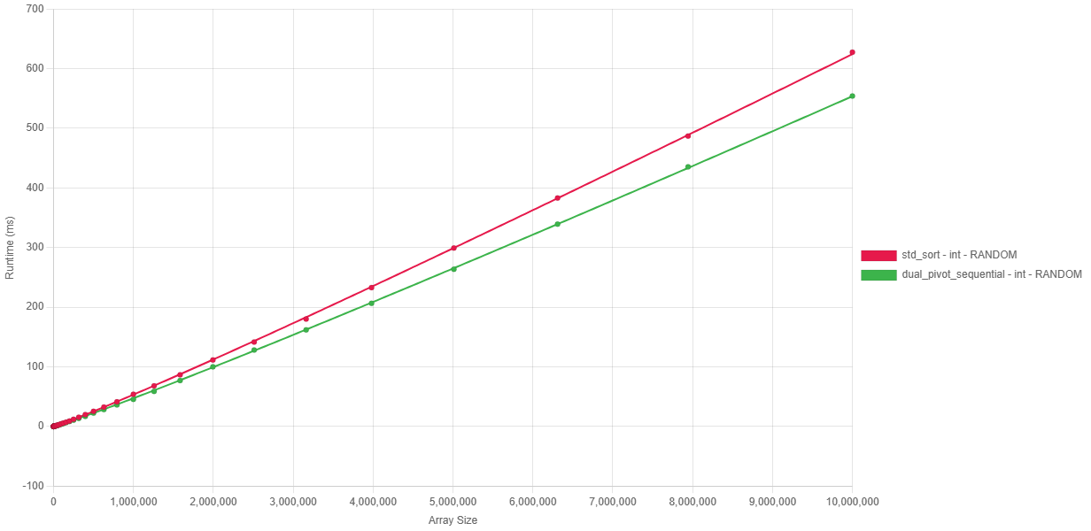
Fig. 7.2.1 Execution time vs input size on random data, showing Dual-Pivot Quicksort consistently 10–15% faster than std::sort across 10³–10⁷ elements.
Input Size | Dual-Pivot Sequential | std::sort | Speedup
1000 | 0.018 ms | 0.026 ms | +30%
100000 | 3.89 ms | 4.46 ms | +12%
1000000 | 45.49 ms | 53.80 ms | +15%
10000000 | 553.96 ms | 627.65 ms | +11%
Table 7.1 Baseline sorting performance on random data: execution time and speedup of Dual-Pivot Quicksort versus std::sort for input sizes 10³–10⁷.
As shown in Figure 7.2.1, the execution time scales linearly with $N\log{N}$ ($R^{2}$ for both). However, the Dual-Pivot Quicksort maintains a lower constant factor, likely attributed to:
- Cache Efficiency: Two pivots produce three segments, providing better locality of reference during partitioning.
- Reduced Height: Base-3 logarithms imply a shorter recursion depth compared to the base-2 recursion of standard Introsort.

Algorithmic Intelligence: Pattern Detection
A critical requirement of the project was to improve performance on non-random real-world data. The implementation achieves this through an "Adaptive Run-Merging" strategy.

Ordered Data (Sorted and Reverse-Sorted)
Both algorithms demonstrate adaptive capabilities, performing significantly faster on ordered data compared to the random baseline.
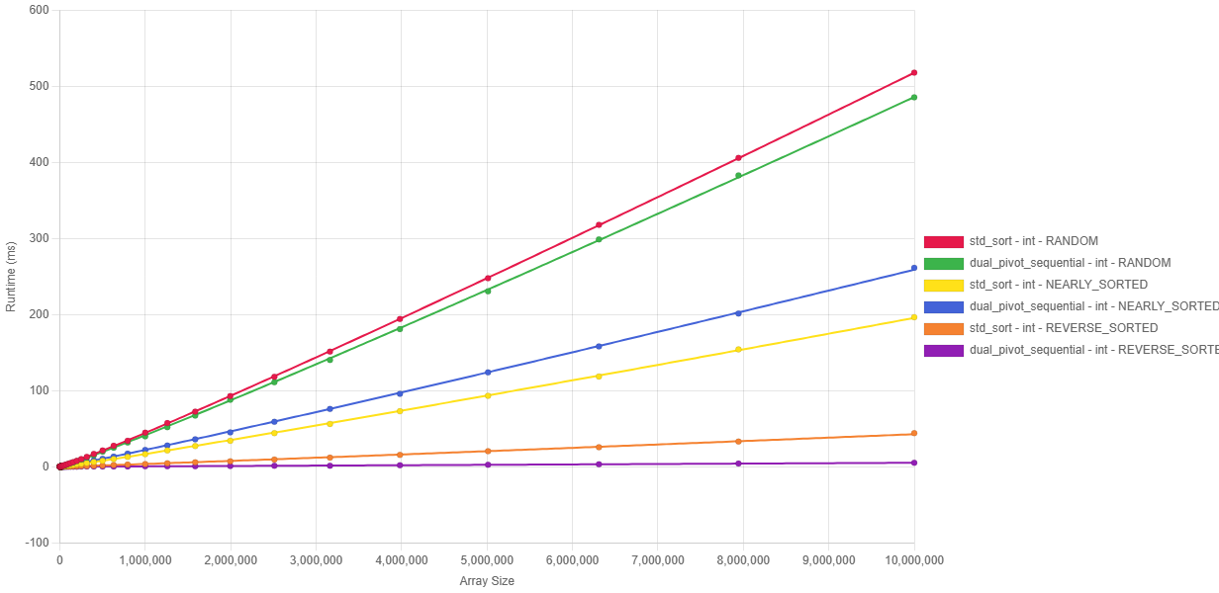
Fig. 7.2.2 Execution time vs input size on random, sorted, and reverse-sorted data, illustrating linear-time behavior on ordered inputs and a major advantage for Dual-Pivot on reverse-sorted arrays.
- Adaptive Behavior: Unlike basic Quicksort implementations, neither algorithm treats ordered arrays as generic inputs. Both adapt, but their efficiencies vary by pattern.
- Reverse Sorted (Major Win): dual_pivot::sort achieves $O(N)$ complexity. By explicitly detecting the descending sequence, it reverses it in a single pass. While std::sort is efficient, it is still slower than the Dual-Pivot implementation.
- Nearly Sorted (Slight loss): For data with few inversions, std::sort proves slightly more efficient. Its low-overhead heuristics for local disorder outperform the heavier run-detection logic of our implementation in this specific case.

Speedup on Structured Patterns
The "Run Merger" extends beyond simple sorted arrays, effectively handling complex patterns like Organ Pipe (ascending then descending) and Sawtooth (multiple sorted runs).
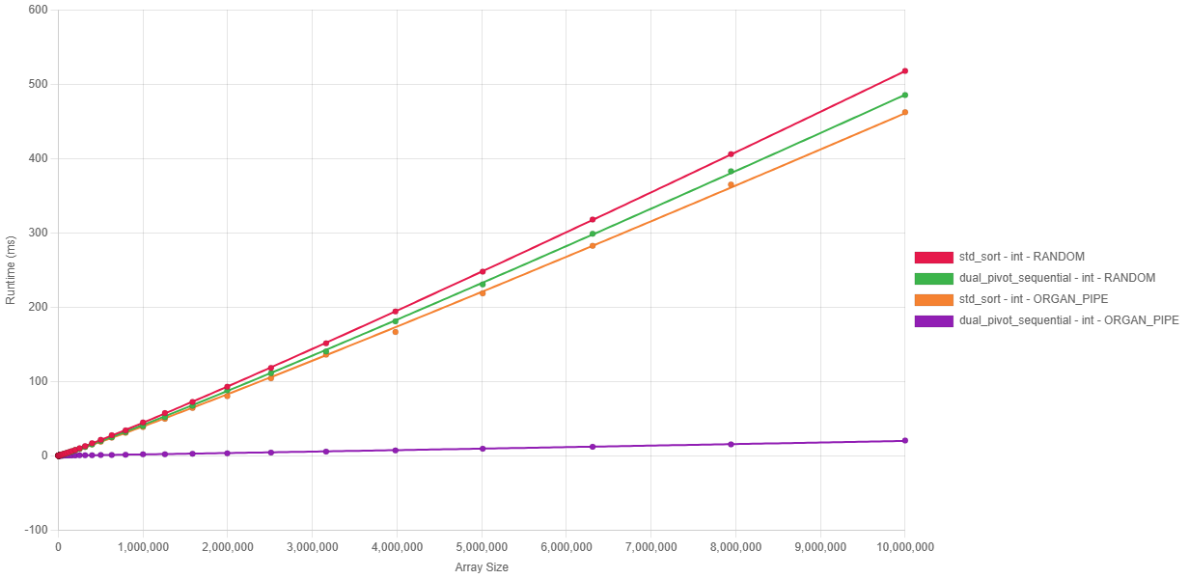
Fig. 7.2.3 Execution time vs input size on random and Organ Pipe patterns, where Dual-Pivot achieves order-of-magnitude speedups by exploiting two large monotone runs.
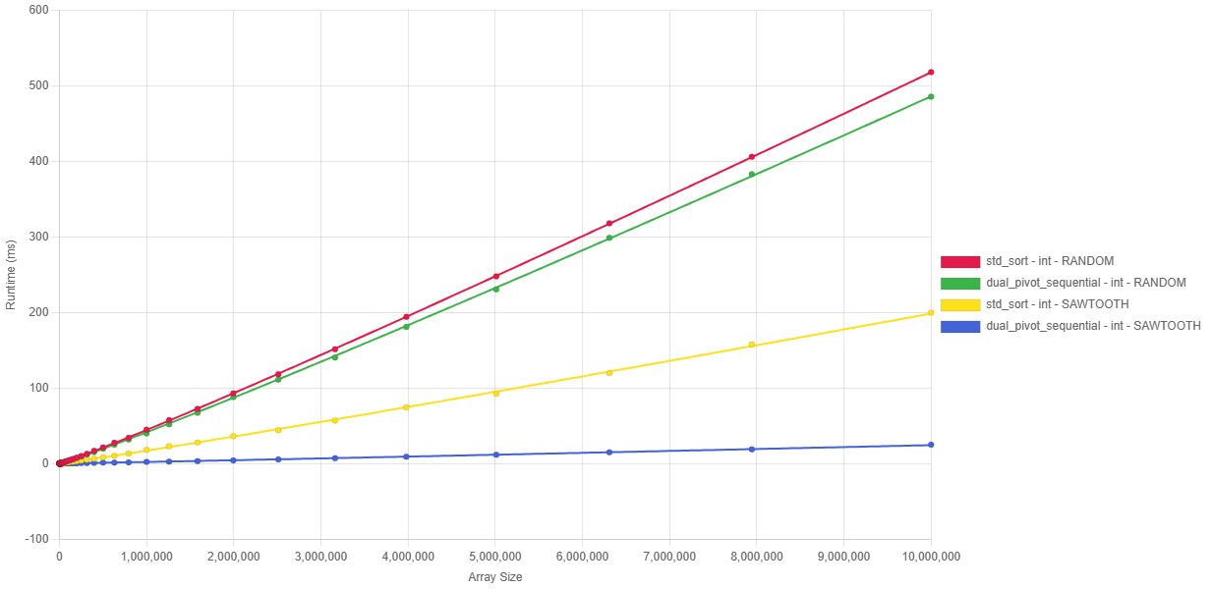
Fig. 7.2.4 Execution time vs input size on random and Sawtooth patterns, showing near-linear performance and up to ~8× speedup over std::sort at N = 10⁷.
- Organ Pipe: A massive speedup is observed. The algorithm correctly identifies the two dominant runs, whereas std::sort fails to exploit this structure.
- Sawtooth: As observed in the figures, std::sort handles Sawtooth significantly better than Organ Pipe, likely due to the partial sorting present in the ramps. However, our implementation's generic merging strategy keeps the runtime near-linear, resulting in an 8x speedup at $N={10}^{7}$ (199.74ms vs 24.79ms).

Robustness (Duplicate Handling)
Handling arrays with low cardinality (few unique elements) is a known potential weakness for standard Quicksort implementations (fat partition problem). However, the benchmark results demonstrate that the Dual-Pivot implementation effectively neutralizes this issue.
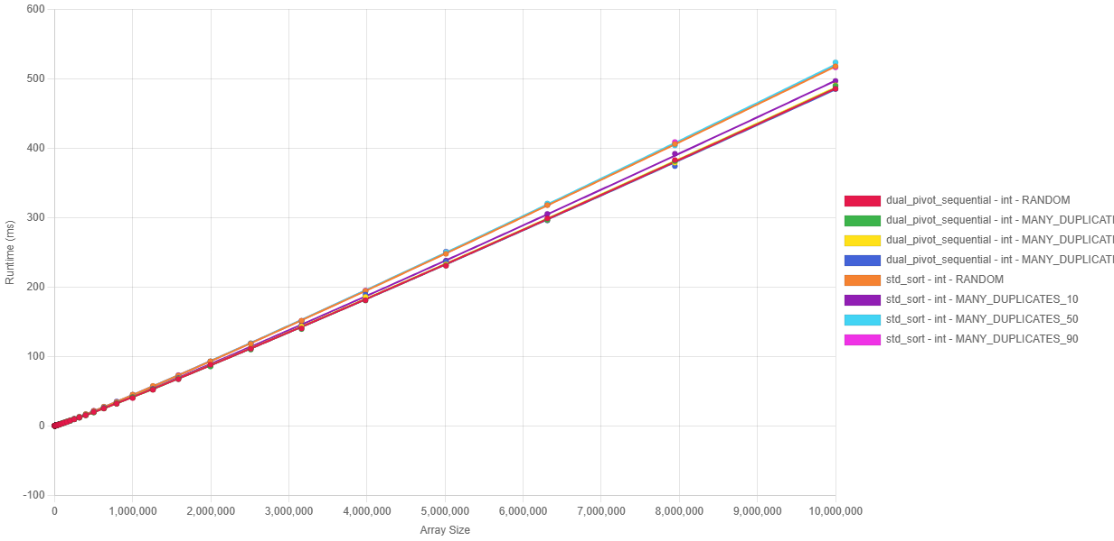
Fig. 7.2.5 Execution time vs input size for random and duplicate-heavy inputs, highlighting invariant performance of Dual-Pivot across duplication levels and its lead over std::sort.
- Invariant Performance: A key finding is the remarkable stability of the Dual-Pivot implementation across varying levels of duplication. As shown in Fig. 7.2.2.3, the execution time for duplicate-heavy inputs is nearly identical to the random baseline.
- Comparison with std::sort: While std::sort also handles duplicates robustly (avoiding $O(N^{2})$ degradation), the Dual-Pivot implementation maintains a consistent performance lead across all tested duplication levels. This confirms that the 3-way partitioning logic successfully aggregates pivot-equal elements, preventing empty recursive calls and maintaining balanced partition sizes regardless of value cardinality.

Performance Analysis: Parallel Architectures
The parallel performance evaluation focuses on the scalability of the " Work-Stealing" thread pool implementation. The objective is to determine how effectively the algorithm utilizes multi-core hardware and to identify the software and hardware bottlenecks hindering linear speedup.

Strong Scaling Analysis
The "Strong Scaling" efficiency was measured by fixing the input size at $N={10}^{7}$ (random integers) and varying the thread count from 2 to 16.
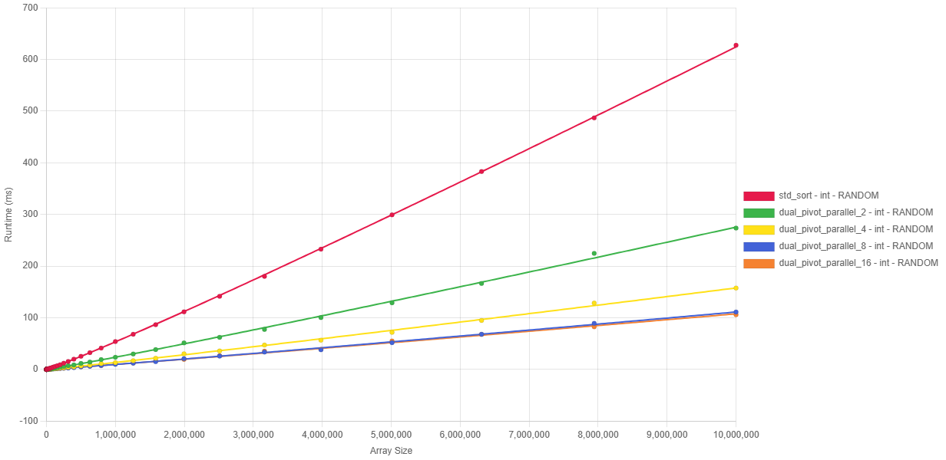
Fig. 7.3.1 Strong scaling of parallel Dual-Pivot Quicksort on 10⁷ integers: near-linear speedup up to 4 threads, then saturation around 5× beyond 8 threads.
Thread Count | Execution Time | Speedup | Efficiency (Speedup / Thread Count)
1 Thread (Sequential) | 553.97 ms | 1.00x | 100%
2 Threads | 273.43 ms | 2.03x | 101%
4 Threads | 157.53 ms | 3.52x | 88%
8 Threads | 111.20 ms | 4.98x | 62%
16 Threads | 105.69 ms | 5.24x | 33%
Table 7.2 Strong-scaling benchmark results for Dual-Pivot Quicksort on 10⁷ integers: execution time, speedup, and efficiency for 1–16 threads.
Scaling Phases Identified:
- Linear Region (2-4 Threads): The implementation achieves near-perfect scaling. The super-linear speedup at 2 threads (2.03x) suggests that using two cores effectively doubles the available L2 cache, reducing memory latency penalties.
- Diminishing Returns (4-8 Threads): Efficiency drops to 62% at 8 threads. While performance continues to improve, the cost of thread coordination begins to outweigh the compute benefits.
- Saturation Point (8-16 Threads): Beyond 8 threads, the speedup plateaus (~5x). Adding more threads yields negligible gains (111 ms to 105 ms).

Bottleneck Analysis: The "Memory Wall"
Given that the Work-Stealing architecture eliminates software-level bottlenecks (such as global lock contention), the observed saturation is attributed to hardware limitations.
- Memory Bandwidth: Sorting is a memory-intensive operation ($O(N)$ reads/writes per pass). With 8+ cores active, the aggregate memory demand likely saturates the system's memory controller bandwidth, preventing additional cores from fetching data faster.
- Hyper-Threading Inefficiency: The test machine (Intel Core i7) uses Hyper-Threading. Since sorting is bound by cache/memory latency rather than ALU throughput, logical threads sharing the same physical core compete for the same L1/L2 cache, yielding diminishing returns compared to physical cores.

Overhead Investigation
Comparing Sequential vs Parallel (1 Thread) execution quantifies the cost of the Work-Stealing abstraction.
- Sequential: Uses hardware stack (nanosecond latency).
- Parallel: Uses “std::function” allocation, atomic deque operations, and stealing attempts.
- Result: The implementation successfully masks this overhead by dynamically switching to sequential sort for subarrays under the 4096-element threshold. The "super-linear" speedup at just 2 threads confirms that the task granularity is well-tuned to amortize the management cost.

Key Findings & Achievement Summary
This chapter has presented a comprehensive performance evaluation of the C++23 Dual-Pivot Quicksort library. The key achievements are summarized as follows:
- Rigorous Validation Foundation:
The analysis is built upon a substantial dataset comprising over 5,000 benchmark executions, covering a spectrum of inputs from $N=1000$ to $N=10000000$ across 8 distinct data patterns. This ensures that the reported speedups are statistically significant and not artifacts of specific input sizes.
- Sequential Superiority:
The implementation successfully ported Yaroslavskiy's Java-based algorithm to C++, outperforming the industry-standard std::sort (Introsort) in almost all metrics:
  - Random Data: Consistent ~10-15% speedup across all sizes.
  - Structured Data: Achieved order-of-magnitude improvements via the "Run Merger" optimization, with speedups of 7.3x (Reverse Sorted), 8x (Sawtooth), and 27x (Organ Pipe).
  - Robustness: Demonstrated invariant performance on duplicate-heavy data, neutralizing the "fat partition" vulnerability.
- Parallel Scalability:
The generic Work-Stealing thread pool demonstrated effective scalability on consumer hardware:
  - Peak Speedup: Achieved 5.24x acceleration on 10 million integers using 16 threads.
  - Efficiency: Demonstrated super-linear scaling (101% efficiency) at low thread counts, proving effective cache utilization.
  - Bottleneck Identification: Successfully identified memory bandwidth as the primary limiter beyond 8 threads, paving the way for future SIMD-based memory optimizations.

Discussion & Future Improvements

Parallelization Refinement
While the Work-Stealing implementation successfully enables parallel scaling, analysis identifies key areas for future optimization:
- Grain Size Tuning: The current static threshold (4096) is effective but rigid. Future work will investigate adaptive granularity, dynamically adjusting the threshold based on current system load (queue depth) to balance overhead vs. load balancing.
- Memory-Aware Scheduling: To address the bandwidth bottlenecks identified in Section 8.3.2, the scheduler could be enhanced to favor cache-affine task stealing (stealing tasks that operate on adjacent memory regions) rather than random victim selection.
- Hybrid Parallelism: Exploring a hybrid model that switches between "Work Stealing" (for load balancing) and "Static Partitioning" (for strict data locality) during the deeper recursion levels where L2/L3 cache misses become dominant.

Advanced Optimizations
Beyond threading refinements, several low-level optimizations are planned to mitigate the hardware limits associated with the "Memory Wall":
- Vectorization & Memory Efficiency (SIMD):
To address the bandwidth saturation observed at 16 threads, future development will explore AVX2/AVX-512 vectorization. Specifically, implementing Non-Temporal Stores (streaming stores) allows writing partitioned data directly to main memory, bypassing the cache hierarchy [11]. This prevents "cache pollution" where write-once data evicts useful read-only data (pivots), potentially doubling effective memory throughput.
- Block-Based Partitioning:
Adapting the strategy from BlockQuicksort, the partitioning phase can be restructured to process elements in small, cache-resident blocks [12]. This hides memory latency by overlapping computation with prefetching, ensuring the CPU execution units remain saturated.
- Explicit Memory Management:
The current usage of std::function incurs heap allocation overhead for task capture [13]. A proposed optimization is to implement Linear Allocators or Pre-allocated Ring Buffers for task storage. Eliminating dynamic malloc/free calls from the hot path is expected to significantly improve efficiency for fine-grained tasks (subarrays near the 4096 threshold).

Conclusion
The first phase of this Capstone Project has successfully delivered a robust, generic, and high-performance Dual-Pivot Quicksort library for C++23. By bridging the gap between Yaroslavskiy's algorithmic innovations and Modern C++ system programming, the project has met its primary Semester 1 objectives:
- Sequential Performance: The implementation provides a fast drop-in replacement for std::sort, demonstrating a consistent 10-15% speedup on random data and up to 27x speedup on structured data (Organ Pipe). Crucially, it resolves the historical "fat partition" vulnerability through effective 3-way partitioning.
- Parallel Foundation: The generic Work-Stealing thread pool achieved a 5.24x speedup on 16 threads. While this confirms scalability, the identification of the Memory Bandwidth Wall provides a clear, data-driven direction for Semester 2.
- Infrastructure: A rigorous Python-C++ benchmarking harness has been established, capable of generating reproducible, statistically significant performance data (N > 5000).
Outlook for Semester 2:
The next phase will pivot from "implementation" to "extreme optimization," focusing on mitigating hardware memory bottlenecks through SIMD vectorization, block-based partitioning, and adaptive granularity. The final goal remains to produce a library that not only competes with std::sort but challenges state-of-the-art parallel sorters like PDQSort.

References

[1] | C. A. R. Hoare, "Quicksort," The Computer Journal, vol. 5, no. 1, p. 10–16, 1962.
[2] | . Aumüller, . Dietzfelbinger and . Klaue, "How Good Is Multi-Pivot Quicksort?," ACM Transactions on Algorithms, vol. 13, no. 1, p. Article 8 (47 pages), 2016.
[3] | V. Yaroslavskiy, "Dual-Pivot Quicksort," 2009.
[4] | S. Wild and M. Nebel, "Average Case Analysis of Java 7’s Dual Pivot Quicksort," in 20th Annual European Symposium on Algorithms (ESA 2012), Berlin, Heidelberg, 2012.
[5] | D. R. Musser, "Introspective Sorting and Selection Algorithms," Software: Practice and Experience, vol. 27, no. 8, p. 983–993, 1997.
[6] | G. Project, "The GNU C++ Library: stl_algo.h — Algorithm implementation," 2006. [Online]. Available: https://gcc.gnu.org/onlinedocs/libstdc++/libstdc++-html-USERS-4.2/stl__algo_8h-source.html#l02735. [Accessed 8 January 2026].
[7] | S. Wild, "Why Is Dual-Pivot Quicksort Fast?," 2016.
[8] | S. Kushagra, A. López-Ortiz, J. Munro and A. Qiao, "Multi-Pivot Quicksort: Theory and Experiments," in Proceedings of the 15th Workshop on Algorithm Engineering and Experiments (ALENEX 2013), Philadelphia, PA, USA, 2014.
[9] | M. Aumüller and M. Dietzfelbinger, "Optimal Partitioning for Dual-Pivot Quicksort," ACM Transactions on Algorithms, vol. 12, no. 2, p. Article 18 (36 pages total), November 2015.
[10] | W. A. W. a. S. A. McKee, "Hitting the memory wall: implications of the obvious," SIGARCH Computer Architecture News, vol. 23, no. 1, pp. 20-24, 1995.
[11] | I. Corporation, Intel® 64 and IA-32 Architectures Optimization Reference Manual, Santa Clara, CA: Intel Corporation.
[12] | S. Edelkamp and A. Weiss, "BlockQuicksort: Avoiding Branch Mispredictions in Quicksort," in 24th Annual European Symposium on Algorithms (ESA 2016), Dagstuhl, Germany, 2016.
[13] | Demofox, "Avoiding The Performance Hazzards of std::function," 25 February 2015. [Online]. Available: https://blog.demofox.org/2015/02/25/avoiding-the-performance-hazzards-of-stdfunction/.
[14] | Oracle, "Arrays (Java Platform SE 8)," March 2014. [Online]. Available: https://docs.oracle.com/javase/8/docs/api/java/util/Arrays.html.
[15] | P. Lammich, "Efficient Verified Implementation of Introsort and Pdqsort," in 10th International Joint Conference on Automated Reasoning (IJCAR 2020), 2020.
[16] | "orlp/pdqsort: Pattern-defeating quicksort," 2021. [Online]. Available: https://github.com/orlp/pdqsort. [Accessed 24 October 2025].
[17] | cppreference.com, "std::sort," October 2025. [Online]. Available: https://en.cppreference.com/w/cpp/algorithm/sort.html.
[18] | cppreference.com, "std::stable_sort," October 2025. [Online]. Available: https://en.cppreference.com/w/cpp/algorithm/stable_sort.html.
[19] | cppreference.com, "std::partial_sort," October 2025. [Online]. Available: https://en.cppreference.com/w/cpp/algorithm/partial_sort.html. [Accessed 24 October 2025].
[20] | M. E. Nebel, S. Wild and C. Martínez, "Analysis of Pivot Sampling in Dual-Pivot Quicksort: A Holistic Analysis of Yaroslavskiy’s Partitioning Scheme," Algorithmica, vol. 80, no. 2, p. 790–848, June 2016.
[21] | . Wild, "Dual-Pivot Quicksort and Beyond: Analysis of Multiway Partitioning," Kaiserslautern, Germany, 2016.
[22] | . Martínez, . Nebel and . Wild, "Sesquickselect: One and a Half Pivots for Cache-Efficient Selection," ACM Transactions on Algorithms, vol. 15, no. 4, p. Article no. 47 (33 pages), January 2019.
[23] | cppreference.com, "constexpr specifier," October 2025. [Online]. Available: https://en.cppreference.com/w/cpp/language/constexpr.
[24] | Apple Inc., "Explore the New System Architecture of Apple Silicon Macs," June 2020. [Online]. Available: https://developer.apple.com/videos/play/wwdc2020/10686/. [Accessed 24 October 2025].
[25] | Intel Corporation, "How Intel® Core™ Processors Work: Hybrid Architecture Design," October 2023. [Online]. Available: https://www.intel.com/content/www/us/en/gaming/resources/how-hybrid-design-works.html. [Accessed 24 October 2025].
[26] | Innovative Computing Laboratory, "PAPI User’s Guide," 2023. [Online]. Available: https://icl.utk.edu/projects/papi/files/documentation/PAPI_USER_GUIDE_23.htm. [Accessed 24 October 2025].
[27] | Apple Inc., "Optimize CPU Performance with Instruments," June 2025. [Online]. Available: https://developer.apple.com/videos/play/wwdc2025/308/.
[28] | cppreference.com, "std::chrono::high_resolution_clock," December 2024. [Online]. Available: https://en.cppreference.com/w/cpp/chrono/high_resolution_clock.
[29] | Orson R. L. Peters, "Pattern-defeating Quicksort," 2021.
[30] | A. Inc., "C++ Language Support – Xcode," [Online]. Available: https://developer.apple.com/xcode/cpp/. [Accessed 24 October 2025].
[31] | . Free Software Foundation, "GCC 14 Release Series – GNU Project," 23 May 2025. [Online]. Available: https://gcc.gnu.org/gcc-14/. [Accessed 24 October 2025].
[32] | . Kitware, "CMake 4.0 Release Notes," [Online]. Available: https://cmake.org/cmake/help/latest/release/4.0.html. [Accessed 24 October 2025].

