**Team:** Team Canada

**Group:** Lin, Duncan, Cha, Liam

**Essential Requirements**

* Responsive Functional Calendar
* Lets professors and students create/read/update/delete account (First name, Last name, login details) in a system.
* Lets professors add/send(GET) students unique calendar keys.
* Lets students subscribe/read/update calendars.
* Lets administrators create/search/read/update/delete professors in a system.
* Lets administrators create/search/read/update/delete students in a system.
* Lets administrators create/search/read/update/delete calendar courses in a system.
* Lets professors create/search/read/update/delete calendar courses in a system.

**Important**

* Calendar Filter
* Lets students create/read/update/delete events to personal calendar
* Navigation Menu Bar
* Lets professors archive calendar courses
* Lets students archive calendars (personal & courses)
* Lets professors and students create/update the date range

**Nice-to-Have**

* Sync Reminders
* Side Menu Bar: To-do List (Daily/Weekly/Monthly)
* Lets users edit wallpaper and theme
* Subscription to Pro version (unlimited personal calendars, fonts, themes)

**Use Case Diagram**

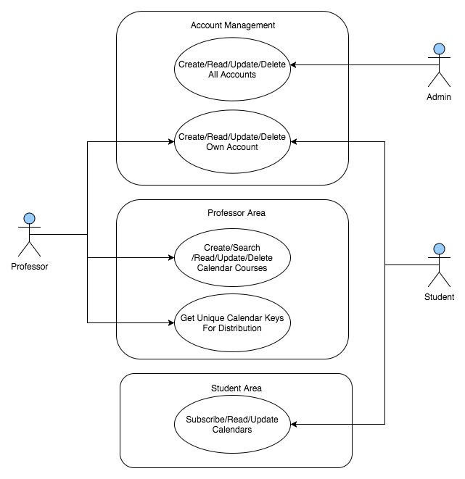

**ERD**

