**Team:** Team Canada

**Group:** Lin, Duncan, Cha, Liam

**Essential Requirements**

* Calendar view of the current month on home page (main panel)
* Lets users create/read/update account (username, email, password)
* Lets users select the account type: professors and students.
* Lets professors create/search/read/update calendars for courses.
* Lets professors add/update/delete events for relevant calendars they created.
* Lets professors generate an access code on calendar create for other users to view the calendar.
* Lets students create one personalized calendar.
* Lets students add events to their personal calendar.
* Lets users subscribe/read a calendar view via an access code.
* Lets users view a list of their personal/subscribed calendars on home page.
* Lets users select which calendar(s) to display on the main panel.
* Lets users view past and future months of the calendar.

**Important**

* Lets users click and drag events on the main panel.
* Lets users toggle between different views (daily/weekly/monthly)
* Lets professors archive calendar courses
* Lets students archive calendars (personal & courses)
* Lets users deactivate their accounts
* Lets each calendars and events have associated color codes.

**Nice-to-Have**

* Sync Reminders
* Subscription to Pro version (unlimited personal calendars, fonts, themes)
* Side Menu Bar: To-do List (Daily/Weekly/Monthly)
* Lets users edit wallpaper and theme
* Lets guest users view a calendar with a granted access code

**Use Case Diagram**

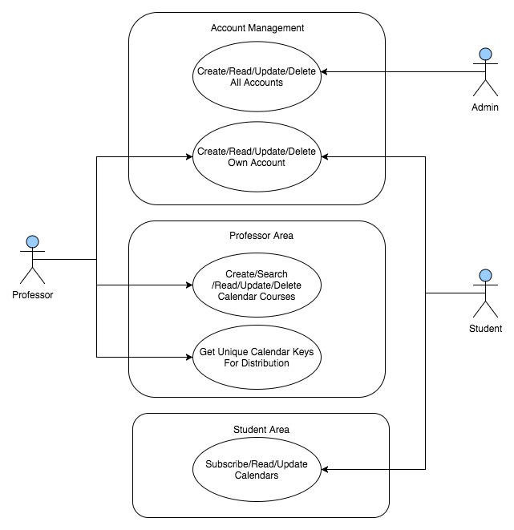

**ERD CHANGEEEEEE**

