## Functional Requirements

|  |
| --- |
| **Essential Requirements**   * Calendar view of the current month on home page (main panel) * Lets users create/read/update account (username, email, password) * Lets users select the account type: professors and students. * Lets professors create/search/read/update calendars for courses. * Lets professors add/update/delete events for relevant calendars they created. * Lets professors generate an access code on calendar create for other users to view the calendar. * Lets students create one personalized calendar. * Lets students add events to their personal calendar. * Lets users subscribe/read a calendar view via an access code. * Lets users view a list of their personal/subscribed calendars on home page. * Lets users select which calendar(s) to display on the main panel. * Lets users view past and future months of the calendar.   **Important**   * Lets users click and drag events on the main panel. * Lets users toggle between different views (daily/weekly/monthly) * Lets professors archive calendar courses * Lets students archive calendars (personal & courses) * Lets users deactivate their accounts * Lets each calendars and events have associated color codes.   **Nice-to-Have**   * Sync Reminders * Subscription to Pro version (unlimited personal calendars, fonts, themes) * Side Menu Bar: To-do List (Daily/Weekly/Monthly) * Lets users edit wallpaper and theme * Lets guest users view a calendar with a granted access code |

## Use Case Diagram (Essentials Only)

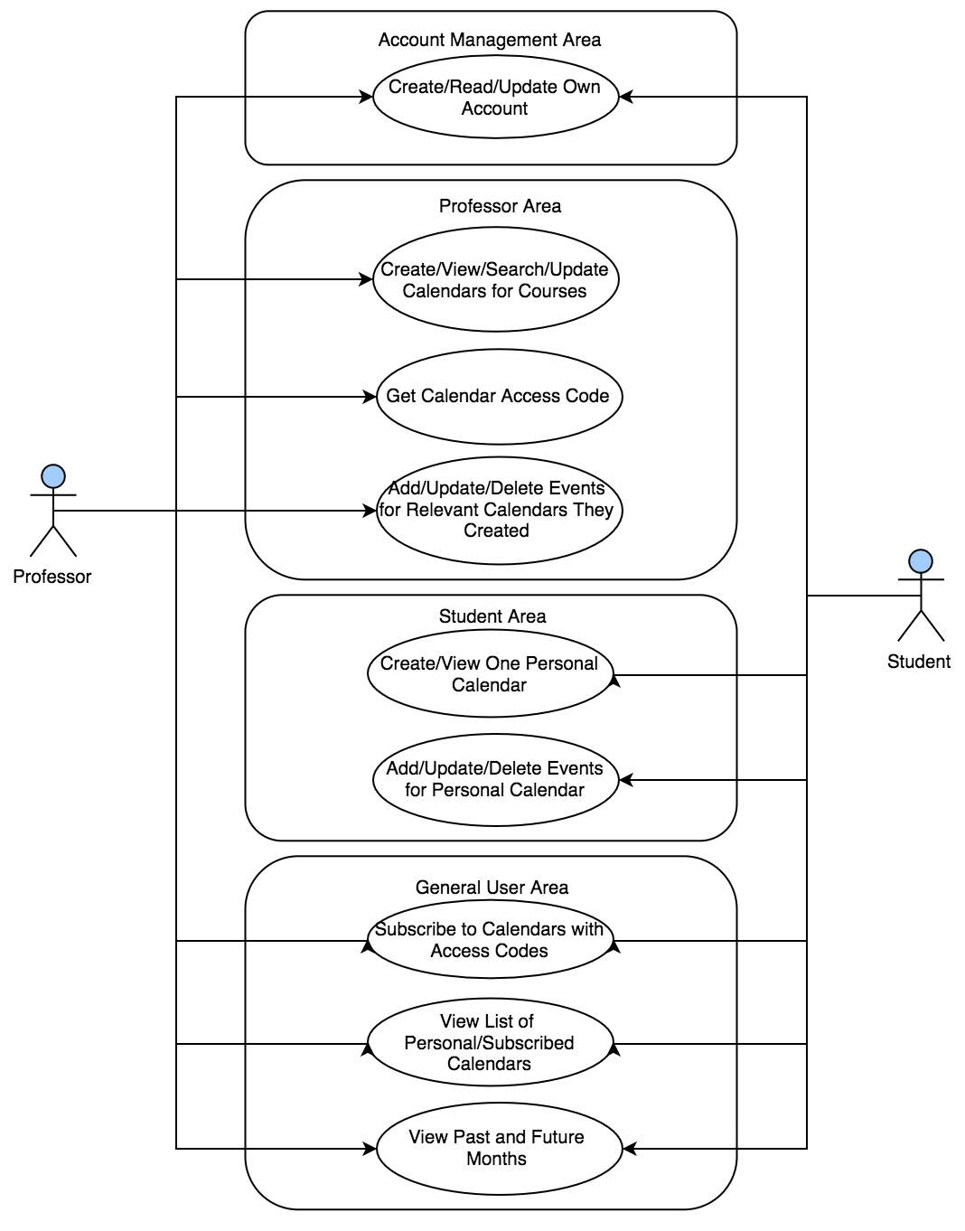

## ERD (Essentials Only)

