

COMP 6411
Comparative Study of Programming Languages
Summer 2013

POTUM: THE BEVERAGE COASTER PROJECT
Deliverable 2

Team D

List of Team Members:
Aravindan Balasubramanian
Lin Zhu
Romil Bandi
Safan Maredia
Shivangi Rathore
Qing Sun

Table of Contents

1.0 ABSTRACT 5
2.0 INTRODUCTION 5
2.1 Comparative Study of Programming Languages 5
2.2 Challenges in comparing Programming Languages 5
3.0 PROBLEM STATEMENT 6
4.0 POTUM ALGORITHM 7
4.1 BASIC THEORY AND CONCEPTION 7
4.1.1 Conversion between Sine and Cosine 7
4.1.2 Maclaurin series of Trigonometric functions 8
4.1.3 Approximations of π-Chudnovsky algorithm 8
4.2 DECISION-MAKING ANALYSIS 8
4.2.1 Analysis of the algorithms of calculating Pi 8
4.2.2 Analysis of the ways of simplifying the equation of alpha 9
4.2.3 Analysis of the ways of calculating L 10
4.3 DESCRIPTION OF THE ALGORITHM 10
4.3.1 Problem Analysis 10
4.3.2 Algorithm 10
5.0 PROGRAMMING LANGUAGES AND STYLE GUIDELINES 13
5.1 C++ 13
5.2 JavaScript 14
5.3 Matlab 15
5.4 PHP 16
5.5 Python 17
5.6 Ruby 18
5.7 Programming Style Guidelines 19
6.0 POTUM: IMPLEMENTATION CODE WITH RESPECTIVE OUTPUTS 21
6.1 C++ 21
6.2 JavaScript 22
6.3 Matlab 22
6.4 PHP 25
6.5 Python 26
6.6 Ruby 27
7.0 CONCLUSION 28
8.0 REFERENCES 28

List of Figures

Figure 1: Two circular coasters of equal area A 2
Figure 2: Overlap axis between two coasters 3
Figure 3: Generalized continued Fraction of sine x 5
Figure 4: Determining the lower boundary of alpha 7
Figure 5: MException class 12
Figure 6: C++ implementation output with Accuracy = 0.0001 17
Figure 7: JavaScript implementation output with Accuracy = 0.0001 18
Figure 8: L changes with the increasing of R with accuracy=0.0001 19
Figure 9: Ratio of L and R changes with the increasing of R 19
Figure 10: Matlab implementation output with Accuracy = 0.0001 20
Figure 11: PHP web form for entering Radius value 21
Figure 12: PHP output based on value of R 21
Figure 13: Python implementation output with Accuracy = 0.0001 22
Figure 14: Ruby implementation output with Accuracy = 0.0001 23

List of Tables

Table 1: Performances for different algorithms of calculating Pi 5
Table 2: C++ computation of L for different values of R 17
Table 3: JavaScript computation of L for different values of R 18
Table 4: Matlab computation of L for different values of R 20
Table 5: PHP computation of L for different values of R 21
Table 6: Python computation of L for different values of R 22
Table 7: Ruby computation of L for different values of R 23

1.0 ABSTRACT

This simple report is written for solving the problem of POTUM - The Beverage Coaster Project, To find the Length of Overlap 'L' of two beverage coasters, which are two overlapping circles such that all the three sections have same Area A/2. To deploy an algorithm to compute 'L' for various values of 'R', which is the radius of the circle and let α be the angle with vertex at the center of the left circle.

The POTUM algorithm needs two equations to solved 'α 'is given by the equation "α – sin(α) = π/2", Then the length 'L' of the segment X1,X2 is given by the equation

"L = 2R(1 – cos(α/2))", is implemented by six different language based on one common algorithm which is designed by Team D. The report starts from the basic description of the problem and the algorithm, gives a detailed analysis. Followed by the implementation in six different languages, which are C++, JavaScript, Matlab, PHP, Python and Ruby. Finally, the algorithm solves the final output 'L' for various values of 'R' in six different programming languages.

2.0 INTRODUCTION
A programming language is an artificial language designed to express computations that can be performed by a machine, particularly a computer. Programming languages can be used to create programs that control the behavior of a machine, to express algorithms precisely, or as a mode of human communication. Thousands of different programming languages have been created, mainly in the computer field with many more being created every year. Most programming languages describe computation in an imperative style, i.e., as a sequence of commands, although some languages, such as those that support functional programming or logic programming, use alternative forms of description
2.1 Comparative Study of Programming Languages:
Picking the best language that might fulfill all necessities for the given issue could be a challenging task. A few languages are more qualified for particular applications than others. To select the correct one for the particular issue domain, one needs to realize what characteristics it furnishes to underpin the necessities. Distinctive languages support different paradigms, provide different abstractions, and have
different levels of expressive power. Some are more qualified to express calculations and others are focusing on the non-technical users. The question is then what is the best tool for a particular problem.
2.2 Challenges in comparing Programming Languages:
Nowadays programming languages are becoming more and more general and all purpose, yet they still have their specializations, and every language has its weaknesses and favorable circumstances.
Languages can generally be divided into a few basic types, though many languages support more than one programming style. This following list isn't all inclusive or as fine-grained as possible, but it brings out some of the basic design decisions behind languages.
Language types:
Procedural: Procedural languages execute a sequence of statements that lead to a result. In essence, a procedural language expresses the procedure to be followed to solve a problem.
Functional: Functional programs typically make little use of stored state, often eschewing loops in favor of recursive functions. The primary focus of functional programming is on the return values of functions, and side effects and other means storing state are strongly discouraged.
Object-oriented: Object-oriented programming views the world as a collection of objects that have internal data and external means of accessing parts of that data.
Scripting: Scripting languages are often procedural and may contain elements of object-oriented languages, but they fall into their own category because they are typically not meant to be full-fledged programming languages with support for large system development.
Logic: Logic programming languages allow programmers to make declarative statements and then allow the computer to reason about the consequences of those statements.
Perspectives, like security and language safety, UI prototyping capabilities, language support for building
distributed systems, and support for automating existing processes, and portability are also important
issues to consider when choosing the programming language. In our project report we talked over the suitability of the selected languages for the specified criteria.

3.0 PROBLEM STATEMENT
For many, a cold beverage in a glass is among the means for survival during summer. The main purpose of a coaster is to absorb condensation dripping along the glass, and thereby protect the surface of a table or any other surface used for placing the glass. The coasters are also of interest to tegestologists.
For the sake of reference, the project (and its product) is called POTUM. The project involves both individual work, as well as collaborative work. Each team member must implement, verify, and present a strand of POTUM.
Problem: Let there be two circular coasters of equal area (and negligible height). The purpose of POTUM is to find how far the two coasters need to be moved on top of each other such that the area of the overlapping region is half the area of any one of the coasters, as illustrated in Figure 1.
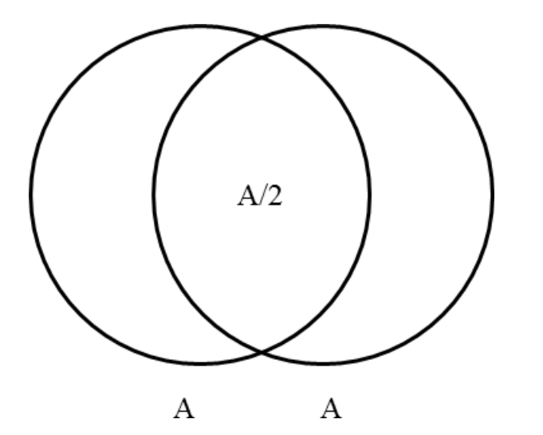
Figure 1 Two circular coasters of equal area A

Solution: The segment X₁X₂ on the x-axis is an indicator of the degree of overlap between the two coasters, as illustrated in Figure 2.
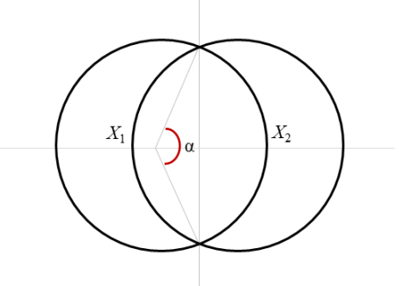
Figure 2 Overlap axis between two coasters

Let R be the radius of any one of the coasters, and let α be the angle with vertex at the center of the left circle, as shown in Figure 2.
Then the length l of the segment X₁X₂ is given by the equation
and α is given by the equation

4.0 POTUM ALGORITHM
4.1 Basic Theory and Conception
4.1.1 Conversion between Sine and Cosine
It is the most common and basic knowledge in trigonometric functions area. It is one of the trigonometry identities.
And also,
In addition, half-angle formula is also needed.
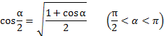

4.1.2 Maclaurin series of Trigonometric functions
In mathematics, a Taylor series is a representation of a function as an infinite sum of terms that are calculated from the values of the function's derivatives at a single point.
When the single point is 0, that representation is called Maclaurin series.
A Maclaurin series is a Taylor series expansion of a function about 0,
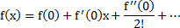
Maclaurin series was named after the Scottish mathematician Colin Maclaurin.
Maclaurin series are a type of series expansion in which all terms are nonnegative integer powers of the variable.
Here, we use the one for sine function:
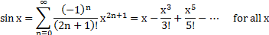

4.1.3 Approximations of π—Chudnovsky algorithm
The Chudnovsky algorithm is a fast method for calculating the digits of π.
It was used by the Chudnovsky brothers to calculate more than one billion digits. It was used in the world record calculations of 2.7 trillion digits of π in December 2009, 5 trillion digits of π in August 2010, and 10 trillion digits of π in October 2011.
The algorithm is based on the following rapidly convergent generalized hypergeometric series:
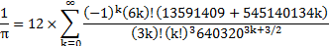
This identity is similar to one of Ramanujan's formulas involving π.
4.2 Decision-Making Analysis
There are three parts which are expected decision-making in this problem.
- Which method or algorithm is a better choice for us to get the value of Pi;
- In which way are we able to simplified the equation of alpha;
- How to calculate the value of L after we get the value of alpha and sine alpha.
4.2.1 Analysis of the algorithms for calculating Pi
Since using the trigonometric functions from the library must be avoided, we have to calculate the value of Pi by ourselves. So the best choice is to find an approximation of Pi in order to get its exact value for certain accuracy. Why we chose Chudnovsky algorithm for calculating Pi over other algorithms?
Here is a table of the performances for different algorithms of calculating Pi. (with the same accuracy)
 | Execution Time (Second) | Minimum number of Iterations
Chudnovsky Algorithm | 0.0001 | 1
Liu Hui Algorithm | 0.078 | 25
Leibniz formula | 5.452 | 100000000
Gregory–Leibniz series | 0.001 | 8
Riemann zeta function | 17.491 | 1000000000
Table 1 Performances for different algorithms of calculating Pi ( Accuracy = 0.0000001, using Matlab)
We can see from the table, the Chudnovsky Algorithm is the fastest one among others, to calculate the value of π, which only takes 0.0001 second and 1iteration. In comparison with other algorithm, Chudnovsky Algorithm is obviously a good choice for this project, since one of the most important algorithm requirements for this problem is a good speed. So that is the reason why we chose Chudnovsky Algorithm to calculate the value of π.

4.2.2 Analysis of the ways of simplifying the equation of alpha
It must not use any native support in programming languages for trigonometric functions, so we have to Simplify Sine Function in the 2nd equation.
It is a non-linear equation of , and it is impossible for us to solve the expression with trigonometric function. Hence, we must find another expression take place of and convert it into a multiple degree polynomial equation one unknown quantity .
Our choice is the Maclaurin series. The condition of determine the last element of this series is comparing the upper boundary of the absolute value for the element with the accuracy. If the kth element is ‘small’ enough, then we can keep the first k elements of the series as the of π.
It will take 0.003 second to calculate the stop position with the accuracy of 0.001.

While for other approximations, some of them are not easy to determine the stop condition. Like the generalized continued fraction of sine x,
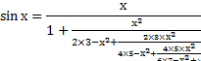
Figure 3 Generalized continued Fraction of sine x
Above all, the Maclaurin series of sine function is appropriate for this problem. So we choose it as our basic algorithm of solving the equation of .
4.2.3 Analysis of the ways of calculating L
We calculate the value of L based on the equation 1.
The value of is the only key point of calculating L since the remaining terms are known. The most obvious way is to calculate the cosine function with the same algorithm Maclaurin series. Since here we have the value of alpha and half of alpha, it is quite easy for us to calculate using the expression:
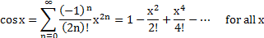
However, it will cause more errors because we ignore the many elements of the series a second time. Instead of producing more errors, we use a ‘safer’ method to get the value of , using the basic conversation between trigonometric functions mentioned previously. It is ‘safe’ and will no longer cause additional errors. And this is why we use it to calculate the value of .
4.3 Description of the Algorithm
4.3.1 Problem Analysis
The key point of this problem is to find a solution of the equation about (the 2nd equation).
Firstly, we should find a method or an algorithm to solve this equation. After the value of is calculated, the value of l can also be solved by the first equation (the 1st equation).
However, there is also another thinking which is to solve the two non-linear equations together by trying to eliminate the variable and find the relationship between l and R directly. However, it is not good for this certain problem since the sample data space of the variables here is not too large.
Above all, the main idea is the first way so that we can focus on solving the 2nd equation and then calculate the l by the 1st equation. And find the relationship between l and R.
4.3.2 Algorithm
Simplification of Sine Function
As it’s mentioned, it must not use any native support in programming languages for trigonometric functions, such as sin(x) and cos(x).
Hence, we have to Simplify Sine Function in the 2nd equation.
From the Maclaurin series, we can get:

Here we get:
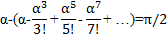
Then we have:
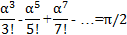
Thus far, we have converted the former equation into a multiple degree polynomial equation one unknown quantity .
Calculate Value of Pi and Boundary of alpha.
Calculate value of Pi with the Chudnovsky algorithm.
This algorithm is based on the following rapidly convergent generalized hypergeometric series:
So the value of Pi is obviously calculated which is:
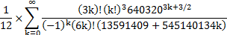

Boundary of alpha is
In order to get this result, we should know a fact that the area of overlapping part is increasing with 2 circles getting closer.
Then the alpha we want to get is larger than , only if the area of overlapping part when is still less than half of the area of one circle.
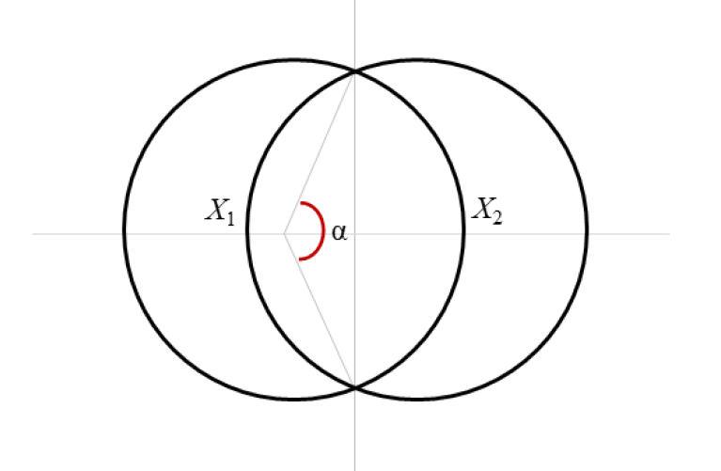
Assume that now
B
P
O
A

Figure 4 Determining the lower boundary of alpha
Area of sector AOB is
Area of triangle OAB is
Then the area of overlapping part when is 2 Area of sector AOB - Area of triangle OAB
After calculating, the area is still less than half of the area of one circle which means the alpha we want to get is larger than .
Above all, the boundary of alpha is
Determine Series End Position & Solve the Simplified Equation
Now the problem is when we should stop the series, since it is endless. That is depended on the accuracy we choose.
Definitely, better accuracy takes longer time of the operation.
For example, for the accuracy of 0.001,
We should make sure the series changes ‘small’ enough so that it fits the accuracy.
Because of is , so let it be , the upper boundary.

Let
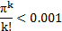
We can get when k is equal to 13, it fits the accuracy of 0.001.
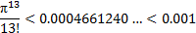

In this case of accuracy, we simplify this equation into
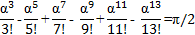
Calculate the Value of l with the 1st Equation
From the 1st equation
We need to calculate the value of .
In order to avoid getting more errors, here we do not use series to convert cosine.
Instead, we use another way. We can get the value of from the 2nd equation
Then use the formula below to get the value of

At last use
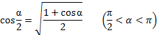
And we will get the value of .
Finally,

5.0 PROGRAMMING LANGUAGES AND STYLE GUIDELINES
5.1 C++ : Shivangi Rathore, Application Version : C++ 11
C++ is a general purpose programming language biased towards systems programming that is a better C, supports data abstraction and object oriented programming. The ISO C++ Standard: C++ is standardized by ISO (The International Standards Organization) in collaboration with national standards organizations, such as ANSI (The American National Standards Institute), BSI (The British Standards Institute), DIN (The German national standards organization). The original C++ standard was issued in 1998, a minor revision in 2003, and current standard, C++11, was issued in September 2011. During its development, C++11 was referred to as C++0xC++ is the main development language used by many of Google's open-source projects.
Advantages:
- Extremely fast, works very well for GUI programming on a computer.
- Good language to write operating systems, drivers, and platform dependent applications with.
- Good language to learn to program with.
- Global data and global functions are used within C++, which aren't used in many other high level languages in computer sciences, which is a great advantage to the programming languages.
Disadvantages:
- Although it is platform independent, it is mostly used for platform specific applications.
- A library set is usually chosen that locks you into a single platform or operating system. C++ is complex for very large high level programs, also difficult to debug when used for web applications.
- C++ does not use objects, it is difficult to make programs that have inheritance data and programs to contribute to other data and programs.
- It is possible to do this however, but is difficult. These inheritance data and programs are known as inheritance trees.
Exception Handling in C++:
Exception handling is a mechanism that separates code that detects and handles exceptional circumstances from the rest of your program. An exceptional circumstance is not always necessarily an error.
When a function detects an exceptional situation, you represent this with an object which is called as an exception object. In order to deal with the exceptional situation you throw the exception. This passes control, as well as the exception, to a designated block of code in a direct or indirect caller of the function that threw the exception. This block of code is called a handler. In a handler, you specify the types of exceptions that it may process. The C++ run time, together with the generated code, will pass control to the first appropriate handler that is able to process the exception thrown. When this happens, an exception is caught. A handler may re-throw an exception so it can be caught by another handler. This exception handling mechanism uses some elements like try blocks catch blocks throw expressions.
5.2 Javascript- Aravindan Balasubramanian,
Application Version: JavaScript's stable and latest release is 1.8.5, as the output is for the implementation is generated in Web browsers, each browser has varied JavaScript versions available in them. However, the implementation of the algorithm in JavaScript was tested with various browsers of different versions and found compatible.
JavaScript (often shortened to JS) is a lightweight, interpreted, object-oriented language with first-class functions, most known as the scripting language for Web pages, but commonly used in many non-browser environments as well such as node.js or Apache. It is a prototype-based, multi-paradigm scripting language that is type safe, dynamic and supports object-oriented, imperative and functional programming styles
The JavaScript standard is ECMAScript. As of 2012, all modern browsers fully support ECMAScript 5.1.
POTUM implementation involves floating point arithmetic calculation in solving the equations, Unlike many other programming languages, JavaScript does not define different types of numbers, like integers, short, long, floating-point etc. All numbers are stored as 64-bit (8-bytes) base 10, floating point numbers.
Exception Handling has been carried out for obtaining user input 'R'. User input exceptions and runtime errors are handled and checked for various conditions such as the entered value should be a positive value, Not a Number (NaN) exception etc., these exceptions are implemented with try and catch statements , all exceptions are caught and handled appropriately.
JavaScript programming language was chosen to implement POTUM algorithm over the other programming languages in lines of following "Continuous Learning" and "Know Well More than Two Programming Languages" concepts mentioned in "97 Things Every Programmer Should Know" which helps the implementer to explore and learn new programming language constructs and compare with the language (s) that they already know or of previous knowledge on programming languages.

Advantages of JavaScript are:
- JavaScript is one of the easy adaptable, and useful scripting languages that are used to improve the functionality among websites.
- JavaScript provides applicative programming techniques with first-class functions
- It is used in calculating data, create forms, complex mathematical equation using scripts and performing processing on web pages.
- JavaScript can be used on the client side or the user’s processor.
- Implementing the algorithms and new ideas are easy as the syntax is similar to simple English.
Disadvantages are:
- Security issues because the code executes on the users' computer, in some cases it can be exploited for malicious purposes. This is one reason some people choose to disable JavaScript.
- JavaScript is sometimes interpreted differently by different browsers. Whereas server-side scripts will always produce the same output, client-side scripts can be a little unpredictable. Scripts had to be checked with all major browsers.
5.3 Matlab: Lin Zhu, Application Version: Matlab 7.11 R2010b
MATLAB is a high-level language and interactive environment for numerical computation, visualization, and programming. Using MATLAB, you can analyze data, develop algorithms, and create models and applications. The language, tools, and built-in math functions enable you to explore multiple approaches and reach a solution faster than with spreadsheets or traditional programming languages, such as C/C++ or Java.
You can use MATLAB for a range of applications, including signal processing and communications, image and video processing, control systems, test and measurement, computational finance, and computational biology. More than a million engineers and scientists in industry and academia use MATLAB, the language of technical computing.
Advantages:
- Matlab is an interpreted language for numerical computation.
- It allows one to perform numerical calculations.
- It visualizes the results without the need for complicated and time consuming programming.
- Matlab allows its users to accurately solve problems, produce graphics easily and produce code efficiently.
- It's very easy for a beginner in computer programming.
Disadvantages:
- Matlab is an interpreted language. The main disadvantage of interpreted languages is execution speed. When a language is compiled, all of the code is analyzed and processed efficiently, before the programmer distributes the application.
- With an interpreted language, the computer running the program has to analyze and interpret the code (through the interpreter) before it can be executed (each and every time), resulting in slower processing performance.
Exception handling
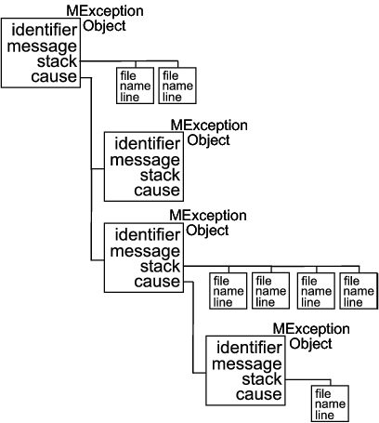
When the MATLAB® software throws an exception, it captures information about what caused the error in a data structure called a MException object. This object is an instance of the MATLAB MException class. You can obtain access to the MException object by catching the exception before your program aborts and accessing the object constructed for this particular error via the catch command. When throwing an exception in response to an error in your own code, you will have to create a new MException object and store information about the error in that object.
The figure shown below illustrates one possible configuration of an object of the MException class. The object has four properties: identifier, message, stack, and cause. Each of these properties is implemented as a field of the structure that represents Figure 5. MException class
the MException object. The stack field is an N-by-1 array of additional structures, each one identifying a function, and line number from the call stack. The cause field is an M-by-1 cell array of MException objects, each representing an exception that is related to the current one.
The MException class has four properties. Each of these properties is implemented as a field of the structure that represents the MException object. Each of these properties is described in the sections below and referenced in the sections on Respond to an Exception and Throw an Exception. All are read-only; their values cannot be changed.
5.4 PHP: Romil Bandi, Application Version: PHP 5.5.1
PHP (recursive acronym for PHP: Hypertext Preprocessor) is a widely-used open source general-purpose scripting language that is especially suited for web development and can be embedded into HTML.

What distinguishes PHP from something like client-side JavaScript is that the code is executed on the server, generating HTML which is then sent to the client. The client would receive the results of running that script, but would not know what the underlying code was. You can even configure your web server to process all your HTML files with PHP, and then there's really no way that users can tell what you have up your sleeve.
PHP is a scripted language, which is another great advantage for PHP programmers. Many programming languages require that you compile files into machine code before they can be run, which is a time-consuming process. Bypassing the need to compile means you’re able to edit and test code much more quickly.

Advantages:
- Open Source: PHP is open source it means that it is readily available and absolutely free for use.
- Cross Platform: PHP is cross-platform and therefore enables operation across various operating systems. It works excellently on LINUX, UNIX and Windows platforms. What’s more, it interfaces effortlessly with Apache/MySQL.
- Quick: PHP is very fast to develop and ensures that there is a quick turnaround time.
- High Returns: PHP often enables people to create dynamic websites. This ensures more visitor participation and thereby better returns.
- Extensions: PHP has multiple extensions and is extremely scalable.
- Stable: Since it is maintained by many developers, so when bugs are found, it can be quickly fixed.
- Powerful library support: you can easily find functional modules you need such as PDF, Graph etc.
Disadvantages:
- Security: since it is open source, so all people can see the source code, if there are bugs in the source code, it can be used by the people to explore weakness of PHP.
- Not suitable for large applications: PHP is hard to maintain science it is not very modular.
- Weak type: Implicit conversions may surprise unwary programmers and lead to unexpected bugs.

5.5 Python: Safan Maredia, Application Version: Python 3.3.0
Python is a remarkably powerful dynamic programming language that is used in a wide variety of application domains. Python is often compared to TCL, Perl, Ruby, Scheme or Java. Some of its key distinguishing features include very clear, readable syntax, strong introspection capabilities, intuitive object orientation, and natural expression of procedural code.

Very high level dynamic data types, extensions and modules easily written in C, C++ (or Java for Jython). Learning Students may be better served by learning Python as their first language. Python has a very simple and consistent syntax and a large standard library and, most importantly, using Python in a beginning programming course lets students concentrate on important programming skills such as problem decomposition and data type design. With Python, students can be quickly introduced to basic concepts such as loops and procedures.

Advantages:
- Python is a high-level general-purpose programming language that can be applied to many different classes of problems.
- The language comes with a large standard library that covers areas such as string processing (regular expressions, Unicode, calculating differences between files), Internet protocols (HTTP, FTP, SMTP, XML-RPC,POP, IMAP, CGI programming), software engineering (unit testing, logging, profiling, parsing Python code),and operating system interfaces (system calls, file systems, TCP/IP sockets). A wide variety of third-party extensions are also available.

Disadvantages:
- Lack of syntax.
- Python is an easy language to program in; however it is not very simple to translate a Python program into any other language.
- The translation from Python to another language would require the user to carefully examine the structure of the code and make sure to implement the same structure using the syntax of the new programming language.
Exception Handling:
Python provides two very important features to handle any unexpected error in your Python programs and to add debugging capabilities in them: Assertion and Exception Handling.
Exception Handling: An exception is an event, which occurs during the execution of a program, which disrupts the normal flow of the program's instructions. In general, when a Python script encounters a situation that it find unusual, it raises an exception. An exception is a Python object that represents an error. When a Python script raises an exception, it must either handle the exception immediately otherwise it would terminate and come out.

5.6 Ruby- Sun Qing, Application Version- Ruby (Ruby-1.8.6-p111)
Ruby is a dynamic, reflective, general-purpose object-oriented programming language that combines syntax inspired by Perl with Smalltalk-like features. It was also influenced by Eiffel and Lisp. Ruby was first designed and developed in the mid-1990s by Yukihiro "Matz" Matsumoto in Japan. It supports multiple programming paradigms, including functional, object oriented and imperative. It also has a dynamic type system and automatic memory management. It was accepted as a Japanese Industrial Standard (JIS X 3017) in 2011 and an international standard (ISO/IEC 30170) in 2012.

Advantages:
- Ruby is powerful: it is a dynamic and object-oriented programming language.
- Ruby is readable: the code comments itself and leads to better naming practices.
- Ruby is concise: it is a kind of very expressive language, so a small number of lines for code are able to accomplish high productivity.
Disadvantages:
- Ruby is slow: Ruby is about 10x slower than Java and 2x slower than PHP.
- Ruby is new: Not many developers or customers; No common IDE; No common application server.

5.7 Programming Style Guidelines
Naming Conventions:
- Abbreviations and acronyms must not be uppercase when used as name.
- Names representing types must be in mixed case starting with upper case.
- Variable names must be in mixed case starting with lower case. Makes variables easy to distinguish from types, and effectively resolves potential naming collision as in the declaration.
- Named constants (including enumeration values) must all be uppercase using underscore to separate words. In general, the use of such constants should be minimized. In many cases implementing the value as a method is a better choice .This form is both easier to read, and it ensures a unified interface towards class values.
- Names representing methods or functions must be verbs and written in mixed case starting with lower case.

Files:
- File content must be kept within 80 columns.
- 80 columns is a common dimension for editors, terminal emulators, printers and debuggers, and files that are shared between several people should keep within these constraints. It improves readability when unintentional line breaks are avoided when passing a file between programmers.
- Split lines occurs when a statement exceed the 80 column limit given above. It is difficult to give rigid rules for how lines should be split, but the examples above should give a general hint. The incompleteness of split lines must be made obvious.
- Break after a comma and an operator.
- Align the new line with the beginning of the expression on the previous line.
- Header files must contain an include guard.
- The construction is to avoid compilation errors. The name convention resembles the location of the file inside the source tree and prevents naming conflicts.

Statements:
- Variables should be initialized where they are declared.
- Variables must never have dual meaning .Enhances readability by ensuring all concepts are represented uniquely. Reduce chance of error by side effects.
- Variables should not be reused unless required by memory limitation.
- Related variables of the same type can be declared in a common statement.
- Unrelated variables should not be declared in the same statement.
- Use of global variables should be minimized.
- Use of global constants should be minimized.
- Loop variables should be initialized immediately before the loop.
- The use of break and continue in loops should be minimized.
- The end lines in nested loops can have comments.
Loops:
- Only loop control statements must be included in the for() construction. Increase maintainability and readability. Make a clear distinction of what controls and what is contained in the loop.
- Loop variables should be initialized immediately before the loop.
Constant and Functions:
- Floating point constants should always be written with decimal point and at least one decimal.
- Functions must always have the return value explicitly listed. Explicit and Implicit Type conversion is an important factor. A programmer must never rely on this feature, since this might be confusing for programmers not aware of this artifact.
Comments:
- Tricky code should not be commented but rewritten!
- In general, the use of comments should be minimized by making the code self-documenting by appropriate name choices and an explicit logical structure.
- All comments should be written in English. In an international environment English is the preferred language.
- Use // for all comments, including multi-line comments.
- Since multilevel C-commenting is not supported, using // comments ensure that it is always possible to comment out entire sections of a file using /* */ for debugging purposes etc.
- There should be a space between the "//" and the actual comment, and comments should always start with an upper case letter and end with a period.
White Space:
- Language specific reserved words, commas, colons should be followed by a white space.
- Semicolons in for statements should be followed by a space character.
- Variables in declarations can be left aligned which in turn enhances readability. The variables are easier to spot from the types by alignment.
- Use alignment wherever it enhances readability.
- There are a number of places in the code where white space can be included to enhance readability even if this violates common guidelines. Many of these cases have to do with code alignment. General guidelines on code alignment are difficult to give, but the examples above should give a general clue.
6.0 IMPLEMENTATION OUTPUTS OVER DIFFERENT LANGUAGES
6.1 C++ OUTPUT:
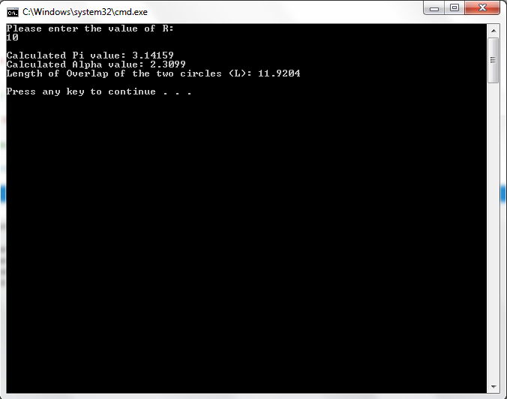
Figure 6 C++ implementation output with Accuracy = 0.0001

Variable name | Variable value
Radius (R) | 1 | 5 | 10 | 20 | 50 | 100 | 200 | 500 | 1000
Length (L) | 1.19204 | 5.96018 | 11.9204 | 23.8407 | 59.6018 | 119.204 | 238.407 | 596.018 | 1192.04
Table 2 C++ computation of L for different values of R

6.2 JAVASCRIPT OUTPUT:
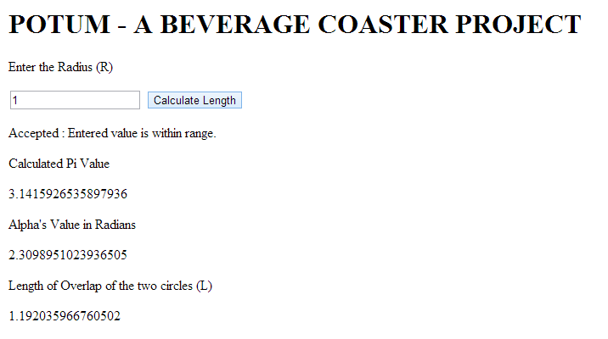
Figure 7 JavaScript implementation output with Accuracy = 0.0001

Radius (R) | Length Overlap of Two Circles (L)
1 | 1.192035966760502
5 | 5.960179833802510
10 | 11.92035966760502
20 | 23.84071933521004
50 | 59.601798338025105
100 | 119.20359667605021
200 | 238.40719335210042
500 | 596.017983380251
10000 | 1192.035966760502
Table 3 JavaScript computation of L for different values of R

6.3 MATLAB OUTPUT:

General Output
For each time running my code, there will have many information been printed out. The information includes all the values of the variables, the accuracy used in a certain case and the running process.
Matlab code can be run in 2 ways.
- Calculating the value of L with an accuracy and value of R typed in.
- Providing two graphs with a given accuracy and a certain range of R.
Graph 1 shows the change of L with the increasing of R, and the Graph 2 shows the radio of the changes of L and R, which means the slope for every point of the line in Graph 1.
Here are 3 kinds of output for Matlab code.

Graphic Output

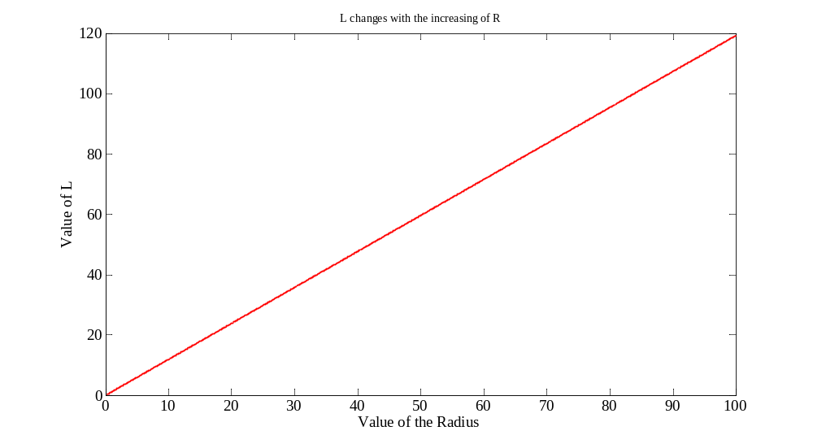
Figure 8 L changes with the increasing of R with accuracy=0.0001

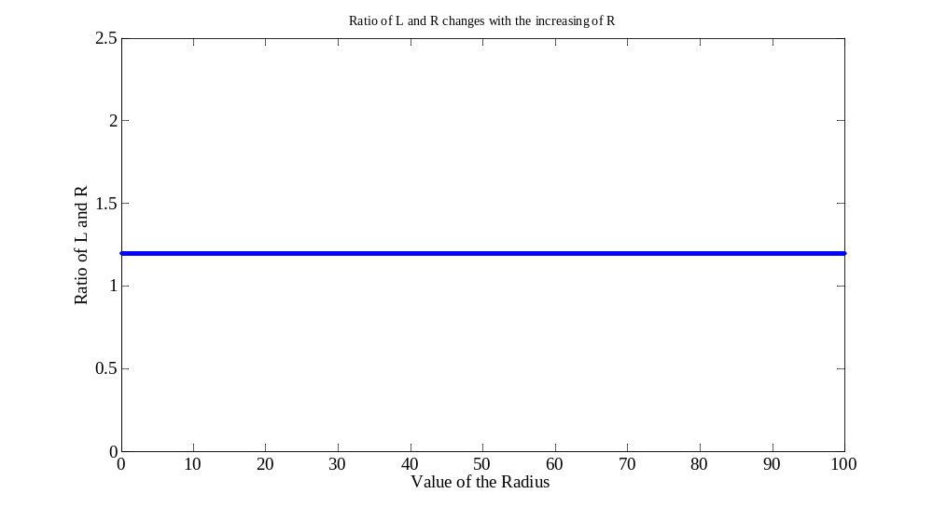
Figure 9 Ratio of L and R changes with the increasing of R

Command Window Output

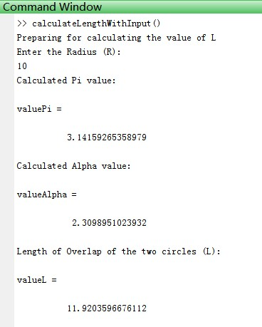
Figure 10 Matlab implementation output with Accuracy = 0.0001

Table Output

Variable name | Variable value
Radius (R) | 1 | 5 | 10 | 20 | 50 | 100 | 200 | 500 | 1000
Length (L) | 1.1920 | 5.9601 | 11.9203 | 23.8407 | 59.6017 | 119.2035 | 238.4071 | 596.0179 | 1192.0359
Table 4 Matlab computation of L for different values of R

6.4 PHP OUTPUT:
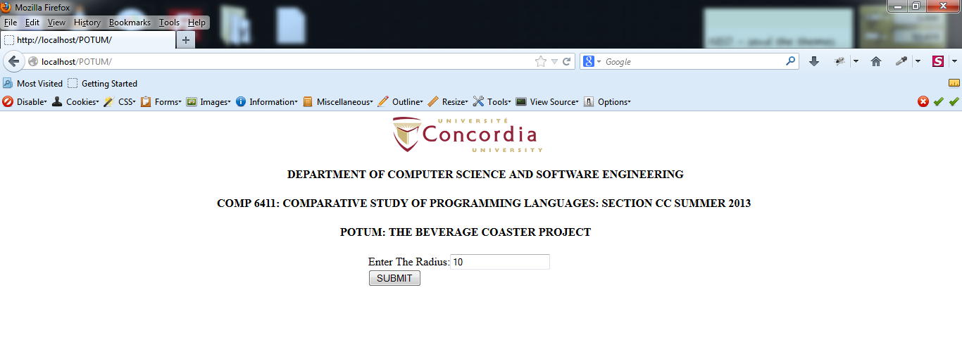
Figure 11 PHP web form for entering Radius value

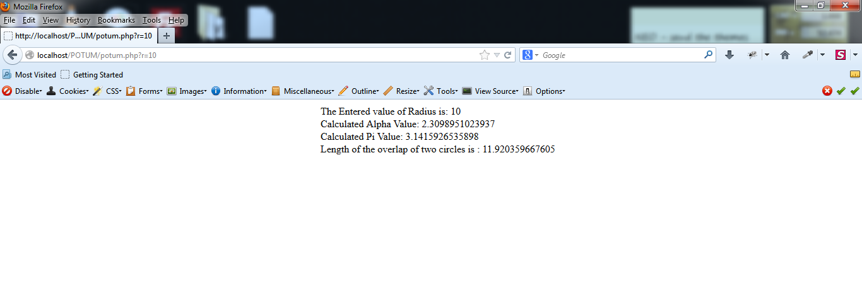
Figure 12 PHP output based on value of R

Variable name | Variable value
Radius (R) | 1 | 5 | 10 | 20 | 50 | 100 | 200 | 500 | 1000
Length (L) | 1.19203596 | 5.9601798 | 11.92035966 | 23.84071933 | 59.60179833 | 119.20359667 | 238.40719335 | 596.01798338 | 1192.03596676
Table 5 PHP computation of L for different values of R

6.5 PYTHON OUTPUT:
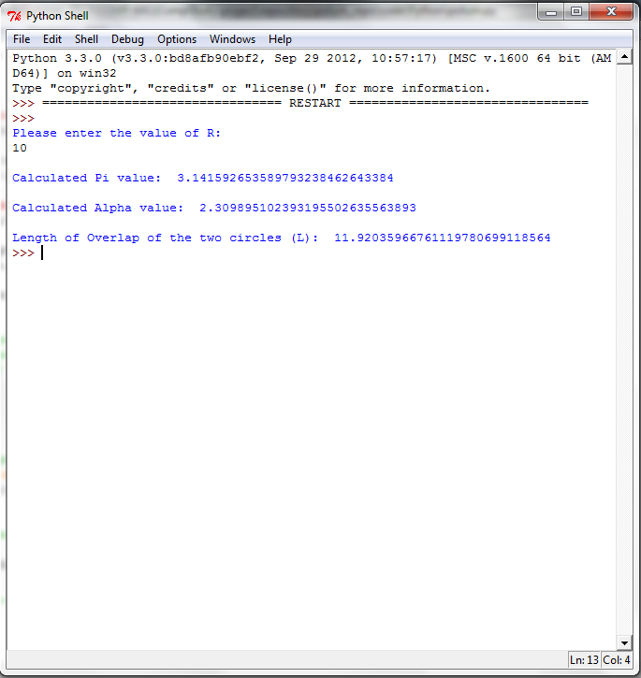
Figure 13 Python implementation output with Accuracy = 0.0001

Variable name | Variable value
Radius (R) | 1 | 5 | 10 | 20 | 50 | 100 | 200 | 500 | 1000
Length (L) | 1.192035967 | 5.960179834 | 11.92035967 | 23.84071934 | 59.60179834 | 119.2035967 | 238.4071934 | 596.0179834 | 1192.035967
Table 6 Python computation of L for different values of R
6.6 RUBY OUTPUT:

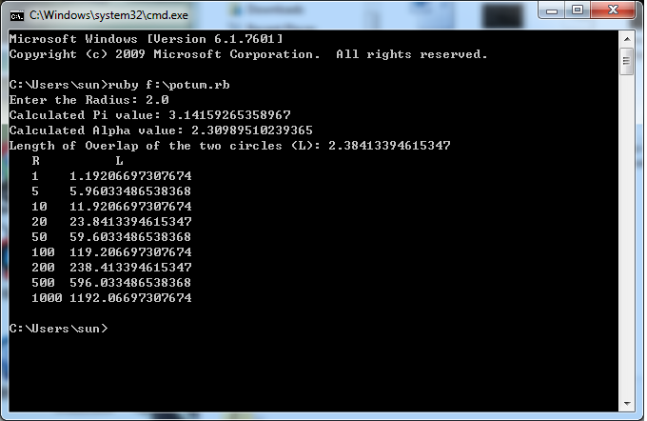
Figure 14 Ruby implementation output with Accuracy = 0.0001

Variable name | Variable value
Radius (R) | 1 | 5 | 10 | 20 | 50 | 100 | 200 | 500 | 1000
Length (L) | 1.19206697 | 5.96033486 | 11.92066973 | 23.84133946 | 59.60334865 | 119.20669730 | 238.41339461 | 596.03348653 | 1192.06697307
Table 7 Ruby computation of L for different values of R

7.0 CONCLUSION
POTUM implementation was implemented successfully in six different languages with their latest application version. An identical algorithm was used after comparing it over all other algorithms. The goal was to outflank the choosing of algorithms which was achieved successfully. Implementation in different programming languages does not use any native support in programming language for calculating trigonometric functions, such as sin(x) and cos(x), and for the mathematical constants, such as π. High efficiency was achieved by using an accuracy of 0.0001. For different values of R, L values were calculated and the sample output was consistent across the team. Programming style guidelines followed throughout the team was consistent.

8.0 REFERENCES
Berggren, L., Borwein, J. and Borwein, P. (2004). Pi, a source book. New York: Springer.
En.wikipedia.org (2012). Chudnovsky algorithm - Wikipedia, the free encyclopedia. [online] Retrieved from: http://en.wikipedia.org/wiki/Chudnovsky_algorithm [Accessed: 23 Jul 2013].
Haydock, R. and Burghes, D. (1992). Trigonometric functions. [Cranfield]: Cranfield Press.
Ferreira, A. (2008). MATLAB codes for finite element analysis. Dordrecht: Springer.
Haydock, R. and Burghes, D. (1992). Trigonometric functions. [Cranfield]: Cranfield Press.
Lynch, S. (2004). Dynamical systems with applications using MATLAB. Boston: Birkhäuser.
Quarteroni, A. and Saleri, F. (2006). Scientific computing with MATLAB and Octave. Berlin: Springer.
Riestra, J. (1995). A generalized Taylor's formula for functions of several variables and certain of its applications. Harlow, Essex, England: Longman.
Zygmund, A. (1988). Trigonometric series. Cambridge: Cambridge University Press.
Fogus, M. (2013). Functional Javascript. Sebastopol, CA: O'Reilly Media, Inc..
Haverbeke, M. (2011). Eloquent Javascript. San Francisco: No Starch Press.
Mediacollege.com (n.d.). The Pros and Cons of JavaScript. [online] Retrieved from: http://www.mediacollege.com/internet/javascript/pros-cons.html.
Mozilla Developer Network (2013). JavaScript. [online] Retrieved from: https://developer.mozilla.org/en-US/docs/Web/JavaScript.
En.wikipedia.org (2013). Python (programming language) - Wikipedia, the free encyclopedia. [online] Retrieved from: http://en.wikipedia.org/wiki/Python_(programming_language) [Accessed: 15 Jul 2013].
Python.org (2013). PEP 8 -- Style Guide for Python Code. [online] Retrieved from: http://www.python.org/dev/peps/pep-0008/ [Accessed: 15 Jul 2013].
Python.org (1990). About. [online] Retrieved from: http://www.python.org/about/ [Accessed: 15 Jul 2013].
Lengstorf, J. 2009. PHP for absolute beginners. [New York.]: Apress.
Php.net. 2013. PHP: Hypertext Preprocessor. [online] Available at: http://www.php.net [Accessed: 24 Jul 2013].
Lecture Notes,Revision 1.9 Joey Paquet, Serguei A. Mokhov (Eds.) August 5, 2010
Boost.org (1990). Boost Library Requirements and Guidelines. [online] Retrieved from: http://www.boost.org/development/requirements.html#Exception-specification [Accessed: 24 Jul 2013].
Geosoft.no (2011). C++ Programming Style Guidelines. [online] Retrieved from: http://geosoft.no/development/cppstyle.html#Recommendation [Accessed: 24 Jul 2013].
Google-styleguide.googlecode.com (n.d.). Untitled. [online] Retrieved from: http://google-styleguide.googlecode.com/svn/trunk/cppguide.xml [Accessed: 24 Jul 2013].
Stroustrup.com (2012). Stroustrup: C++. [online] Retrieved from: http://www.stroustrup.com/C++.html#standard [Accessed: 24 Jul 2013].
Andrews, V. (1994). Ruby. New York: Pocket Books.
Flanagan, D. and Matsumoto, Y. (2008). The Ruby programming language. Beijing: O'Reilly.
Snelling, L. (2003). Ruby. Minneapolis: Bethany House Publishers.

