The first system is <http://39.106.216.230:1111/dialog>

The second system is <http://39.106.216.230:8787/dialog>

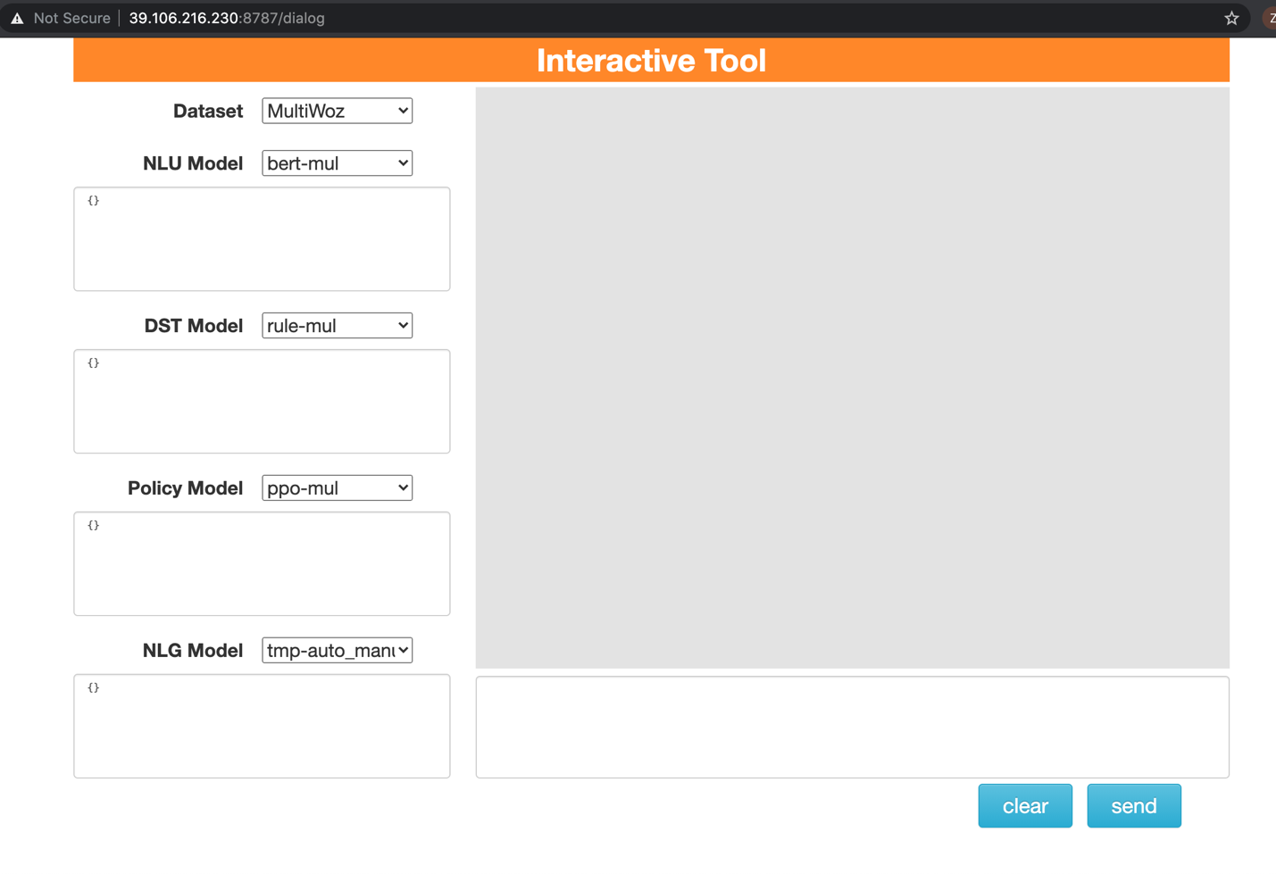

The systems above are two multi-domain dialog systems. The tasks we test here involve 7 domains (hotel, restaurant, taxi, hospital, attraction, train, police).

Tips:

1. Check the ‘usergoal.txt’ file. There are 500 tasks in total.
2. Each task contains a user goal dictionary and a description. You should first read the task description and then find concrete information in the user goal dictionary. Then you interact with the dialog system to complete the task.
3. In each task, you need to type the information from the file (in the ‘info’ field) to the dialog system, and ask system question according to your request (in the ‘reqt’ field). The system will give a response to your request.
4. After getting the answer from the dialog system, you need to fill in the requested slot values (which is shown as ‘?’). If a task contains ‘book’ filed, you also need to ask the system to book for you.
5. Refresh the browser when completing one task so that you can enter a new dialog session.

Steps:

1. For each task, refresh the browser first.
2. Interact with the dialog system.
3. If your requests are answered, then you fill the answer in the request’s slot.
4. If your requests are not answered, then you fill a ‘none’ in the request’s slot.
5. After finishing one task, refreshing browser and continue the next task.

Example:

0. {'attraction': {'info': {'area': 'centre', 'type': 'museum'}, 'reqt': {'entrance fee': '?'}}, 'restaurant': {'info': {'name': 'pizza express Fen Ditton'}, 'reqt': {'address': '?'}}, 'taxi': {'info': {'leaveAt': '01:45'}, 'reqt': {'car type': '?', 'phone': '?'}}}

task description: You are excited about seeing local tourist attractions. The attraction should be in the centre. The attraction should be in the type of museum. Once you find an attraction, make sure you get entrance fee. You are looking forward to trying local restaurants. You are looking for a particular restaurant. Its name is called pizza express Fen Ditton. Once you find a restaurant, make sure you get address. You also want to book a taxi to commute between the two places. The taxi should leave from the restaurant to the attraction after 01:45. Once you find a taxi, make sure you get car type, phone number.

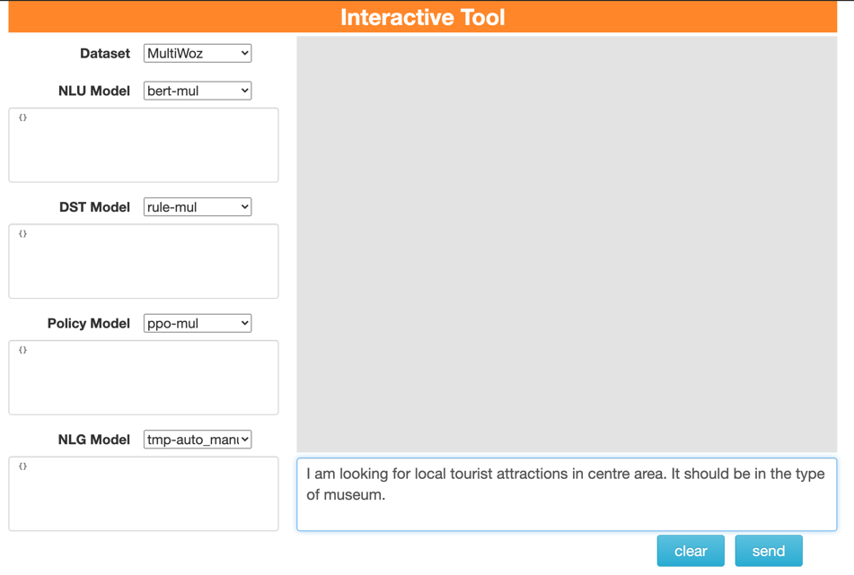

Interact by typing the text and then click ‘send’ button.

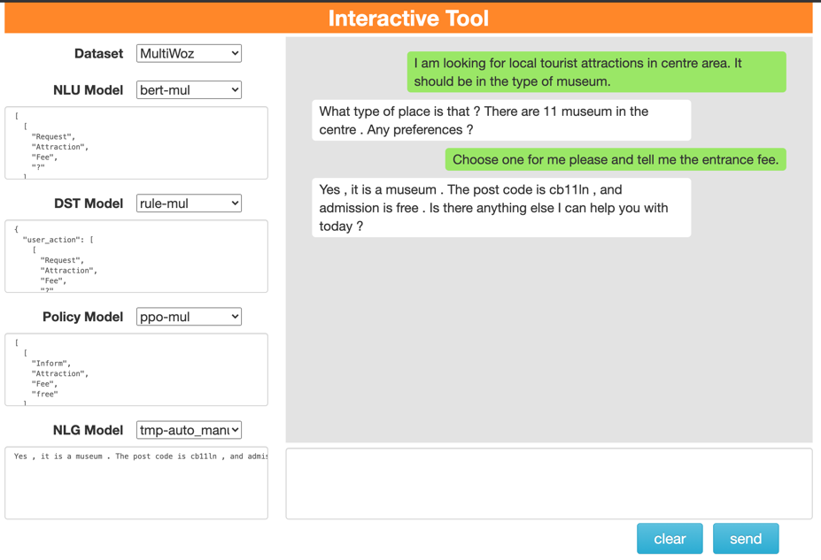

Fill in:

{'attraction': {'info': {'area': 'centre', 'type': 'museum'}, 'reqt': {'entrance fee': 'free'}}, 'restaurant': {'info': {'name': 'pizza express Fen Ditton'}, 'reqt': {'address': '?'}}, 'taxi': {'info': {'leaveAt': '01:45'}, 'reqt': {'car type': '?', 'phone': '?'}}}

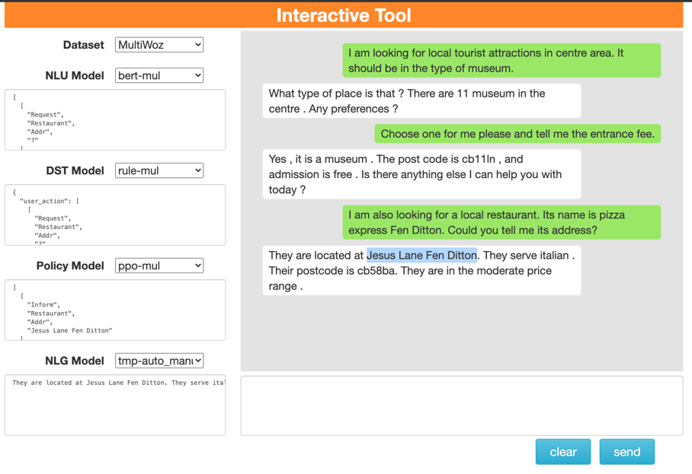

Fill in:

{'attraction': {'info': {'area': 'centre', 'type': 'museum'}, 'reqt': {'entrance fee': 'free'}}, 'restaurant': {'info': {'name': 'pizza express Fen Ditton'}, 'reqt': {'address': 'Jesus Lane Fen Ditton'}}, 'taxi': {'info': {'leaveAt': '01:45'}, 'reqt': {'car type': '?', 'phone': '?'}}}

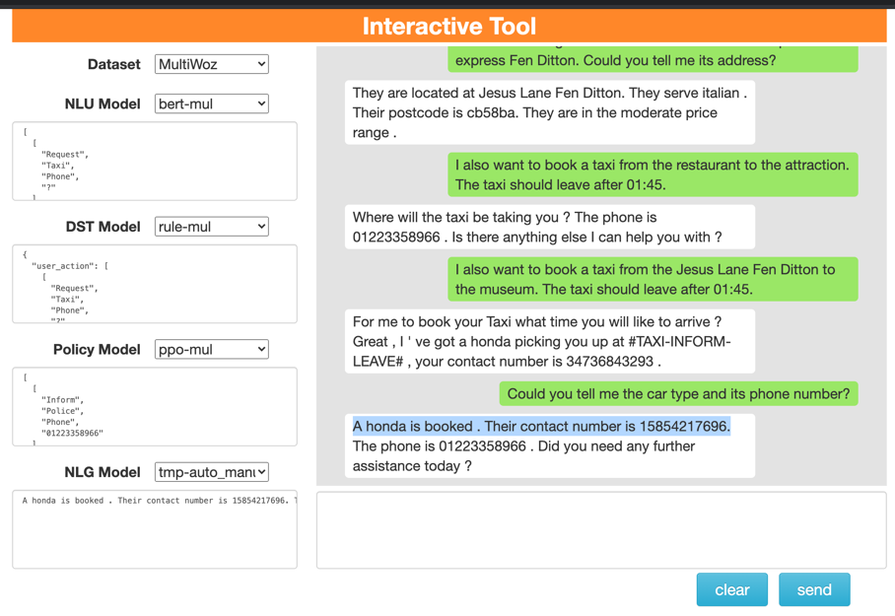

Fill in:

{'attraction': {'info': {'area': 'centre', 'type': 'museum'}, 'reqt': {'entrance fee': 'free'}}, 'restaurant': {'info': {'name': 'pizza express Fen Ditton'}, 'reqt': {'address': 'Jesus Lane Fen Ditton'}}, 'taxi': {'info': {'leaveAt': '01:45'}, 'reqt': {'car type': 'honda', 'phone': '15854217696'}}}